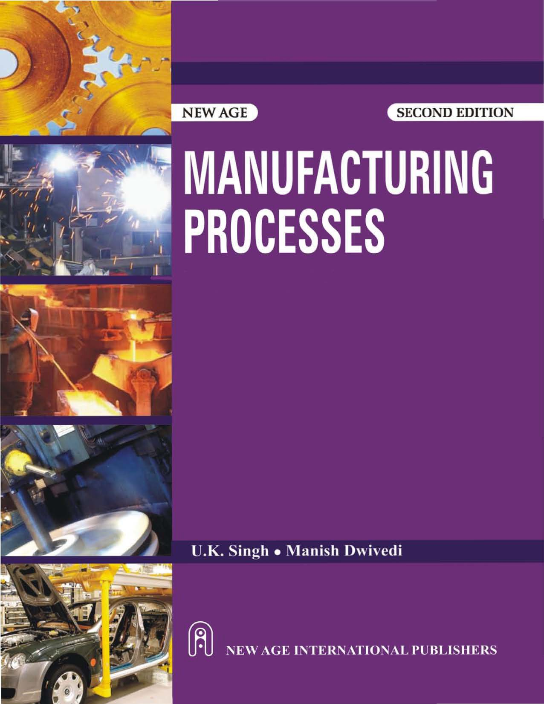

[www.EngineeringEBooksPdf.com](http://www.EngineeringEBooksPdf.com/)

**Manufacturing**

**Processes**

**This page**

**intentionally left blank**

**MANUFACTURING**

PROCESSES

Second Edition

U K. Siagb

Ph,D.

Professti & Hea,d

D part1mm,1ot'Meeha't':!lcal Engrnnarh1g Kamla Nehru Institute 01 Teotmotc,oy Sutta11:pur {l.l' P.)

Manish Dwivedi

EU .. **M** 'T@ah,

10epu *y* hec1cr Hea.d

Depanmeni ot Meohanh::a,1 : g n.eerl:ll,g Arya:'liarl1 tnetirut.e £i •Teo.-mitngy .& M:ana.geman:I LuCknow (U.P.)

(E>t. Asstl* 01r;ec o

Ghabha lni;tltu e01·Technolow

Kanpur Oel'lru)

**NEWAGE**



lil tlp ri: • 1i,ci **n1** ;oc.l!im •

.bl' •K.ol;u_m - L.u nll'w t-

New

V !ii11: !,is WWWil'lfl'fllppO • ti &r,nn

Copyright © 2009, New Age International (P) Ltd., Publishers Published by New Age International (P) Ltd., Publishers

All rights reserved.

No part of this ebook may be reproduced in any form, by photostat, microfilm, xerography, or any other means, or incorporated into any information retrieval system, electronic or mechanical, without the written permission of the publisher. *All inquiries should be emailed to* [***rights@newagepublishers.com***](mailto:rights@newagepublishers.com)

**ISBN (13) : 978-81-224-2875-9**

**Publishing for one world**

**NEW AGE INTERNATIONAL (P) LIMITED, PUBLISHERS**

4835/24, Ansari Road, Daryaganj, New Delhi - 110002 Visit us at [**www.newagepublishers.com**](http://www.newagepublishers.com/)

**PREFACE TO THE SECOND EDITION**

I feel satisfied with the amount of effort put in to present this second edition of this popular book. This revised edition of the book has been provided with lot of useful material to improve its quality and use.

In this new edition, stress-strain diagram has been redrawn and rewritten the article 1.2 for presenting clarity to the students.

Objective questions, short & long answer type questions are given at the end of each chapter as per new pattern of UP Tech. University. Also two set of model papers of new pattern and examination paper (Dec. 2008) with solution have been given at the end of book.

Although every care has been taken to check mistakes and misprints in this new edition of book, yet it is difficult to claim perfection. We shall be very grateful to the readers and users of this book for pointing any mistake that might have crept in.

Suggestions for improvement are most welcome and would be incorporated in the next edition with a view to make the book more useful.

For any suggestions please mail: **U.K. Singh**

e-mail: [manpri97@rediffmail.com](mailto:manpri97@rediffmail.com) **Manish Dwivedi**

**PREFACE TO THE FIRST EDITION**

Manufacturing Process is a basic course at the undergraduate level for Ist Year common to all branches. This book has been written specifically to meet the requirements of engineering students of U.P. Technical University as well as all major Indian Universities.

Best efforts have been made to place the exact course material covering the prescribed syllabus in a very compact mode without affecting the authenticity of details. The book includes treatment of the subject matter according to the problems asked in the university examinations.

While preparing the text efforts have been made to maintain a simple lucid text which the students may reproduce while answering the questions in University Exam. To make the book a student friendly comprehensive unit, it is hoped that the book shall be preferred by the readers over other books available in the market. The suggestions from the readers for the improvement of the book are welcome and shall be acknowledged.

###### U.K. Singh Manish Dwivedi

**CONTENTS,**

*.Prlrfa.,w .t,,* di: ; *1:0,ul F.Jiilv,n*

*Pr .facr to t Ffr. 'I" Et1f.iia,i*

1. PROPE-R1''[ 
   1. l'l\ pmlr..s o .Materials

_[. ' . n:css..:;trn:in Diqmms

ID.3 Prin ip,d , e(h · ii al Ptope:i:tics

L4 Fn:l g!LIC mrJ r'1lfiiiuc it:! 1

l.5 C:r:et:p lillld Cr-effl Tdl'.futg

L6 mp 11nm: 'Tenn

*Ob;wr:ril''fll* (lue fll'>lll1' & *Am:* "'

*-Short* m *v* ***r*** *Que, 'lio1u*

*UJng I"twer Qt,ti!tUcm*



1. I It11rnduc litm

l. • c· 'ifn:: t m,o futak

2,3 l"jg Iron

"Vl BJ ,1 F11n1ai::c

'!.5 \Ynmgl1t Ir.on.

;6 C t Iron

*.:..1* Cup1;I : um1100

2..8 Cl'11:Ss.r.fkarion o[ Cast Iron

c.. 9 Gr11:,.· C t 001i

* 1. Whit • c l Iran

II

·-•

**l**

1

'J

*5*

5:

6

R

9

10

**11-17**

**H**

**ll**

13

1.4

.17

1 .

19

2

* 1. Jl%bl1t ,• **t** 11'.·n
  2. ,., N,o,11lH 'a,st hon

2 .13 .Alloy Cnslt kcu

2.1 ,, I

2.1- C, rbo11-,tclili

2 16 Alkly ted'

red

60NTE[l.JTS

26

27

7

M

_g

2

2:9

0

]

2..30



·1 u lfoyinl!l . .

* (I '!Is

;1.

2;2-1

.. 2

.2.:B

2.24

·gAIIys

futrQdmmoo to lle...t tr

tmcnt

Ohjoclivc uf H ill.1'TI.'8l'mcll1 Sta: *_es* f }kw: '.Ireatn.1e11L Heal CaJonrs •:or 81e.eJ Mcl.ltod uf Heal .n::llllnrnn Ann ling·

.. 31

2.32

....33

3

33

orm lizin!: 3

Ha:rde11ing 34

SWf *c* !tvtlctting "5

Ti 0111edng g

Quenclun. 40

QuC111 -bing Media 40

*Objsctfr Qu,u;tt_mµ &: m we1·.f* 44

*Sfwrl Amw ·r Qu.flllhm.* 46

1. *.,o,ig Att,i!* · ti' *Que1tio1* 47

.l. ]_1,' RR •*ti* - MF.T L.

. l bt.l od11 •tion

3.2 AJuminin.n lllld its All

1. " Junilitlun \J • y
   1. C'.oppc.1: nd il A1Jo)'
   2. Co11pe.r Alkrys

.6 Zinc 11.ild i Alloys

*?i* .'7 'Zmc llllJ&

3,8 l.eli.d and illi Alloy

.9 'fin a:nd Alloys

. tO Nickel aml i lfoy



.11 0th« d;v;U1 Mat ria lsh\lloys

- *.11* .U gteria· •

*ObjPr.J.i'lii!: Q t io ,r &* Jt&\ lc't'!r',I

*Shor Ant* • *t'tlicmj*

*lpl;g* A,1 *,nir:m*

1. l\ffli'. L **FORMING**

4.J •• i[cttl Furm i:i1.

4..2 El ·•r1. w,d Plastic- D fol'matio

4. Urn Workin:g and Cold Woikiu •

11- 2

9

49

50

S1

51

4

a54

.55"

*55*

*$6*

*51*

58

.;9

**61**

ti

63-104

4-.

#### 4.5

**+.b**

4,7

4-.8

mgms.

.R.Huig



6.l

v..1re Tu ,v:iog

Tub Dl 1iug

M4. ing ilnd • •ln!Sion

60NTENTS

*4..*9 Prcss-wi.lfl!.

4.10 Die & Pmlcfi semhl

-1.11 h.,mng

4.12 hl2tit1& Die$

.1 De p f>r.fwing.

*Qbjc:L,"lfre Q:u::sli:om Arn11iers*

*SJ an* AtM:, *-er gur,s,tJOt11 lhng A* n.11.Wc'T *QKesti.mu*

"S G

.I Pattern

5;'2. Draft

*5*.3 Monlillng . teri I

.5*,4* Mouldin . Saud

*.5* Mlluld if kiR.g wdh Di 

5.6 GatinJ! S)'•tern

*:r* n*crs in "'-i;tio& 11d• emed i

5.8. upoJ

;9 Die CM ing

*06j6Cliv Question.l n Vt':J':I*

*SI oti An h!tl.J'* ( *rlmi&*

*wrig Amwer Qr.u:.:rtia;u*

0.1 

6.2 Basi Wm:kiug, Pt.in: .iple of I...ililie.Machine [ Llu.ttion Pcdo.nned QD Lillh M rune

6.4 Tem1 sed in Lril1 • M11dlii1ilig

0.5 • hiap

* 1. PJ ner
  2. Drilling • ,f chine

6.8. • filling

'6.9' C:anding

*Ob/et:lrv QU&:it.lfoii.r* • • mWt?',J

·1im1 *An w. r Qii . rl,m*

*Lang Art5'"1/ef Que:;ilkml*

*'J'.* WELD G

90'

91

9)

98

I)

102

103

104

**105- l**

I *5*

108.

109

110

11

113

11'.1

ill

126

129

1.30

130

1;u-:ll,!

13

133

138

1 1

M5 149

*151*

16:3

164

165

167-193

1.1

1.2

7.

7.

*1.5*

*1:6*

*7.1*

*1.*

*1.9*

7,H:I

[m f ·g.

ldiog

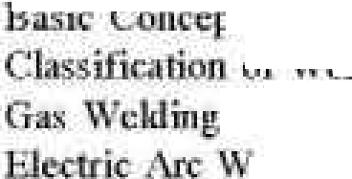

•

ii

·

' [illn.g

ding l'wee es

Cmnpur;sbn Rct\ ci:ri • •·.and De W,d'ding Typ o



* ' l'l.j ·1arioe '\ . ddin

R• ' *tancc* t ld.i:ng

o]ilumg

*161*

16.7

16

J6R

176

Hl2

182

L 4

1

18

7.11 R:r ri11'"

1. l" Dit ettnc't Bc:tw luring nd Br . n.

*Ohj&:Jii. Quielfltm Ari* · -er.1:

*$Ii rt Ani\ r Qu fTI* tu

*wng Art W£,w' uelhim*



ln1pmtn11,cc a f !J:atcri s

Manufacturing

il• hrrpnrt DC: 1:11 •. if.'inula.citll/m,.

.4 l;mufi turlng T ard.s •r- Im J ii & • i.o-e.conomic- yelopmeu..

*.5* □o iliica.tion r NLumfactw'.ing Pfi(]i,e,C St.'i

* + Ji Plnni L<,,c, lion

1. 7 Pill.fill Lay out

8.8 of PLml Layoot

.9 **Lll}OYt**

* lO uf Prwlm:liun

l:!.1**l** • • .vid rr: duct.Mt *Obj,p:t QuR1fimu* • Ii& L't3'7',f *'i1()_rt A* i *• ,1er Qu11sthms*

*u,m.g Amwer Q .:rlir.:in1*



.1

*9.2*

,3 CcrarnjCl:i

9.4 Ru b •

1. S PlasliC!I: lntmd11eti.1}n

9.6 Composim l'l,lai eruds

*Ohj&:Jii. Quielfltm Ari* · -er.1:

*$Ii rt Ani\ r Qu fTI* tu

*wng Art W£,w' uelhim*

I0. • DL CE.I.I . NOOl' PR:OC

. l lii:,l'.lo nf Pm Jcr MarnUarg)'

l 0.2 lain Ch r, iett:fis.ti of Powd cs

1. • Pn\Yi:lq etidlm Prm::11:l
2. I Applit: Hom of Powd c, et.\llurgy

10,5 Piastic

1. Ji Pl.stic/l'olyniec *·* sing
   1. Ga[vaniz.ing CO.R F.lcctrnplatin@.

*Ol o1fre: Qut J >•* .*vi w*

. *fwrt Amw r Qu tim* ,f

*Lon.• br* i' *r Q14 r-ior* ,,

E wDinnliou Papl.'I'- 2068-09

,1.odtd T ·t **Papn-=I**

lodcl T .•r Paper-ll

60NTE[l.JTS

U1$.

nm

189

9

192

195-208

J.95 19.5 J96 19.

196

19 .

199

200

703

2.0S

:w

207

208

QI

209-227

2'»

21-

"11.4

216

- u

1. ,,

226

226

227

..,19-_7

129

'!130

232

z 0

24l

24

245

,6

M7 248

2:.

2,49,

.l,7:

278

|  |  |  |
| --- | --- | --- |
|  | 1 |  |
|  |  |
|  | | |
| **PROPERTIES OF MATERIALS** | | |

## PROPERTIES OF MATERIALS

Different materials possess different properties in varying degree and therefore behave in different ways under given conditions. These properties includes Mechanical properties, Electrical properties, Thermal properties, Chemical properties, Magnetic properties and Physical properties.

A design engineer is interested in the behaviour of materials under load which is mechanical in nature, for the design of machines & structures. Any material subjected to a load either deforms, yield, or break, depending upon the magnitude of the load.

We are basically interested in knowing as to how a particular material will behave under applied load i.e. in knowing the mechanical properties.

## STRESS-STRAIN DIAGRAMS

### Stress-Strain Curves for Ductile Materials

If a mild steel bar of uniform cross-sectional area is subjected to gradually increasing axial tensile force (generally is done in Universal Testing Machine) till failure of the bar occurs, and if we plot the graph for stress and strain, the following curve (Fig. 1.1) may be obtained:

The curve may be divided into following parts:

**Portion *OA*:** This portion is absolutely straight, where the stress is proportional to strain and the material obeys Hooke’s law. The value of stress at point A is called proportional limit.

Proportionality Limit Elastic Limit

Upper Yield Point



C

Maximum or Ultimate Point

D

**Portion *AB*:** In this portion, Hook’s law is not

A B C*'* Lower Yield Fracture or E

obeyed, although the material may still be elastic.

Stress

()

Point

Breaking Strength

The point B indicates the elastic limit.

**Portion *BC*:** In this portion, the metal shows an appreciable strain even without further increase in stress and the strain is not fully recoverable when load is removed.

**Portion *CC****'***:** Yielding commences in this

Plastic Zone Elastic Zone

Area = Modulus of Resilience

O Strain (e) 

**Fig. 1:** – e Diagram for Ductile Material

**Fig. 1:** σ e Diag ram for Ductile Material

2 MANUFACTURING PROCESSES

portion and there is a drop of stress at the point *C'* immediately after yielding commences at *C*. The point *C'* is termed as lower yield point and *C* is called upper yield point.

**Portion *C****'****D*:** After yielding has taken place at *C'*, further straining takes place at this portion by increasing the stress and the stress–strain curve continues to rise up to the points *D*.

Strain in this portion is about 100 times that of portion *O* to *C*. At the point *D*, the bar begins to form a local neck. The point *D* is termed as ultimate tensile stress point. Ultimate stress is calculated at this point.

**Portion *DE*:** In this portion, the load falling off from the maximum until fracture at *E* takes place. The point *E* is termed as fracture or breaking

High Carbon Steel

Cast Iron

Concrete

Strain (e)

point and the corresponding stress is called breaking stress.

### Stress Strain Curves for Brittle Materials

Materials which show very small elongation before they fracture are called brittle materials. The shape of curve for high carbon steel is shown in fig. 1.2 and is typical of many brittle materials such as G .I., concrete and high strength light alloys. For most brittle materials the permanent elongation (*i.e.* increase in length) is less than 10%.

## PRINCIPAL MECHANICAL PROPERTIES

Stress ()

**Fig. 2:**  – e Diagram for Brittle Material

Those characteristics of the materials which describe their behaviour under external loads are known as Mechanical Properties.The most important and useful mechanical properties are:

### Strength

It is the resistance offered by a material when subjected to external loading. So, stronger the material the greater the load it can withstand.

Depending upon the type of load applied the strength can be tensile, compressive, shear or torsional.

The maximum stress that any material will withstand before destruction is called its ultimate strength (Point *D* as shown in Fig. 1.1).

### Elasticity

Elasticity of a material is its power of coming back to its original position after deformation when the stress or load is removed. Elasticity is a tensile property of its material.

The greatest stress that a material can endure without taking up some permanent set is called elastic limit (Point *A* as shown in Fig. 1.1.).

### Stiffness (Rigidity)

The resistance of a material to deflection is called stiffness or rigidity. Steel is stiffer or more rigid than aluminium.

PROPERTIES OF MATERIALS 3

Stiffness is measured by Young’s modulus *E*. The higher the value of the Young’s modulus, the stiffer the material. *E* is the ratio of stress over strain and is given by the slope of line *O* – *A*.

### Plasticity

The plasticity of a material is its ability to undergo some degree of permanent deformation without failure. Plastic deformation will take place only after the elastic range has been exceeded, beyond point b.

Plasticity is an important property and widely used in several mechanical processes like forming, shaping, extruding and many other hot and cold working processes. In general, plasticity increases with increasing temperature and is a favourable property of material for secondary forming processes.

Due to this properties various metal can be transformed into different products of required shape and size. This conversion into desired shape and size is effected either by the application of pressure, heat or both.

### Ductility

Ductility of a material enables it to draw out into thin wire on application of the load. Mild steel is a ductile material. The wires of gold, silver, copper, aluminium, etc. are drawn by extrusion or by pulling through a hole in a die due to the ductile property. The ductility decreases with increase of temperature.

The per cent elongation and the reduction in area in tension is often used as empirical measures of ductility.

### Malleability

Malleability of a material is its ability to be flattened into thin sheets without cracking by hot or cold working. Aluminium, copper, tin, lead, steel, etc. are malleable metals.

Lead can be readily rolled and hammered into thin sheets but can not be drawn into wire. Ductility is a tensile property, whereas malleability is a compressive property. Malleability increases with increase of temperature.

### Brittleness

The brittleness of a material is the property of breaking without much permanent distortion. There are many materials, which break or fail before much deformation take place. Such materials are brittle e.g., glass, cast iron.

Therefore, a non-ductile material is said to be a brittle material. Usually the tensile strength of brittle materials is only a fraction of their compressive strength. A brittle material should not be considered as lacking in strength. It only shows the lack of plasticity. On stress-strain diagram, these materials don’t have yield point and value of *E* is small.

### Toughness

The toughness of a material is its ability to withstand both plastic and elastic deformations. It is a highly desirable quality for structural and machine parts to withstand shock and vibration. Manganese steel, wrought iron, mild steels are tough materials.

For Ex: If a load is suddenly applied to a piece of mild steel and then to a piece of glass the

4 MANUFACTURING PROCESSES

mild steel will absorb much more energy before failure occurs. Thus, mild steel is said to be much tougher than a glass.

Toughness is a measure of the amount of energy a material can absorb before actual fracture or failure takes place. **“The work or energy a material absorbs is called modulus of toughness”** Toughness is also resistance to shock loading. It is measured by a special test on Impact Testing

Machine.

### Hardness

Hardness is closely related to strength. It is the ability of a material to resist scratching, abrasion, indentation, or penetration.

It is directly proportional to tensile strength and is measured on special hardness testing machines by measuring the resistance of the material against penetration of an indentor of special shape and material under a given load. The different scales of hardness are Brinell hardness, Rockwell hardness, Vicker’s hardness, etc.

Hardness of a metal does not directly relate to the hardenability of the metal. Hardenability is indicative of the degree of hardness that the metal can acquire through the hardening process. i.e., heating or quenching.

### Hardenability

Hardenability is the degree of hardness that can be imparted to metal by process of hardening. A metal capable of being hardened throughout its structure is said to have high hardenability. The material is heated above a certain temperature and then suddenly quenched in a cold oil or water bath.

### Impact Strength

It can be defined as the resistance of the material to fracture under impact loading, i.e., under quickly applied dynamic loads.Two standard tests are normally used to determine this property.

* + - 1. The IZOD impact test.
      2. The CHARPY test.

### Resilience

Resilience is the capacity of material to absorb energy elastically. On removal of the load, the energy stored is released as in a spring.

The maximum energy which can be stored in a body up to elastic limit is called the proof resilience. The quantity gives capacity of the material to bear shocks and vibrations. The strain energy stored in a material of unit volume gives proof resilience and is measured by work stretching.

## FATIGUE AND FATIGUE TEST

The fatigue strength of a material is the maximum stress at which failure may occur after a certain number of cyclic load applications. A component is designed to give a certain length of service under a specified loading cycle. Many components of high speed aero and turbine engines are designed for fatigue strength.

The fatigue strength or endurance limit of material is used in the design of parts subjected to repeated alternating stresses over an extended period of time.

PROPERTIES OF MATERIALS 5

Specimens are tested to failure using different loads. The number of cycles is noted for each load. The results of such tests are plotted as graphs of applied stress against the logarithm of the number of cycles of failure. The curve is known as *S*-*N* curve. The tests are carried out on special fatigue testing machines.

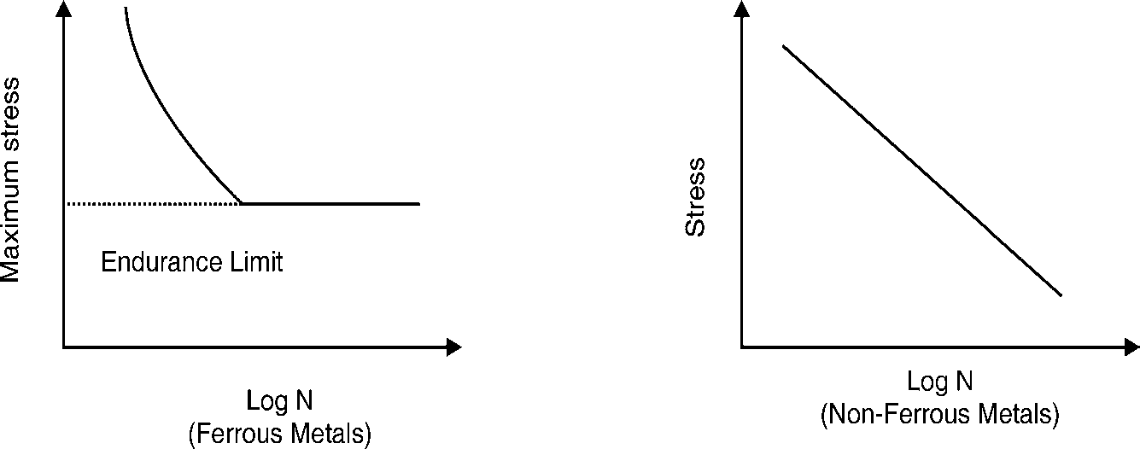

(N = No. of cycles before failure)

**Fig. 1.3:** Fatigue Curves

## CREEP AND CREEP TESTING

The slow and continuous elongation of a material with time at constant stress and high temperature below elastic limit is called creep. At high temperatures, stresses even below the elastic limit can cause some permanent deformation on stress-strain diagram.

There are three stages of creep. In the first stage the material elongates rapidly but at a decreasing rate. In the second stage, the rate of elongation is constant. In third stage, the rate of elongation increases rapidly until the material fails. The stress for a specified rate of strain at a constant temperature is called creep strength.

Creep test is carried out at high temperature. A creep curve (Fig. 1.4) is a plot of elongation of a tensile specimen versus time, for a given temperature and under constant stress. Tests are carried out for a period of a few days to many years. The test can be carried out on Universal Testing Machine with special attachments.

Creep curve shows four stages of elongation:

1. Instantaneous elongation on application of load.
2. Primary creep: Work hardening decreases and recovery is slow.
3. Secondary creep: Rate of work hardening and recovery processes is equal.
4. Tertiary Creep: Grain boundary cracks. Necking reduces the cross-sectional area of the test specimen.

The creep strength is used for the design of blades and other parts of steam and gas turbines working at high temperatures.

6 MANUFACTURING PROCESSES

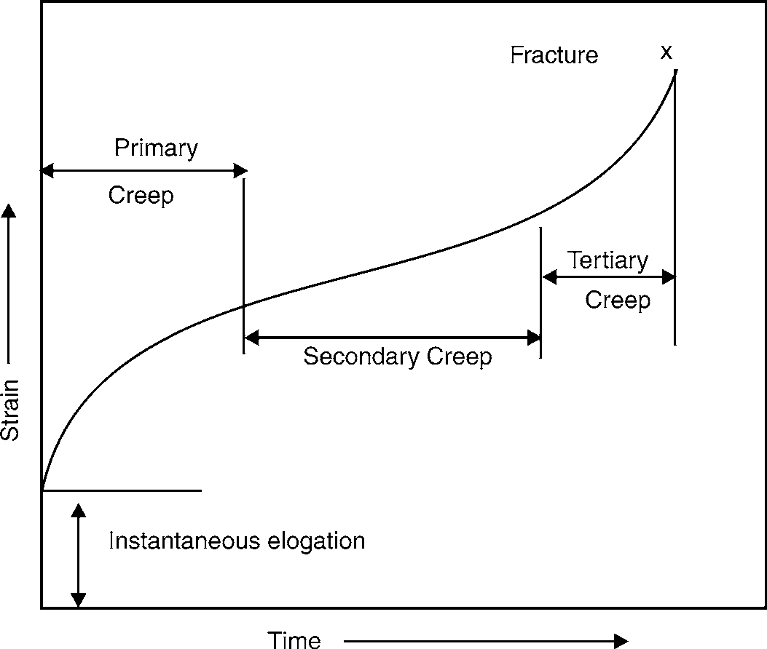

**Fig. 1.4:** Creep Test Curve

## IMPORTANT TERM

### Simplification

It is the process through which a limited number of grades, types and size of a product are determined in order to have better control, minimise waste, simplify production and thus, reduces price. By eliminating unnecessary varieties, size and design it leads towards interchangeable manufacture of products.

### Standardization

It is the second step towards interchangeable manufacture, increased output and higher economy. The process of standardization involves determining the best material, manufacturing processes and allied techniques for the manufacturing processes and allied techniques for the manufacture of a product.

### Inspection and Quality Control

It is another important function of a production unit. If a manufacturing firm wants to maintain its reputation among the users, it should under all conditions, strive hard not only to keep up the standard of quality of its products once established but to improve upon the same. For this every concern, maintain a full-fledged inspection and quality control department which inspects the product at various stages of its production.

### Interchangeability

It is a principle applied to the mass production of identical components such that any one of the components, selected at random, will suit the assembly condition to meet the requirement of operation. For this, the components are allowed a predetermined amount of variation in their finished

PROPERTIES OF MATERIALS 7

dimensions lie within these limits are acceptable components.This facilitates easy and quicker production, easy inspection, requires less skill on the part of worker and accommodates a slight inaccuracy in the machine as well, resulting in an overall reduction in the production cost of the component.

### Mechanization

It is the term which implies a trends towards minimizing the human efforts, to the extent it is possible, by adopting mechanical means or methods for different processes. Such a trend may be in material handling, loading and unloading of components. Actual operations done on the job or transporation, etc. But no feed back is provided by the process, operations or machine.

### Automation

It is a further extension of mechanization and involves adoption of automatic controls for the operations of different machines. This automatic control may be adopted for only a few operation or all the operation of a m/c and accordingly the m/c will be known as Semi-automatic or Fully-automatic.

### Computer Aided Design(CAD)

The CAD enables design engineers to rough out a particular product configuration and receive immediate feedback on its specification. In utilizing CAD, the computer draws pictures on the video screen. So, CAD can speed up the normally slow and laborious work of drafting.

### Computer Aided Manufacturing(CAM)

We have studied that the CAD function of their application fully takes care of product design, product research and analysis, preparation of assembly drawings, part drawings, bill of materials, make or buy decision, etc. Similarly, computers are being widely used in Numerical Control (NC) of machines.With similar advantages the computers are being used in almost all area of actual manufacturing, including process optimization and production control, parts and material movement, material management, monitoring, scheduling etc., which is known as CAM.

### Material Requirement Planning(MRP)

Inventory management is another vital area where computer are widely used. MRP, which is based on production schedule, bill of materials and records of inventory in respect of raw materials, in-process materials, purchase parts and components, parts in-process, finished products, delivery schedules, etc.

### Group Technology

Group technology is a wide concept of manufacturing in which it is conceived that several problems have similar features which if solved together in a group, result in greater economy and efficiency. For the application of this concept to manufacturing different parts are analysed in respect of the similarities in their design feature, manufacturing processes and the sequence of operations.

### N.C.Machines

This term stands for NUMERICALLY CONTROLLED MACHINES, which implies controlling the relative movements of the cutting tool and work, cutting speeds, feeds and depths of cuts,

8 MANUFACTURING PROCESSES

sequencing of proper tools for a particular operation and almost all the machining parameters automatically with the help of a prearranged programme fed into the control unit. Such a control of machine tools enables higher accuracies, closer dimensional tolerances, enhanced productivity and reduction in production costs.

# OBJECTIVE QUESTIONS

1. Which of the following are the mechanical properties of material?
   1. Hardness (b) Specific heat

(c) Fatigue (d) Both (a) and (c)

1. Which of the following are the thermal properties of materials?
   1. Fatigue (b) Specific heat

(c) Thermal conductivity (d) Both (b) and (c)

1. The ability of material to sustain loads without failure is known as
   1. Mechanical strength (b) Impact strength

(c) Hardness (d) Brittleness

1. The ability of a material to resist elastic deflection is known as
   1. Fatigue (b) Stiffness

(c) Creep (d) Hardness

1. The ability of material to resist softening at high temperature is known as
   1. Fatigue (b) Creep

(c) Hot hardness (d) Impact strength

1. Hardness of steel depends on
   1. Amount of carbon it contains (b) The shapes and distribution of the carbides in iron

(c) Method of fabrication (d) The quality of ores from which it is made

1. The capacity of material to undergo deformation under tension without rupture is known as
   1. Impact strength (b) Stiffness

(c) Creep (d) Ductility

1. When a material sustains steady loads for long periods of time, the material may continue to deform until it may tend to fracture under the same load. The phenomenon is known as
   1. Creep (b) Hardness

(c) Impact strength (d) Fatigue

1. The capacity of a material to absorb energy in the elastic range is known as
   1. Creep (b) Hardness

(c) Resilience (d) Fatigue

PROPERTIES OF MATERIALS 9

1. The properties of material to resist penetration by another material is known as
   1. Impact strength (b) Hardness

(c) Fatigue (d) Resilience

1. The capacity of a metal to exhibit considerable elastic recovery upon release of load is known as
   1. Creep (b) Fatigue

(c) Impact strength (d) Stiffness

1. Ductility of a material may be defined as
   1. Ability to undergo large permanent deformation in compression
   2. Ability to undergo large permanent deformation in tension
   3. Ability to recover its original shape
   4. All of above

|  |  |  |  |  |  |
| --- | --- | --- | --- | --- | --- |
|  | | | **ANSWERS** |  | |
| 1. (d) | 2. (d) | 3. (a) | 4. (b) | 5. (c) | 6. (d) |
| 7. (d) | 8. (a) | 9. (c) | 10. (b) | 11. (d) | 12. (b) |

# SHORT ANSWER QUESTIONS

|  |  |  |
| --- | --- | --- |
| 1. | Briefly explain what do you understand by Toughness. | Dec-0, 01,02, C.O.-02, May-03 |
| 2 | Briefly explain what do you understand by Fatigue. | Dec-00, 02 |
| 3. | Briefly explain what do you understand by Creep. | Dec-00 |
| 4. | Differentiate between Elasticity and Creep. | May-02 |
| 5. | Differentiate between Fatigue and Creep. | Dec-03 |
| 6. | Write short notes on | May-01 |
|  | (i) Automation (ii) Group Technology |  |
|  | (iii) Interchange ability (iv) Mechanization |  |
| 7. | Write short notes on |  |

* + 1. Elasticity Dec-01 (ii) Plasticity Dec-01

(iii) Hardness Dec-01, May-02 (iv) Malleability. Dec-02, 03, May-02, 03

(v) Ductility C.O.-02 (vi) Plasticity Dec-03

1. Differentiate among strength, stiffness and toughness. May-01
2. What is the difference between
   1. Brittleness and hardness C.O.-02
   2. Ductility and brittleness May-03
   3. Hardness and brittleness (iv) Strength and stiffness

(v) Elasticity and creep (vi) Malleability and ductility

(vii) Hardness and Impact resistance

1. What property is dependent on time and temperature?
2. On what factors does the hardness of steel depend?

10 MANUFACTURING PROCESSES

# LONG ANSWER QUESTIONS

1. What do you understand from the term “Mechanical properties of metals” ? On which factor these properties mainly depend. Dec-02
2. Briefly explain  *–* e diagrams for copper and high carbon steel. Dec-00
3. What is meant by mechanical properties of materials? State their importance in the design of a machine or structural element.
4. Explain the term ‘fatigue’. Also explain the term fatigue strength and fatigue limit related to fatigue.
5. Draw a typical “Creep test” curve, showing different stages of elongation for a long time high temperature creep test. State how the information is useful to the design engineers.

❍ ❍

|  |  |  |
| --- | --- | --- |
|  | 2 |  |
|  |  |
|  | | |
| **FERROUS MATERIALS** | | |

## INTRODUCTION

A metal may be described as a material which is solid at room temperature has relatively high density, high melting temperature, low specific heat, good electrical and thermal conductivity, strength and hardness.

A metal can exist in the solid, liquid or gaseous state depending upon the temperature and pressure exerted on the metal. Some of the common metals and alloys are iron, copper, aluminium, nickel, tin, brass and bronze etc.

The non-metals in the solid state are mostly brittle and are poor electrical and thermal conductors. They do not form alloy but combined chemically to form compounds. Ex: Glass, wood, plastic and concrete.

Hence, in accordance to their properties the materials are broadly divided into two groups i.e., METAL and NON-METAL.

## CLASSIFICATION OF METALS

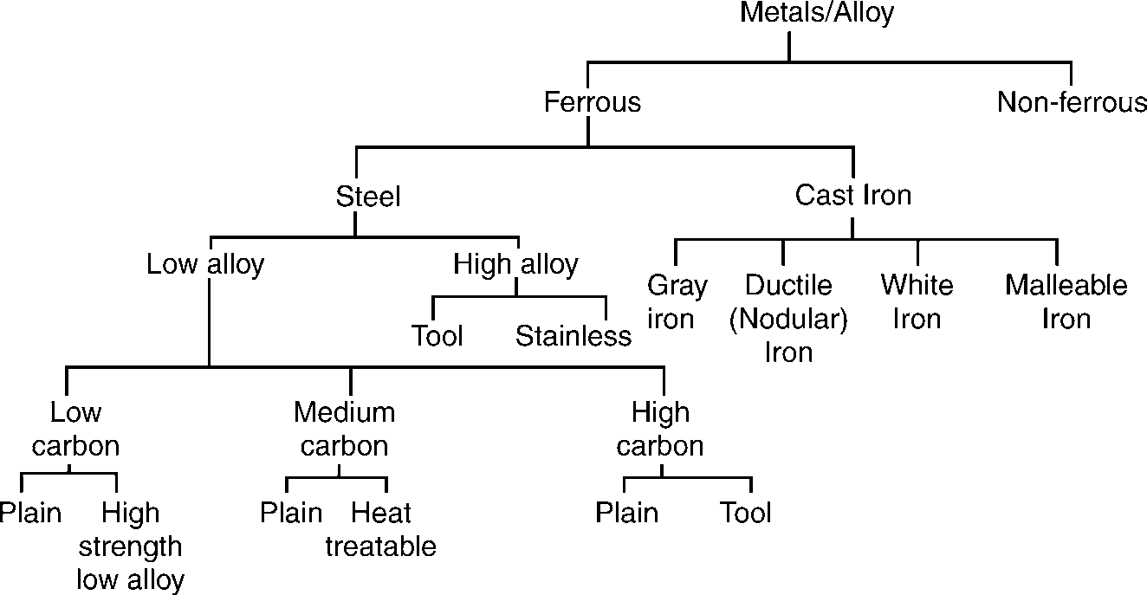All the metals are classified into two groups: FERROUS and NON-FERROUS. Ferrous Metals are those which contain iron.The latin words of iron is **ferrum**. Ferrous metals are Pig iron, Cast iron, Wrought iron, Carbon Steel, Alloy Steel.

**Fig. 2.1:** Ferrous Materials

12 MANUFACTURING PROCESSES

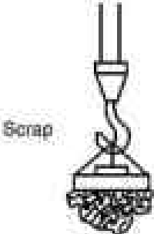

**w• J**

**f'r**

'

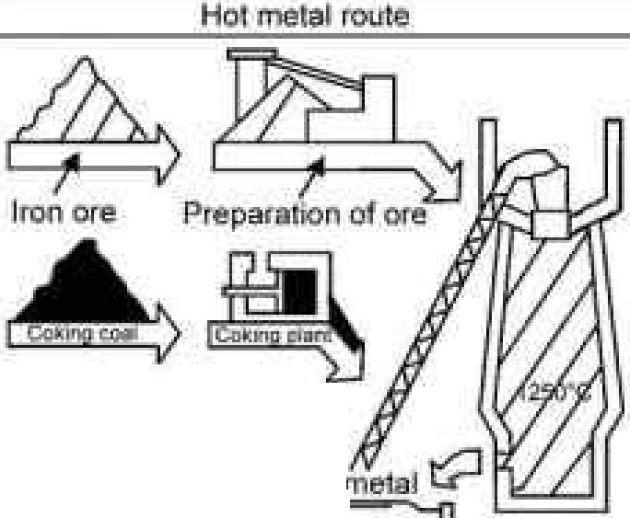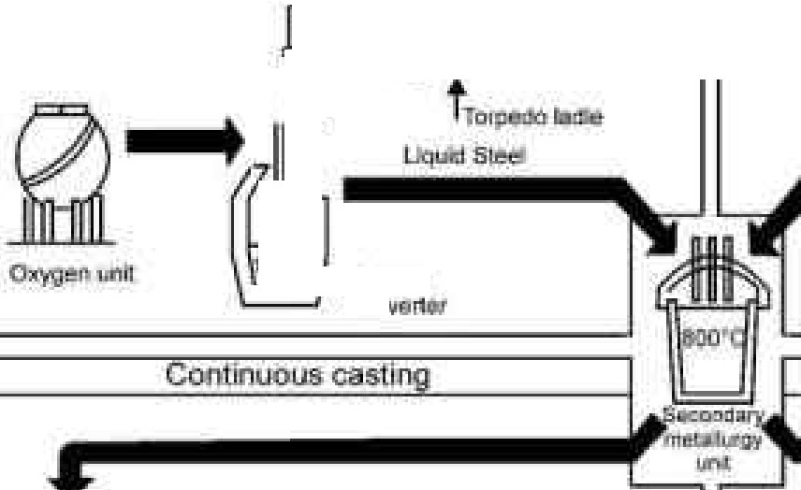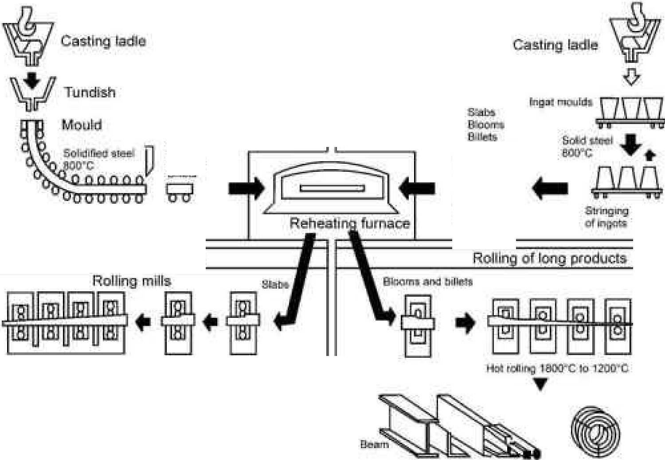

n

. **ot**

r'- -

, 81:,f;lhaTl!ll'I'

·

**..:I.**

. t""=

-

**co,,**

**:,,g**

**be**

AOl rig otirat rodi:icts

**Ho.t 1o111o**.., .110·,:::ciG **:zoo•c**

**Mi**■**a:Dnn..,cro RllY**

**aiKliQ**

**Rod**

**Fig. 2.2:** Steel Production Process

FERROUS MATERIALS 13

Non-ferrous metals are those which do not contain iron. Ex: Lead, Copper, Zinc, and tin. Non- ferrous metals are more costly as compared to ferrous metals, but they are good conductivity of heat and electricity lightness in weight, good machinability, high resistance to corrosion and the property of being anti-magnetic.

## PIG IRON

All iron and steel products are derived originally from pig iron. This is the raw material obtained from the chemical reduction of iron ore in a blast furnace. The process of reduction of iron ore to pig iron is known as **SMELTING**. Pig Iron partly refined in a coupla furnace produces various grades of Cast Iron. By puddling or shotting processes, wrought iron is produced from pig iron. Steel is produced from pig iron by various steel making processes, such as Bessemer Converter, Open-hearth Furnace, Oxygen Processes, Electric and Spray steel making furnace

Ore

Blast Furnace

Pig Iron

Cupola

Cast Iron

Puddling furnace

Bessener Converter

Open-hearth Furnace Electric Furnace Oxygen Processes

Wrought Iron

Steel

**Fig. 2.3**

The main raw materials required for pig iron are:

1. Iron ore
2. Fuel
3. Flux

### Iron Ore

Iron ore are generally carbonates, hydrates or oxides of the metals. These iron ores are found in India in several states—namely, Bihar, Orissa, MP, AP, Mysore, Tamil Nadu. Following are the common varieties of iron ores:

|  |  |  |  |
| --- | --- | --- | --- |
| ***ORE*** | ***Composition*** | ***Form*** | ***% of Metal*** |
| Red hematite | Fe2O3 | Oxide | 60-70 |
| Magnetite | Fe3O4 | Oxide | 62-72 |
| Limonite | Fe3O3H2O | Oxide | 40-60 |
| Iron Pyrite | FeS2 | Sulphide | 30-40 |
| Iron Stone(Siderite) | FeCO3 | Carbonate | 35-50 |

14 MANUFACTURING PROCESSES

### Fuel

Hard coke is commonly used as a fuel in blast furnace. This coke has two functions, One is to provide the required heat for melting and the other to combine with the oxygen of the ore in order to reduce the same. It is desirable that the fuel used should be hard enough to withstand the heavy weight of the charge without being crushed. It should possess, high calorific value, low ash content, high density and good porosity.

### Flux

Flux is a mineral substance that is charged into a blast furnace to lower the milting point of the ore and to promote the removal of the ash, sulphur and the residues of the burnt fuel. **Lime stone** is the most commonly used flux in blast furnace.

## BLAST FURNACE

The blast furnace is a vertical furnace designed for the continuous operation. The smelting room of the blast furnace comprises a throat, stack, body, bosh and hearth. It consist of a tall steel structure supported on a strong foundation and heavy columns all around. The outer shell is made of mild steel plates and the inner surface is lined throughout by the refractory materials (called fire bricks). It’s structure is divided into two parts, upper parts is known as **stack or shaft** and lower parts is known as **bosh.**

The upper part is tapered upwords and the lower one downwords.Two tapping holes are provided near the bottom for removing the metal and slag resp.

The raw materials known as the charge are taken to the top of the furnace by a specially designed bucket called **“skip”** running along an incline(or by the conveyor). The charge is then introduced into the throat of the furnace by means of a cup and cone hopper arrangement to prevent the escape of blast furnace gas which is used as a fuel. The proportion of raw materials are approximately 1/2 iron ore, 1/3 fuel and 1/6 flux.

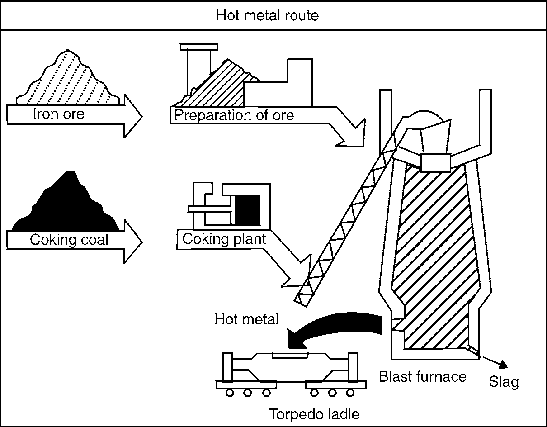

**Fig. 2.4:** Blast-furnace Process

FERROUS MATERIALS 15

In addition to the pig iron, slag (60% of pig iron) and gas also produced (500% of pig Iron).

A hot blast is forced into the furnace through a number of **nozzle** called **tuyeres**.

The tuyeres are cooled by water circulating between the pipe walls. The air blast is heated to minimise fuel comsumption by passing the cold air blast through the heated checker-work of hot blast stoves.

The temperature of the furnace just above the level of the tuyeres (melting zone) being 1000°C to 1700°C all substance inside the furnace start melting in the heat.The limestone that serves as a flux is combined with the ore to form a molten slag which floats on the top of the molten iron. The slag is tapped off from the furnace through the slag hole. The molten iron is tapped at intervals from 6 to 12 hours through a tapping holes, the blast being turned off meanwhile. The furnace is kept in operation until it gets worn-out.

### Charging Operation of Blast Furnace

The mined ore carries a number of earthy impurities and before smelting they are separated from the ore to the extent it is possible. The operation performed for doing so is calcination or roasting. In these preparatory process the mined ore is first crushed into small size and concentrated followed by roasting it in kilns.This enables considerable reduction in moisture content carbondioxide and also to some extent sulphur and arsenic. Ferrous oxide (FeO) is converted into ferric oxide (Fe2O3) and ore attains enough porosity which helps in its quicker reduction to iron.

This ore with suitable amount of coke and flux is charged in the blast furnace.These materials are lifted through a hoisting mechanism to the top of the furnace and charged through the double ball arrangement into the throat. The hot air blast enters the furnace through tuyeres and rises upwords. Through the downwards moving charge as the charge is melted, the molten metal is collected as the bottom and the slag floats over its top surface.The normal capacity of this furnace range from 800 to 1200 tonnes of pig iron per 24 hour. This furnace once started can run non-stop fot the years together.

### Chemistry of Blast Furnace

Different chemical reaction take place in different parts of the blast furnace. According to the temp in those parts, the highest temp in the furnace is at the bottom and the lowest at the top. According to these temp range, the blast furnace can be divided into following zones.

* + - 1. **Preheating Zone (From the top to gas outlet level):** Temp range in this zone is 200°C to 350°C which provided only a preheating effect on the charge and helps in evaporating the moisture content from it.
      2. **Reduction Zone (from the gas outlet to nearly the max cross-section level):** Temp range between 350°C to 1200°C. This is further sub-divided into two zones.

###### Upper Reduction Zone: (350°C to 700°C)

Here, iron oxide is reduced to metallic iron by reaction with the ascending carbon monoxide. So, this zone is also called iron oxide reduction zone.

Fe2O3 + 3CO = 2Fe + 3CO2

In this zone limestone (flux) also starts dissociating as follows: CaCO = CaO + CO2

16 MANUFACTURING PROCESSES

###### Lower Reduction Zone (700°C to 1200°C)

Here change becomes hotter as it descends.The decomposition of CaCO3 started earlier is completed at about 850°C. The CO2 formed due to this decomposition recast with the carbon of coke to reduce to CO.

CO2 + C = 2CO

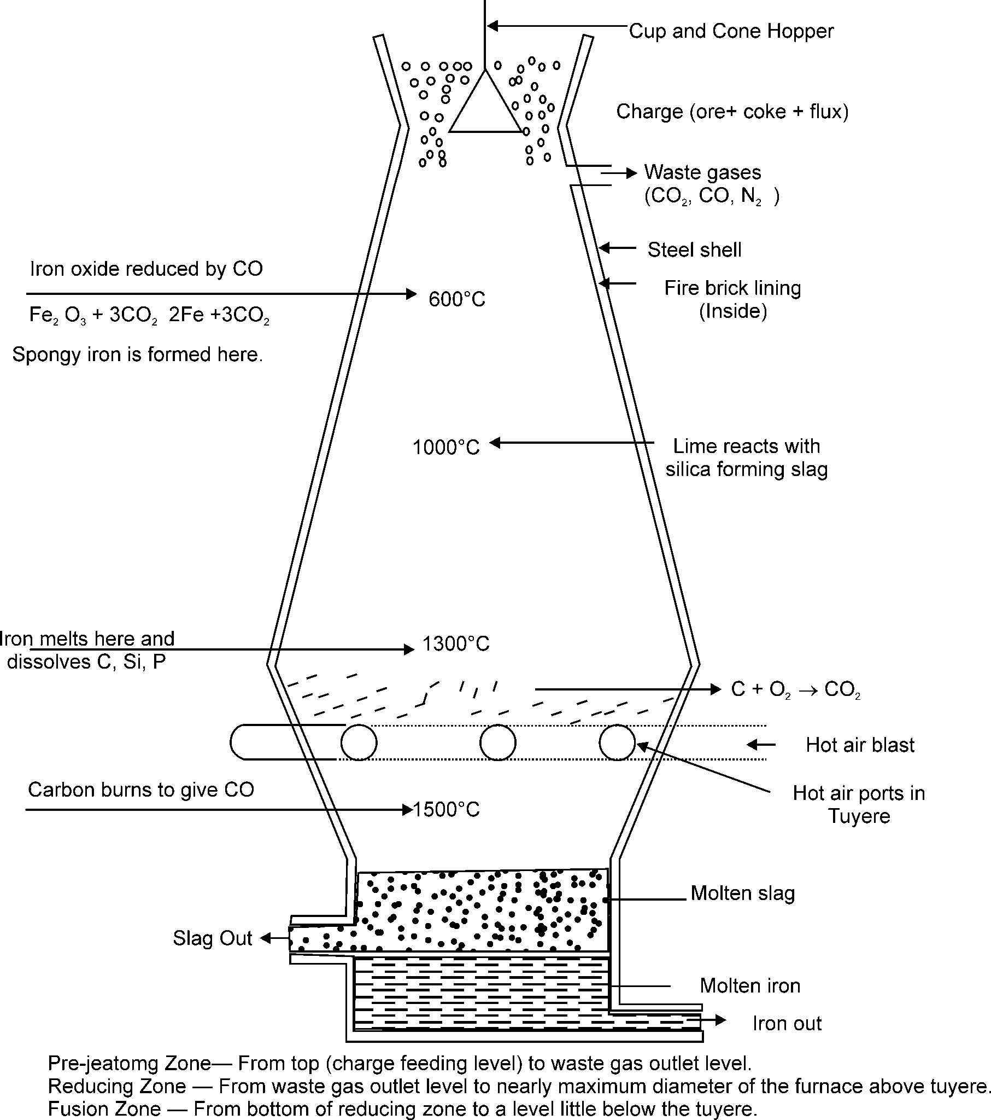

Fe2O3  3CO2  2Fe  3CO2

**Fig. 2.5:** Blast Furnace

FERROUS MATERIALS 17

Reduction of iron oxide is completed here

Fe2O3 + 3C = 2Fe + 3CO

The calcium oxide formed by the decomposition of lime. Stone combines all the impurities like silica and aluminium with it to form the slag. The higher temp of about 1200°C also causes the reduction of other oxides in the ore like P2O5 , MnO2 and SiO2 etc, into respective free element P, Mn and Si. They are absorbed by the metal formed(Fe) as above. As a result of all these, the melting point of iron is lowered and it starts melting at about 1200°C instead of 1530°C (The melting point of pure iron)

**(3) Fusion Zone(1200°C to 1600**°**C):** Evidently this parts carries highest temperature and in this region the melting of charge is finally completed. The iron get superheated here.The slag and molten metal are tapped separately from the furnace.The molten metal is poured into the moulds.Where it solidified to form what is known as pig iron.

The product of blast furnace has the following composition (approx)

|  |  |
| --- | --- |
| ***Composition*** | ***%*** |
| **Carbon** | 3 to 4% |
| **Silicon** | 1 to 3% |
| **Manganese** | 0.1 to 1% |
| **Phosphorus** | 0.3 to 1.7% |
| **Sulphur** | Less than 1% |
| **Iron** | Remainder |

## WROUGHT IRON

It is a highly refined mechanical mixture of very pure iron and a silicate slag.. It is the purest iron which contain at least 99.5% iron but may contain 99.9% iron.

### Chemical Composition

The product has the following chemical composition (approx)

|  |  |
| --- | --- |
| ***Composition*** | ***%*** |
| **Carbon** | 0.02 to 0.03% |
| **Silicon** | 0.02 to 0.10% |
| **Sulphur** | 0.008 to 0.02% |
| **Maganese** | Nil to 0.02% |
| **Phosphorus** | 0.05 to 0.25% |
| **Slag** | 0.05 to 1.5% |
| **Iron** | Balance |

18 MANUFACTURING PROCESSES

### Properties

The following are the main properties of wrought Iron.

* + - 1. It is never cast.
      2. It is weldable,forgeable,corrosion resistant and shock resistant.
      3. It is tough, malleable and ductile.
      4. It cannot be melted.
      5. It cannot stand sudden and excessive shocks.
      6. It can neither hardened nor tempered like steel.
      7. The melting point of wrought iron is 1510°C.
      8. It is used for bolts, nuts, chains, crane hooks, railway coupling, pipe and pipe fitting, plates, sheets,water pipe.

### Manufacture of Wrought Iron

The main point in the manufacture of wrought iron is the oxidation of nearly all the carbon and other elements fron pig iron. The following two processes are commonly used in the manufacture of wrought iron.

##### PUDDLING PROCESS

Pig iron for this purpose is first subject to a preliminary process of refining, the object of which is to remove silicon as compleltely as possible together with the greater part of the phosphorus, and to convert the graphite into combined carbon and this produces **white iron.**

The next process is to convert the white iron into wrought iron. To do this the slab of white iron are broken into pieces and taken to the puddling furnace which is a coal fired reverberatory furnace.

The term **reverberatory** is applied to furnace in which the charge is not in actual contact with the fire, but receives its heat by reflection from the roof of the shaped furnace.

Flue



hearth

Puddling door

Roof

Fire door

Fire

Door for extracting blooms

**Fig. 2.6**

The products obtained is known as **blooms** having a mass of about 50Kg. The hot metal is then passed through grooved rollers which convert blooms into bars called **muck bars** or **Puddle bars** which have a cross-section of approximately 15 to 100 mm. These bars are cut into short length, fastened together in piles, reheated to a welding temperature and again rolled into bars.

##### ASTON OR BYERS PROCESS

The large scale production of wrought iron resulted from the work of Dr. James Aston and his associates at the A.M. Byers Co.

FERROUS MATERIALS 19

In the Aston or Byers process, to produce wrought iron, the pig iron is first melted in a cupola furnace and refining of molten metal is done in a Bessemer converter. At the same time, a quantity of iron silicate slag is prepared in an open heart furnace. The refined iron so made in the Bessemer converter is poured at predetermined rate into a ladle containing the molten slag already prepared.

After the excess slag is poured from the ladle, the remaining mass of iron and slag is taken to a press where some slag is removed. The rectangular block formed in the press is known as **bloom**. The hot bloom as before is immediately passed through rolling mills to produce products of wrought iron of different shapes and sizes.

## CAST IRON

Cast iron is a general term that describes a series of iron-carbon silicon alloys, which are produced by pouring the molten(sand or metal) alloy into moulds.

It is most common material for making castings such as for automobile engine blocks, machine tool structure, frames for electric motor.

It is brittle and gray in colour, So, it can not be used in those parts which are subjected to shock (due to brittleness).

It contains so much carbon that, as cast, it is not appreciably malleable at any temperature. The main properties are its low cost, good casting characteristics, high compressive strength,

wear resistant and excellent machinability, no plasticity, unsuitable for forging works.

### Chemical Composition

|  |  |
| --- | --- |
| ***Composition*** | ***%*** |
| **Carbon** | 2 to 4% |
| **Silicon** | 1 to 3% |
| **Manganese** | 0.5 to 1.0% |
| **Phosphorus** | 1% |
| **Sulphur** | 0.02 to 0.15% |

* + 1. **Production of Cast Iron**

It is obtained by remelting pig iron with coke and lime stone in a furnace known as cupola. The limestone and fluxes aid in separating the impurities from the pig iron. The lime stone also acts as a flushing agent to carry off the oxides and ash from the fuel.

## CUPOLA FURNACE

The pig iron obtained from blast furnace is most impure and needs refining before using it for making suitable castings. The process involved in refining is remelting of pig iron with coke, limestone (or shell lime) and scrap castings in a cupola, as shown in fig. 2.7. It does not produce metal of uniform quality.

It is very similar to a blast furnace but small size and is much simpler in construction. It consists of a vertical steel cylindrical shell of uniform diameter of about 1 meter and 4 meters high. It is lined with fire bricks and rests on a square bed plate which is supported on four cast iron pillars, above the ground. The square bed plate has a circular opening of the size of the inside dimensions

20 MANUFACTURING PROCESSES

of the furnace which is closed by two semicircular cast iron hinged doors. Generally cupolas are not worked continuously as are blast furnaces but are run for such period as required. Therefore, before using the furnace, it is cleaned of all the unburnt coke, slag etc., Which settles at the floor of the furnace, by dropping down the semicircular hinged doors. The tuyeres are placed regularly round the circumference of the furnace near the bottom for blowing air into the furnace. The furnace is open at the top for charging. The different projecting spouts are provided at the bottom in opposite directions and at different levels for tapping off the slag and the molten iron.

The charge consisting of alternate layers of coke, pig iron mixed with scrap castings and limestone is fed to the furnace through the charging door. The scrap iron is used in order to improve quality of the cast iron and also to effect economy in the cost of its production. The air for combustion is forced under pressure through the tuyers. The lime stone is added as a flux, which combines with the impurities left in the pig iron and removes them in the form of slag which floats above the molten iron. The molten iron thus obtained is called cast iron and is cast into moulds.

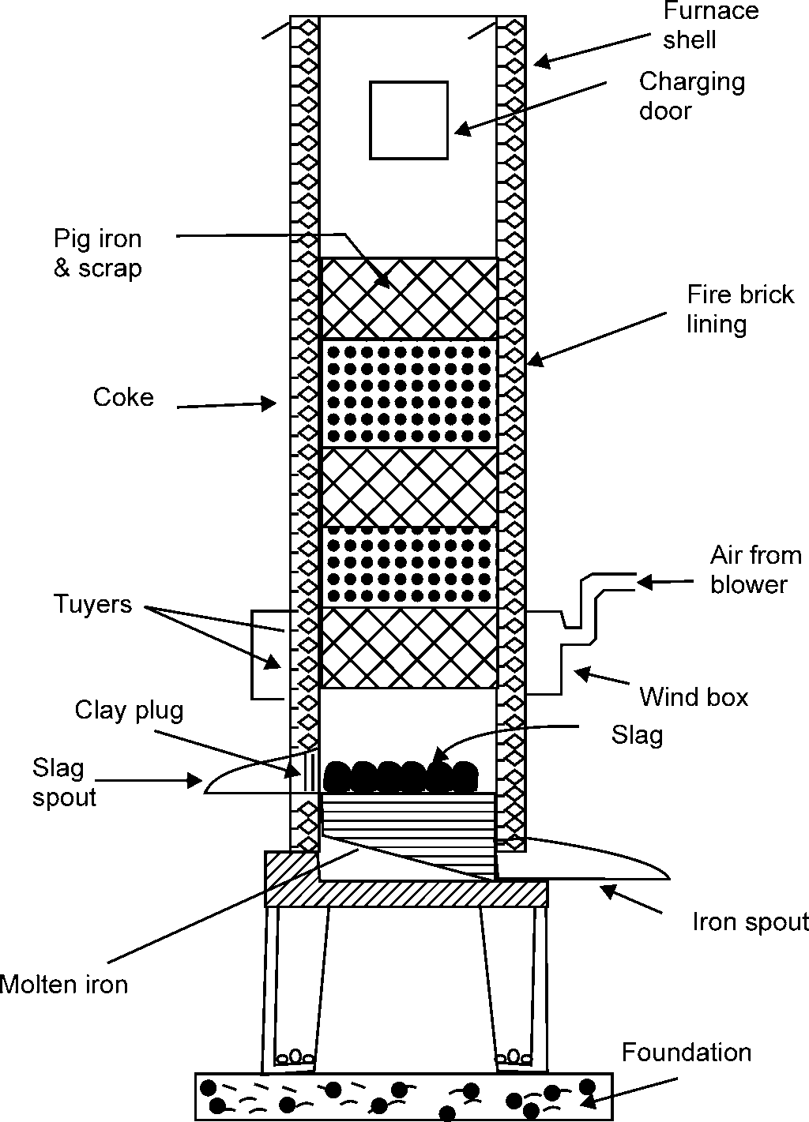

**Fig. 2.7**

FERROUS MATERIALS 21

The different steps involved in cupola operation are:

1. Preparation of cupola ( including repairs)
2. Lighting the fire into the coke bed
3. Charging of cupola
4. Melting
5. Slagging and metal tapping
6. Dropping down the cupola bottom

### Zones of Cupola

The different zones of cupola are marked in fig. 2.7 and they are explained as under.

1. **Well:** It is a sort of well of molten iron. The molten iron collects in this zone before being tapped. The well is situated between the tapered rammed sand bottom and the bottom of the tuyeres.
2. **Superheating Combustion or Oxidizing Zone:** All the oxygen in the air blast is consumed here owing to the (actual) combustion taking place in this zone. Thus, a lot of heat is supplied from here to other zones. Oxidation of Mn and Si evolve still more heat. The chemical reactions which occur in this zone are:

C + O2 (from air) = CO2 + Heat **...(1)**

2Mn + O2 (from air) = MnO2 + Heat **...(2)**

Si + O2 (from air) = SiO2 + Heat **...(3)**

The temperature of combustion zone varries from 1550°C to 1850°C.

1. **Reducing Zone or Protective Zone:** It extends from the top of combustion zone to the top of coke bed. It protects from oxidation. The metal charge above and that dropping through it. An endothermic reaction takes place in this zone, in which some of hot CO2 moving upward through hot coke gets reduced.

CO2 + C(Coke) = 2CO – Heat **...(4)**

This reduces the heat in the reducing zone and it has a temperature only of the order of 1200°C.

1. **Melting Zone:** Iron melts in this zone. The temperature in the melting zone is around or above 1600°C. As per the following reaction taking place in this zone, the molten iron picks up carbon.

3Fe + 2CO = Fe3C + CO2 **...(5)**

1. **Preheating Zone:** Preheating zone starts from above the melting zone and extends up to the bottom of the charging door. This contain cupola charge as alternate layers of coke, limestone and metal. Gases like CO2, CO, N2 rising upwards from combustion and reducing zones preheated the cupola charge to about 1100°C. Thus preheated charge gradually moves down in the melting zone.
2. **Stack Zone:** Stack zone extends from above the preheating zone to where the cupola shell ends and spark arrester is attached. Hot gases from cupola pass through the stack zone and escape to atmosphere. Stack gases (i.e. gases passing through stack zone) will normally contain about equal amounts of CO2 and CO which is 12% each and rest

76% is Nitrogen.

22 MANUFACTURING PROCESSES

## CLASSIFICATION OF CAST IRON

The quality of cast iron depends upon the amount of carbon and also the form in which it exists . Cast iron(C.I.) are classified as:

1. Gray cast iron
2. White cast iron
3. Malleable cast iron
4. Nodular cast iron
5. Clilled cast iron
6. Alloy cast iron
7. Mechanite cast iron

## GRAY CAST IRON

It is obtained by allowing the molten metal to cool and solidify slowly. On solidifying , the iron contain the greater part of carbon (2.5 to 3.75 %) in the form of graphite flakes. The grey colour is due to the fact that the carbon is present in the form of free graphite. It has a low tensile strength, high compressive strength and no ductility. It can be easily machined. A very good property of gray C.I. is that the free graphite in its structure acts as a lubricant. So, it is very suitable for sliding parts.

### Properties

1. A low cost material that can be used for many purposes.
2. It possesses the lowest melting point of the ferrous alloys. Its melting temperature is 1150°C.
3. It is easily machined. It possesses machinability better than steel.
4. It is readily cast into a desired shape in a sand mould.
5. It has no ductility and low impact strength as compared with steel.
6. It possesses excellent casting qualities for producing simple and complex shapes.
7. Free graphite in its structure acts as a lubricants.

### Applications

1. Machine tool structures (bed, frame, etc).
2. Gas or water pipes for underground purposes.
3. Manhole covers.
4. Cylinder blocks and heads for I.C. Engines.
5. Framens for electric motors.
6. Piston rings, household applications.

## WHITE CAST IRON

It contains 1.75 to 2.30 % carbon in the form of cementite(iron carbide) .The slow rate of cooling in sand produces free graphite while rapid cooling helps to produces cementite.

FERROUS MATERIALS 23

### Properties

1. White C.I. is very hard and brittle and shows a white fracture.
2. It is brittle and not machinable but requires grinding as shaping process.
3. It has low machineability and poor mechanical properties.
4. White iron possess excellent abrasive wear resistance.

### Applications

1. It is used in the manufacture of wrought iron and malleable cast iron.
2. Used for outer surface of car wheels.
3. Rolls for crushing grains and jaw crusher plates.

## MALLEABLE CAST IRON

The ordinary cast iron is hard and brittle. So, it is unsuitable for articles which are thin, light and subjected to shock and vibration or for small casting used in various machine components. The malleable C.I. is obtained from white C.I. by a suitable heat treatment process (Annealing). The annealing process separates the combined carbon of the white cast iron into nodles of free graphite. Two method in – **White heart process** and **Black heart process** – are used for this purpose. It contain 2.2% to 3.6% carbon.

### Properties

1. It is one which can be hammered and rolled to obtain different shapes.
2. It has low to moderate cost.
3. Melleable C.I. as compared with ordinary C.I. is less brittle and stronger, tougher, more fluid.
4. It is ductile and may be bent without breaking or fracturing the section.
5. It possesses good wear resistance and vibration damping capacity.

### Applications

1. Conveyor chain links.
2. Gear case.
3. Electrical line hardware.
4. Automotive crankshaft.
5. Crankshaft sprocket.
6. For making hinges, door, keys, spanners, mountings, gearwheels, cranks, levers, textile ma- chine.

## NODULAR CAST IRON

This iron is also known as, Ductile C.I.,

Spheroidal Graphite C.I.,

24 MANUFACTURING PROCESSES

High strength C.I.

This cast iron is produced by adding magnesium to the molten cast iron. The magnesium converts the graphite of C.I. from flake form to spheroidal or nodular form.

### Properties

1. It has high fluidity, which permits the casting of intricate shapes.
2. It can be produced in thicker pieces.
3. It possesses excellent castability and wear resistance.
4. It possesses very good machinability.

### Applications

1. It is widly used in cast parts where density and pressure tightness is a highly desirable quality.
2. They includes hydraulic cylinders, valves, pipes and pipe fittings, cylinder head etc.
3. Widly used in paper industries machinery.
4. For making power transmission equipment.
5. For making earth moving machinery.
6. For making pumps and compressure.

## ALLOY CAST IRON

The C.I. discussed above are called plain C.I. The alloy C.I. is produced by adding alloying elements like nicel,chromium , molybdenum, copper, silicon and manganese. These alloying elements give more strength and result in improvement of properties.

### Properties

The alloy C.I. has special properties like increased strength, high wear resistance, corrosion resistance or heat resistance.

### Application

The alloy C.I. are mostly used for automobile parts like cylinder, pistons, piston rings, crank case, brake drums, parts of crushing and grinding m/c.

## STEEL

Steel is an alloy of iron and carbon with carbon content upto a maximum of 1.5%.The carbon occurs in the form of iron carbide (Fe3C), because of its ability to increase the hardness and strength of the steel. If, however, the carbon is increased above 1.5 %, a stage soon arrives when no more carbon can be contained in the combined state and any excess must be present as free carbon (graphite), this state make CAST IRON. Therefore, for a material to be clossed as STEEL there must be no free carbon in its composition; immediately free graphite that occurs passes into the category of CAST IRON.

Steel can be classified as:

1. Carbon Steels
2. Alloy Steels

FERROUS MATERIALS 25

## CARBON STEELS

The factors affecting the properties of carbon steels are carbon content and the microstructure. Carbon has a strengthening and hardening effect. It lowers ductility, machineability, weldability, corrosion resistance, thermal and electrical conductivity and magnetic permeability. Carbon steel does not contain more than 0.5% of silicon and 1.5% of manganese. Most of the steel produced nowadays is PLAIN CARBON STEEL .

The plain carbon steels varying from 0.05% carbon to 1.5% carbon are divided into the following types.

|  |  |
| --- | --- |
| ***Plain Carbon Steel*** | ***% of Carbon*** |
| Dead Mild Steel(Low Carbon Steel) | 0.05 - 0.15 % carbon |
| Mild Steel | 0.10 - 0.30 % carbon |
| Medium Carbon Steel | 0.30 – 0.50 % carbon |
| High Carbon Steel | 0.50 - 0.90 % carbon |
| High carbon Steel (Tool Steel) | 0.90 – 1.50 % carbon |

|  |  |  |  |  |  |  |
| --- | --- | --- | --- | --- | --- | --- |
| **Mechanical Properties and Application of Carbon Steel** | | | | | | |
| **Type of steel** | **% carbon** | **BHN No.** | **Tensile Strength** | **Yield Strength** | **% elongation** | **% Reduction in area** |
| **Dead mild Steel** | **0.05-0.15** | **100-110** | **390** | **260** | **40** | **60** |
| **Uses:** Chains, stampings, rivets, nails, seamwelded pipe, tin plates, automobile body. Steel and material subject to drawing and pressing. | | | | | | |
| **Mild Steel** | **0.10-0.30** | **120-150** | **420-555** | **355-480** | **36-21** | **66-55** |
| **Uses:** Structural steels, universal beams, screw, drop forging,case hardening steel, gears free cutting steel, shaft. | | | | | | |
| **Medium Steel** | **0.30-0.50** | **150-350** | **700-770** | **550-580** | **18-20** | **51-53** |
| **Uses:** Conecting rods, shafting, axles, crankhooks, forging, Gears, Dies, Rotors, Tyres, Wheels. | | | | | | |
| **High carbon** | **0.50-0.90** | **350-600** | **1200-665** | **750-645** | **10-12** | **35-33** |
| **Uses:** Loco Tyres, rails, wire ropes, Drop Hammer Dies, Saws, Screw Drivers, Band Saw, Hammers, Laminated Springs, Cable wire, Large Dies for cold press, drills. | | | | | | |
| **Tool Steel** | **0.90-1.10** | **550-600** | **580** | **415** | **13** | **26** |
| **Uses:**Axes kinves, drill, tapes, screws ring dies. | | | | | | |
| **High Carbon** | **1.10-1.50** | **600-750** | **500** | **375** | **13** | **20** |
| **Uses:** Ball Bearing, files, broaches, boring and finishing tools, machine parts where resistance to were is essential. | | | | | | |

26 MANUFACTURING PROCESSES

## ALLOY STEELS

In alloy steel, elements other than carbon are added in sufficient amounts to produce improvements in properties.

The most common alloying elements are chromium, nickel, manganese, silicon, vanadium, molybdenum, tungsten, phosphorous, copper, titanium, zirconium, cobalt, columbium, and aluminium. They are used separately or in combination to produce desired characteristics in the steel.

## EFFECT OF ALLOYING ELEMENTS ON STEEL

The various alloying elements affect the properties of steel as follows:

1. **Silicon:** The amount of silicon in the finished steel usually ranges from 0.05 to 0.30 %. Silicon is added in low carbon steels to prevent them from becoming porous. It removes the gases and oxides, prevent blow holes and thereby makes the steel tougher and harder. Higher % of silicon gives rise to corrosion resisting alloys.
2. **Manganese:** It serves as a valuable deoxidising and purifying agent, in steel. Manganese also combines with sulphur and thereby decreases the harmful effect of this element re- maining in the steel. When used in ordinary low carbon steels, manganese makes the metal ductile and of good bending qualities. In high speed steels , it is used to toughen the metal and to increase its critical temperature. The manganese content of carbon steels commonly ranges from 0.30 to 1.00 %.
3. **Nickel:** It improves toughness, tensile strength, ductility and corrosion resistance.
4. **Chromium:** It increase strength, hardness, toughness, and corrosion resistance.
5. **Cobalt:** It improves hardness, toughness, tensile strength, thermal resistance, and magnetic properties.
6. **Molybdenum:** It increase wear resistance, thermal resistance, hardness ability to retain mechanical properties as elevated temperature. When added with nickel, it improves corrosion resistance.
7. **Tungsten:** It increase hardness, toughness, wear resistance, shock resistance, magnetic reluctance and ability to retain mechanical properties at elevated temperature.
8. **Vanadium:** It improve tensile strength, elastic limit, ductility, shock resistance and also acts as a degausser when added to molten steel. It is added in low and medium carbon steels in order to increase their yield tensile strength properties.
9. **Boron:** It increase hardenability and is therefore, very useful when alloyed with low carbon steels.
10. **Aluminium:** It is basically used as a deoxidiser. It improve the growth of fine grains and helps in providing a high degree of hardness through nitriding by forming aluminium nitrides.
11. **Titanium:** It is fairly good deoxidiser and promotes grain growth. Also , it readily forms titanium carbides but has no marked effect on the hardenability of the material.
12. **Copper:** It increases the strength and improves resistance to corrosion. Its proportion nor- mally varies from 0.2 % to 0.5 %.

FERROUS MATERIALS 27

1. **Niobium:** It improve ductility, decrease hardenability and substantially increases the impact strength.

## SPECIAL ALLOY STEELS

Steel manufactured for special purposes, such as stainless steel, high speed steel, heat resisting steel, free cutting steel and spring steel are called special steels. These steels form a very important groop of alloy steels which have been developed to meet specific requirement in respect of properties under specific situations and special aplications. The most common varities of these steels are:

1. Stainless steel
2. High speed steel
3. Cutting alloys

## STAINLESS STEELS

They are also known as corrosion resistant steels. Their principal alloying element is **chromium**

while some other element like nickel, manganese, etc. can also be present in small amount.

Chromium reacts with the oxygen to form a strong layer of chromium oxide on the surface of the metal which is responsible for offering the resistance to corrosion. Stainless Steels carrying more than 12% chromium are known as **true stainless steels**. As this steel cannot be stained easily, so it is called stainless steel. Classification of stainless steels are generally done on the basis of their structures as followers:

1. Ferritic Stainless Steels
2. Martensitic Stainless Steel
3. Austenitic Stainless Steels

### Ferritic Stainless Steels

This group of stainless steel carries chromium content in the range of 11 to 27 %, usually without any other alloying element. Sometime of course manganese (1 to 1.5%) and silicon (up to 1%) are added. Their ductility and formability are poor. They possess good weldability. They can be made good heat resistant by the addition of about 3% silicon and can not be hardened through heat treatment.

These steels are widely used in dairy equipment, food processing plants, chemical industries, heat exchangers, surgical instruments, neuclear plants.

### Martensitic Stainless Steel

This group of stainless steel carries chromium 12 to 18% but contains a higher % of carbon usually (0.15 to 1.2%). The carbon dissolves in austenite which when quenced, provides a martensitic structure to the alloy, hence the name. They are costlier than ferritic stainless steels and can be hardened by heat treatment. Their main applications are in the manufacture of items like springs, bolts, nuts, screws, valves, cutlery.

### Austenitic Stainless Steels

A steel containing 18 % chromium and 8 % nickel is very widely used and is commonly referred

28 MANUFACTURING PROCESSES

to as 18/8 stainless steels. Such a steel may be readily cold-worked. They cannot be hardened. It is non-magnetic.

## HIGH SPEED STEELS

HSS are used for cutting metals at a much higher cutting speed than plain carbon tool steels. The HSS have the valuable properties of retaining their hardness even when heated to red heat. Most of the high speed steels contain tungsten as the chief alloying element, but other alloying element like cobalt, chromium, and vanadium etc. may be present in some proportion. Certain highly alloyed steels, designed as HSS, have been developed which must retain their cutting properties at temperature upto 600°C to 620°C. Following are the different types of HSS.

### 18-4-1 High Speed Steel

This steel containing 18% tungsten, 4% chromium and 1% vanadium with about 0.75% carbon is considered to be one of the best of all purposes tool steels. It is widely used for lathe, planer and shaper tools, drills, reamers, threading dies, punches, and milling cutters.

### Cobalt High Speed Steel or Super HSS

This is also known as Super High Speed Steel . Normally, cobalt is added from 5 to 8 per cent to increase better hot hardness and wear resistance than 18-4-1 type. One analysis of cobalt high- speed steel contains 20% tungsten, 4% chromium, 2% vanadium and 12% cobalt. Since, the cost of this steel is more, therefore it is principally used for heavy cutting operation which impose high pressure and temperature on the tool.

### Molybdenum High Speed Steel

This steel contain 6% tungsten, 6% molybdenum, 4% chromium and 2% vanadium and have excellent toughness and cutting ability. These steel are better and cheaper than other types of steel. It is particularly used for drilling and tapping operation.

### Vanadium High Speed Steel

This steel contain 0.70% carbon and more than 1% vanadium. High vanadium with carbon high-speed steel is superior to 18-4-1 type for difficult to machine materials.

## CUTTING ALLOYS

Cutting alloys are used on tools that operates at very high cutting speeds with high temperature upto 1000°C to 1100°C developing on cutting edges.This property enables the use of these alloys for manufacture of cutting tools used in metal machining at very high cutting speeds. Solid tools are not made from these alloys because if made, they are bound to break due to high brittleness and also because it is diffcult to machine them. According to the method of production, these alloy can be grouped as:

### Cemented Carbides

They are made of a powdery mixture of tungsten and titenium carbides and metallic cobalt which is first compacted and then sintered, thus employing the well-known powder metallurgy process. Due to high brittleness they are used as BITS. These bits are available in many standard shapes

FERROUS MATERIALS 29

like triangular, square, diamond , and round etc. and different sizes. These bits can either be brazed or held mechanically on the tool shanks. Brazed bits provide better stability and accuracy but the mechanically held bits (inserts) enable longer tool life because when their one edge becomes blunt it can be turned over or rotated to bring another edge in front for cutting. These tool materials are extremely hard, possess better hot hardness, exhibit better stiffness and less friction and are chemically more stable.They can retain their hardness up to 1200°C and, therefore, very high cutting speeds can be used. Their higher wear resistance makes them suitable material for making wire drawing, dies and similar other tools.

### Cast Cutting Alloys (Stellites)

These alloys are rich in cobalt content and contain tungsten, chromium, niobium, boron, nickel and tantalum etc. also in varying proportions. As cutting tool materials they perform better than H.S.S. with the result they can be safely operated at 50% or more higher speeds than H.S.S. tools. They can not be heat treated but possess high hardness in ‘AS CAST’ condition itself.These alloys are popularly known as STELLITES. They are neither forged nor machined to shape. Usually they are cast to shape and then finished by grinding. They are effectively used for machining of several hard materials like cast irons, alloy steels, plain carbon steels and non-ferrous alloys.They are costlier than H.S.S. tips or rods from 5 to 10 mm thick, cast of these alloys are used in the hard-facing of tools by welding techniques to increase the life of the cutting edges. Dies and wear surfaces of various machines parts are hardfaced in the same manner.

## INTRODUCTION TO HEAT TREATMENT

We are interested in the heat treatment of metals, because we have to know what effects the heat produced by welding or cutting has on metal. We also need to know the methods used to restore metal to its original condition. The process of heat-treating is the method by which metals are heated and cooled in a series of specific operations that never allow the metal to reach the molten state.

## OBJECTIVE OF HEAT TREATMENT

The purpose of heat-treating is to make a metal more useful by changing or restoring its mechanical properties. Through heat-treating, we can make a metal harder, stronger, and more resistant to impact. Also, heat-treating can make a metal softer and more ductile. The one disadvantage is that no heat-treating procedure can produce all of these characteristics in one operation. Some properties are improved at the expense of others; for example, hardening a metal may make it brittle.

Heat Treatment is the *controlled heating and cooling of metals to alter their physical and mechanical properties without changing the product shape*. Heat treatment is sometimes done inadvertently due to manufacturing processes that either heat or cool the metal such as welding or forming.

Heat Treatment is often associated with *increasing the strength of material*, but it can also be used to *alter certain manufacturability* objectives such as improve machining, improve formability, and restore ductility after a cold working operation. Thus, it is a very enabling manufacturing process that can not help only other manufacturing process, but also can improve product performance by increasing strength or other desirable characteristics.

30 MANUFACTURING PROCESSES

Steels are particularly suitable for heat treatment, since they respond well to heat treatment and the commercial use of steels exceeds that of any other material.

Steels are heat treated for one of the following reasons:

1. Softening
2. Hardening
3. Material Modification
   1. **Softening:** Softening is done *to reduce strength or hardness*, *remove residual stresses*, *improve toughness*, *restore ductility*, *refine grain size* or *change the electro-* *magnetic properties of the steel*.

Restoring ductility or removing residual stresses is a necessary operation when a large amount of cold working is to be performed, such as in a cold-rolling operation or wire- drawing. Annealing full process, Spheroidizing, Normalizing, Tempering austempering.

Mar tempering are the principal ways by which steel is softened.

* 1. **Hardening:** Hardening of steels is done *to increase the strength and wear proper- ties.* One of the prerequisites for hardening is *sufficient carbon and alloy content*. If there is sufficient Carbon content then the steel can be directly hardened. Otherwise, the surface of the part has to be Carbon enriched using some diffusion treatment hardening techniques.
  2. **Material Modification**: Heat treatment is used to modify properties of materials in addition to hardening and softening. These processes modify the behaviour of the steels in a beneficial manner to maximize service life, e.g., stress relieving, or strength properties, e.g., cryogenic treatment, or some other desirable properties, e.g., spring aging.

## STAGES OF HEAT TREATMENT

Heat-treating is accomplished in three major stages:

**Stage l—heating** the metal slowly to ensure a uniform temperature

**Stage 2—soaking** (holding) the metal at a given temperature for a given time and cooling the metal to room temperature

**Stage 3—cooling** the metal to room temperature.

### Heating Stage

The primary objective in the heating stage is to maintain uniform temperatures. If uneven heating occurs, one section of a part can expand faster than another and result in distortion or cracking. Slow heating attains uniform temperatures.

The heating rate of a part depends on several factors. One important factor is the heat conductivity of the metal. A metal with a high-heat conductivity heats at a faster rate than one with a low conductivity. Also, the condition of the metal determines the rate at which it may be heated. The heating rate for hardened tools and parts should be slower than unstressed or untreated metals. Finally, size and cross section figure into the heating rate. Parts with a large cross section

FERROUS MATERIALS 31

require slower heating rates to allow the interior temperature to remain close to the surface temperature that prevents warping or cracking. Parts with uneven cross sections experience uneven heating; however, such parts are less apt to be cracked or excessively warped when the heating rate is kept slow.

### Soaking Stage

After the metal is heated to the proper temperature, it is held at that temperature until the desired internal structural changes take place. This process is called SOAKING. The length of time held at the proper temperature is called the SOAKING PERIOD. The soaking period depends on the chemical analysis of the metal and the mass of the part.

During the soaking stage, the temperature of the metal is rarely brought from room temperature to the final temperature in one operation; instead, the steel is slowly heated to a temperature just below the point at which the change takes place and then it is held at that temperature until the heat is equalized throughout the metal. We call this process PREHEATING. Following preheat; the metal is quickly heated to the final required temperature.

When apart has an intricate design, it may have to be preheated at more than one temperature to prevent cracking and excessive warping. For example, assume an intricate part needs to be heated to 1500°F for hardening. This part could be slowly heated to 600°F, soaked at this temperature, then heated slowly to 1200°F, and then soaked at that temperature. Following the final preheats; the part should then be heated quickly to the hardening temperature of 1500°F.

***Note:*** Non-ferrous metals are seldom preheated, because they usually do not require it, and preheating can cause an increase in the grain size in these metals.

### Cooling Stage

After a metal has been soaked, it must be returned to room temperature to complete the heat- treating process. To cool the metal, you can place it in direct contact with a COOLING MEDIUM composed of a gas, liquid, solid, or combination of these. The rate at which the metal is cooled depends on the metal and the properties desired. The rate of cooling depends on the medium; therefore, the choice of a cooling medium has an important influence on the properties desired.

## HEAT COLOURS FOR STEEL

You are probably familiar with the term red-hot as applied to steel. Actually, steel takes on several colours and shades from the time it turns a dull red until it reaches a white heat. These colours and the corresponding temperatures are listed in table 2.1.

During hardening, normalizing, and annealing, steel is heated to various temperatures that produce colour changes. By observing these changes, you can determine the temperature of the steel.

As an example, assume that you must harden a steel part at 1500°F. Heat the part slowly and evenly while watching it closely for any change in colour. Once the steel begins to turn red, carefully note each change in shade. Continue the even heating until the steel is bright red; then quench the part.

The success of a heat-treating operation depends largely on your judgement and the accuracy with which you identify each colour with its corresponding temperature. From a study of table 2.1,

32 MANUFACTURING PROCESSES

you can see that close observation is necessary. You must be able to tell the difference between faint red and blood red and between dark cherry and medium cherry. To add to the difficulty, your conception of medium cherry may differ from that of the person who prepared the table. For an actual heat-treating operation, you should get a chart showing the actual colours of steel at various temperatures.

**Table 2.1.** Heat Colours for Steel

|  |  |  |
| --- | --- | --- |
| ***Colour*** | ***Temperature*** | |
| ***°F*** | ***°C*** |
| Faint red visible in dark | 750 | 399 |
| Faint red | 900 | 482 |
| Blood red | 1050 | 565 |
| Dark cherry | 1075 | 579 |
| Medium cherry | 1250 | 677 |
| Cherry or full red | 1375 | 746 |
| Bright red | 1550 | 843 |
| Salmon | 1650 | 899 |
| Orange | 1725 | 940 |
| Lemon | 1825 | 996 |
| Light yellow | 1975 | 1079 |
| White | 2200 | 1204 |
| Dazzling white | 2350 | 1288 |

## METHOD OF HEAT TREATMENT

The various types of heat-treatment processes are similar because they all involve the heating and cooling of metals; they differ in the heating temperatures and the cooling rates used and the final results. The usual methods of heat-treatment of ferrous metals (metals with iron) are

Annealing, Normalizing, Quenching,

Case Hardening and Tempering

Most non-ferrous metals can be annealed, but never tempered, normalized, or casehardened. Successful heat treatment requires close control over all factors affecting the heating and cooling of a metal. This control is possible only when the proper equipment is available. The furnace must be of the proper size and type and controlled, so the temperatures are kept within the prescribed limits for each operation. Even the furnace atmosphere affects the condition of the metal being heat-treated. The furnace atmosphere consists of the gases that circulate throughout the heating chamber and surround the metal, as it is being heated. In an electric furnace, the atmosphere is either air or a controlled mixture of gases. In a fuel-fired furnace, the atmosphere is the mixture of gases that comes from the combination of the air and the gases released by the fuel during

FERROUS MATERIALS 33

combustion. These gases contain various proportions of carbon monoxide, carbondioxide, hydrogen, nitrogen, oxygen, water vapor, and other various hydrocarbons. Fuel-fired furnaces can provide three distinct atmospheres when you vary the proportions of air and fuel. They are called oxidizing, reducing, and neutral.

## ANNEALING

We anneal metals to relieve internal stresses, soften them, make them more ductile, and refine their grain structures. Annealing consists of heating a metal to a specific temperature, holding it at that temperature for a set length of time, and then cooling the metal to room temperature. The cooling method depends on the metal and the properties desired. Some metals are furnace-cooled, and others are cooled by burying them in ashes, lime, or other insulating materials.

Welding produces areas that have molten metal next to other areas that are at room temperature. As the weld cools, internal stresses occur along with hard spots and brittleness. Welding can actually weaken the metal. Annealing is just one of the methods for correcting these problems.

1. **For Ferrous Metal:** To produce the maximum softness in steel, we heat the metal to its proper temperature, soak it, and then let it cool very slowly. The cooling is done by burying the hot part in an insulating material or by shutting off the furnace and allowing the furnace and the part to cool together. The soaking period depends on both the mass of the part and the type of metal. The approximate soaking periods for annealing steel are given in table 2.2.

Steel with extremely low-carbon content requires the highest annealing temperature. As the carbon content increases, the annealing temperatures decrease.

1. **For Non-ferrous Metal:** Copper becomes hard and brittle when mechanically worked; however, it can be made soft again by annealing. The annealing temperature for copper is between 700°F and 900°F. Copper may be cooled rapidly or slowly since the cooling rate has no effect on the heat treatment. The one drawback experienced in annealing copper is the phenomenon called “hot shortness.” At about 900°F, copper loses its tensile strength, and if not properly supported, it could fracture.

Aluminium reacts similar to copper when heat-treating. It also has the characteristic of “hot shortness.” A number of aluminium alloys exist and each requires special heat-treatment to produce their best properties.

**Table 2.2:** Approximate Soaking Periods for Hardening, Annealing, and Normalizing Steel

|  |  |  |
| --- | --- | --- |
| ***Thickness of Metal (inches)*** | ***Time of heating to***  ***Required Temperature (hr)*** | ***Soaking Time (hr)*** |
| Up to 1 | 3/4 | 1/2 |
| 1 to 2 | 1 1/4 | 1/2 |
| 2 to 3 | 1 3/4 | 3/4 |
| 3 to 4 | 2 1/4 | 1 |
| 4 to 5 | 2 3/4 | 1 |
| 5 to 8 | 3 1/2 | 1 1/2 |

34 MANUFACTURING PROCESSES

## NORMALIZING

Normalizing is a type of heat treatment applicable to ferrous metals only. It differs from annealing in that the metal is heated to a higher temperature and then removed from the furnace for air cooling.

The purpose of normalizing is to remove the internal stresses induced by heat-treating, welding, casting, forging, forming, or machining. Stress, if not controlled, leads to metal failure; therefore, before hardening steel, you should normalize it first to ensure the maximum desired results. Usually, low-carbon steels do not require normalizing; however, if these steels are normalized, no harmful effects result. Castings are usually annealed, rather than normalized; however, some castings require the normalizing treatment. Table 2.2 shows the approximate soaking periods for normalizing steel. Note that the soaking time varies with the thickness of the metal.

Normalized steels are harder and stronger than annealed steels. In the normalized condition, steel is much tougher than in any other structural condition. Parts subjected to impact and those that require maximum toughness with resistance to external stress are usually normalized. In normalizing, the mass of metal has an influence on the cooling rate and on the resulting structure. Thin pieces cool faster and are harder after normalizing than thick ones. In annealing (furnace cooling), the hardness of the two are about the same.

## HARDENING

In general hardening is the opposite of annealing. The hardening treatment for most steels consists of heating the steel to a set temperature and then cooling it rapidly by plunging it into oil, water, or brine. Most steels require rapid cooling (quenching) for hardening but a few can be air-cooled with the same results. Hardening increases the hardness and strength of the steel, but makes it less ductile. Generally, the harder the steel, the more brittle it becomes. To remove some of the brittleness, you should temper the steel after hardening.

Many non-ferrous metals can be hardened and their strength increased by controlled heating and rapid cooling. In this case, the process is called heat-treatment, rather than hardening.

To harden steel, you cool the metal rapidly after thoroughly soaking it at a temperature slightly above its upper critical point. The approximate soaking periods for hardening steel are listed in table 2.2. The addition of alloys to steel decreases the cooling rate required to produce hardness. A decrease in the cooling rate is an advantage, since it lessens the danger of cracking and warping. Pure iron, wrought iron, and extremely low-carbon steels have very little hardening properties and are difficult to harden by heat treatment. Cast iron has limited capabilities for hardening. When you cool cast iron rapidly, it forms white iron, which is hard and brittle. And when you cool it slowly,

it forms gray iron, which is soft but brittle under impact.

In plain carbon steel, the maximum hardness obtained by heat treatment depends almost entirely on the carbon content of the steel. As the carbon content increases, the hardening ability of the steel increases; however, this capability of hardening with an increase in carbon content continues only to a certain point. In practice, 0.80 per cent carbon is required for maximum hardness. When you increase the carbon content beyond 0.80 per cent, there is no increase in hardness, but there

FERROUS MATERIALS 35

is an increase in wear resistance. This increase in wear resistance is due to the formation of a substance called hard cementite.

When you alloy steel to increase its hardness, the alloys make the carbon more effective in increasing hardness and strength. Because of this, the carbon content required to produce maximum hardness is lower than it is for plain carbon steels. Usually, alloy steels are superior to carbon steels.

Carbon steels are usually quenched in brine or water, and alloy steels are generally quenched in oil. When hardening carbon steel, remember that you must cool the steel to below 1000°F in less than 1 second. When you add alloys to steel, the time limit for the temperature to drop below 1000°F increases above the l-second limit, and a slower quenching medium can produce the desired hardness.

Quenching produces extremely high internal stresses in steel, and to relieve them, you can temper the steel just before it becomes cold. The part is removed from the quenching bath at a temperature of about 200°F and allowed to air-cool. The temperature range from 200°F down to room temperature is called the “cracking range” and you do not want the steel to pass through it. In the following paragraphs, we discuss the different methods of hardening that are commercially used.

## SURFACE HARDENING

### Case Hardening

Case hardening produces a hard, wear-resistant surface or case over a strong, tough core. The principal forms of case hardening are carburizing, cyaniding, and nitriding. Only ferrous metals are case-hardened.

Case hardening is ideal for parts that require a wear-resistant surface and must be tough enough internally to withstand heavy loading. The steels best suited for case hardening are the low-carbon and low-alloy series. When high-carbon steels are case-hardened, the hardness penetrates the core and causes brittleness. In case hardening, you change the surface of the metal chemically by introducing a high carbide or nitride content. The core remains chemically unaffected. When heat- treated, the high-carbon surface responds to hardening, and the core toughens.

## CARBURIZING

Carburizing is a case-hardening process by which carbon is added to the surface of low-carbon steel. This results in carburized steel that has a high-carbon surface and a low-carbon interior.

When the carburized steel is heat-treated, the case becomes hardened and the core remains soft and tough.

Two methods are used for carburizing steel. One method consists of heating the steel in a furnace containing a carbon monoxide atmosphere. The other method has the steel placed in a container packed with charcoal or some other carbon-rich material and then heated in a furnace. To cool the parts, you can leave the container in the furnace to cool or remove it and let it air cool. In both cases, the parts become annealed during the slow cooling. The depth of the carbon penetration depends on the length of the soaking period. With today’s methods, carburizing is almost exclusively done by gas atmospheres.

36 MANUFACTURING PROCESSES

### Cyaniding

This process is a type of case hardening that is fast and efficient. Preheated steel is dipped into a heated cyanide bath and allowed to soak. Upon removal, it is quenched and then rinsed to remove any residual cyanide. This process produces a thin, hard shell that is harder than the one produced by carburizing and can be completed in 20 to 30 minutes vice several hours. The major drawback is that cyanide salts are a deadly poison.

### Nitriding

This case-hardening method produces the hardest surface of any of the hardening processes. It differs from the other methods in that the individual parts have been heat-treated and tempered before nitriding. The parts are then heated in a furnace that has an ammonia gas atmosphere. No quenching is required so there is no worry about warping or other types of distortion. This process is used to case harden items, such as gears, cylinder sleeves, camshafts and other engine parts, that need to be wear resistant and operate in high-heat areas.

### Flame Hardening

Flame hardening is another procedure that is used to harden the surface of metal parts. When you use an oxyacetylene flame, a thin layer at the surface of the part is rapidly heated to its critical temperature and then immediately quenched by a combination of a water spray and the cold base metal. This process produces a thin, hardened surface, and at the same time, the internal parts retain their original properties. Whether the process is manual or mechanical, a close watch must be maintained, since the torches heat the metal rapidly and the temperatures are usually determined visually.

Flame hardening may be either manual or automatic. Automatic equipment produces uniform results and is more desirable. Most automatic machines have variable travel speeds and can be adapted to parts of various sizes and shapes. The size and shape of the torch depends on the part. The torch consists of a mixing head, straight extension tube, 90° extension head, an adjustable yoke, and a water-cooled tip. Practically any shape or size flame-hardening tip is available (fig. 2.8). Tips are produced that can be used for hardening flats, rounds, gears, cams, cylinders, and other regular or irregular shapes.

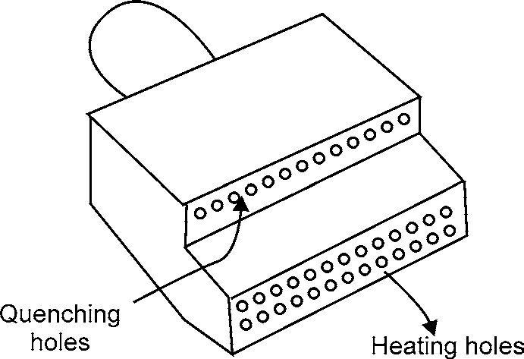

**Fig. 2.8:** Progressive Hardening Torch tip

In hardening localized areas, you should heat the metal with a standard hand-held welding torch. Adjust the torch flame to neutral for normal heating; however, in corners and grooves, use a slightly oxidizing flame to keep the torch from sputtering. You also should particularly guard against

FERROUS MATERIALS 37

overheating in comers and grooves. If dark streaks appear on the metal surface, this is a sign of overheating, and you need to increase the distance between the flame and the metal.

For the best heating results, hold the torch with the tip of the inner cone about an eighth of an inch from the surface and direct the flame at right angles to the metal. Sometimes it is necessary to change this angle to obtain better results; however, you rarely find a deviation of more than 30°. Regulate the speed of torch travel according to the type of metal, the mass and shape of the part, and the depth of hardness desired.

In addition, you must select the steel according to the properties desired. Select carbon steel when surface hardness is the primary factor and alloy steel when the physical properties of the core are also factors. Plain carbon steels should contain more than 0.35% carbon for good results inflame hardening. For water quenching, the effective carbon range is from 0.40% to 0.70%. Parts with a carbon content of more than 0.70% are likely to surface crack unless the heating and quenching rate are carefully controlled.

The surface hardness of a flame-hardened section is equal to a section that was hardened by furnace heating and quenching. The decrease in hardness between the case and the core is gradual. Since the core is not affected by flame hardening, there is little danger of spalling or flaking while the part is in use. Thus, flame hardening produces a hard case that is highly resistant to wear and a core that retains its original properties.

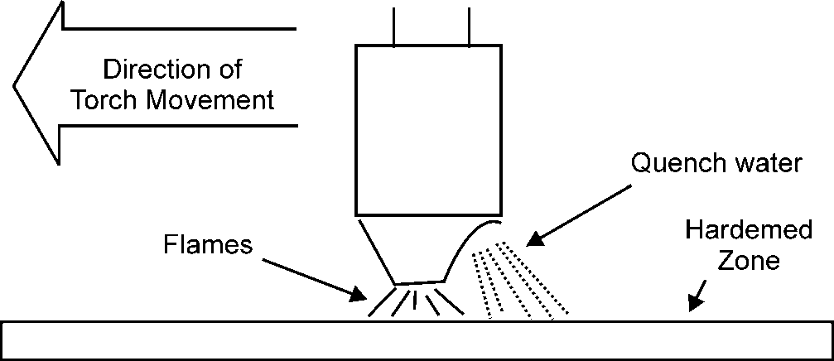

**Fig. 2.9:** Progressive Hardening.

Flame hardening can be divided into five general methods: stationary, circular band progressive, straight line progressive, spiral band progressive, and circular band spinning.

1. **Stationary Method:** In this method the torch and the metal part are both held stationary.
2. **Circular Band Progressive Method:** This method is used for hardening outside surfaces of round sections. Usually, the object is rotated in front of a stationary torch at a surface speed of from 3 to 12 inches per minute. The heating and quenching are done progressively, as the part rotates; therefore, when the part has completed one rotation, a hardened band encircles the part. The width of the hardened band depends upon the width of the torch tip. To harden the full length of a long section, you can move the torch and repeat the process over and over until the part is completely hardened. Each pass or path of the torch should overlap the previous one to prevent soft spots.
3. **Straight-line Progressive Method:** With the straight-line progressive method, the torch travels along the surface, treating a strip that is about the same width as the torch tip. To

38 MANUFACTURING PROCESSES

harden wider areas, you move the torch and repeat the process. Figure 2.9 is an example of progressive hardening.

1. **Spiral Band Progressive Method:** For this technique a cylindrical part is mounted be- tween lathe centers, and a torch with an adjustable holder is mounted on the lathe carriage. As the part rotates, the torch moves parallel to the surface of the part. This travel is synchro- nized with the parts rotary motion to produce a continuous band of hardness. Heating and quenching occur at the same time. The number of torches required depends on the diameter of the part, but seldom are more than two torches used.
2. **Circular Band Spinning Method:** The circular band spinning method provides the best results for hardening cylindrical parts of small or medium diameters. The part is mounted between lathe centers and turned at a high rate of speed pasta stationary torch. Enough torches are placed side by side to heat the entire part. The part can be quenched by water flowing from the torch tips or in a separate operation.

When you perform heating and quenching as separate operations, the tips are water-cooled internally, but no water sprays onto the surface of the part. In flame hardening, you should follow the same safety precautions that apply to welding.

In particular, guard against holding the flame too close to the surface and overheating the metal. In judging the temperature of the metal, remember that the flame makes the metal appear colder than it actually is.

## TEMPERING

After the hardening treatment is applied, steel is often harder than needed and is too brittle for most practical uses. Also, severe internal stresses are set up during the rapid cooling from the hardening temperature. To relieve the internal stresses and reduce brittleness, you should temper the steel after it is hardened. Tempering consists of heating the steel to a specific temperature (below its hardening temperature), holding it at that temperature for the required length of time, and then cooling it, usually instill air. The resultant strength, hardness, and ductility depend on the temperature to which the steel is heated during the tempering process.

The purpose of tempering is to reduce the brittleness imparted by hardening and to produce definite physical properties within the steel. Tempering always follows, never precedes, the hardening operation. Besides reducing brittleness, tempering softens the steel. That is unavoidable, and the amount of hardness that is lost depends on the temperature that the steel is heated to during the tempering process. That is true of all steels except high-speed steel. Tempering increases the hardness of high-speed steel.

Tempering is always conducted at temperatures below the low-critical point of the steel. In this respect, tempering differs from annealing, normalizing, and hardening in which the temperatures are above the upper critical point. When hardened steel is reheated, tempering begins at 212°F and continues as the temperature increases toward the low-critical point. By selecting a definite tempering temperature, you can predetermine the resulting hardness and strength. The minimum temperature time for tempering should be 1 hour. If the part is more than 1 inch thick, increase the time by 1 hour for each additional inch of thickness.

FERROUS MATERIALS 39

Normally, the rate of cooling from the tempering temperature has no effect on the steel. Steel parts are usually cooled in still air after being removed from the tempering furnace; however, there are a few types of steel that must be quenched from the tempering temperature to prevent brittleness. These blue brittle steels can become brittle if heated in certain temperature ranges and allowed to cool slowly. Some of the nickel chromium steels are subject to this temper brittleness.

Steel may be tempered after being normalized, providing there is any hardness to temper. Annealed steel is impossible to temper. Tempering relieves quenching stresses and reduces hardness and brittleness. Actually, the tensile strength of a hardened steel may increase as the steel is tempered up to a temperature of about 450°F. Above this temperature it starts to decrease. Tempering increases softness, ductility, malleability, and impact resistance. Again, high-speed steel is an exception to the rule. High-speed steel increases in hardness on tempering, provided it is tempered at a high temperature (about 1550°F). Remember, all steel should be removed from the quenching bath and tempered before it is completely cold. Failure to temper correctly results in a quick failure of the hardened part.

Permanent steel magnets are made of special alloys and are heat-treated by hardening and tempering. Hardness and stability are the most important properties in permanent magnets. Magnets are tempered at the minimum tempering temperature of 212°F by placing them in boiling water for 2 to 4 hours. Because of this low tempering temperature, magnets are very hard.

Case hardened parts should not be tempered at too high a temperature or they may loose some of their hardness. Usually, a temperature range from 212°F to 400°F is high enough to relieve quenching stresses. Some metals require no tempering. The design of the part helps determine the tempering temperature.

Colour tempering is based on the oxide colours that appear on the surface of steel, as it is heated. When you slowly heat a piece of polished hardened steel, you can see the surface turn various colours as the temperature changes. These colours indicate structural changes are taking place within the metal. Once the proper colour appears, the part is rapidly quenched to prevent further structural change. In colour tempering, the surface of the steel must be smooth and free of oil. A torch, in a furnace, may heat the part over a hot plate, or by radiation.

**Table 2.3:** Oxide Colours for Tempering Steel

|  |  |  |
| --- | --- | --- |
| ***Colour*** | ***Temperature*** | |
| ***°F*** | ***°C*** |
| Pale yellow | 428 | 220 |
| Straw | 446 | 230 |
| Golden yellow | 469 | 243 |
| Brown | 491 | 255 |
| Brown dapple with purple | 509 | 265 |
| Purple | 531 | 277 |
| Dark blue | 550 | 288 |
| Bright blue | 567 | 297 |
| Pale blue | 610 | 321 |

40 MANUFACTURING PROCESSES

Cold chisels and similar tools must have hard cutting edges and softer bodies and heads. The head must be tough enough to prevent shattering when struck with hammer. The cutting edge must be more than twice as hard as the head, and the zone separating the two must be carefully blended to prevent a line of demarcation. A method of colour tempering frequently used for chisels and similar tools is one in which the cutting end is heated by the residual heat of the opposite end of the same tool. To harden and tempera cold chisel by this method, you heat the tool to the proper hardening temperature and then quench the cutting end only. Bob the chisel up and down in the bath, always keeping the cutting edge below the surface. This method air-cools the head while rapidly quenching the cutting edge. The result is a tough head, fully hardened cutting edge, and a properly blended structure.

When the cutting end has cooled, remove the chisel from the bath and quickly polish the cutting end with a buff stick (emery). Watch the polished surface, as the heat from the opposite end feeds back into the quenched end. As the temperature of the hardened end increases, oxide colours appear. These oxide colours progress from pale yellow, to a straw colour, and end in blue colours. As soon as the correct shade of blue appears, quench the entire chisel to prevent further softening of the cutting edge. The metal is tempered as soon as the proper oxide colour appears and quenching merely prevents further tempering by freezing the process. This final quench has no effect on the body and the head of the chisel, because their temperature will have dropped below the critical point by the time the proper oxide colour appears on the cutting edge. When you have completed the above-described process, the chisel will be hardened and tempered and only needs grinding.

During the tempering, the oxide colour at which you quench the steel varies with the properties desired in the part. Table 2.3 lists the different colours and their corresponding temperatures. To see the colours clearly, you must turn the part from side to side and have good lighting. While hand tempering produces the same result as furnace tempering, there is a greater possibility for error. The slower the operation is performed, the more accurate are the results obtained.

## QUENCHING

Quenching is the procedure used for cooling metal rapidly in oil, water, brine, or some other medium. Because most metals are cooled rapidly during the hardening process, quenching is usually associated with hardening; however, quenching does not always result in an increase in hardness; for example, to anneal copper, you usually quench it in water. Other metals, such as air-hardened steels, are cooled at a relatively slow rate for hardening.

Some metals crack easily or warp during quenching, and others suffer no ill effects; therefore, the quenching medium must be chosen to fit the metal. Brine or water is used for metals that require a rapid cooling rate, and oil mixtures are more suitable for metals that need a slower rate of cooling. Generally, carbon steels are water-hardened and alloy steels are oil-hardened. Non- ferrous metals are normally quenched in water.

## QUENCHING MEDIA

The cooling rate of an object depends on many things. The size, composition, and initial temperature of the part and final properties are the deciding factors in selecting the quenching medium. A quenching medium must cool the metal at a rate rapid enough to produce the desired results.

FERROUS MATERIALS 41

Mass affects quenching in that as the mass increases, the time required for complete cooling also increases. Even though parts are the same size, those containing holes or recesses cool more rapidly than solid objects. The composition of the metal determines the maximum cooling rate possible without the danger of cracking or warping. This critical cooling rate, in turn, influences the choice of the quenching medium.

The cooling rate of any quenching medium varies with its temperature; therefore, to get uniform results, you must keep the temperature within prescribed limits. The absorption of heat by the quenching medium also depends, to a large extent, on the circulation of the quenching medium or the movement of the part. Agitation of the liquid or the part breaks up the gas that forms an insulating blanket between the part and the liquid.

Normally, hardening takes place when you quench a metal. The composition of the metal usually determines the type of quench to use to produce the desired hardness. For example, shallow- hardened low-alloy and carbon steels require severer quenching than deep-hardened alloy steels that contain large quantities of nickel, manganese, or other elements. Therefore, shallow-hardening steels are usually quenched in water or brine, and the deep-hardening steels are quenched in oil. Sometimes it is necessary to use a combination quench, starting with brine or water and finishing with oil. In addition to producing the desired hardness, the quench must keep cracking, warping, and soft spots to a minimum.

The volume of quenching liquid should be large enough to absorb all the heat during a normal quenching operation without the use of additional cooling. As more metals are quenched, the liquid absorbs the heat and this temperature rise causes a decrease in the cooling rate. Since quenching liquids must be maintained within definite temperature ranges, mechanical means are used to keep the temperature at prescribed levels during continuous operations.

### Liquid Quenching

The two methods used for liquid quenching are called still-bath and flush quenching.

Instill-bath quenching, you cool the metal in a tank of liquid. The only movement of the liquid is that caused by the movement of the hot metal, as it is being quenched.

For flush quenching, the liquid is sprayed onto the surface and into every cavity of the part at the same time to ensure uniform cooling. Flush quenching is used for parts having recesses or cavities that would not be properly quenched by ordinary methods. That assures a thorough and uniform quench and reduces the possibilities of distortion.

Quenching liquids must be maintained at uniform temperatures for satisfactory results. That is particularly true for oil. To keep the liquids at their proper temperature, they are usually circulated through water-cooled coils. Self-contained coolers are integral parts of large quench tanks.

A typical portable quench tank is shown in figure 2.10. This type can be moved as needed to various parts of the heat-treating shop. Some tanks may have one or more compartments. If one compartment contains oil and the other water, the partition must be liquid-tight to prevent mixing. Each compartment has a drain plug, a screen in the bottom to catch scale and other foreign matter, and a mesh basket to hold the parts. A portable electric pump can be attached to the rim of the tank to circulate the liquid. This mechanical agitation aids in uniform cooling.

42 MANUFACTURING PROCESSES

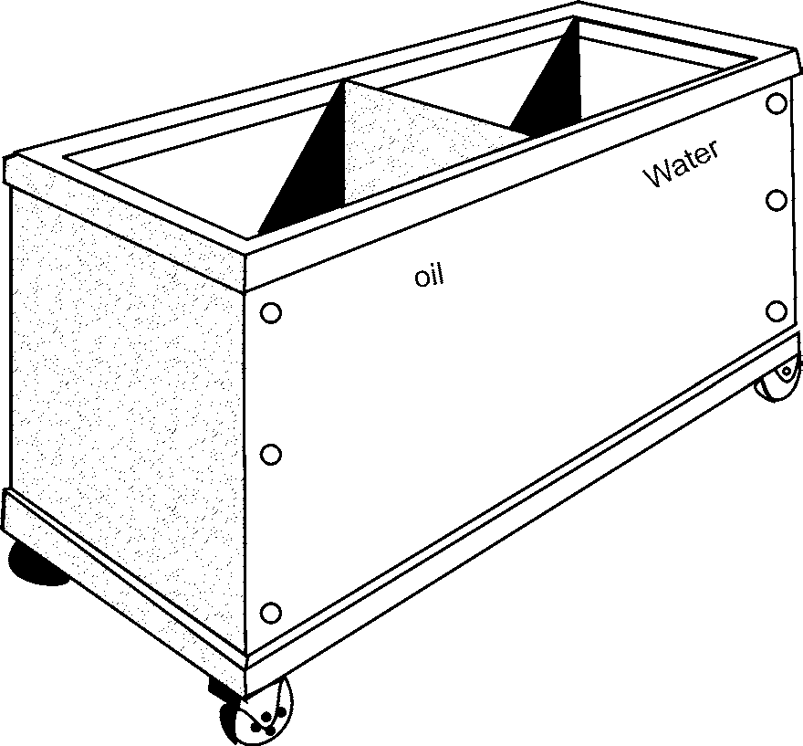

**Fig. 2.10:** Portable Quench Tank

1. **Water:** Water can be used to quench some forms of steel, but does not produce good results with tool or other alloy steels. Water absorbs large quantities of atmospheric gases, and when a hot piece of metal is quenched, these gases have a tendency to form bubbles on the surface of the metal. These bubbles tend to collect in holes or recesses and can cause soft spots that later lead to cracking or warping.

The water in the quench tank should be changed daily or more often if required. The quench tank should be large enough to hold the part being treated and should have adequate circula- tion and temperature control. The temperature of the water should not exceed 65°F.

When aluminium alloys and other non-ferrous metals require a liquid quench, you should quench them in clean water. The volume of water in the quench tank should be large enough to prevent a temperature rise of more than 20°F during a single quenching operation. For heavy-sectioned parts, the temperature rise may exceed 20°F, but should be kept as low as possible. For wrought products, the temperature of the water should be about 65°F and should never exceed 100°F before the piece enters the liquid.

1. **Brine:** Brine is the result of dissolving common rock salt in water. This mixture reduces the absorption of atmospheric gases that, in turn, reduces the amount of bubbles. As a result, brine wets the metal surface and cools it more rapidly than water. In addition to rapid and uniform cooling, the brine removes a large percentage of any scale that may be present.

The brine solution should contain from 7% to 10% salt by weight or three-fourth pound of salt for each gallon of water. The correct temperature range for a brine solution is 65°F to 100°F.

Low-alloy and carbon steels can be quenched in brine solutions; however, the rapid cooling rate of brine can cause cracking or stress in high-carbon or low-alloy steels that are uneven in cross section.

FERROUS MATERIALS 43

Because of the corrosive action of salt on non-ferrous metals, these metals are not quenched in brine.

**Table 2.4:** Properties and Average Cooling Abilities of Quenching Media

|  |  |  |  |
| --- | --- | --- | --- |
| ***Quenching Medium*** | ***Cooling Rate Compared to Water*** | ***Flash Point (°F)*** | ***Fire Point (°F)*** |
| Sodium hydrodixe (10%) | 2.06 |  |  |
| Brine (10%) at 65°F | 1.96 |  |  |
| Caustic soda (10%) | 1.38 |  |  |
| Water at 65°F | 1.00 |  |  |
| Prepard oil | 0.44 | 365 | 405 |
| Fuel oil | 0.36 | 205 | 219 |
| Cottonseed oil | 0.36 | 610 | 680 |
| Neatsfoot oil | 0.33 | 500 | 621 |
| Sperm oil | 0.33 | 500 | 581 |
| Flash oil | 0.31 | 401 | 446 |
| Castor oil | 0.29 | 565 | 640 |
| Machine oil | 0.22 | 405 | 464 |
| Lard oil | 0.19 | 565 | 685 |
| Circulated air | 0.032 |  |  |
| Still air | 0.0152 |  |  |

1. **Oil:** Oil is used to quench high-speed and oil-hardened steels and is preferred for all other steels provided that the required hardness can be obtained. Practically any type of quench- ing oil is obtainable, including the various animal oils, fish oils, vegetable oils, and mineral oils. Oil is classed as an intermediate quench. It has a slower cooling rate than brine or water and a faster rate than air. The quenching oil temperature should be kept within a range of 80°F to 150°F. The properties and average cooling powers of various quenching oils are given in table 2.4.

Water usually collects in the bottom of oil tanks but is not harmful in small amounts. In large quantities it can interfere with the quenching operations; for example, the end of a long piece may extend into the water at the bottom of the tank and crack as a result of the more rapid cooling.

Non-ferrous metals are not routinely quenched in oil unless specifications call for oil quenching.

1. **Caustic Soda:** A solution of water and caustic soda, containing 10% caustic soda by weight, has a higher cooling rate than water. Caustic soda is used only for those types of steel that require extremely rapid cooling and is NEVER used as a quench for non-ferrous metals.

44 MANUFACTURING PROCESSES

**Warning:** Caustic soda requires special handling because of its harmful effects on skin and clothing.

### Dry Quenching

This type of quenching uses materials other than liquids. In most cases, this method is used only to slow the rate of cooling to prevent warping or cracking.

1. **Air:** Air quenching is used for cooling some highly alloyed steels. When you use still air, each tool or part should be placed on a suitable rack so the air can reach all sections of the piece. Parts cooled with circulated air are placed in the same manner and arranged for uniform cooling. Compressed air is used to concentrate the cooling on specific areas of a part. The airlines must be free of moisture to prevent cracking of the metal.

Although non-ferrous metals are usually quenched in water, pieces that are too large to fit into the quench tank can be cooled with forced-air drafts; however, an air quench should be used for non-ferrous metal only when the part will not be subjected to severe corrosion conditions and the required strength and other physical properties can be developed by a mild quench.

1. **Solids:** The solids used for cooling steel parts include cast iron chips, lime, sand, and ashes. Solids are generally used to slow the rate of cooling; for example, a cast-iron part can be placed in a lime box after welding to prevent cracking and warping. All solids must be free of moisture to prevent uneven cooling.

# OBJECTIVE QUESTIONS

1. Write the material for twist drill tool.
2. Write approximate % of C in mild steel.
3. Write the approximate melting point of cast iron.
4. Zinc coating over carbon steel to prevent corrosion is called
5. Name the furnace for cast iron.
6. Name the state in which Rourkela steel plant is situated.
7. Write the material for Engine cylinder block.
8. Write typical composition of stainless steel.
9. Write full form of HSS (tool material)
10. Full forms of TlSCO and SAIL. Dec-00
11. Name the material of : Carpentry Saw Dec-03
12. Name the material of : Hammers Dec-03
13. Name the material of : Taps Dec-03
14. Name the material of : Anvils Dec-03
15. Name the material of : Drill Bits Dec-03
16. Name the material of : Window Grills. Dec-03

FERROUS MATERIALS 45

1. The iron ore mostly used for the production of pig iron is
   1. Magnetite b. Hematite

c. Limonite d. Pyrite

1. Approximate %age of carbon in white cast iron
   1. 1.7–2.3% b. 2.5–5%

c. 0.6–2.4% d. None

1. Tractor springs can be made by
   1. Gray cast iron b. White cast iron

c. Ductile cast iron d. None

1. Approximate %age of carbon in grey cast iron
   1. 2.5–3.8% b. 0.4–1%

c. 0.15–.5% d. 0%

1. Wrought iron can be manufactured by
   1. Cementation processes b. Puddling processes

c. Duplex processes d. None

1. The portion of the blast furnace below its widest cross-sectional is called
   1. Hearth b. Stock

c. Bosh d. None

1. Chilled cast iron is produced
   1. by adding Mg to the molten cast iron
   2. by quick cooling of molten cast iron
   3. from white cast iron by annealing process
   4. none
2. 18-4-1 high speed steel contains
   1. Vanadium 4%, chromium 18%, and tungsten 1%
   2. Vanadium 1%, chromium 4%, and tungsten 18%
   3. Vanadium 18%, chromium 1%, and tungsten 4%
   4. None
3. 18/8 steel contains

|  |  |  |
| --- | --- | --- |
| a. | 18%Ni, 8%Cr | b. 18% Cr, 8% Ni |
| c. | 18%Ni, 18%Cr | d. None |
| The Cupola is used to manufacture | | |
| a. | Pig iron | b. Cast iron |
| c. | Steel | d. None |
| The melting point of wrought iron is about | | |

1. ​
2. ​

|  |  |  |
| --- | --- | --- |
| a. | 1530°C | b. 530°C |
| c. | 1539°C | d. None |

|  |  |  |
| --- | --- | --- |
| 46 |  | MANUFACTURING PROCESSES |
| 28. | Fe3C is known as  a. Cementite | b. Ferrite |
|  | c. Austenite | d. None |

29. Material for window grill and for Lathe-bed Dec-2000

**ANSWERS**

|  |  |  |
| --- | --- | --- |
| 1. HSS | 2. 0.06% to 1.5% | 3. Approx 1300°C |
| 4. Galvanizing | 5. Cupola | 6. Orissa |

7. nodular C.I. 8. Cr >12%, Mn- 1 to 1.5%, Si – up to 1%,

9. High Speed Steel 10. Tata iron & steel Company Ltd., Steel Authority of India Ltd.

11. Water hardening Tool Steel

|  |  |  |
| --- | --- | --- |
| 12. Plain carbon steel | 13. High carbon steel | 14. High carbon steel |
| 15. HSS | 16. MS | 17. b |
| 18. a 19. c | 20. a 21. b | 22. c 23. b |
| 24. b 25. b | 26. b 27. a | 28. a, 29. MS, CI |

# SHORT ANSWER QUESTIONS

1. Classify plain carbon-steel on the basis of percentage of carbon present. May-01
2. Define Mild Steel. How is it different from Cast Iron? Dec-01, 03
3. Write short notes on
   1. High speed steel Dec-01
   2. High speed steel Dec-02, 03, May-03
   3. High carbon steel Dec-02
   4. Stainless steel Dec-02, 03, May-03
4. How does mild steel differ from high carbon steel? Also give their uses. May-03
5. Differentiate between Gray Cast-iron and White Cast-Iron? State one industrial application of each. Write short notes on May-01 (e)
   1. White Cast Iron Dec-01
   2. Nodular Cast iron Dec-02
6. What are Cutting Alloys? Describe Cast cutting alloy. Dec-01
7. What is alloy cast iron? Give its composition and uses. May-02
8. Distinguish between gray cast iron and white cast iron. Also, give their uses. May-03
9. What is nodular cast iron? Where does it find applications as engineering metal? May-03
10. Reasons why thermal processing is done.
11. What is austenizing and the difference between normalizing, full annealing and spheroidizing.

FERROUS MATERIALS 47

1. How cooling rates depend on the size of a metal piece and distance to the surface.
2. Why cooling rate is related to hardness.
3. What is hardenability and why it depends on alloying.
4. How is hardenability measured.
5. What steps are involved in precipitation hardening (aging).
6. What is solution hardening.
7. What are the conditions for precipitation hardening.
8. Calculate the temperature and time constraints of aging that will produce desired properties.
9. What is overaging.
10. Write short notes on: 18-4-1 H.S.S and Cobalt H.S.S.
11. What is tempering? Why is it done? Describe in brief, the various types of tempering.

# LONG ANSWER QUESTIONS

1. Write Name and Draw very briefly Percentage of Carbon in Mild steel and gray Cast Iron.

Dec-00

1. Classify the various types of Carbon on Steels on basis of percentage (%) of Carbon and mention the properties and applications of each. Dec-00, May-02
2. How do Alloy steels differ from carbon steels. Describe briefly the Comparisons, properties and uses of stainless steel and High speed steel. Dec-00
3. How does mild steel differ from medium and high carbon steels? Give one applications for each of the steels. May-01
4. What is Cast Iron? Write its important characteristics and uses. Dec-02
5. Mention the important characteristic and uses of cast Iron. How and where is C.I, produced? Differentiate between grey and white C.I. Dec-00
6. List various types of cast iron. Also give their uses. May-02, Dec-03
7. Briefly describe any two steel making furnaces. Also name the furnace used for making wrought–iron and cast iron. Differentiate between carbon steel and alloy steels.
8. What do you understand by case hardening? Name the various case hardening processes and explain one of them.
9. Define annealing processes.

❍ ❍

[www.EngineeringEBooksPdf.com](http://www.EngineeringEBooksPdf.com/)

**This page**

**intentionally left blank**

**NON-FERROUS METALS**

3

## INTRODUCTION

Non-ferrous metals are those which do not contain iron as the base material. Their melting points are generally lower than that of ferrous metals. These have low strength especially at high temp. Common use of Non-ferrous metals in engineering offers the following advantages:

1. High resistance to corrosion.
2. Very good electrical and magnetic properties.
3. Softness and facility of cold working.
4. Fusibility and ease of casting.
5. Lower density.
6. Attractive color.
7. Good formability.

The Non-ferrous metals used in engineering are: Aluminium, Copper, Lead, Tin, Zinc, Nickel and their alloys.

## ALUMINIUM AND ITS ALLOYS

Aluminium ore is found as a hydrated Aluminium oxide, called BAUXITE. The impurities present in it are oxide of iron, silicon and titanium.

The first process therefore is to separate Aluminium oxide from these impurities. For this purpose, bauxite is fused in an electric furnace and carbon is added to reduce the impurities which form a sludge and can be removed. As a result of this refining, pure Aluminium oxide is separated from the impurities, then an electrolytic bath is used to reduce Aluminium from its oxide. As the electrolytic process proceeds the oxygen escapes through the bath and molten Aluminium collects at the bottom from where it is periodically tapped off. Aluminium is available in our country in Bihar, Maharashtra, MP, Karnataka and Tamil Nadu.

### Properties and Uses

* + - 1. It is a silvery white, light metal, with a density about a third that of steel or brass.

50 MANUFACTURING PROCESSES

* + - 1. It is a very good conductor of electricity**;** Al is better conductor than copper. Use for heavy conductors and overhead cables.
      2. It has a high resistance to corrosion than many other metals, used in manufacture of contain- ers for chemical industry.
      3. High heat conductivity: Used in various heat conductivity appliances.
      4. Very Ductile, so it can be easily rolled, forged, die cast.
      5. Light in weight, widely used in aircraft industry.
      6. It becomes hard by cold working.
      7. Water and air have practically no effect on it.
      8. The milting point of pure Aluminium is about 650°C .

## ALUMINIUM ALLOYS

The addition of small quantities of other alloying element converts this soft, weak metal into a hard and strong metal, while still retaining its lightweight. Alloys can be classified as cast or wrought. The classes are further classified according to whether they respond to heat treatment.

### Duralumin

It contains 3.5% to 4.5% copper, 0.4% to 0.7% manganese, 0.4% to 0.7% magnesium, and remainder is Aluminium.

Duralumin possesses high machinability, high tensile strength after heat treatment, strength, excellent casting and forging properties.

It is widely used for forging, stamping, bars, sheets, tubes, and rivets. Aircraft and automobile parts, as light structure.

### Y- Alloy

It is also called copper-Aluminium alloy. The addition of copper to pure aluminum increases its strength and machinability.

It contains 3.5 to 4.5% copper 1.8 to 2.3% nickel, 1.2 to 1.7% magnesium, 0.6% each of Silicon, Magnesium and iron.

Y-alloy is useful for cast purpose such as piston, cylinder head and other components of aero-engines. It is also used in the form of sheets and strips.

### Magnalium

It is made by melting the aluminium with 2 to 10% magnesium in a vacuum and then cooling it in a vacuum or under a pressure of 100 to 200 atmospheres. It also contains about 1.75% copper. Due to its light weight and good mechanical properties, it is mainly used for aircraft and automobile components.

### Hindalium

It is an alloy of aluminium and magnesium with a small quantity of Chromium. It is the trade name of Aluminium alloy produced by Hindustan Aluminum Corporation Ltd., Renukoot (UP). It is produced as a rolled product in 16 gauges.

NON-FERROUS METALS 51

## COPPER AND ITS ALLOYS

It is not available in pure form under the earth. It is extracted from its ores, through a series of processes. A couple of locations where copper ores are found in India are KHETRI in Rajasthan and GHATSILA in Bihar. Copper pyrites are the main ore used for extracting Copper.

The copper ore is first roasted to drive out water, CO2 and sulphur. It is followed by melting in a furnace of the type used for wrought iron. Silica is added to the charge to form slag with impurities like iron and alumina etc. The molten metal is tapped and transferred to a converter where air is blown through it to burn the impurities. This result in the production of a crude form of copper known as BLISTER COPPER, containing 68% purity. An electrolytic process, pure copper depositing on the cathode, does final refining. This gives a highly pure (99.9%) copper, which is remelted and cast into suitable shapes.

### Properties and Uses

* + - 1. Excellent resistance to corrosion
      2. Non-magnetic properties.
      3. It is soft, very malleable, ductile and flexible. So easy to work
      4. High heat and electrical conductivity. So, it is used in wire and sheet form for electrical purposes.
      5. Melting point of copper is 1083°C.
      6. It is tough and strong.
      7. It can be easily polished, plated and possesses a pleasing appearance.
      8. It can be soldered, brazed or welded.
      9. Very good machinability.

Copper is used for the following:

1. Electrical parts.
2. Heat exchangers,
3. Screw machine products.
4. For making various copper alloys, such as brass and bronze.
5. Copper may be cast, forged, rolled and drawn into wires.
6. Copper in the form of tubes is used widely in mechanical engineering.
7. It is used for making useful alloys with tin, zinc, nickel and aluminium.

## COPPER ALLOYS

Copper alloys normally possess excellent corrosion resistance, electrical and thermal conductivities. Some copper alloys combine high strength and corrosion resistance, a combination desirable for marine applications. Some copper alloys are selected for decorative applications because of appearance.

The copper alloys are broadly classified into the following two groups:

1. Copper-Zinc alloys (Brasses), in which zinc is the principal alloying metal.
2. Copper-Tin alloys (Bronzes), in which tin is the principal alloying metal.

52 MANUFACTURING PROCESSES

## BRASS

The most widely used copper-zinc alloy is brass. There are various types of brasses, depending upon the proportion of copper and zinc. By adding small quantities of other elements, the properties of brass may be greatly changed. Brasses are very resistant to atmospheric corrosion and can be easily soldered. They can be easily fabricated by processes like spinning and can also be electroplated with metals like nickel and chromium.

All brasses are basically alloys of copper and zinc. There are two main type of brass.

1. Alpha brass (up to 37% Zn) for cold working
2. Alpha beta brass (33% to 46% Zn) for hot working.

**Composition of Various Types of Brasses According to Indian Standards**

|  |  |  |  |
| --- | --- | --- | --- |
| ***S.***  ***No.*** | ***Indian Standard Designation*** | ***Composition in %*** | ***Properties and Uses*** |
| 1. | Beta brass | Cu = 50, Zn = 50 | It is hard and brittle, used for brazing solder. |
| 2. | Cartridge brass | Cu = 70, Zn = 30 | It consist good ductility and strength.It is a cold working brass used for cold rolled sheets, wire drawing, deep drawing, pressing and tube manufacturing. Caps of electric lamp bulbs, head lamp reflectors, radiator shells |
| 3. | Yellow brass (Muntz metal) | Cu = 60, Zn = 40 | Good corrosion resistance. It is suitable for hot working by rolling, extrusion and stamping, casting pump parts, valves, taps and other similar items. |
| 4. | Leaded brass | Cu = 62.5, Zn = 36,  Pb = 1.5 | These are used for plates, tubes, parts of condenser, |
| 5. | Admiralty brass | Cu = 70, Zn = 29  Sn = 1 | It is resistance to seawater action; So, it is widely used for marine casting, marine fitting. Also used for plates, tubes bolts, and nuts, washers, also used in condenser plant, etc. |
| 6. | Naval brass | Cu = 59, Zn = 40  Sn = 1 | It is resistance to seawater action; So, it is widely used for marine casting, marine fitting. |
| 7. | Nickel brass | Cu = 60–45, Zn = 35–20, Ni = 5-35 | It is used for valves, plumbing fitting, automobile fittings, type writer parts and musical instruments. |
| 8. | Silicon brass | 80% Cu, 16% Zn  and 45% Si | Widely used for refrigerators also used as a cheaper substitute for phosphor bronze. |
| 9. | Gilding brass | Cu = 85%, Zn = 15% | It is very good cold working alloy and is used for jewellery, decorative  work. It is commercially available as cold rolled strip, wire or sheet. It colour varies from red to bright yellow according to the % of Zn. |
| 10. | Delta brass | 60% Cu, 34% Zn | It can be easily hot worked, forged, rolled. It has fairly good tensile strength after hot working and casting. It has good corrosion resistance, can suitably replace steel castings. |
| 11. | Free cutting brass | 60% Cu, 37% Zn  & 3% Pb | It is specially used in machining work. |
| 12. | Clock brass | 65% Cu, 34% Zn | The lead content improves its bearing qualities and machinability. Mostly available in strip form and is widely used in making small gears and pinions for clock work. |

NON-FERROUS METALS 53

Alpha brasses are very ductile and can be readily cold worked without any chance of fracture. They can be cold rolled into sheets drawn into wires, drawn into tubes. As the proportion of zinc increase their strength increases but ductility decreases. They are work hardened when subjected to intensive cold working. But ductility can be regained by annealing them at 6000C.Slow cooling provides maximum ductility.

An alpha-beta brass loses strength at high temperature but becomes very plastic. It responds very well to hot rolling, hot stamping and casting when cold worked, fractures are always likely to develop. The follow table shows the composition of various types of brasses according to Indian standards.

### Bronzes

Bronze is basically an alloy of copper (75% to 95%) and tin (5 to 25%). It possesses superior mechanical properties and corrosion resistance than brass. They can be easily cold worked, rolled, formed and drawn. They are available in various forms as strip, wire and sheet. With the increase in tin content, its strength and corrosion resistance increase. Then it is known as HOT WORKING BRONZE.

* It is hard, resist surface wear.
* Can be cast into shape or rolled into wire, roads and sheets very easily.
* Corrosions resistant
* It is used in hydraulic fitting; pump linings, bearing, bushes, sheets, rods, and wires. Some important bronzes are:

|  |  |  |  |
| --- | --- | --- | --- |
| ***S.***  ***No.*** | ***Indian Standard Designation*** | ***Composition in %*** | ***Properties and Uses*** |
| 1. | Phosphor Bronze | Cu = 94.16, Sn = 5.56  P = 0.24 | Phosphor increases the strength, ductility and good casting properties. The alloy possesses good wearing resistant quality and high elasticity. The metal is resistant to salt water corrosion. It is used for bearing; pump parts, linings and propellers. Also used for worm wheels,  gears, nuts for machine lead screws, springs. |
| 2. | Gun Metal | Cu = 88, Sn = 10  Zn = 2 | It is forged when at about 600°c.The metal is very strong and resistant to corrosion by water and atmosphere. Used for Boiler fitting, bushes,  bearings, glands are made of gunmetal. |
| 3. | Bell Metal | Cu = 85, Sn = 10,  Zn = 5 | It can be readily cast and is generally used for casting of belts |
| 4. | Silicon Bronze | Cu = 93.75, Si = 4  Mn = 1.25, Fe = 1 | It has high strength, toughness and corrosion resistance.Most widely used for making casted articles like boiler parts, marine fitting and stove parts. |
| 5. | Manganese Bronze | Cu = 53.5, Zn = 38,  Sn = 1.5, Fe = 2,  Al = 1.5, Mn = 3.5 | It has superior mechanical properties and high corrosion resistance. It has poor response to cold working. Used for such parts where high strength and corrosion resistance are desired, such as in ship and rudders, bushes, feed pumps, worm gears. |
| 6. | Aluminium Bronze | Cu = 88, Fe = 3,  Al = 9 | It possesses good strength, high corrosion resistance and good heat resistance. Widely used in making worm gear, wheels, valve sheets, Gun slide, and bearing, condenser bolt, pump component, tubes, air pumps, bush, rollers. |

54 MANUFACTURING PROCESSES

## ZINC AND ITS ALLOYS

The chief ore of zinc is zinc sulphide, which contains 67% of zinc. The zinc ore is first concentrated through a suitable process. This concentrate is fed into a retort with a suitable amount of carbonaceous material (Say coal.) Several retorts are housed in one furnace and their temperature raised to 1100°C.Zinc emerges as vapour and is passed through a condenser, where it is collected as a liquid. The impurities are given out as gases and burn at the mouth of the condenser. By rapid cooling the zinc powered zinc.

### Properties and Uses

* + - 1. Zinc is heavy, bluish-white metal.
      2. It is not very malleable and ductile at ordinary temperature.
      3. It can easily rolled into thin sheets or drawn into wires.
      4. It becomes so brittle that it may be powered.
      5. Low cost.
      6. Corrosion resistance.
      7. Alloying properties.
      8. The melting point of zinc is 419°C.
      9. The protection of iron and steel from corrosion is done by galvanizing/electroplating.
      10. Zinc is used as die-casting alloys.
      11. The other important uses of zinc are in the manufacture of brass.
      12. Zinc is used for roof covering and for providing a damp-proof non-corrosive lining to con- tainers.

## ZINC ALLOYS

The most of the die castings are produced from zinc base alloys. These alloys can be casted easily with a good finish at fairly low temperatures. They have also considerable strength and low in cost. The usual alloying elements for zinc are aluminium, copper and magnesium and they are all held in close limits.

The compositions of two standard die casting zinc alloys are as follows:

1. Al = 4.1%, Cu = 0.1%, Mg = 0.04% and the remainder is zinc.
2. Al = 4.1%, Cu = 1.0%, Mg = 0.04% and the remainder is zinc.

Here, Al improves the mechanical properties and also reduces the tendency of zinc to dissolve iron. Copper increases the hardness and ductility.

Magnesium has the beneficial effect of making the castings permanently stable.

These alloys are widely used in the automotive industry and for other high production markets such as washing machines, oil burners, refrigerators, radios, phonographs, television, and business machines.

NON-FERROUS METALS 55

## LEAD AND ITS ALLOYS

Lead ore (Lead sulphide, known as GALENA) are generally found as oxide or sulphides. Other impurities present in the ores are iron, copper and zinc etc. The prepared ore concentrate, together with the flux (lime and silica), is fed into a small blast furnace where the temperature is raised to about 1010°C .The lead is melted and a liquid slag formed of the impurities. Both slag and molten lead are tapped at intervals. Further refining is carried out in a reverberatory furnace, where an oxidizing atmosphere is maintained to burn out the impurities.

### Properties and Uses

* + - 1. Good corrosion resistance so used for water pipes and roof protection.
      2. Good resistance to chemical action so used for acid baths and containers in chemical industries.
      3. It is very much used in electrical and paint industries.
      4. It is soft, heavy and malleable can be easily worked and shaped.
      5. It can be rolled easily.
      6. It is also alloyed with brass and steel. To impart them free cutting properties.
      7. The milting point of lead is 327°C.
      8. Used for manufacturer of storage batteries.
      9. As an alloying element to improve the machinability of bronze.
      10. Tank linings for corrosion protection.
      11. Bearing materials, radiation protection (from X-rays)
      12. Available in the form of sheet, castings, laminations, powder, shot, wool, lead alloys.

### Lead Alloys

* + - 1. Lead (80% to 30%) alloyed with Tin (20% to 70%) forms solders.
      2. Alloyed with other metals, makes bearing white metals and type metal.
      3. Alloyed with small % of arsenic, lead is used to produce short for munitions.

## TIN AND ALLOYS

Main ore of tin is CASSITERITE or TIN STONE. It is also contain compound of copper, iron, lead, antimony, bismuth and zinc etc. Firstly, ore concentrate is prepared. This concentrate is roasted to drive off excess arsenic and sulphur. The roasted ore is transferred to a furnace, Where it is heated Anthracite is added to the charge which reacts chemically to separate tin, the latter sinking to the bottom of the furnace from there it is tapped at interval. This crude tin is remelted and refined further for obtaining high purity tin the electro deposition method is used.

### Properties and Uses

* + - 1. It is silvery white, soft malleable and ductile.
      2. It can be rolled into very thin sheets.
      3. It is brightly shining white metal.

56 MANUFACTURING PROCESSES

* + - 1. It is also used for tinning copper wire.
      2. Tin does not corrode in wet and dry climates, making it useful as a protective coating for iron and steel.
      3. It is used for making important alloys, fine solder.
      4. Its melting point is 232°C.

### Tin Alloys

Basic tin alloys are Tin-solder and Tin-copper alloys (Bronze), as discussed above.

## NICKEL AND ITS ALLOYS

The most important ore for nickel is iron sulphides, which contain about 3% of nickel. About 90% of the total production of nickel is obtained by this source.

Its extraction process consists of first roasting the ore, followed by smelting in a small blast furnace. Limestone and quartz are added as flux. They form slag with impurities. Coke is used as fuel. Crude molten nickel is tapped off periodically from the bottom of the furnace. This crude metal is further refined in a Bessemer converter followed by treating with sulphuric acid to extract pure nickel. Copper is separated as copper sulphate.

### Properties and Uses

* + - 1. Nickel is tough, silvery, white colored metal.
      2. Malleable, weldable and magnetic.
      3. Articles of iron and steel are nickel-plated to protect them from rusting.
      4. Nickel is used as a catalyst in important industrial processes.
      5. It has a good resistance to both acid and alkali corrosion .It is, therefore, widely used in food processing equipments.
      6. It has high tensile strength and be easily worked cold and hot.
      7. Its melting point is 1453°C.

### Nickel Alloys

The nickel base alloys are widely used in engineering and industry on account of their high mechanical strength properties, corrosion resistance etc. The most important nickel base alloys are as:

* + - 1. **Monel Metal:** It is an alloy of 68% nickel, 29% copper and a small amount of aluminum or manganese.
         1. It is white, tough and ductile metal.
         2. It can be readily machined. It can be welded and heat- treated.
         3. It is resistant to corrosion
         4. It has high strength at elevated temp.
         5. It is used in the form of rod, sheet, wire and welded tubing.
         6. Widely used for structural and M/C parts, steam turbine blade.

NON-FERROUS METALS 57

* + - 1. **German Silver:** As discussed above.
      2. **Inconel:** It contains 80% nickel, 14 % chromium and the rest iron. It can be used for parts that are exposed to high temp for extended period. It is less reactive than nichrome to acid. It can be cast, rolled and cold drawn. It is used for making springs which have to withstand high temperatures and are exposed to corrosive action.
      3. **Nichrome:** It consists of 65% nickel, 15% Cr, and 20% Fe. Used widely as resistance wire for electrical appliances.
      4. **Nimonics:** It consists of 80% Ni, and 20%Cr. Nimonics has excellent properties for very high temperature service. They contain 15 to 18% chromium, 15 to 18% cobalt, 3.5 to 5% Molybdenum, and remainder nickel.

## OTHER ADVANCED MATERIALS/ ALLOYS

### Magnesium

The main ore of magnesium are Dolomite (CaCO3.MgCO3), Magnesite (MgCO3) etc. It is the lightest metal used as an engineering material. It is harder than aluminium. It is employed in the form of sheets, wires rods, and tubes. The magnesium ribbon is now chiefly used for the degasification of radio tubes.

### Cadmium

It is probably the first metal that was not discovered in an ore. It may be obtained by electrolytic methods or by precipitation with metallic zinc.

It is a white metal with bluish tinge, capable of taking a high polish. Its melting point is 321°C. It is slightly harder than tin but is softer than zinc. It is malleable and ductile.

It is chiefly used in antifriction alloys for bearings. It is also used as a rust- proof coating for iron and steel. Bolts, nuts and other small parts employed in automobile manufacture, refrigerator, locks and wire products are plated with it.

### Vanadium

The important ore of vanadium is PATRONITE (V2S9). The preparation of pure vanadium is difficult and very little is produced commercially. For obtaining the metal, acceptable methods are the reduction of the dichloride with hydrogen, and the electrolysis of vanadium trioxide.

It is silvery white in color. Its melting point is 1710°C. It is harder than quartz, but is sufficiently malleable and tough so that when heated to a suitable temperature, it may be rolled and hammered into rods and drawn into wires.

The chief use of vanadium is in manufacture of alloy steels.

### Antimony

It is found in free in nature. But the chief ore is stibnite (Sb2S3).

It is silvery white, hard, highly crystalline and so brittle that it may be readily powdered under the hammer. Its melting point is 630°C.

It is mostly used as an alloying element with most of the heavy metals. The metals with which antimony is most commonly alloyed are lead, tin and copper.

58 MANUFACTURING PROCESSES

## BEARING MATERIALS

Bearing support the moving parts, such as shaft and spindles, of a machine or mechanism. Bearing may be classified as

1. Rolling contact (i.e., Ball and roller) Bearing
2. Plain bearings.

Rolling contact bearings are almost invariably made of steel that can be hardened after machining. Both plain carbon and alloy (Ni, Cr, Mo) steels are employed for different applications.

For making plain bearings, an extremely wide range of materials is available.

### Properties of Bearing Materials

A bearing material should:

1. Possess low coefficient of friction
2. Provide hard, wear resistant surface.
3. Be able to bear shocks and vibrations.
4. It can be easily fabricated.
5. Possess resistance to corrosion.
6. Maintain a continuous film of oil between shaft and bearing in order to avoid metal to metal contact.
7. It should have good casting quality.
8. It should have a sufficient melting point.
9. Should be cheap and easily available.

### Types of Bearing Materials

The following are the widely used bearing metals.

1. Copper based alloys
2. Lead and tin based alloys
3. Cadmium based alloys.
4. Aluminum based alloys
5. Silver based alloys

### Copper Based Alloys

The copper based alloys are the most important bearing alloys. These alloys are harder and stronger than the white metals and are used for bearing subjected to heavy pressures. These include brasses and bronzes.

### Lead or Tin Base Alloys

They may be divided as:

1. The high tin alloys with more than 80% tin and little or no lead.
2. The high lead alloys with about 80% lead and 1 – 12% tin.
3. The alloys with intermediate % of tin and lead.

Lead based alloys are softer and brittle than tin base alloys.

NON-FERROUS METALS 59

Lead based alloys are cheaper than tin base alloys.

Tin based alloys have a low coefficient of friction as compared to lead based alloys.

Lead based alloys are suitable for light and medium loads such as rail, road, freight cars, whereas tin base alloys are preferred for higher loads and speeds. Such as high-speed engines, steam turbines,

### Cadmium Based Alloys

The cadmium based alloys contain 95% cadmium and 5% silver. It is used for medium loaded bearings subjects to high temperature. These alloys are not very popular because of high price of cadmium. These alloys were tried in automobile and aircraft industries and good results were obtained.

### Aluminum Based Alloys

These alloys find applications as bearings in diesel engines and tractors. They contain 91.5% Al, 6.5% Sn, 1% each Cu and Ni. These alloys possess: Excellent corrosion resistance, High coefficient of expansion.

### Silver Based Alloys

The electro deposition of a 0.3–0.5 mm layer of silver on a steel support shell, with an intermediate layer of Cu or Ni, produces silver bearings. These are highest priced bearing alloys. They are employed where other materials do not produce satisfactory result. These alloys are used on the connecting rod bearings of aircraft engines.

# OBJECTIVE QUESTIONS

1. Which of the following is not an ore?
   1. Bauxite (b) Malachite

(c) Zinc blende (d) Wrought iron

1. The cryolite is used in the electrolytic extraction of aluminium?
   1. To get more aluminium (b) To dissolve bauxite

(c) To protect anode (d) To act as a reducing agent

1. High purity copper metal is obtained by?
   1. Carbon reduction (b) Hydrogen reduction

(c) Electrolytic reduction (d) Thermit process

1. Copper is refined by?
   1. Electrolytic method (b) Roasting

(c) Smelting (d) Heating

1. Aluminium metal is extracted from?
   1. AICI3 (b) AI2S3

(c) AI2O3 (d) AI2(CO3)3

60 MANUFACTURING PROCESSES

1. Which of the following is not an ore of nickel?
   1. Nickel glance (b) Garneirite

(c) Haematite (d) Pentlandite

1. Aluminium is used in Thermit process because?
   1. Of its activity (b) Of its lightness

(c) Of its tendency to form alloys (d) Of its resistance of corrosion

1. In the electro refining of copper, the pure copper is found?
   1. At the cathode (b) At the anode

(c) In the electrolyte (d) In the sludge

1. Which of the easily fusible?
   1. Mineral (b) Ore

(c) Flux (d) Slag

1. Which is not correct in case of copper?
   1. High heat conductivity (b) Low electrical conductivity

(c) Tensile (d) Malleability

1. Zinc coating over carbon steel to prevent corrosion is called

|  |  |  |  |
| --- | --- | --- | --- |
| a. Electroplating | | b. | Galvanizing |
| c. Metal spraying | | d. | None |
| 12. | k-alloy is a  a. Ni-base alloy | b. | Cu-base alloy |
|  | c. Zn-base alloy | d. | None |
| 13. Manganese bronze contains | | | |
| a. 5% Mn | | b. | 10% Mn |
| c. 0.12% Mn | | d. | None |

**ANSWERS**

|  |  |  |  |  |  |
| --- | --- | --- | --- | --- | --- |
| 1. (d) | 2. (b) | 3. (c) | 4. (a) | 5. (c) | 6. (c) |
| 7. (a) | 8. (a) | 9. (d) | 10. (b) | 11. (b) | 12. (d) |
| 13. (a) |  |  |  |  |  |

# FILL IN THE BLANKS

1. Chemical symbols of Lead and Tin. Dec-2000
2. Chemical composition of Gun metal and Duralium. Dec-2000
3. Materials used for Solder wire and metallic cans for soft drinks Dec-2000
4. ln German Silver, the main metal is
5. ln 70/30 brass, the metal whose percentage is 70 is
6. Write the material for Filament of Electric bulb.

NON-FERROUS METALS 61

1. Write the chemical symbol of Tin.
2. Write the material for Fire-proof clothings.
3. Write typical composition of Gun Metal.

**ANSWERS**

14. Pb, Sn 15. Gun Metal = Cu=88%, Sn=10%, Zn=2%; Duralumin=Cu=3.5-4.5%, Mn=0.4-0.7%, Al= remaining,

16. Tin & lead, Tin 17. Cu 18. Cu

19. Tungsten 20. Sn 21. Magnesium

22. Gun Metal = Cu=88%, Sn=10%, Zn=2%

# SHORT ANSWER QUESTIONS

1. Write Industrial application of Zinc. Dec-00
2. Write short notes on Aluminium, their properties and uses. May-1, 02
3. Write short notes on Bronze, their properties and uses. May-01,03
4. Write short notes on Copper, their properties and uses. May-01,02
5. Write short notes on Gun metal, their properties and uses. May-01
6. Discuss any three types of aluminium alloys giving their composition, properties and uses.

May-01

|  |  |
| --- | --- |
| 7. Write short notes on Lead and its uses. | Dec-01,03 |
| 8. Write short notes on Alloys of nickel and their uses. | May-02 |
| 9. Write short notes on Brass. | C.O., May-03 |
| 10. Write short notes on Solder. | C.O.-02 |
| 11. Write short notes on Alloys of Aluminium. | C.O.-02 |
| 12. Write short notes on Copper and its Alloys. | Dec-03 |

1. Write short notes on the following types of brasses, stating their compositions and uses:
   1. Cartridge brass (b) Muntz metal

(c) Naval brass (d) Admiralty brass.

1. What are the sources for obtaining magnesium? Describe its properties and uses.
2. How is zinc produced? Write its properties and uses.
3. How is tin produced? Write its properties and uses?
4. How is nickel produced? What are its properties and uses?

62 MANUFACTURING PROCESSES

1. Briefly describe the following brasses, stating their compositions and uses:
   1. Gilding brass (b) Delta brass

(c) Free cutting brass (d) Beta brass

1. Give common compositions and uses of the following types of brasses:
   1. Colouring brass (b) Silicon brass

(c) Clock brass (d) Precipitation hardening brass

1. How high tensile brass differs from naval brass?
2. What are bronzes? Write short notes on the following types of bronzes:
   1. Phosphor bronze (b) Aluminium bronze

(c) Silicon bronze (d) Manganese bronze

1. What are bearing metals? What important characteristics should they possess?
2. Write the compositions and uses of babbit metal, lead alloy, cintered metal and cadmium alloy:
3. Describe Dow Metal, Beryllium Copper in brief.
4. Describe the compositions, main properties and applications of the following alloys:
   1. Gun metal (b) Speculum metal

(c) Bell metal (d) Duralumin

# LONG ANSWER QUESTIONS

1. Differentiate between Brass and Bronze. List a few types of brasses and Bronzes and give their application. Dec-00
2. Differentiate between Brass and Bronze and enumerate their properties. May-01
3. What is brass? Describe the composition and properties of important types of brass. Dec-02
4. What are bronzes? Describe any two types of bronzes. Dec-01
5. What are the main characteristic of non-ferrous alloys? Why are they preferred over ferrous alloys inspite of their high cost? Dec-02

❍ ❍

|  |  |  |
| --- | --- | --- |
|  | 4 |  |
|  |  |
|  | | |
| **METAL FORMING** | | |

## METAL FORMING

Metal forming can be defined as a process in which the desired size and shape are obtained through the deformation of metals plastically under the action of externally applied forces.

Metal forming processes like rolling, forging, drawing etc. are gaining ground lately. It is due to the fact that metal forming is the wasteless process which is highly economical. They give high dimensional accuracy, easy formability for complex shapes and good surface finish with desired metallurgical properties.

The metal forming is based upon the plastic deformation of metals. For finding out the complete information of the stresses and strains that developed in the metal due to application of loads, comprehensive study and calculations are required.

To start with, there are three conditions to be satisfied, while going for stress estimation:

1. There should be equilibrium at all points.
2. The volume should remain same before and after the forming.
3. Stress-strain relationship of material should be maintained. There are two methods for analysing forming processes:
   1. Lower bound method
   2. Upper bound method

The main objective is to find out the yield stress developed in the material body and its distribution in the material. This helps in estimating the load required for the initiation of the process and its maximum value that a body can bear. If the body is under single load e.g., only tensile load or only compressive load is applied to a body, then the yield stress can be measured easily by stress-strain diagram, but in reality different loads are there on body which make the process complex and thus also make it difficult to find out the yield stress distribution in the body.

## ELASTIC AND PLASTIC DEFORMATIONS

Deformation is the change in dimensions or form under the action of applied load. Deformation is caused either by mechanical action of external load or by various physical and physicochemical processes. The process of deformation comprises the following consecutive stages

64 MANUFACTURING PROCESSES

1. Elastic deformation
2. Plastic deformation
3. Fracture

**Elastic deformation** of a material is its power of coming back to its original position after deformation when the stress or load is removed i.e., deformation completly disappears after removal of load.

The **plastic deformation** means that the material undergoes some degree of permanent deformation without failure on application of load. Plastic deformation will take place only after the elastic range has been exceeded. Plastic deformation is important in case of forming, shaping, extruding and many other hot and cold working processes.

Due to this various metal can be transformed into different products of required shape and size. This conversion into desired shape and size is effected either by the application of pressure, heat or both.

The plastic deformation of metals may occur in the following ways

1. By slip
2. By formation of twins
3. Deviations from regular positions of atoms
4. Breakdown of structure.

## HOT WORKING AND COLD WORKING

### Hot Working

1. Properties
   1. Hot working is done at a temperature above recrystallization but below its melting point. It can therefore be regarded as a simultaneous process of deformation and recovery.
   2. Hardening due to plastic deformation is completely eliminated by recovery and recrystallization.
   3. Improvement of mechanical properties such as elongation, reduction of area and impact values.
   4. No effect on ultimate tensile strength, yield point, fatigue strength and hardness.
   5. Poor surface finish due to oxidation and scaling.
   6. Refinement of crystals occurs.
   7. Due to hot working cracks and blowholes are welded up.
   8. No internal or residual stress developed.
   9. Force required for deformation is less.
   10. Light equipment is used in hot working.
   11. Difficult to handle a hot worked metal.
   12. Hot working processes are—hot forging, hot rolling, hot spinning, hot extrusion, hot drawing, and hot piercing, pipe welding.

METAL FORMING 65

1. Advantages of Hot Working
   1. Porosity in the metal is largely eliminated. Most ingots contain many small blow holes. These are pressed together and eliminated.
   2. Impurities in the form of inclusions are broken up and distributed throughout the metal.
   3. Coarse or columnar grains are refined. Since this hot work is in the recrystalline temperature range, it should be continued until the low limit is reached to provide a tine grain structure.
   4. Physical properties are generally improved owing principally to grain refinement. Ductility and resistance to impact are improved, strength is increased, and greater homogeneity is developed in the metal. The greatest strength of rolled steel exists in the direction of metal flow.
   5. The amount of energy necessary to change the shape of steel in the plastic state is far less than that required when the steel is cold.
2. Disadvantages/Limitations of Hot Working
   1. Because of the high temperature of the metal, there is rapid oxidation or scaling of the surface with accompanying poor surface finish.
   2. Difficult to achieve close tolerances due to scaling.
   3. Some metals cannot be hot worked because of their brittleness at high temperatures.
   4. Hot working equipment and maintenance costs are high.

### Cold Working

1. Properties

l. Cold working is done at temperature below recrystallization temperature. So, no appreciable recovery can take place during deformation.

1. Hardening is not eliminated since working is done below recrystallization temperature.
2. Decreases elongation, reduction of area etc.
3. Increase in ultimate tensile strength, yield point and hardness.
4. Good surface finish is obtained.
5. Crystallization does not occur. Grains are only elongated.
6. Possibility of crack formation and propagation is great.
7. Internal and residual stresses are developed in the metal.
8. Force required for deformation is high.
9. Heavy and powerful equipment is used for cold working.
10. Easier to handle cold parts.
11. Cold working processes are—cold rolling, cold extrusion, press work (drawing, squeezing, bending, and shearing).
12. Advantages of Cold Working
    1. Cold working increases the strength and hardness of the material due to the strain hardening which would be beneficial in some situations. Further, there is no possibility of decarburisation of the surface.

66 MANUFACTURING PROCESSES

* 1. Since the working is done in cold state, hence no oxide formation on the surface and conse- quently, good surface finish is obtained.
  2. Greater dimensional accuracy is achieved.
  3. Easier to handle cold parts and also economical for small sizes.
  4. Better mechanical properties are achieved.

1. Disadvantages/Limitations of Cold Working
   1. Only small sized components can be easily worked as greater forces are required for large sections. Due to large deforming forces, heavy and expensive capital equipment is required.
   2. The grain structure is not refined and residual stresses have harmful effects on certain properties of metals.
   3. Many of the metals have less ductility e.g., carbon steel and certain alloy steels, cannot be cold worked at room temperature. It is therefore, limited to ductile metals and the range of shapes produced is not as wide as can be obtained by machining.
   4. Tooling costs are high and as such it is used when large quantities of similar components are required.

## FORGING

Forging can be defined as a method of shaping, heated metal by compression. The forging process evolved from the manual art of simple blacksmithing. The special tools that a blacksmith use are various kinds of dies, swages and fullers.

Modern forging uses machine driven impact hammers or presses which deform the work piece by controlled pressure. The forging process is superior to casting in that the parts formed have denser microstructures, more defined grain patterns, and less porosity, making such parts much stronger than a casting. Forgings usually have great strength, as compared with other methods of producing products.

### Forging Operations

Forging is the oldest metal working process. Because it just requires heating and hammering of metals, man found it easy. The following forging operations are performed.

**Drawing down or swaging:** The process of increasing length and decreasing cross sectional area of the metal is known as drawing. The compressive force (hammering or pressing) are applied perpendicular to the length axis of the metal piece.

**Upsetting:** It is just reverse of drawing. The cross-sectional area of the work piece is increased and length decreases. For it, the compressive forces are applied along the length axis of the metal piece.

**Coining (closed-die forging):** Minting of coins, where the slug is shaped in a completely closed cavity, is an example of closed-die forging. To produce the fine details of a coin, high pressures, and sometimes several operations are needed, while lubricants are not used because they can prevent reproduction of fine die surface details.

**Heading (open-die forging):** Heading is an example of open-die forging. It transforms a rod, usually of circular cross-section, into a shape with a larger cross-section. The heads of bolts, screws,

METAL FORMING 67

and nails are some examples of heading. The work piece has a tendency to buckle if the length- to-diameter ratio is too high.

**Punching:** It is the process of making holes by using punch over or hardy hole on an anvil **Hubbing:** It is a piercing process where the die cavity produced is used for subsequent forming operations. To generate a cavity by hubbing, a pressure equal to three times the ultimate tensile strength of the material of the workpiece is needed.

**Cogging:** Also called drawing out, successive steps are carried to reduce the thickness of a bar. Forces needed to reduce the thickness of a long bar are moderate, if the contact area is small. **Fullering and Edging:** It is an intermediate process to distribute the material in certain regions of the workpiece before it undergoes other forging processes that give it the final shape.

**Roll Forging**: A bar is passed through a pair of rolls with grooves of various shapes. This process reduces the cross-sectional area of the bar while changing its shape. This process can be the final forming operation. Examples are tapered shafts, tapered leaf springs, table knives, and numerous tools. Also, it can be a preliminary forming operation, followed by other forging processes. Examples are crankshafts and other automotive components.

**Skew Forging:** It is similar to roll forging but used for making ball bearings. A round wire is fed into the roll gap and spherical blanks are formed continuously by the rotating rolls.

### Classification of Forging

Forging is classified into three categories:

* + - 1. Open-die Forging (Hand Forging, Power Forging)
      2. Impression-die Forging
      3. Closed-die Forging.

1. OPEN-DIE FORGING

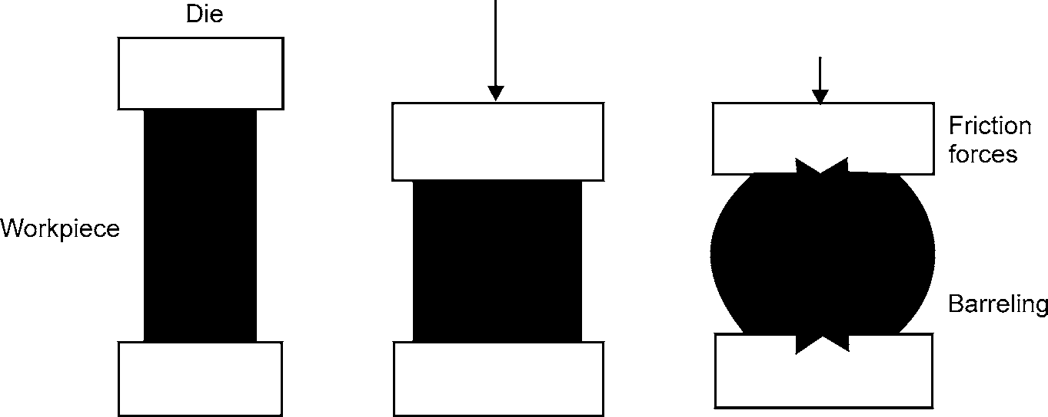Open-die forging is a hot forging process in which metal is shaped by hammering or pressing between flat or simple contoured dies (see Fig. 4.1). In open die forging the dies do not completely cover the workpiece. Instead, there are open spaces that allow various aspects of the workpiece to move from direct hot die contact, and to cooler open areas. In this type of forging, metals are worked above their recrystallization temperatures. Because the process requires repeated changes in workpiece positioning. The workpiece cools during open die forging below its hot-working or recrystallization temperature. It must be reheated before forging can continue.

**Fig. 4.1:** Open-die Forging

68 MANUFACTURING PROCESSES

###### Operations performed on open die presses

* + 1. Drawing out or reducing the cross-section of an ingot or billet to lengthen it.
    2. Upsetting or reducing the length of an ingot or billet to a larger diameter.
    3. Upsetting, drawing out, and piercing-processes sometimes combined with forging over a mandrel for forging rough-contoured rings. Practically all forgeable ferrous and non-fer- rous alloys can be open-die forged, including some exotic materials like age-hardening super alloys and corrosion-resistant refractory alloys.

###### Applications

Open-die processes can produce:

* + 1. Step shafts, solid shafts (spindles or rotors) whose diameter increases or decreases at multiple locations along the longitudinal axis.
    2. Hollow cylindrical shapes, usually with length much greater than the diameter of the part Length, wall thickness, internal and outer diameter can be varied as needed.
    3. Ring-like parts can resemble washers or approach hollow cylinders in shape, depending on the height/wall thickness ratio.
    4. Contour-formed metal shells like pressure vessels, which may incorporate extruded nozzles and other design features.

Open-die forging is further classified as hand forging and power forging:

1. HAND FORGING

Sometimes called smithy or blacksmithing, hand forging is the simplest form of forging and it is one of the methods by which metal was first worked. The metal to be forged is first heated to red heat in the fire of a forge, and then is beaten into shape on a metal anvil with sledges or hammers.

**Hand Forging Tools and Equipment:** Besides a furnace hand forging needs anvil, swage block, blacksmith hammers, tongs, swages, fullers and flatters for the various forging operations. These are discussed below.

###### Anvil

An anvil acts as a supporting device which is capable of withstanding heavy blows rendered to the job. It is made of cast steel, wrought iron or mild steel provided with a hardened top. The horn or beak is used in bending the metal or forming curved shapes. At the top of the anvil, is a square and a round hole. The square hole (also known as hardie hole) is used for holding square shank, shaped tools like bottom fullers, swages etc. The round hole is used for admitting the ends of the punches or drifts. This hole is also used for bending round bars of different curvatures. The anvil is supported either on an iron base or on a wooden block.

METAL FORMING 69

Hardie hole

Punching hole

Face

Tail

Cutting face

Body

Beak or horn

Base

###### Swage Block

**Fig. 4.2:** Anvil

It is generally made of cast iron and has round, square, rectangular and half round grooves. These grooves are used either for holding bars while bending or providing support in punching holes. The swage block is supported on a cast iron stand.

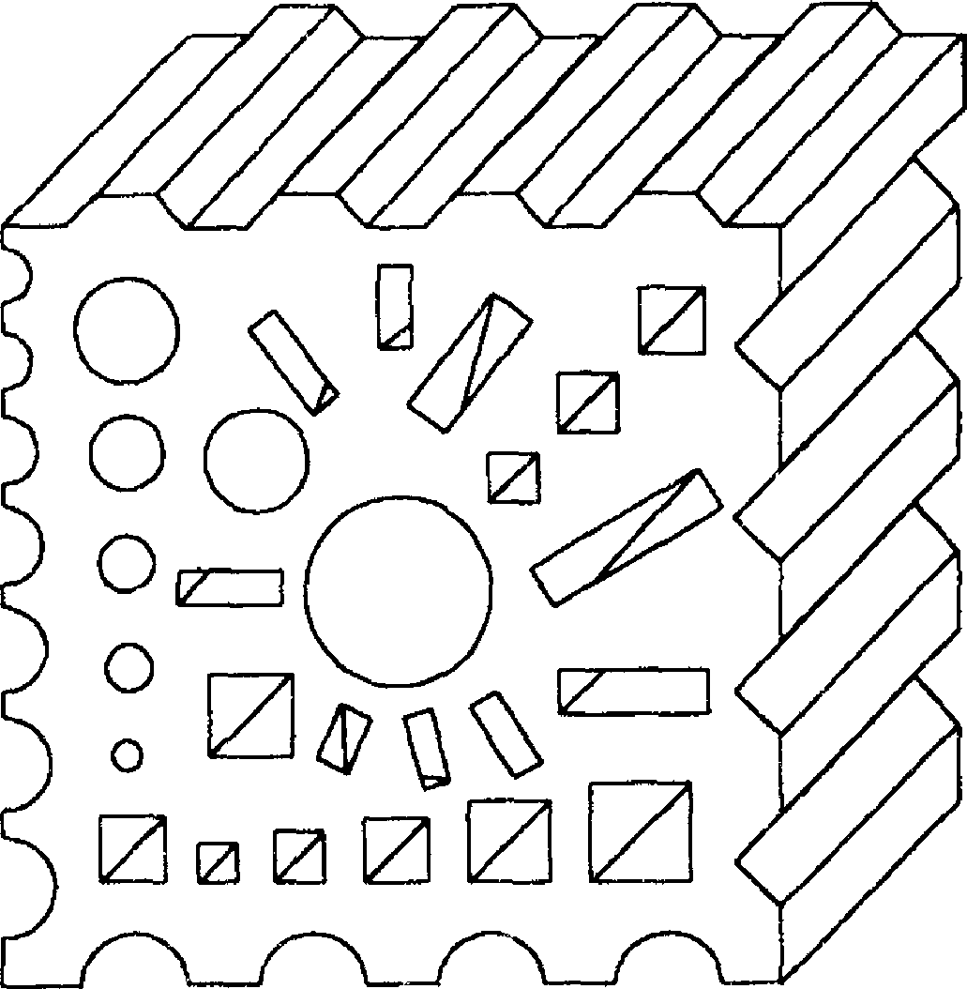

**Fig. 4.3:** Swage Block

70 MANUFACTURING PROCESSES

* 1. **Hammers:** *These are basically of two types—*
     1. Hand hammer, and
     2. Sledge hammer

* + - 1. Ball peen hammer
      2. Cross peen hammer
      3. Straight peen hammer
      4. Double faced hammer

**Fig. 4.4:** Various Types of Hammers

The hand hammers are generally ball peen hammers. These have a slightly convex striking face and generally weigh from 1 to 1.5 kg.

The sledge hammers are usually 3 to 4 times heavier than the hand hammers. These are used when heavy blows are needed in forging. Sledge hammers are further classified as cross peen, straight peen and double faced type.

###### Tongs

These are used for holding the jobs in position during forging. Tongs are made of mild steel and are usually named according to the inner shape of the jaws.



1. Flat bit tongs



1. Square bit tongs



1. Round bit tongs

METAL FORMING 71



###### Swages

1. Pick up tongs

**Fig. 4.5:** Various Types of Tongs

These are used in pairs i.e., top and bottom parts. Swages are used to reduce and finish the job to the exact size and shape. During swaging the workpiece is rotated between swages, which are hammered to produce smooth round surface.

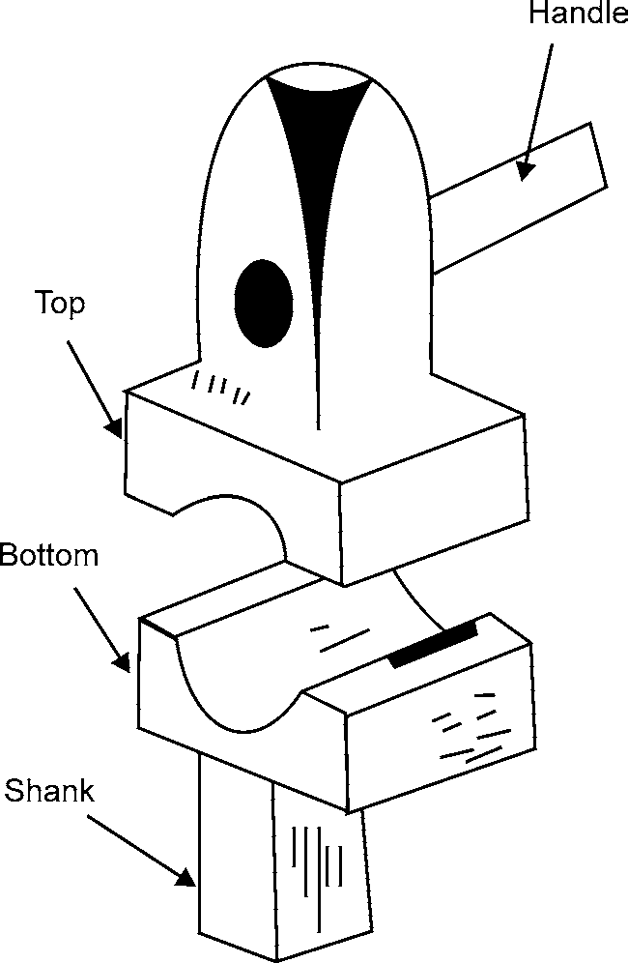

**Fig. 4.6:** Swages

###### Fullers

These are used for necking down a workpiece. It spreads the metal and reduces the thickness of the workpiece. Fullers are made of tool steel and are made in pairs. The top fuller is held by a handle while the bottom fuller is fitted into the hardie hole of the anvil.

72 MANUFACTURING PROCESSES

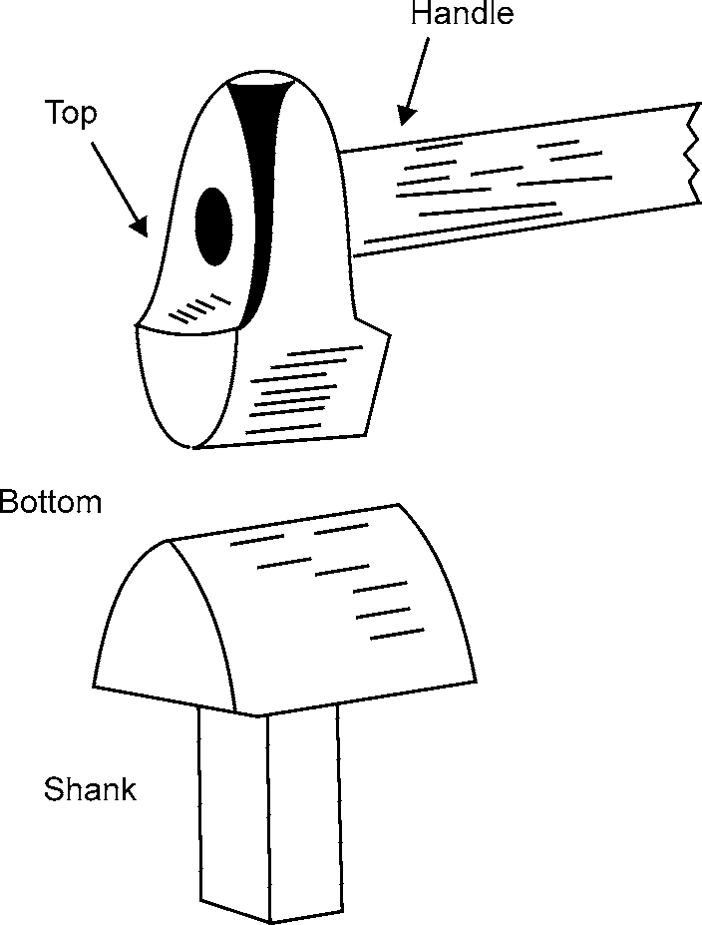

**Fig. 4.7:** Fullers

###### Flatter

These are used for finishing flat surfaces and are made with a perfect flat face. It provides smoothness and accuracy to the workpiece. Flatter is made of tool steel. It is struck by hammer on the head.

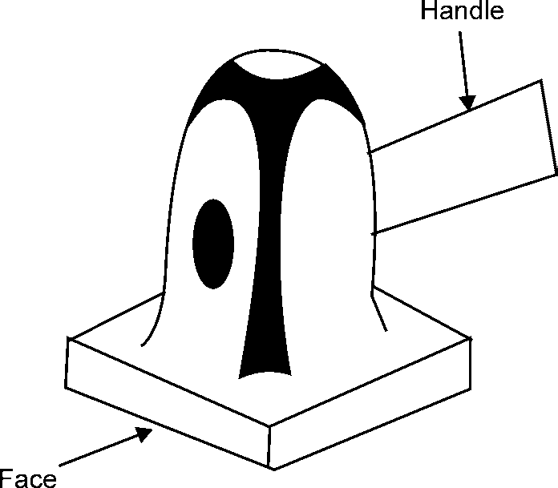

**Fig. 4.8:** Flatter

Smith Forging Operations

In general, six basic types of forging operations exist—-

1. Upsetting, or decreasing the length and increasing the diameter of the metal;
2. Swaging, decreasing the diameter of the metal;

METAL FORMING 73

1. Bending;
2. Welding, joining two pieces of metal together by semifusion;
3. Punching, the forming of small openings in the metal; and
4. Cutting out, the forming of large holes in the metal.
   1. **Upsetting:** A piece of metal, called the work, is upset when it is struck along the longest dimension (for example, the end of a rod or bar), which shortens and thickens it.
   2. **Swaging:** It is accomplished by hammering the metal stock while it is held on the anvil within any one of various concave tools called swages.
   3. **Bending:** It is accomplished either by hammering the work around a form or by leveraging it against a supporting fulcrum
   4. **Welding:** In forge welding of iron, a flux such as borax is first applied to the heated metal to remove any oxides from the surfaces of the two pieces, and the pieces are then joined by hammering them together at high temperature. A welded joint of this kind, when properly made, is entirely homogeneous and is as strong and uniform, as the parent metal.
   5. **Punching:** To punch small holes, the work is supported on a ring shaped piece of metal above the anvil, and a punch of the proper shape is driven through the work by hammer blows.
   6. **Cutting:** Larger holes are cut out, and portions of the work are cut off with heavy, sharp chisels similar to cold chisels which are used to cut cold metal.

Combinations of several of these operations can produce forgings of a wide variety of shapes.

Applications

Hand forging is used for making simple shapes such as chains, hooks, shackles, and agriculture equipment and tools.

1. POWER FORGING

It is used to produce large number of identical forgings. Machines which work on forgings by blow are called hammers and those which work by pressure are called presses.

1. IMPRESSION-DIE FORGING/PRECISION FORGING

As the name implies, two or more dies containing impressions of the part shape are brought together, the workpiece undergoes plastic deformation until its enlarged sides touch the die side walls (see Fig. 4.9). During the process, flash is formed, as some of the molten metal from the workpiece flows outside the die impression. As the flash cools, it imparts deformation resistance to the workpiece, strengthening the final product. This builds pressure inside the bulk of the workpiece, aiding material flow into unfilled impressions. The finished part closely resembles the die impression. Because metal flow is restricted by the die contours, this process can yield more complex shapes and closer tolerances than open-die forging processes.

74 MANUFACTURING PROCESSES

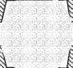

**Fig. 4.9:** Impression Dies Forging

Most engineering metals and alloys can be forged via conventional impression-die processes, among them: carbon and alloy steels, tool steels, and stainless, aluminum and copper alloys, and certain titanium alloys.



Applications

1. Part geometry’s range from some of the easiest to forge simple spherical shapes, block-like rectangular solids, and disc-like configurations to the most intricate components with thin and long sections that incorporate thin webs and relatively high vertical projections like ribs and bosses.
2. Although many parts are generally symmetrical, others incorporate all sorts of design ele- ments (flanges, protrusions, holes, cavities, pockets, etc.) that combine to make the forging very non-symmetrical.
3. In addition, parts can be bent or curved in one or several planes, whether they are basically longitudinal, equidimensional or flat.

Impression die forging is further classified as drop, press and machine forging:

* 1. **Drop forging:** It gets its name from the fact that the upper half of the die is dropped onto the lower half. Drop forgings are made by squeezing the metal at forging heat into shaped impressions cut in heavy steel blocks called dies. The job is divided equally in upper and lower die block. When the upper die block falls on the lower die, block metal is squeezed in the die cavity due to impact force. The die block falls from a height of 3 to 5 m. The bottom die block is held by set screws on to the base and top is raised by certain mechanism after its free fall. A workpiece may be forged by a series of punch and die operations (or by several cavities in the same die) to gradually change its shape.

The process involves several steps:

* + 1. The first two steps are called fullering and edging. Here, the cross-sectional area of the metal is reduced in some areas and gathered in other areas. This also starts the fibrous grain flow.

METAL FORMING 75

* + 1. The third step is referred to as blocking. The shape of the part is not pronounced hence, it may take several drops in the blocking cavity of the die. In step three, flash begins to appear. This is a thin (0.04) fin of metal that is squeezed between the dies.
    2. The fourth step is called finishing. Here, the final shape of the part is completed.
    3. The last step is called trimming. Holes are cleared and the flash is removed from the forging. Drop forging requires machining to obtain dimensional tolerances and good surface finish.
  1. **Press forging:** Press forging is a process similar to kneading, where a slow-continuous pressure is applied to the area to be forged. The pressure will extend deep into the material and can be completed either cold or hot. A cold press forging is used on a thin, annealed material, and a hot press forging is done on large work such as armor plating, locomotives and heavy machinery. In this type, only one blow is given as compared with number of blows in drop forging. In press forging number of stages are used and only in last stage die cavity is used to get finished forging. Dies may have less draft, and the forging comes nearer to the desired sizes. Press forging are shaped at each impression with a single smooth stroke and they stick to the die impression more rigidly. Unless some provision is made, the escape of air and excess die lubricant may be difficult. Thus, press-forging dies require a mechanical means for ejecting the forging.

Press forging are generally more accurate dimensionally than drop forging. The cost of the process is three to four times than that in drop forging but with press forging, unskilled labour can be used and production rate is higher. The working conditions with the press are better as there is no noise and vibrations.

* 1. **Machine forging:** The chief difference between hand forging and machine forging is that in the latter technique various types of machine powered hammers or presses are used instead of hand sledges. The power hammer can be mechanical or pneumatic type. The stroke of the hammer varies from 350 mm to 1000 mm and corresponding speeds range form 200 to 800 blows per minute. These machines enable the operator to strike heavy blows with great rapidity and thus to produce forgings of large size and high quality as swiftly as required by modern production-line methods. Another advantage of machine forging is that the heavier the blows struck during forging, the greater the improvement in the quality of metallic structure. Fine grain size in the forging, which is particularly desirable for maximum impact resistance, is obtained by working the entire piece. With large, hand-forged metal, only the surface is deformed, whereas the machine hammer or press will deform the metal throughout the entire piece.

Machine forging operations are frequently accomplished by use of a series of dies mounted on the same press or hammer. The dies are arranged in sequence so as to form the finished forging in a series of steps. After the piece has been partially formed by one stroke, it is moved to the next die for further shaping on the next stroke.

1. CLOSED-DIE FORGING

In closed-Die Forging, no flash is formed and the workpiece is completely surrounded by the dies. In this process, a billet with carefully controlled volume is deformed (hot or cold) by a punch in

76 MANUFACTURING PROCESSES

order to fill a die cavity without any loss of material. Therefore, proper control of the volume of material is essential to obtain a forging of desired dimensions. Undersized blanks in closed-die forging prevent the complete filling of the die, while oversized blanks may cause premature die failure or jamming of the dies. Press used for closed-die forging is of two types:

1. Hydraulic and
2. Mechanical.

A hydraulic press for closed-die forging has the same principle as that of a press for smith or flat-die forging except the construction of the dies.

In smith forging the press dies have flat surface, while in a closed-die forging the press dies have shaped impressions cut on dies. Moreover, they form an integral part of the frame to maintain accurate alignment of the dies.

Mechanical forging presses of the crank type have found wide application in forging practice. The operative units of the press are powered from motor mounted on the press frame. They are used for the production of rivets, screws, and nuts where a high operating speed is desired. In capacity, they range from 50,000 to 8,000,000 kg and speeds from 35 to 90 strokes per minute.

Most engineering metals and alloys can be forged with closed die forging processes; among them are carbon and alloy steels, aluminum alloys and copper alloys. .

Applications

Precision forgings, hollow forgings, fittings, elbows, tees, etc.

### Forging Defects and Remedies

The common forging defects are:

* + - 1. Dirt, slag, blow holes: These are defects, resulting from the melting practice.
      2. Seams, piping, cracks, scales or bad surface and segregation: These are ingot defects.
      3. Decarburization: These defects results from improper heating of the forging.
      4. Flakes: These defects results from improper cooling of the forging.
      5. Fins and rags: These are small projections or loose metal driven into the forging surface.
      6. Mismatch: This occurs due to improper alignment between the top and bottom forging dies.
      7. Pitting: These are shallow surface depressions caused by scales which is not removed from dies.
      8. Cold shut or laps: These are short cracks which usually occur at corners and at right angles to the surface. These are caused when the metal surface folds against itself during forging.
      9. Dents: These arise due to careless work.
      10. Unfilled section: It occurs when metal does not completely fill the die cavity.

Remedies

1. Shallow cracks and cavities can be removed by chipping out of the cold forging with pneu- matic chisel or with hot sets during the forging processes.
2. Surface cracks and decarburized areas are removed from important forgings by grinding on special machines. Care should also be taken to see that the work piece is not under-heated, decarburized, overheated and burnt.

METAL FORMING 77

1. Die design should be properly made taking into consideration all relevant and important aspects that may impair forging defects and ultimate spoilage.
2. The parting line of a forging should lie in one plane to avoid mismatching.
3. Distorted forgings are straightened in presses, if possible.

### Advantages of Forging

* + - 1. **Directional strength:** Forging produces predictable and uniform grain size and flow characteristics. These qualities translate into superior metallurgical and mechanical qualities, and deliver increased directional strength in the final part.
      2. **Structural strength:** Forging also provides a degree of structural integrity that is unmatched by other metalworking processes. It eliminates internal voids and gas pockets that can weaken metal parts. Predictable structural integrity reduces part inspection requirements, simplifies heat treating and machining, and ensures optimum -part performance under field-load conditions.
      3. **Variety of sizes:** Open die forged part weights can run from a single pound to over 400,000 pounds.
      4. **Variety of shapes:** Shape design is just as versatile, ranging from simple bar, shaft and ring configurations to specialized shapes.
      5. **Metallurgical spectrum:** Forgings can be produced from literally all ferrous and non-ferrous metals.
      6. **Material savings:** Forging can measurably reduce material costs since it requires less starting metal to produce many part shapes.
      7. **Machining economies:** Forging can also yield machining, lead time and tool life advantages.
      8. **Reduced rejection rules:** By providing weld-free parts produced with cleaner forging quality material and yielding improved structural integrity, forging can virtually eliminate rejections.
      9. **Production efficiencies:** Using the forging process, the same part can be produced from many different sizes of starting ingots or billets. This flexibility means that forged parts of virtually any grade can be manufactured more quickly and economically.

### Limitations of Forging

* + - 1. The forged parts often need to be machined before use.
      2. Tooling for complicated geometry may be expensive and require multiple passes on the same workpiece.
      3. The rapid oxidation of metal surfaces at high temperature results in scaling which wears the dies.
      4. Initial cost of dies and maintenance cost is high.

### Applications of Forging

Typical parts made by forging are crankshafts and connecting rods for engines, turbine disks, gears,

78 MANUFACTURING PROCESSES

wheels, bolt heads, hand tools, and many types of structural components for machinery and transportation equipment.

## ROLLING

It is the process of reducing the thickness or changing the cross-section of a long workpiece by compressive forces applied through a set of rolls. One effect of the hot working rolling operation is the grain refinement brought about by recrystallization, which is shown in Fig. 4.10. Coarse grain structure is broken up and elongated by the rolling action. Because of the high temperature, recrystaliization starts immediately and small grains begin to form. These grains grow rapidly until recrystallization is complete. Growth continues at high temperatures, if further work is not carried on, until the low temperature of the recrystalline range is reached.

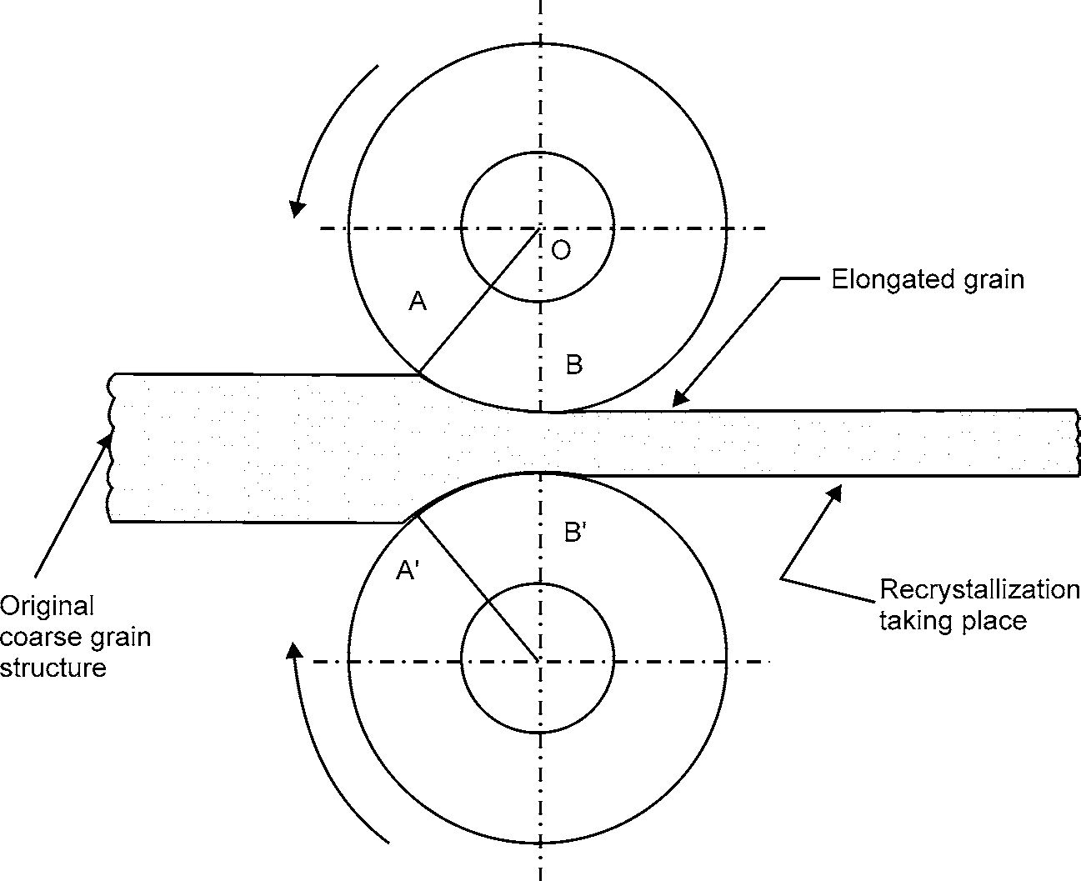

**Fig. 4.10:** Hot-rolling Process

(Showing the deformation and recrystallization of the metal being rolled.)

### Principle of Rolling

In Fig. 4.10 AB and A’B’ are the contact arcs on the rolls. The wedging action on the work is overcome by the frictional forces that act on these arcs and draw the metal through the rolls. In the process of rolling, stock enters the rolls with a speed less than the peripheral roll speed. The metal emerges from the rolls travelling at a higher speed than it enters. At a point midway between A and B, metal speed is the same as the roll peripheral speed. Most deformation takes place in thickness, although there is some increase in width. Temperature uniformity is important in all rolling operations. Since it controls metal flow and plasticity.

METAL FORMING 79

In rolling, the quantity of metal going into a roll and out of it is the same, but the area and velocity are changed.

In the process of becoming thinner, the rolled steel becomes longer and may become wider, but it is constrained by vertical rolls set to restrict this sideways growth. As the cross-sectional area is decreased, the velocity increases as does the length of the material. For example, a heated slab 18 cm. thick weighing more than 12 tons is reduced to a coil of thin sheet in a matter of minutes.

### Rolling Mill

A rolling mill consists of one or more roll stands, motor drive, reduction gears, and flywheel and coupling gears between units. The roll stand is the main part of the mill, where the rolling process is performed. It basically consists of housings in which bearings are fitted, which are used for mounting the rolls. Depending upon the profile of the rolled product, the body of the roll may be either flat for rolling sheets (plates or strips) or grooved for making structural members (channel, I-beam, rail).

Rolling mills are classified according to the number and arrangement of rolls in a stand. They are classified as:

1. For hot rolling of metals (Two-high rolling mill, Three-high rolling mill)
2. For cold rolling of metals (Four high rolling mill, Cluster rolling mill)

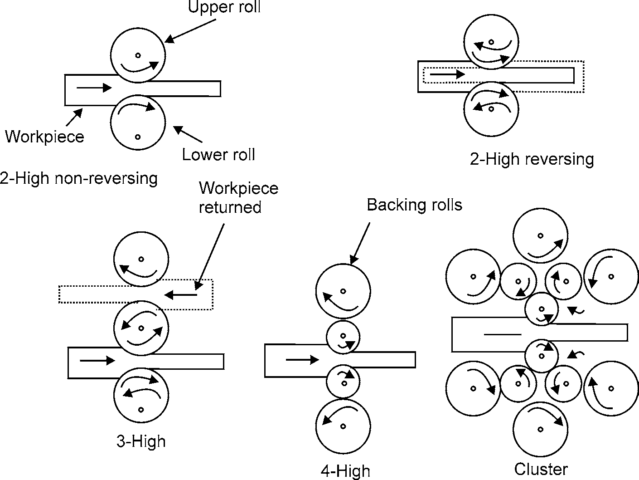

**Fig. 4.11:** Various Roll Arrangements Used in Rolling Mills.

* 1. **Two-high rolling mill:** It is basically of two types i.e., non-reversing and reversing rolling mill. The two high non-reversing rolling stand arrangements is the most common arrange- ment. In this the rolls always move in only one direction, while in a two-high reversing rolling

80 MANUFACTURING PROCESSES

stand the direction of roll rotation can be reversed. This type of stand is particularly useful in reducing the handling of the hot metal in between the rolling passes. About 30 passes are required to reduce a large ingot into a bloom. This type is used in blooming and slabbing mills.

* 1. **Three-high rolling mill**: It is used for rolling of two continuous passes in a rolling sequence without reversing the drives. After all the metal has passed through the bottom roll set, the end of the metal is entered into the other set of the rolls for the next pass. For this purpose, a table-tilting arrangement is required to bring the metal to the level with the rolls. Such type of arrangement is used for making plates or sections.
  2. **Four-high rolling mill:** It is generally a two-high rolling mill, but with small sized rolls. The other two rolls are the backup rolls for providing the necessary rigidity to the small rolls. It is used for both hot and cold rolling of wide plates and sheets.
  3. **Cluster rolling mill:** It uses backup rolls to support the smaller work rolls. In this type of mill, the roll in contact with the work can be as small as 1/4 in. in diameter. Foil is always rolled on cluster mills since the small thickness requires small-diameter rolls.

### Roll Passes

The final rolled products such as plates, flats, sheets, rounds and sections are obtained in a number of passes starting from billet or slabs. For rolling the flat product, plain cylindrical rolls are used but for sections, grooved rolls are used. The type of grooving done is decided by the final section desired. The roll pass sequence can be broadly classified into three types:

* + - 1. **Breakdown passes:** These are used for reducing the cross-sectional area nearer to what is desired. These would be the first to be present in the sequence.
      2. **Roughing passes:** In these passes also, the cross-section gets reduced, but along with it, the shape of the rolled material comes nearer to the final shape.
      3. **Finishing passes:** These are the final passes which give the required shape of pass follows a leader pass.

The principal breakdown pass sequence are:

* + - * 1. box pass series
        2. diamond square series
        3. oval square series

### Defects in Rolling

There may be defects on the surfaces of the rolled plates and sheets or there may be structural defects within the material. The various defects are

1. **Surface defects** may result from inclusions and impurities in the material, scale, rust, dirt, roll marks and other causes related to the prior treatment and working of the material. In hot rolling blooms, billets and slabs, the surface is usually preconditioned by various means, such as torch to remove scale.
2. **Structural defects** are defects that distort or affect the integrity of the rolled product.

METAL FORMING 81

1. **Wavy edges** are caused by bending of the rolls; the edges of the strip are thinner than the centre. Because the edges elongate more than the centre and are restrained from expanding freely, they buckle.

Rolling direction

**Fig. 4.12 (a)**

1. **Zipper cracks** are usually caused by low ductility and barreling.

**Fig. 4.12 (b)**

1. **Edge cracks** are occurs in plates and slabs because of either limited ductility of metal or uneven deformation especially at the edges.

**Fig. 4.12 (c)**

1. **Alligatoring** is a complex phenomenon that results from inhomogeneous deformation of the material during rolling or from defects in the original cast ingot, such as piping. The workpiece splits along a horizontal plane on exit from the rolls.

**Fig. 4.12 (d)**

82 MANUFACTURING PROCESSES

### Applications of Rolling

Rolling is used to produce components having constant cross-section throughout its length. The whole range of rolled products can be divided into the following types:

1. **Structural shapes or sections:** This includes sections like round, square, hexagonal bars, channels, H and I beams and special sections like rail section. Fig. 4.13 shows some of the rolled structural shapes.

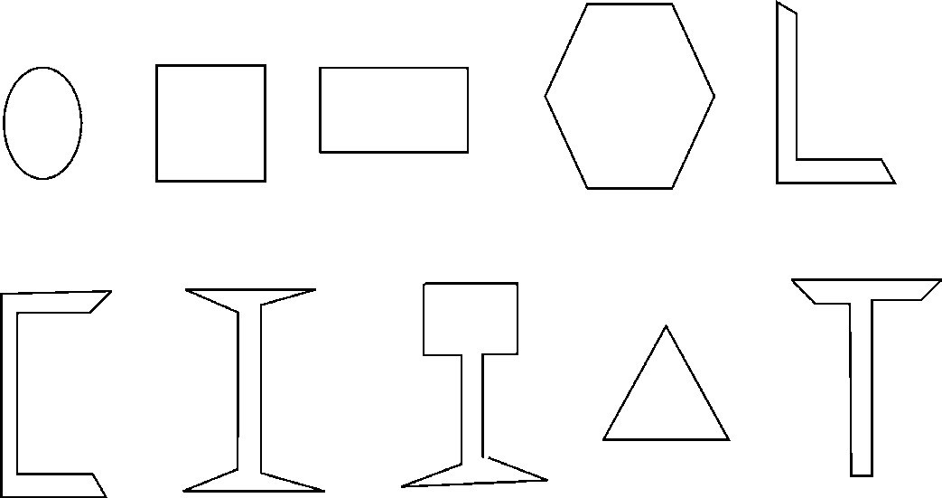

**Fig. 4.13:** Rolled Products

1. **Plates and sheets:** These are produced of varying thickness.
2. **Special purpose rolled products:** These include rings, balls, wheels and ribbed tubes.

## WIRE DRAWING

To manufacture long slender products (wire, tube), material is drawn through a die. The material is deformed by compression, but the deformation force is supplied by pulling on the deformed end of the wire or rod. This is termed ‘indirect compression’. Most drawing is done cold.

Wire drawing is an operation to produce wire of various sizes within certain specific tolerances. The process involves reducing the diameter of rods or wires by passing them through a series of wire drawing dies with each successive die having smaller bore diameter than the one preceding it (see Fig. 4.14). The drawing force must not exceed the strength of the drawn wire. Typically this means that the maximum reduction (as area, not diameter) attainable is less than 50%. In practice reduction is usually limited to 20-30% to avoid frequent breakage. The final wire size is reached as the wire passes through the last die in the series.



 Direction of wire drawing  Wire drawing dies with

reducing bore diameter

**Fig. 4.14:** Wire Drawing

METAL FORMING 83

A wire drawing die as shown in Fig. 4.15 is a tool that consist of a highly polished, shaped hole through which wire is drawn to reduce its diameter. The choice of die material, viz., natural or synthetic single crystal diamond, polycrystalline diamond, carbide etc. depends on the material of the wire to be drawn and the operating parameters.

Entry of wire

Cemented tungsten carbide support annulus

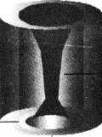

Polycrystalline diamond

Exit of wire

**Fig. 4.15:** Wire Drawing Die

Shaper hole

*When the metal is forced through the die by a tensile force applied to the metal at the exist of die it is called drawing, while when a compressive force is applied at the entry of the die it is called extruding.*

### Defects in Wire Drawing

Defects occur in wire drawing because of ploughing by hard particles and local breakdown of the lubricating film. Some common defects are:

* + - 1. **Bulge formation:** This occurs in front of the die due to low reduction and high die angle.
      2. **Internal cracks (Centre burst or centre-cracking):** The tendency of cracking increases with increasing die angle, with decreasing reduction per pass, with friction and with the presence of inclusions in the material.
      3. **Seams:** These appear as longitudinal scratches or folds in the material. Such defects can open up during subsequent forming operations by upsetting, heading, thread rolling or bending of the rod or wire.
      4. **Surface defects**: Various types of surface defects can also result due to improper selection of process parameters and lubrication.

### Applications of Wire Drawing

Wire drawing is used for the manufacture of fine wires for electrical and electronic equipments, cables, springs, musical instruments, fencing, bailing, wire baskets and shopping carts, etc.

## TUBE DRAWING

Tube drawing normally makes tubes to size from hollow ‘tube shells’ produced by extrusion. They are then cold drawn to size by a succession of passes, with inter stage anneals as required and supplied either in straight lengths or coil. Fig. 4.16 shows a typical tube drawing process with a floating plug.

84 MANUFACTURING PROCESSES

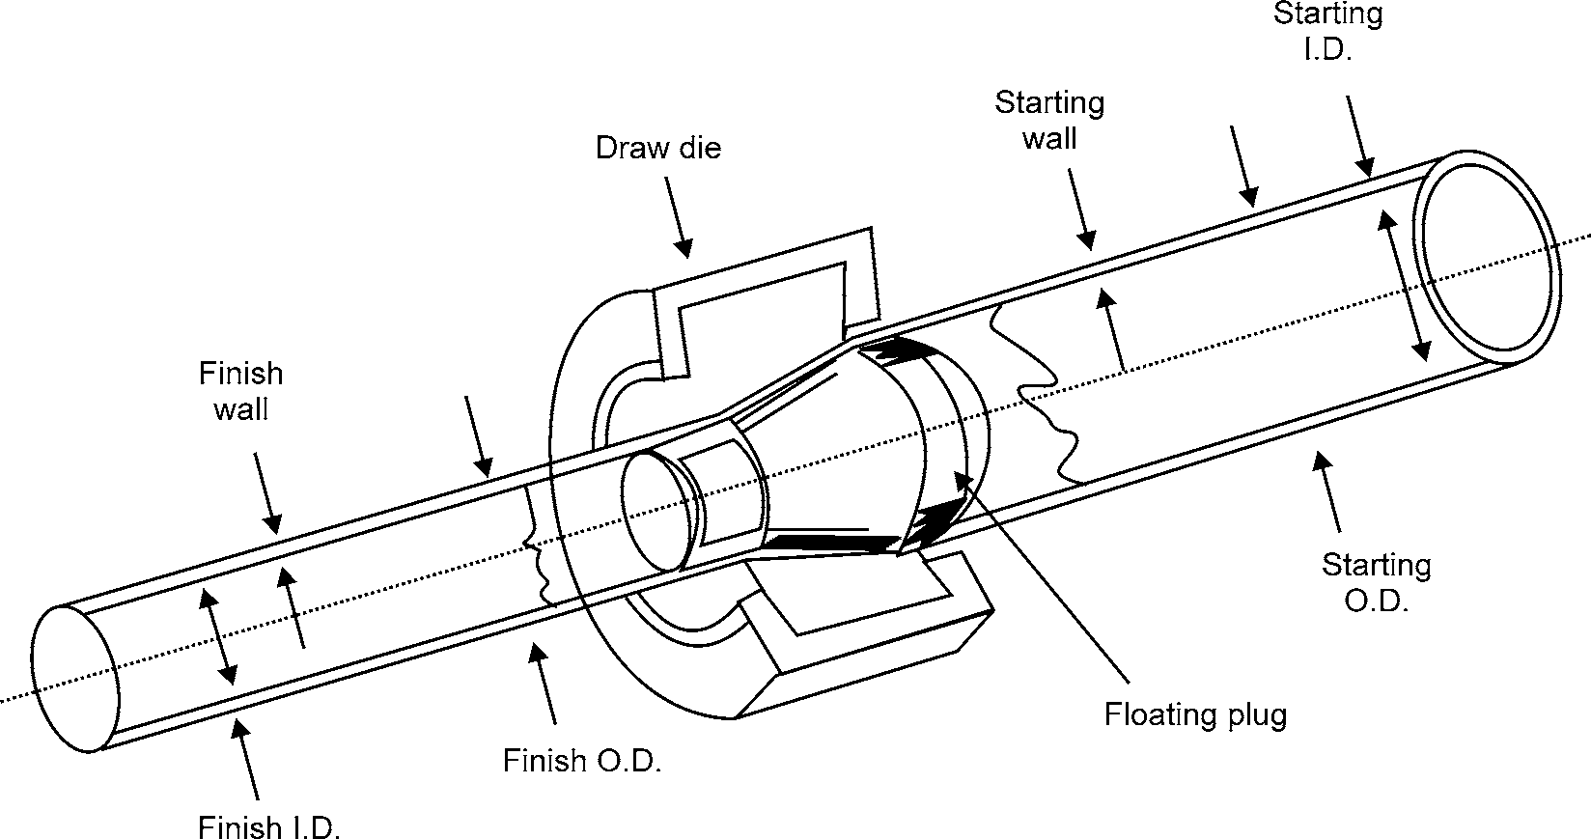

**Fig. 4.16:** Tube Drawing

The common methods of tube drawing are: Tube sinking, Tube drawing with a plug or stationary mandrel and Tube drawing with a moving mandrel.

1. **Tube sinking:** This method is generally not preferred since no support is provided on the inner surface of the tube and as a result wall thickness may slightly increase.

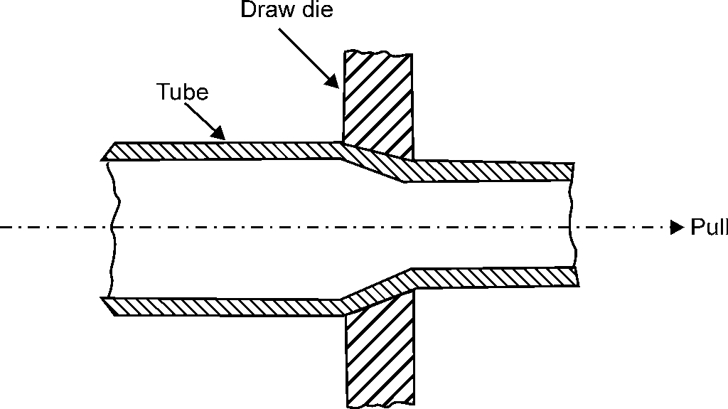

**Fig. 4.17:** Tube Sinking

1. **Tube drawing with a plug:** In this method tubes of greater dimensional accuracy are obtained because of the proper support provided both at the inner and outer surfaces of the tube. The plug used may be of cylindrical or conical shape and is of either fixed or floating type (see Fig. 4.18). In a fixed plug, friction is more as compared to a floating plug. For the same reduction in area, the drawing load will be less with floating plug than with a fixed plug.

METAL FORMING 85

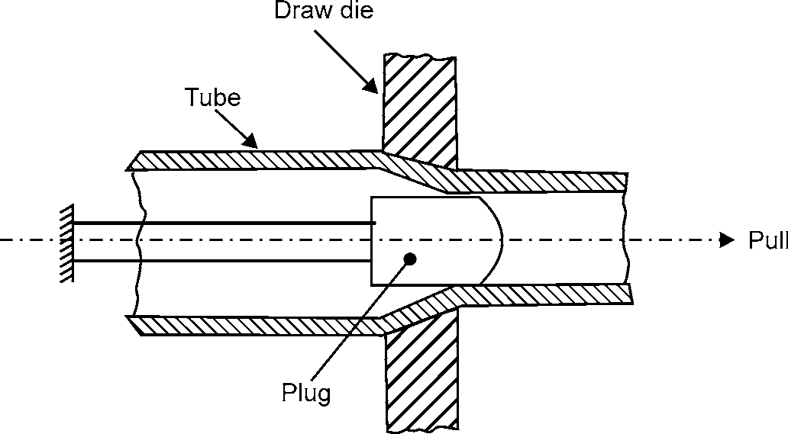

* 1. Fixed Plug

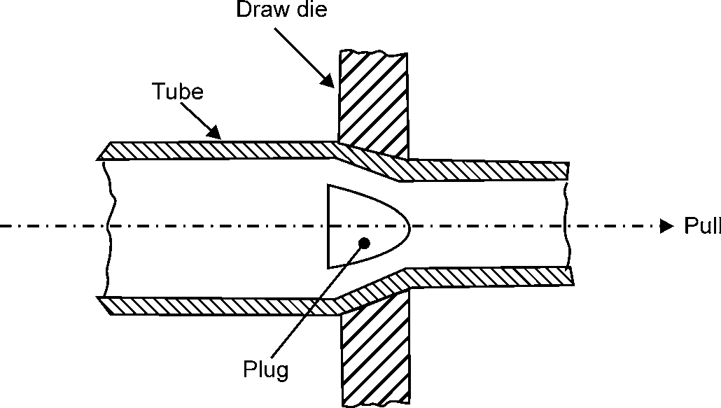

* 1. Floating Plug

**Fig. 4.18:** Tube Drawing with a Plug.

1. **Tube drawing with a moving mandrel:** This method is similar to that of a plug drawing except the difference that in this case a movable mandrel is used. Because of the movable mandrel, friction is minimized but the mandrel has to be removed by rolling, hence there is a slight increase in the diameter of tube. This results in reduction of dimensional tolerances.

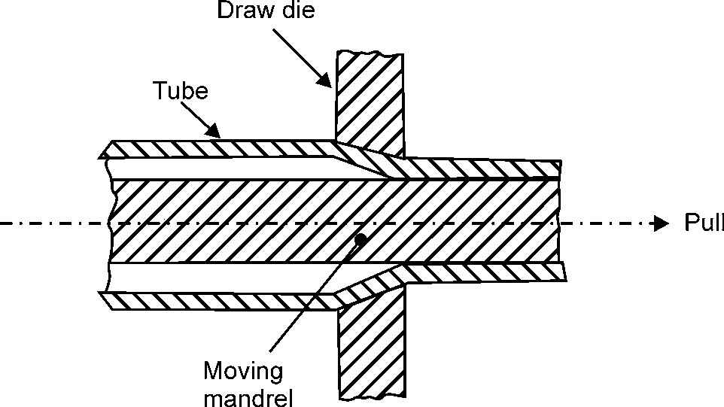

**Fig. 4.19:** Tube Drawing with a Moving Mandrel.

86 MANUFACTURING PROCESSES

## MAKING AND EXTRUSION

Extrusion is the process that forces metal to flow through a shape-forming die. The metal is plastically deformed under compression in the die cavity. Extrusion produces only compressive and shear forces in the stock without any tensile force, which makes high deformation possible without tearing the metal. It is a hot-working process which, like forging, rolling, etc., uses the good deformability of heated metallic materials for shaping them.

A metal billet heated to the appropriate temperature is fed into the cylindrical container of the extrusion press and is forced by the action of a ram through a steel die whose orifice has the desired shape to produce the solid or hollow section (Fig. 4.20). The metal emerges from the die as a continuous bar, which is cut to the required lengths. Extrusion products are therefore essentially linear in character, in the sense that shaping is confined to the cross-section only. The process is therefore eminently suitable for the production of bar-like and tubular objects.

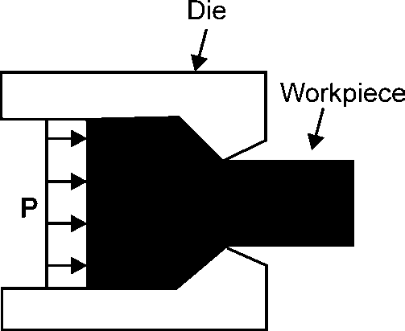

**Fig 4.20:** Extrusion Process

The cross-section that can be produced vary from solid round, rectangular, to L shapes, T shapes, tubes and many other different types. Extrusions, often minimize the need for secondary machining, but are not of the same dimensional accuracy or surface finish as machined parts. However, this process can produce a wide variety of cross-sections that are hard to produce cost-effectively using other methods.

Extrusion differs from drawing in that the metal is pushed, rather than pulled under tension.

Extrusion processes can be carried on hot or cold.

**Cold extrusion:** Cold extrusion is the process done at room temperature or slightly elevated temperatures. This process can be used for most materials subject to designing robust enough tooling that can withstand the stresses created by extrusion. Cold extrusion can be used with any material that possesses adequate cold work ability–e.g., lead, tin, aluminum alloys, copper, titanium, molybdenum, vanadium, steel. Typical parts which are cold extruded are collapsible tubes, aluminum cans, cylinders, gear blanks.

The advantages of cold extrusion are:

1. No oxidation takes place.
2. Good mechanical properties due to severe cold working as long as the temperature created are below the recrystallization temperature.
3. Good surface finish with the use of proper lubricants.

METAL FORMING 87

**Hot extrusion:** Hot extrusion is basically a hot working process. It is done at fairly high temperatures, approximately 50 to 75% of the melting point of the metal. The pressures can range from 35-700 MPa. Due to the high temperatures and pressures and its detrimental effect on the die life as well as other components, good lubrication is necessary. The principal variables, which influence the force required to cause extrusion, are:

1. The type of extrusion
2. The extrusion ratio
3. The working temperature
4. The speed of deformation, and
5. The frictional conditions at the die and container wall.

Typical parts produced by hot extrusion are trim parts used in automotive and construction applications, window frame members, railings, aircraft structural parts.

### Types of Extrusion

Extrusion processes can be classified in five ways: Direct, Indirect, Combined, Hydrostatic and Impact.

* + - 1. **Direct (forward) extrusion:** Forward or direct extrusion is sometimes known as the Hooker process. In this process a ram forces the preheated billet through the die (see Fig. 4.21). The billet slides relative to the container wall; the wall friction increases the ram force consider- ably. A dummy block or pressure plate is placed at the end of the ram in contact with the billet. The process can be compared like squeezing toothpaste out of a tube. Using this method, it is possible to extrude LIP to SIX lengths from one die.

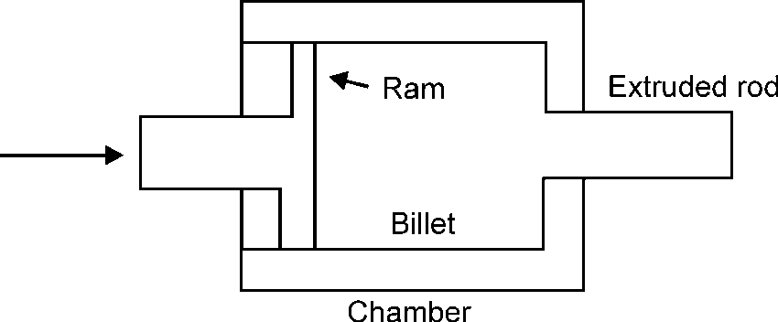

**Fig. 4.21:** Direct Extrusion

The process is generally used to produce profiled sections, thin-walled tubular parts with heavy flanges, straight tubular shapes, and hollow bar products. Typical products produced are bolts, screws or stepped shafts.

* + - 1. **Indirect (reverse, inverted or backward) extrusion:** Indirect extrusion is a process that forces the metal confined in the cavity to flow in a direction opposite to that of the ram travel (see Fig. 4.21). Here, the die moves toward the billet; thus, except at the die, there is no relative motion at the billet-container interface. As a consequence, the frictional forces are lower and the power required for extrusion is less than for direct extrusion. In practice, a hollow ram carries a die, while the other end of the container is closed with a plate.

88 MANUFACTURING PROCESSES

Frequently, for indirect extrusion, the ram containing the die is kept stationary, and the container with the billet is made to move.

Backward extrusion is useful in forming a variety of cylindrical shapes such as nuts, sleeves and tubular rivets.

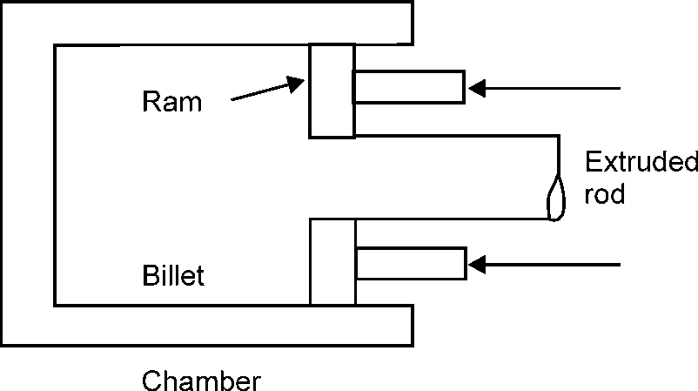

**Fig. 4.22:** Indirect Extrusion

* + - 1. **Combined extrusion:** Combined extrusion uses a combination of forward extrusion and backward extrusion. The metal is confined inside a matrix between the lower and upper punches. This forces the metal to flow both up and down. The extruded part is lifted from the die on the upward stroke of the slide by a lift out on the bed of the press. Some aspects of combined extrusion are:

1. It is fast
2. It can complete parts in few steps
3. It can produce large quantities with low unit costs
4. It wastes little material
5. It can make parts with small radii
6. It requires mirror tooling
   * + 1. **Hydrostatic extrusion:** In this process, the chamber is filled with a fluid that transmits the pressure to the billet, which is then extruded through the die. (Fig. 4.23) There is no friction along the walls of the container. Because the billet is subjected to uniform hydrostatic pres- sure, it does not upset to fill the bore of the container as it would in conventional extrusion. This means that the billet may have a large length to diameter ratio (even coils of wires can be extruded) or it may have an irregular cross section. Because of the pressurized fluid, lubrication is very effective, and the extruded product has good surface finish and dimen- sional accuracy. Since friction is nearly absent, it is possible to use dies with very low semi- cone angle which greatly minimizes the redundant deformation. The only limitation with this process is the practical limit of fluid pressure that may be used because of the constraint involving the strength of the container and the requirement that the fluid does not solidify at high pressure.

METAL FORMING 89

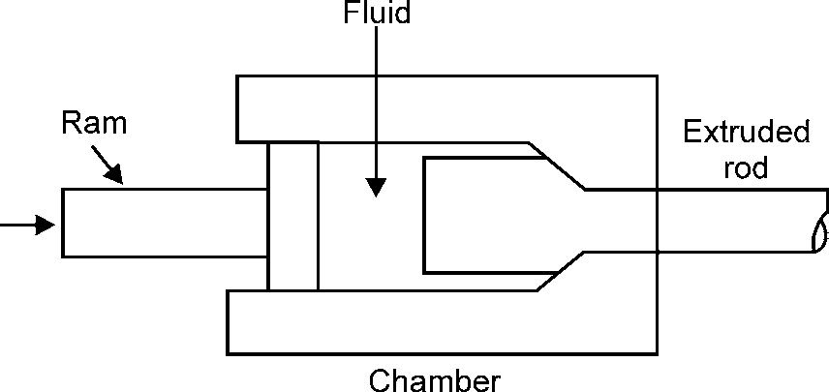

**Fig. 4.23:** Hydrostatic Extrusion

* + - 1. **Impact extrusion:** It is a form of indirect extrusion and is particularly suitable for hollow shapes. It is usually performed on a high-speed mechanical press. The punch descends at a high speed and strikes the blank, extruding it upwards (Fig. 4.24). The thickness of the extruded tubular section is a function of the clearance between the punch and the die cavity. Although the process is performed cold, considerable heating results from the high-speed deformation. Impact extrusion is restricted to softer metals such as lead, tin, aluminum and copper.

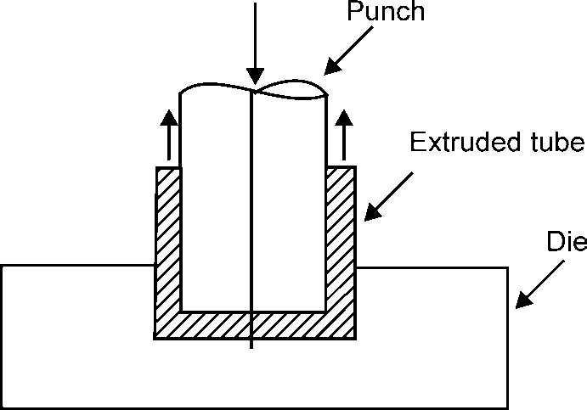

### Advantages of Extrusion

**Fig. 4.24:** Impact Extrusion.

* + - 1. The tooling cost is low, as well as the cost due to material
      2. Intricate cross sectional shapes, hollow shapes and shapes with undercuts can be produced.
      3. The hardness and the yield strength of the material are increased.
      4. In most applications, no further machining is necessary.

### Limitations of Extrusion

* + - 1. High tolerances are difficult to achieve.
      2. The process is limited to ductile materials.
      3. Extruded products might suffer from surface cracking. It might occur when the surface temperature rise significantly due to high extrusion temperature, friction, or extrusion speed.

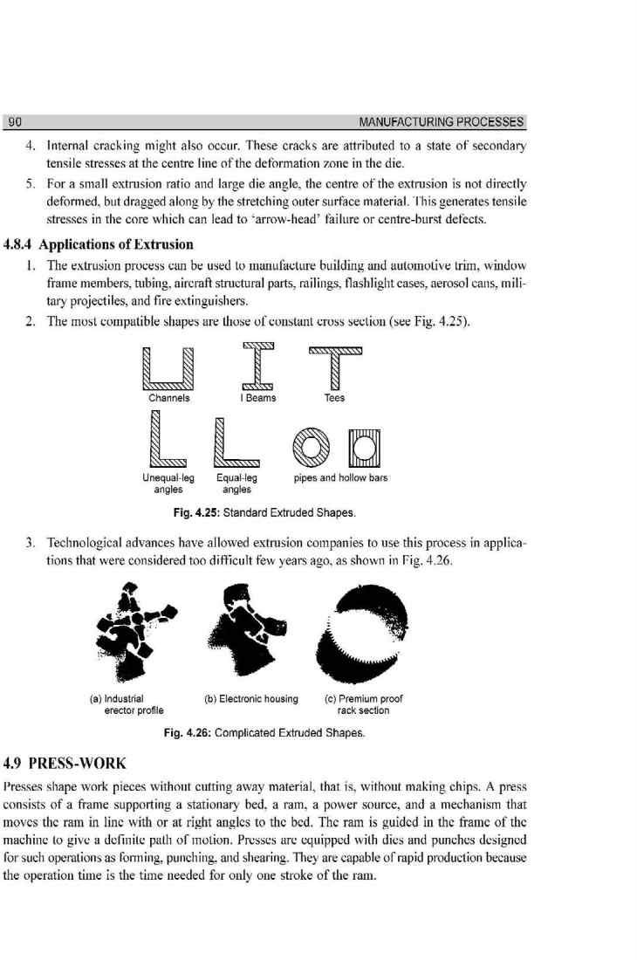

[www.EngineeringEBooksPdf.com](http://www.EngineeringEBooksPdf.com/)

METAL FORMING 91

There are three methods of working sheet metal in presses:

* + - * 1. **Shearing:** It is a sheet-metal cutting operation along a straight line between two cutting edges. Shearing is used to cut large sheets into smaller sections for subsequent press work- ing operations.
        2. **Deep Drawing:** It is characterized by the production of a parallel-wall cup from a flat blank of sheet metal.
        3. **Bending:** It is the straining of material, usually flat sheet or strip metal, by moving it around a straight axis lying in the neutral plane. Metal flow takes place within the plastic range of the metal, so that the bent part retains a permanent set after removal of the applied stress.

### Classification of Presses

Presses are classified according to the following characteristics:

* + - 1. Source of power
         1. Hand press or fly press
         2. Power press
      2. Type and design of frames
         1. Inclined press
         2. Gap press
         3. Straight side press
         4. Arch press
         5. Horn press
      3. According to action
         1. Single action
         2. Double action
         3. Triple action
      4. Mechanism used for applying power to ram
         1. Crank .
         2. Eccentric
         3. Cam
         4. Toggle
         5. Knuckle
         6. Rack and Pinion
         7. Hydraulic
      5. Number of drive gears
         1. Single drive
         2. Twin drive
         3. Quadruple drive

92 MANUFACTURING PROCESSES

* + - 1. Method of power transmission from motor to crankshaft.
         1. Direct
         2. Non-geared
      2. Based on tonnage
         1. Mechanical press
         2. Hydraulic press

1. **Hand Press or Fly-Press:** This type of press is made of cast-iron frame and is hand operated. The construction consist of a screw which carries a wheel fitted with a handle at one end, and a ram which slides in the guide fitted at the other end of the screw. Further, the ram carries the punch at its bottom. Thus, as the ram moves, the punch also moves providing the required thrust on the sheet metal.
2. **Power Press:** In a power press the ram is moved by a crank and a connecting rod. The punch is connected to the ram, while die is attached to the bolster plate. The machine is driven by means of a belt and pulley arrangement. A flywheel and a clutch store and control the flow of energy. This energy is supplied continuously at a relatively constant rate to the crankshaft, but it is consumed periodically at each stroke of the ram.

## DIE & PUNCH ASSEMBLY

For a specific operation or job on a press special tooling is designed. The tooling consist of a die and punch assembly or simply a press tool die. The various components of a die and punch assembly are shown in fig 4.27. A simple description of each part is also given:

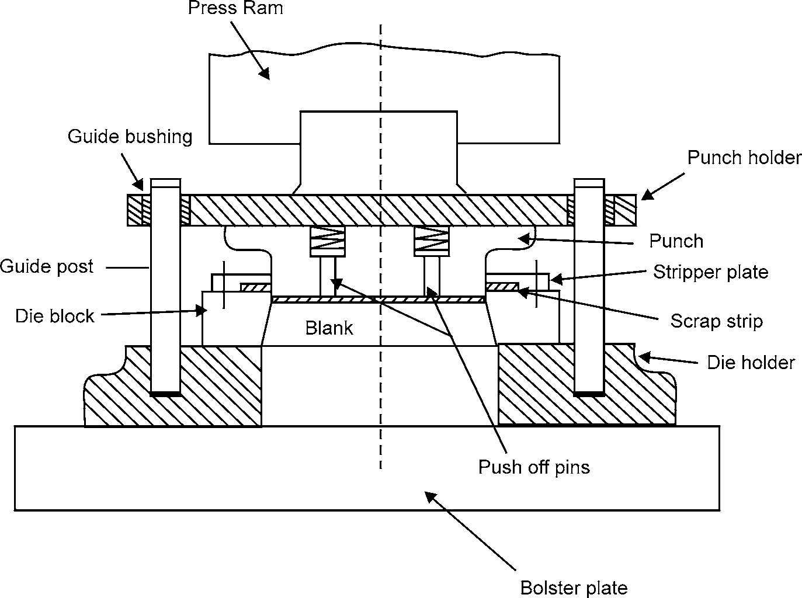

**Fig. 4.27:** Die and Punch Assembly



METAL FORMING 93

1. **Punch:** It is the male member of the unit and is usually small having sufficient strength and rigidity. The punch is made up of hard and wear resistant metal.
2. **Punch holder:** It is anchored to the lower end of press ram with the help of a shank. It provides a wide flat surface and is made of cast steel.
3. **Die Block:** It is the female working member which contains a die cavity.
4. **Die holder:** It is mounted on the bolster plate of the press. Both the guide post and die block are mounted on the die holder.
5. **Guide Posts and Bushings:** These are used to hold the punch and die members in proper alignment during an operation.
6. **Bolster Plate:** It is a thick plate secured to the press bed and is used for locating and supporting the die assembly. It is usually 5 to 12.5 cm thick.
7. **Stripper Plate:** It is used to free the punch from scrap strip during the returning motion of the punch.
8. **Pilots:** These are used in progressive dies to bring the stock into the correct position for the successive blanking and piercing operations.

## SHEARING

Shearing is a process which involves cutting sheet metal by subjecting it to shear stresses, usually between a punch and a die (see Fig. 4.28).

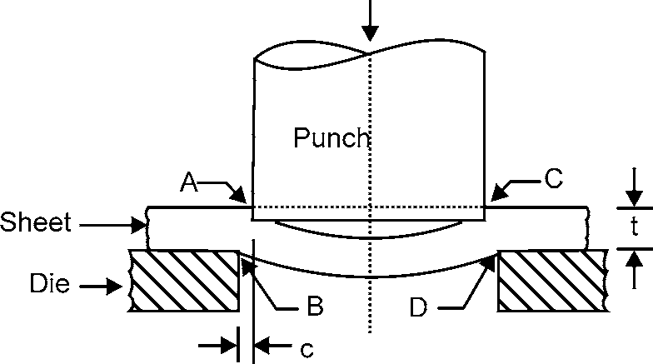

**Fig. 4.28:** Schematic Illustration of the Shearing Process with a Punch and Die.

The major variables in the shearing process are the punch force (F), the speed of the punch, lubrication, the edge condition of the sheet, the punch and die materials, the comer radii of the punch and die, and the clearance between the punch and die.

Rollover depth

Penetration depth

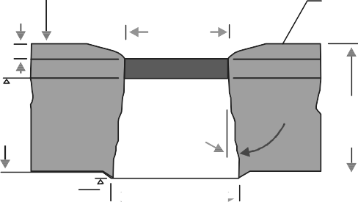Burnish

dimension

Burnish depth

Flattened portion under the punch

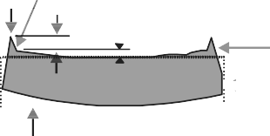Burr Burr height

Fracture depth

Burr height

Fracture angle

Breakout dimension

(a)

A

Sheet thickness (t) B

Ideal slug

Dishing

(b)

C

Rough surface

Smooth surface (burnished)

D

**Fig. 4.29:** Characteristic Features of (a) a Punched Hole and (b) The Punched Slug

94 MANUFACTURING PROCESSES

Fig. 4.28 shows the overall features of a typical sheared edge for the two sheared surfaces i.e., the sheet and the slug. The clearance ‘c’ is the major factor that determines the shape and quality of the sheared edge. Usually shearing starts with the formation of cracks on both the top and bottom edges of the workpiece (A and B in Fig. 4.28). These cracks eventually meet and complete separation takes place.

The rough fracture in the slug as shown in Fig. 4.28 (b) is caused by these cracks. The smooth, shiny and burnished surface is from the contact and rubbing of the sheared edge against the walls of the die. The ratio of the burnished to rough areas on the sheared edge increases with increasing ductility of the sheet metal; it decreases with increasing material thickness and clearance. Note also the formation of a burr in Fig. 4.28 (b). Burr height increases with increasing clearance and increasing ductility of the metal. Tools with dull edges are also a major factor in burr formation.

The amount of punch travel required to complete the shearing process depends on the maximum shear strain that the material can undergo before fracture. Hence, a brittle metal or a material that is highly cold worked requires little travel of the punch to complete shearing.

### Shearing Operations

**l. Blanking:** It is a metal fabricating process, during which a metal workpiece is removed from the primary metal strip or sheet when it is punched. The material that is removed is the new metal work piece or blank. Fig. 4.30 provides a two-dimensional look at a typical blank- ing process. Note that the primary metal workpiece is the scrap and the punched part is the desired new metal workpiece.

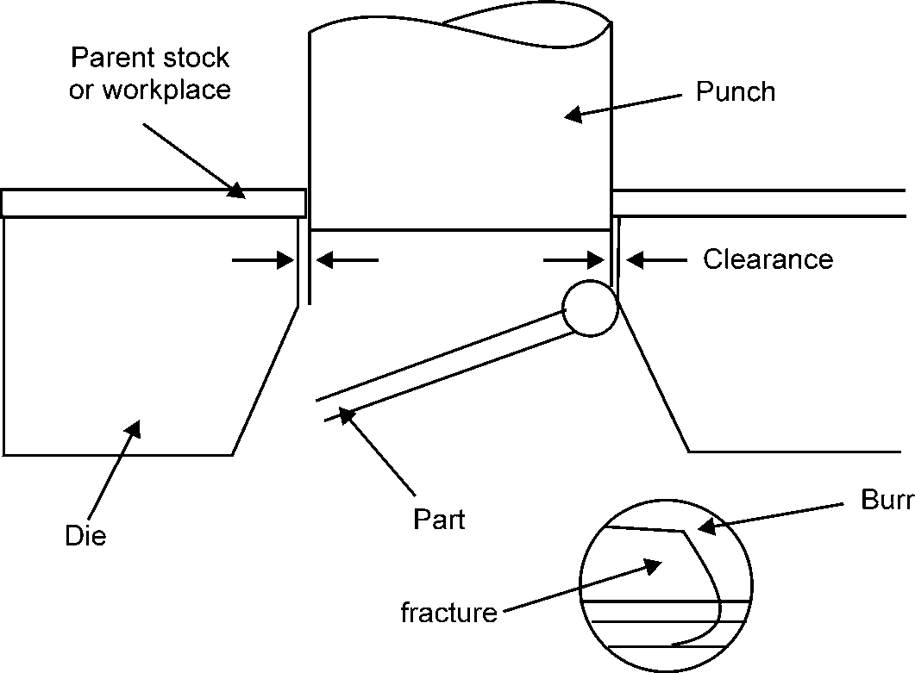

**Fig. 4.30:** Blanking

1. **Piercing:** It is the general term for cutting (shearing or punching) openings, such as holes and slots, in sheet material, plate, or parts. This operation is similar to blanking; the difference is that the slug or piece produced by piercing is scrap, while the blank produced by blanking is the useful part. The punch diameter determines the size of the hole created in the workpiece.

METAL FORMING 95

Fig. 4.31 provides a two-dimensional look at piercing process: Note how the workpiece remains and the punched part falls out as scrap as the punch enters the die. The scrap drops through the die and is normally collected for recycling.

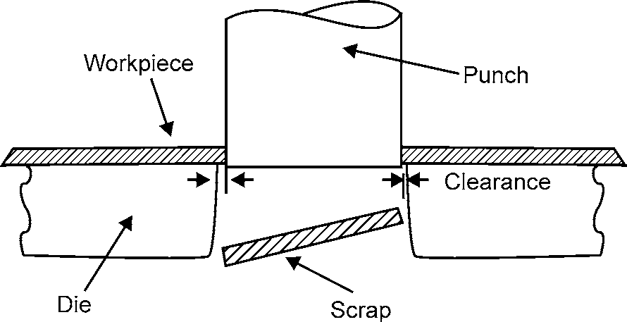

**Fig. 4.31:** Piercing

1. **Slitting:** It is also a shearing process, but rather than making cuts at the end of a workpiece like shearing, slitting is used to cut a wide coil of metal into a number of narrower coils as the main coil is moved through the slitter. During the slitting process, the metal coil passes lengthwise through the slitter’s circular blades. Fig. 4.32 provides a two-dimensional look at a typical coil slitting process. Note, how the metal workpiece is drawn past the upper and lower slitting blades, leaving two coils of the same length as the original wide coil.

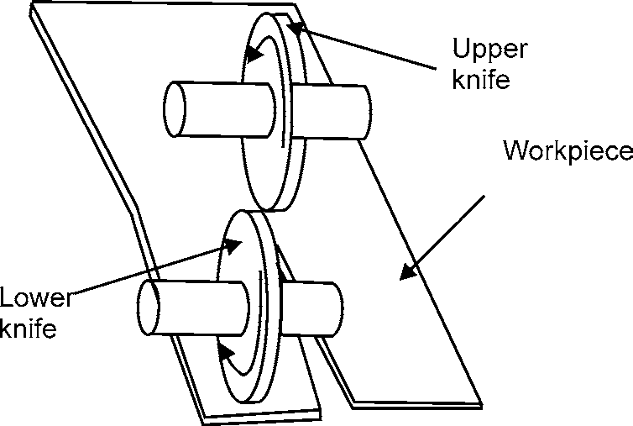

**Fig. 4.32:** Slitting

1. **Notching:** It is a shearing process during which a metal scrap piece is removed from the outside edge of a metal workpiece. Notching is typically a manually operated, low-produc- tion process. During a notching operation, the metal workpiece has an outside edge removed by the use of multiple shear blades that are set at right angles to each other.

Fig. 4.33 provides a two-dimensional look at a typical notching process. Note, how the tool removes the notched part.

96 MANUFACTURING PROCESSES

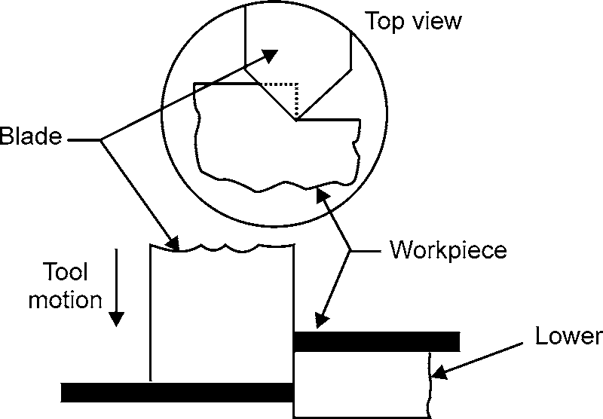

**Fig. 4.33:** Notching

As mentioned above, the notching process removes material from only the outside edges of the workpiece. Fig. 4.34 shows how a metal workpiece may look after the notching process is employed and has removed material from the outside edges.

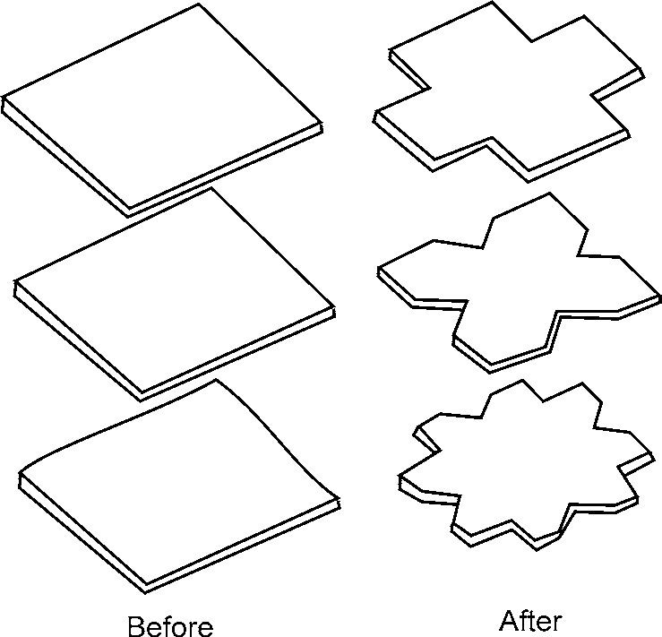

**Fig. 4.34:** Notched Shapes

1. **Perforating:** It is the punching of many holes, usually identical and arranged in a regular pattern, in a sheet, workplace blank, or previously formed part. The holes are usually round, but may be of any shape. The operation is also called multiple punching. (Fig. 4.35).



**Fig. 4.35:** Perforating

METAL FORMING 97

1. **Nibbling :** It is the process of cutting out a contour or other shape by punching a series of overlapping round or square holes along the edge of the part (Fig. 4.36).

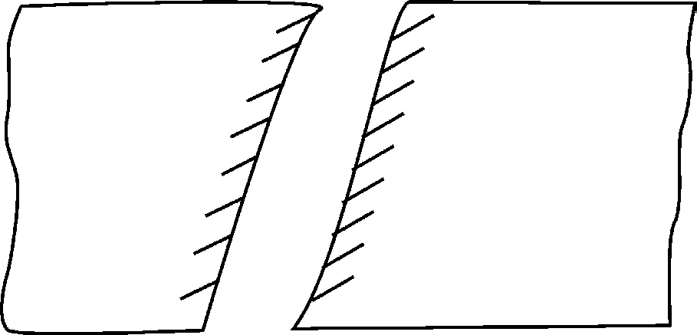

**Fig. 4.36:** Nibbling

1. **Shaving:**It is a finishing or sizing process and very little material is removed from the edges. Usually, the edge has been press worked previously. Shaving is intended to produce tight tolerance holes or blanks.
2. **Slotting:** It is the cutting of elongated holes or slots.
3. **Trimming:** It is the cutting away of excess material in a flange or flash from a piece. (Fig. 4.37)

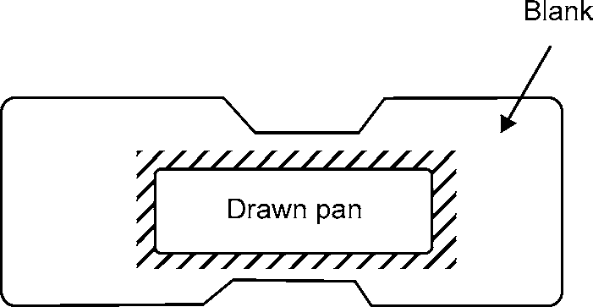

**Fig. 4.37:** Trimming

1. **Lancing:** It is a cutting operation in which a hole is partially cut and then one side is bent down to form a sort of tab. (Fig. 4.38).

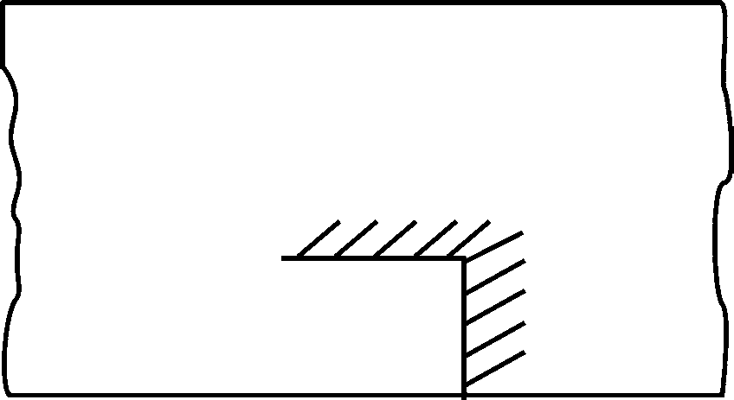

**Fig. 4.38:** Lancing

98 MANUFACTURING PROCESSES

## SHEARING DIES

Shearing dies are broadly classified into three types: Progressive dies, Compound dies and Combination dies.

1. **Progressive Dies:** These are used for making parts requiring multiple operations, such as punching, bending and blanking, at high production rates. The progressive dies perform two or more operations simultaneously in a single stroke of a punch press, so that a complete component is obtained for each stroke. The place where each of the operations are carried out are called stations. The stock strip moves from one station to other undergoing the particular operation. When the strip finally leaves the last station, a finished component is ready.

Fig. 4.39 shows a schematic illustration of the making of a washer in a progressive die. While the piercing punch cuts a hole in the stock, the blanking punch blanks out a portion of the metal in which a hole had been pierced at a previous station. Thus, after the first stroke, when only a hole will be punched, each stroke of the press produces a finished washer.

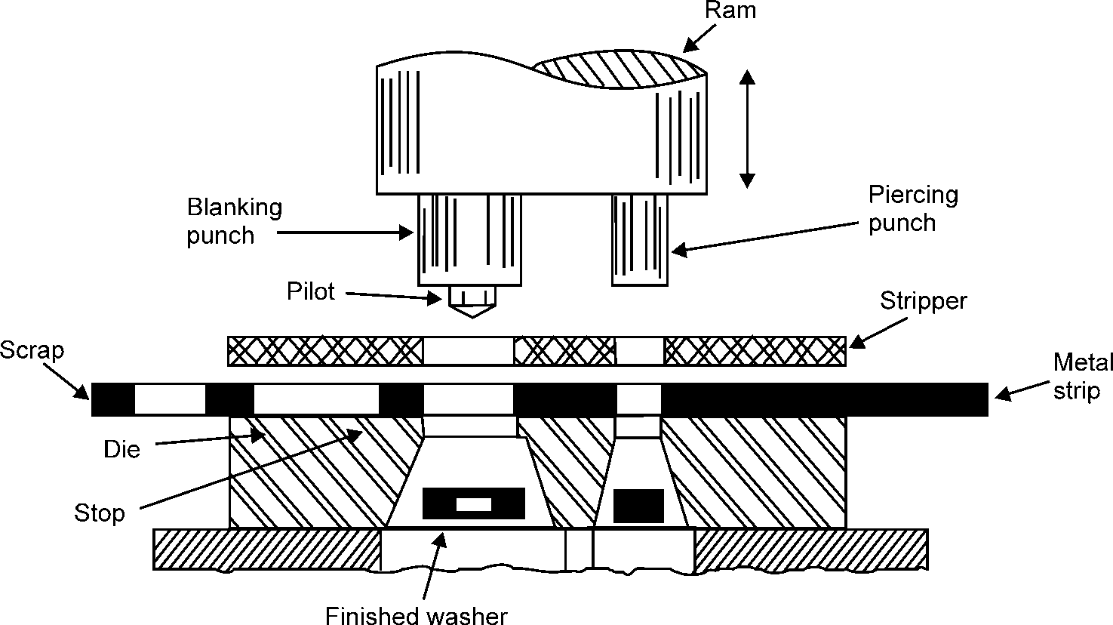

**Fig. 4.39:** Washer Production in Progressive Die

1. **Compound Dies:** In a compound die several operations on tile same strip may be performed in a single stroke of the ram at one station. To do more than one set of operations, a compound die consists of the necessary sets of punches and dies.

Fig. 4.40 (a) shows a compound die before cutting operation and Fig. 4.40 (b) shows the compound die after cutting operation is performed for making a washer. During the part of the stroke, piercing of holes is done in the stock and upon further travel, the blanking opera- tion is done. Hence, a washer is made by simultaneous blanking and piercing operations. For the blanking operation, the punch used for piercing becomes a die as shown in Fig. 4.40 (a). In other words, blanking is done in a direction opposite to that of piercing.

METAL FORMING 99

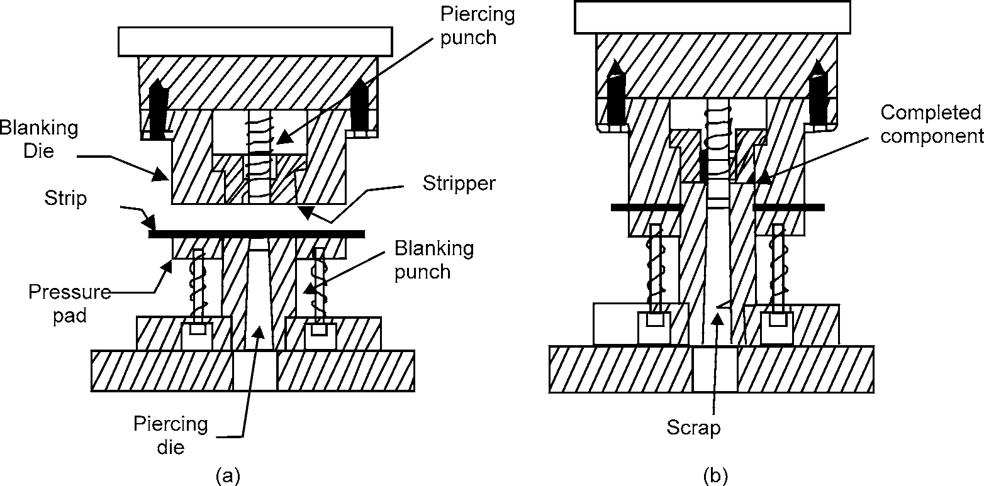

**Fig. 4.40:** Compound Die

Compound dies are slower in operation and gives better tolerances than progressive dies. This is mainly because the part located in one position undergoes all the operations. Also in compound dies, small strips can be advantageously used, whereas in progressive dies very long strips are needed to cover all the stations.

1. **Combination Dies:** This type of die is similar to that of a compound die except that here non-cutting operations such as bending and forming are also included as part of the opera- tion. A combination blank and form die is shown in Fig. 4.41.

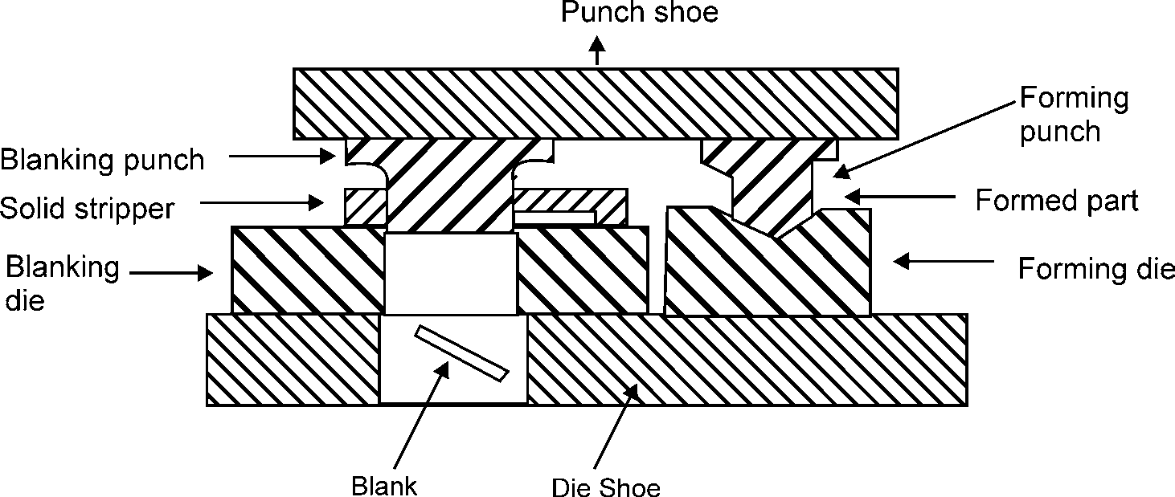

## DEEP DRAWING

**Fig. 4.41:** Combination Die.

Objects that have depth to them such as cylinders, pans, or domes typically are fabricated with a deep draw forming method. Deep Drawing of sheet metal is used to form containers or objects with depth. It is a plastic deformation in which a flat sheet or plate is formed into a recessed,

100 MANUFACTURING PROCESSES

three-dimensional part with a depth several times the thickness of the metal. The process is accomplished with the use of a hydraulic or mechanical press. The process of deep drawing begins with a flat sheet metal blank held on the upper surface of the die (Fig. 4.42).

A sheet metal blank is a flat piece of sheet metal used to form the finished product. Typically, all holes or cutouts are punched prior to forming. The center portion of the sheet is pressed into the die opening to draw the metal into the desired shape without folding or collapsing the corners. This process requires a double action force. One force holds the sheet metal blank in position and another force punches or draws the material into the desired shape. A blank holder is used which holds the work piece against the draw ring to control metal flow. Blank holder is also called binder, binder ring, or ring. The tooling required to produce the part consists of a male punch and a female die. Clearance between these parts is closely controlled to minimize movement of the part therefore, preventing the sidewalls from wrinkling. The die and the punch have sufficient radii or relief to allow for the metal to be formed without tearing the material. In most deep-drawing operations, the part has a solid bottom to form a container and a retaining flange that is trimmed later in the processing. In some cases, the cup shape is ejected through the bottom opening of the die.

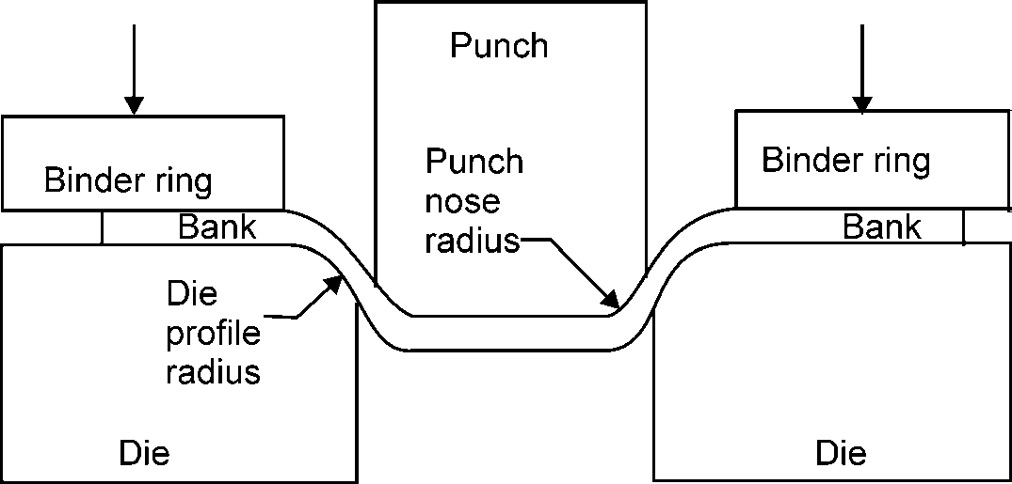

**Fig. 4.42:** Method of Deep Drawing

There are certain properties that are considered to be important in sheet metal products designed for deep drawing. This requires a minimum amount of inclusions or impurities in the material. Material quality is important to prevent failure or defects during production. Mechanical properties such as yield strength, percentage elongation. ductility, and plastic deformation are also important for the process. Properties such as dimensional constraints and modulus of elasticity must be considered so that the part will maintain the desired shape after forming is complete. These are all key properties that need to be considered when using the deep-drawing fabrication process. The ability to draw a material is based on two important parameters. The first parameter is the drawing force and the second is the *r* factor, which is a measure of the resistance of the material to thinning. This is of particular importance when drawing sheet to form cans, as the greater the resistance to thinning, the less material is wasted, as the thinnest gauge possible can be used to start with.

### Advantages of Deep Drawing

* + - 1. Production of shallow or deep parts with relatively simple shapes.
      2. High production rates.

The only disadvantage is high tooling and equipment costs.

METAL FORMING 101

### Deep Drawing Operations

* + - 1. **Ironing:** It is the operation in which the thickness of the shell wall is reduced and its surface smoothed. The die and punch set used is similar to that of drawing operation except that the clearance between the die and punch is smaller than that used in the drawing operation. The material gets compressed between punch and die as shown in Fig. 4.43, which reduces the thickness and increases the height of the cup. The thickness of the shell wall can be reduced up to 50% in a single operation.

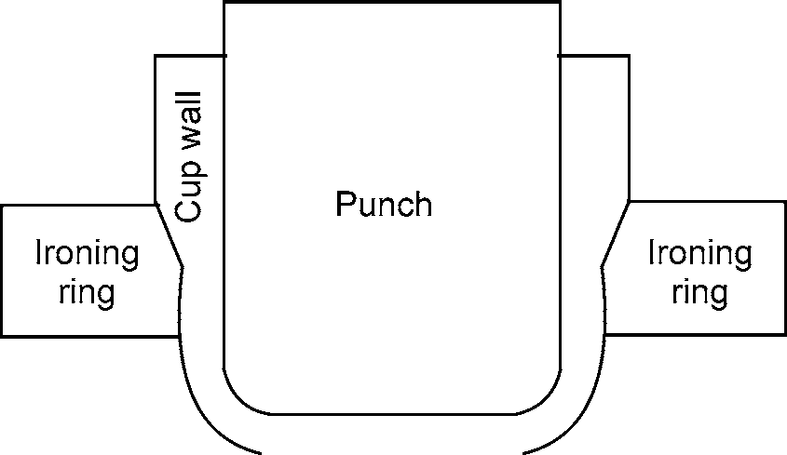

**Fig. 4.43:** Ironed Cups

* + - 1. **Redrawing:** When the ratio of the blank diameter and the final cup diameter is too large, the drawing operation is performed in more than one stage. The successive drawing operations after the first one are known as redrawing.
      2. **Reverse drawing:** In this process, a drawn cup is subjected to bending in the opposite direction to its original drawn direction. This reverse drawing results in strain softening.

### Defects in Deep Drawing

* + - 1. **Earing:** It is the formation of ears or scalloped edges around the top of a drawn shell which results from directional differences in the plastic working properties of rolled metal with, across, and at angles to the direction of rolling.
      2. **Buckling:** An uncontrolled deformation pattern perpendicular to the surface of a sheet caused by compressive stresses is known as Buckling. It causes a bend, kink, or other wavy condition of the workpiece. Buckling in the flange of the part is referred to as wrinkling, and buckling in the wall of the part is referred to as puckering.
      3. **Bulging:** In this the diameter of a cylindrical shell (usually to a spherical shape) increases or it is the expanding of the outer walls of any shell or box shape whose walls were previously straight.
      4. **Surface Scratch:** This occurs on the surface of the drawn cup.

102 MANUFACTURING PROCESSES

# OBJECTIVE QUESTIONS

1. The hot working of metals is carried out
   1. At the recrystallisation temperature
   2. The any temperature
   3. Below the recrystallisation temperature
   4. Above the recrystallisation temperature
2. The process of decreasing the cross-section of a bar and increasing its length is called
   1. Drawing down (b) Upsetting

(c) Spinning (d) Peening

1. The process of increasing the cross-section of a bar and decreasing its length is called
   1. Drawing down (b) Upsetting

(c) Spinning (d) Peening

1. The cold working of metals is carried out
   1. At the recrystallisation temperature
   2. The any temperature
   3. Below the recrystallisation temperature
   4. Above the recrystallisation temperature
2. Cold working of metals increases
   1. Tensile strength (b) Yield strength

(c) Hardness (d) All of these

1. Structural sections such as rails, angles, I-beams are made by
   1. Hot spinning (b) Hot drawing

(c) Squeezing (d) All of these

1. Cold working processes are
   1. Shearing (b) Drawing

(c) Squeezing (d) All of these

1. A method of producing several holes in the work piece with one stroke of the process
   1. Perforating (b) Lancing

(c) Parting (d) None

1. A process of cutting hole of various shapes and sizes into a work piece
   1. Punching (b) Nibbling

(c) Trimming (d) Slitting

1. The process extensively used for making bolts and nuts
   1. Hot piercing (b) Extrusion

(c) Shot peening (d) None

|  |  |  |  |  |  |
| --- | --- | --- | --- | --- | --- |
|  | | | **ANSWERS** |  | |
| 1. (d) | 2. (a) | 3. (b) | 4. (c) | 5. (d) | 6. (d) |
| 7. (b) | 8. (d) | 9. (a) | 10. (a) |  |  |

METAL FORMING 103

# SHORT ANSWER QUESTIONS

1. What is the difference between smithy and forging?
2. What do you understand by open fire and stock fire? Which of the two is more advantage and why?
3. Explain the various types of furnaces used in forging work?
4. Name the important process variables in drawing and explain how they affect the drawing process.
5. Explain why the die pressure in drawing process decreases towards the exit of the die.
6. Explain what effects back tension has on the die pressure in wire or rod drawing, and discuss why these effects occur.
7. Why stainless steel is not used in extension process?
8. Explain

(a) Forward extrusion, (b) Backward extrusion, and

(c) Impact extrusion processes.

1. What is the primary shape limitation of the extrusion processes?
2. Describe some common detects of
   1. Wire drawing (ii) Extrusion Also indicate remedial measures.
3. Explain centre-burst defect in wire drawing/extrusion.
4. Give few examples of extruded products.
5. Mention the advantages and limitations of extrusion processes.
6. Briefly explain rolling process.
7. Why is the strength of a rolled part considered usually better than a cast piece?
8. Describe various types of rolls used during rolling process.
9. In a four-high rolling mill, why do we use small diameter rolls as working rolls and large diameter rolls as back up rolls?
10. What is the significance of roll diameter with reference to the roll diameter with reference to the roll separating force in rolling?
11. Give any three examples of rolling stand arrangements.
12. What is meant by breakdown passes in rolling?
13. Describe some common rolling defects. Also, indicate remedial measures.
14. Give few examples of rolled products.
15. Discuss various metal working lubricants giving their field of application.
16. What is a press? Discuss various types of presses.

104 MANUFACTURING PROCESSES

1. Explain the difference between a die and a punch.
2. Write Short notes on:

(a) Drop forging (b) Press forging

(c) Flattening (d) Smith’s Forge

(e) Pedestal grinder (f) Power hammers

|  |  |
| --- | --- |
| 27. Describe factors affecting plastic deformation. | May-05 |
| 28. Draw Neat free hand sketches of (1) Anvil (2) Sewage block and  (3) Tong used in smithy. | May-03 |
| 29. Give few examples of rolled products. | May-03 |
| 30. Explain centre–burst defect in wire drawing/ Extrusion. | May-02 |
| 31. Give Few examples of extruded products. | May-03 |
| 32. Explain and differentiate: Progressive and compound die. | May-02 |

# LONG ANSWER QUESTIONS

1. Enlist various hot working and cold working process. Compare hot working and cold working processes indicating advantages and disadvantages of each. May-05
2. Enlist hand forging (smithy) operations and tools and briefly describe a few (Say 2 ) with sketches. Why are forged components considered superior? May-01
3. Briefly explain rolling process. May-05
4. Describe some common rolling defects. Also indicate remedial measures. May-02,03, 04,05
5. Describe some common defects of
   1. Wire drawing May-02
   2. Extrusion May-02, 03,04,05
6. Draw a neat sketch of die–punch assembly with accessory parts / components. Also explain how cutting operations such as blanking or piercing differ from deep drawing operation.

May-03

1. The extrusion ratio, die geometry, extrusion speed, and billet temperature all affect the extrusion pressure. Explain why?
2. Describe the following shapes used in connection with the rolling of steel: ingot, bloom, slab, and billet.

❍ ❍

**CASTING**

5

## PATTERN

Pattern is a replica of the final object to be made by casting process, with some modifications. The main modifications are:

1. The addition of pattern allowances,
2. The provision of core prints,
3. Elimination of fine details which cannot be obtained by casting and hence are to be obtained by further processing

**PARTING LINE:** This is the dividing line between the two molding flasks that makes up the sand mould. In split pattern it is also the dividing line between the two halves of the pattern.

**BOTTOM BOARD:** This is a board normally made of wood which is used at the start of the mould making. The pattern is first kept on the bottom board, sand is sprinkled on it and then the ramming is done in the drag.

## PATTERN ALLOWANCES

The dimensions of the pattern are different from the final dimensions of the casting required. This is required because of various reasons. These are detailed as follows.

### Shrinkage

All the metal shrinks when cooling except bismuth. This is because of the inter-atomic vibrations which are amplified by an increase in temperature. However, there is a distinction to be made between liquid shrinkage and solid shrinkage.

Liquid shrinkage refers to the reduction in volume when the metal changes from liquid to solid state at the solidus temperature.

Solid shrinkage is the reduction in volume caused, when metal loses temperature in solid state.

The shrinkage allowance is provided to take care of this reduction.

The rate of contraction with temperature is dependent on the material. For example, steel contracts to a higher degree as compared to aluminium. The contraction also depends upon the metallurgical transformation taking place during the solidification. For example, white cast iron shrinks

106 MANUFACTURING PROCESSES

by about 21.0 mm/m during casting. However, when annealed it grow by 10.5 mm/m, resulting in a net shrinkage of 10.5 mm/m. Similarly, in grey cast iron and spheroidal graphite iron, the amount of graphitization controls the actual shrinkage. When graphitization is more, the shrinkage would be less and vice versa.

As a rule all the dimensions are going to be altered uniformly unless they are restrained in some way. For example, a dry sand core at the casting may restrain the casting from contracting but the edges are not restrained. Thus, it may be desirable to provide a higher shrinkage allowance for outer dimensions compared to those which may be restrained. The actual value of shrinkage depends on various factors specific to a particular casting, namely the actual component of the alloy cast, mould materials used, mould design, complexity of the pattern and the component size. The pattern maker’s experience and a little bit of trial are to be used in arriving at the final shrinkage provided on the pattern.

The shrinkage allowance is always to be added to the liner dimensions. Even in case of internal dimensions (e.g., internal diameters of cylinders), the material has a tendency to contract towards the entry and thus are to be increased. It is also possible to obtain shrink rules for specific materials such as steels which are nothing but special scales where dimensions shown are actually longer by a measure equal to the shrinkage allowance. Dimensions provided by such a rule can be used at the time of making the pattern. Different shrink rules are used for different casting materials as given in table 5.1.

**Table 5.1.** Shrinkage Allowances for Various Metals

|  |  |  |  |
| --- | --- | --- | --- |
| ***Material mm/m*** | ***Pattern dimension*** | ***Section thickness*** | ***Shrinkage allowance*** |
| Grey cast iron | up to 600 | – | 10.5 |
|  | 600 to 1200 | – | 8.5 |
|  | Over 1200 | – | 7.0 |
| White cast iron | – | – | 16.0 to 23.0 |
| Ductile iron | – | _ | 8.3 to 10.4 |
| Malleable iron | – | 6 | 11.8 |
|  |  | 9 | 10.5 |
|  |  | 12 | 9.2 |
|  |  | 15 | 7.9 |
|  |  | 18 | 6.6 |
|  |  | 22 | 4.0 |
|  |  | 25 | 2.6 |
| Aluminium | – | – | 13.0 |

**Example 1:** The casting shown in Fig. 5.1(a) is to be made in steel using a wooden pattern.

Assuming only shrinkage allowance, calculate the dimensions of the pattern.

From table 5.1 for steel the dimensions allowance is 21.0 mm/m

CASTING 107

For dimensions 200, allowance is 200 × 21.0/1000 = 4.20 For dimensions 150, allowance is 150 × 21.0/1000 = 3.15

= 3.20

For dimensions 100, allowance is 100 × 21.0/1000 = 2.10 For dimensions 80, allowance is 80 × 21.0/1000 = 1.68

= 1.70

The pattern drawing with required dimensions taking shrinkage into account is shown in Fig. 5.1(b). Double shrinkage allowance is to be provided on the pattern dimensions, if it is to be used for casting the metallic pattern which would ultimately be used for moulding to take care of the shrinkage of the actual metal cast as well as the shrinkage of the pattern metal. This is illustrated in the following example.

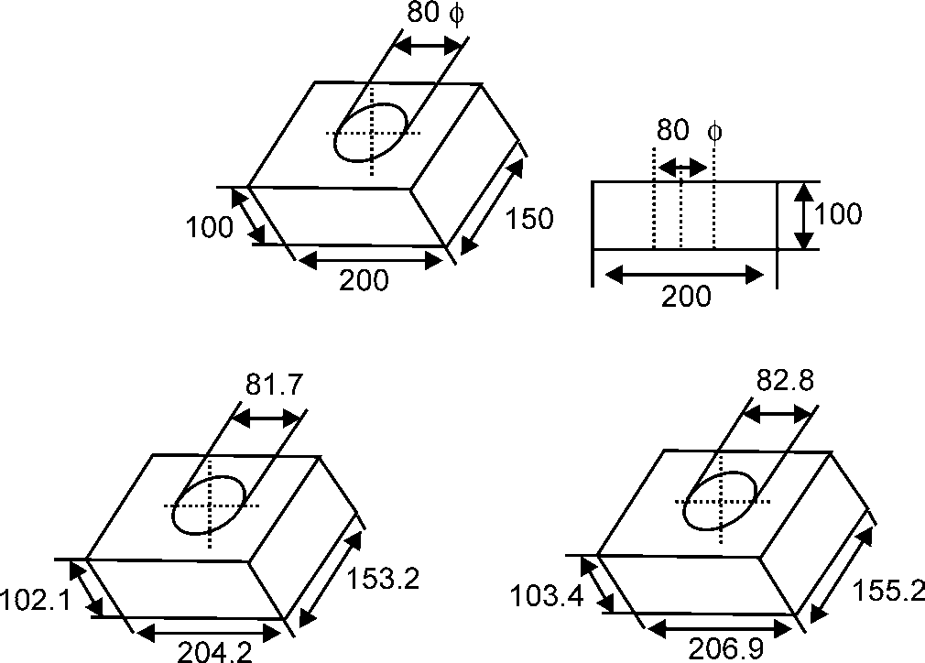

(a)

(b) (c)

**Fig. 5.1:** Provision of Allowances for Patterns in Sand Castings

**Example 2:** For the same example as shown in Fig. 5.1(b), if the master pattern is to be made of aluminum, calculate the dimensions of the wooden pattern which is to be used for making the aluminium pattern.

Fig.5.1(b) shows the dimensions of the aluminium pattern. For aluminium the shrinkage allowance is 13.0 mm/m

For dimensions 204.2, allowance is 204.2 × 13.0/1000 = 2.6546

= 2.70

For dimensions 153.2, allowance is 153.2 × 13.0/1000 = 1.9916

= 2.00

For dimensions 102.1, allowance is 102.1 × 13.0/1000 = 1.3273

= 1.30

For dimensions 81.7, allowance is 81.7 × 13.0/1000 = 1.0621

= 1.10

108 MANUFACTURING PROCESSES

The final dimensions of the wooden pattern for making the aluminium master pattern are shown in Fig. 5.1(c). The pattern allowance applied for this wooden pattern is called double shrinkage allowance.

### Draft

At the time of withdrawing the pattern from the sand mould, the vertical faces of the pattern are in continual contact with the sand, which may damage the mould cavity, as shown in Fig.5.2 (a). To reduce the changes of this happening, the vertical faces of the pattern are always tapered from the parting line Fig. 5.2(b). This provision is called draft allowance.



(a)

Parting line



(b)

**Fig. 5.2:** Effect of Draft on Pattern Withdrawing

Draft allowance varies with the complexity of the job. But in general, inner details of the pattern require higher draft than outer surface. The draft allowance given varies for hand moulding and machine moulding. More draft needed to be provided for hand moulding compared to machine moulding. In machine moulding the actual draft given varies with the condition of the machine (new, rigid, properly aligned, etc. require less draft).

One thing to be noted here is that draft is always provided as an extra metal over above the original casting dimension.

### Finish or Machining Allowance

The finish and accuracy achieved in sand casting are generally poor and therefore when the casting is functionally required to be of good surface finish or dimensionally accurate, it is generally achieved by subsequent machining. Also, ferrous materials would have scales on the skin which are to be removed by cleaning process. Hence, extra material is to be provided which is to be subsequently removed by machining or cleaning process. This depends on dimensions, the type of casting material and the finish required. This may range from 2 to 20 mm. The machining allowance provided would ultimately have to be removed by machining. Hence, the cost of providing additional machining allowance should be carefully examined before finalizing.

### Shake Allowance

Before withdrawal from the sand mould, the pattern is rapped all around the vertical faces to enlarge the mould cavity slightly which facilitates its removal. Since it enlarges the final casting made, it is desirable that the original pattern dimensions should be reduced to account for this increase. There

[www.EngineeringEBooksPdf.com](http://www.EngineeringEBooksPdf.com/)

CASTING 109

is no sure way of quantifying this allowance, since it is highly dependent on the foundry personnel and practices involved.

It is a negative allowance and is to be applied only to those dimensions which are parallel to the parting plane. One way of reducing this allowance is to increase the draft which can be removed during the subsequent machining.

### Distortion Allowance

A metal when it has just solidified is very weak and therefore is likely to be distortion prone. This is particularly so for weaker sections such as long flat portion, V, U sections or in a complicated casting which may have thin and long sections which are connected to thick sections. The foundry practice should be to make extra material provision for reducing the distortion. Alternatively, the shape of pattern itself should be given a distortion of equal amount in the opposite direction of the likely distortion direction. This can be done by trial and error basis.

## MOULDING MATERIAL

A large variety of moulding materials are used in foundries for manufacturing mould and cores. They are: Moulding sand, System sand (backing sand), Rebounded sand, facing sand, Parting sand, and Core sand. The choice of moulding materials is based on their processing properties.

The properties that are generally required in moulding materials are:

1. **Refractoriness:** It is the ability of the moulding materials to withstand the high tempera- tures of the molten metal so that it does not cause fusion. Some refractory materials are given in Table5.2:

**Table 5.2.** Properties of Some Refractory Materials

|  |  |  |
| --- | --- | --- |
| ***Material*** | ***Melting Point,°C*** | ***Coefficient of linear expansion, ×* 106/ °*C*** |
| Silica (SiO) | 1710 | 16.2 |
| Alumina (Al2O3) | 2020 | 8.0 |
| Magnesia (MgO) | 2800 | 13.5 |
| Thoria (ThO2) | 3050 | 9.5 |
| Ziroconia (ZrO2) | 2700 | 6.5 |
| Ziron (ZrO2 . SiO2 ) | 2650 | 4.5 |
| Silicon Carbide (SiC) | 2700 | 3.5 |
| Graphite | 4200 | — |

1. **Green strength:** The moulding sand that contains moisture is termed as green sand. The green sand should have enough strength so that the constructed mould retains its shape.
2. **Dry strength:** When the moisture in the moulding sand is completely expelled, it is called dry sand. When molten metal is poured into a mould, the around the mould cavity is quickly converted into dry sand as the moisture in the sand immediately evaporates due to the heat in the molten metal. At this stage, it should retain the mould cavity and at the same time withstand the metallostatic forces.

110 MANUFACTURING PROCESSES

1. **Hot strength:** After all the moisture is eliminated, the sand would reach a high temperature when the metal in the mould is still in the liquid state. The strength of the sand that is required to hold the shape of the mould cavity then is called hot strength.
2. **Permeability:** During the solidification of a casting, large amount of gases are to be expelled from the mould. The gases are those which have been absorbed by the metal in the furnace, air absorbed from the atmosphere and other gases that are generated by the moul- ding and core sands. If these gases are not allowed to escape from the mould, they would be trapped inside the casting and cause defects. The moulding sand should be sufficiently porous so that the gases are allowed to escape from the mould. This gas evolution of the moulding sand is termed as permeability.

Besides these specific properties, the moulding sand should also have collapsibility so that during the contraction of the solidified casting, it does not provide any resistance which may result in cracks in the casting, they should be reusable and should have good thermal conductivity so that from the casting is quickly transferred.

## MOULDING SAND

### Composition

The main ingredients of any moulding sand are:

* + - 1. Silica sand (SiO2) 80.8%
      2. Alumina (Al2O3) 14.9%
      3. Iron oxide(Fe2O3) 1.3%
      4. Combined water 2.5%
      5. Other inert materials 1.5%

Besides, some other materials are also added to these to enhance the specific properties of moulding sand.

### Properties of Moulding Sand

The moulding sand should posses the following properties:

1. **Porosity or permeability:** It is that property of sand which permits the steam and other gases to pass through the sand mould. When hot molten metal is poured into the sand mould, it evolves a great amount of other gases while coming in contact with the moist sand. If these gases do not escape completely through the mould, the casting will contain gas holes and pores. Thus, the sand from which the mould is made must be sufficiently porous or permeable. The porosity of sand depends upon its grain size, grain shape, and moisture and clay contents in the moulding sand. The extent of ramming of sand directly affects the porosity of the mould. If the sand is too fine, its porosity will be low.
2. **Plasticity:** It is that property of sand due to which it flows to all portions of the moulding box and acquires a predetermined shape under ramming pressure and retain this shape when the pressure is removed. The sand must have sufficient plasticity to produce a good mould. The plasticity is increased by adding water and clay to sand.
3. **Adhesiveness:** It is the property of sand due to which it adhere or cling to the sides of the moulding box. Good sand must have sufficient adhesiveness so that heavy sand masses can

CASTING 111

be successfully held in moulding box without any danger of its falling out when the box is removed.

1. **Cohesiveness:** It is that property of sand due to which the sand grains stick together during ramming. It may be defined as the strength of the moulding sand. It is of the following three types,
   1. **Green strength:** The green sand, after water has mixed to it, must have adequate strength and plasticity for making and handling of mould. The green strength depends upon the grain shape and size, amount and type of clay and the moisture content.
   2. **Dry strength:** When the molten metal is poured, the sand adjacent to the hot metal quickly loses water content as steam. The dry sand must have the strength to resist erosion and also the metallostatic pressure of the molten metal, otherwise the mould may enlarge.
   3. **Hot strength:** After the moisture has evaporated, the sand may be required to pos- sess strength at some elevated temperature, above 100°c.If the sand does not possess hot strength, the metallostatic pressure of the liquid metal bearing against the mould walls may cause mould enlargement or if metal is still flowing, it may cause erosion, cracks or breakage.
2. **Refractoriness:** It is that property of the sand which enables it to resist high temperature of the molten metal without breaking down or fusing. The higher pouring temperature, such as those for ferrous alloys, requires great refractoriness of the sand.

The degree of refractoriness depends upon the quartz contents, and the shape and grain size of the particles. The higher the quartz content and rougher the granulometric composition, the higher is the refractoriness of the sand. The refractoriness is measured by the sinter point of the sand rather than its melting point. The sinter point of the sand must be higher than the temperature at which the molten metal is poured into the sand mould.

1. **Flowability:** It is the property of sand due to which it behaves like a fluid so that, when rammed, it flows to all portions of a mould and distributes the ramming pressure evenly. Generally, sand particles resist moving around corners or projections. In general, flowability increases with decrease in green strength and decrease in grain size. It also varies with moisture content.
2. **Collapsibility:** It is the property the sand due to which the sand mould collapses automati- cally after the solidification of the casting in order to allow free contraction of the metal. This property of sand is dependent upon the amount and type of binder, the temperature to which it is heated in contact with the metal and the time of contact.

### Types of Moulding Sand

1. **Silica Sand:** The sand which forms the major portion of the moulding sand (up to 96%) is essentially silica grains, the rest being the other oxides such as alumina, sodium (Na2O

+K2O) and magnesium oxide (MgO + CaO). These impurities should be minimized to about 2% since they affect the fusion point of the silica sand. The main source is the river sand which is used with or without washing. Ideally the fusion point of sands should be



112 MANUFACTURING PROCESSES

about 1450°C for cast irons and about 1550°C for steels. In the river sand, all sizes and shapes of grains are mixed. The sand grains may very in size from a few micrometers to a few millimeters. Shape of the grain may be round, sub-angular, angular and very angular. The size and shapes of these sand grains greatly affect the properties of the moulding sands.

1. **Zircon Sands:** It is basically a zirconium silicate (ZrSiO4)*.* The typical composition is ZrO2 – 66.25%, SiO2 – 30.94%, Al2O3 – 1.92%, Fe2O3 – 0.74% and traces of other oxides. It is very expensive. In India, it is available in the Quilon beach of Kerala. It has a fusion point of about 2400°C and also a low coefficient of thermal expansion. The other advantages are high thermal conductivity, high chilling power and high density. It requires a very small amount of binder (about 3%). It is generally used to manufacture precision steel casting requiring better surface finish and for precision investment casting.

Chromite sand is crushed from the chrome ore whose typical composition is Cr2O3 – 44%, Fe2O3 – 28%, SiO2 – 2.5%, CaO – 0.5%, and Al2O3 + MgO – 25%. The fusion point is about 1800°C. It also requires a very small amount of binder (about 3%). It is also used

to manufacture heavy steel castings requiring better surface finish. It is best suited to austenitic manganese steel castings.

1. **Olivine Sand:** Contains the minerals fosterite (Mg2SiO4) and fayalita (Fe2SiO4). It is very versatile sand and the same mixture can be used for a range of steels. Comparative prop- erties relevant for moulding of these various base sands.

## MOULD MAKING WITH THE USE OF A CORE

Mould making with the use of core is usually of two types namely,

1. Dry sand core method,
2. Cover core method

Cop

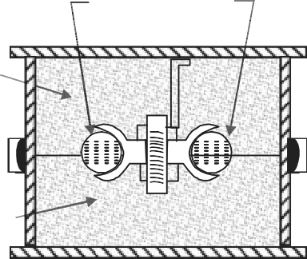

Dry sand core

e

Drag

**Fig. 5.3:** Dry Sand Core Method of Moulding

* 1. Dry Sand Core Method

This method of moulding is widely used for small wheels or pulleys with grooved rims and for shrouded gearing. The groove in the rim of a pulley, as shown in Fig.5.3 may be produced by placing dry sand cores (usually dried oil sand) in groove while moulding.

CASTING 113

* 1. Cover Core Method

Dovetail face



Bottom face

(C)

Cover core

(a )



Drag



(b)

**Fig. 5.4:** Cover Core Method of Moulding

(c)

A cover core is a flat core used to cover the cavity in the mould. Fig 5.4(a) shows the pattern of a steam hammer block which has to be cast face downwards.

Firstly, the drag is rammed up with dovetail face of the pattern downward with a cover placed at each dovetail recesses, as shown in Fig 5.4(b). The drag is now rolled over, cover removed and the patter is withdrawn. The cover cores are then replaced in position, as shown in Fig.5.4(c).

## GATING SYSTEM

The passage-way which serves to deliver the molten metal into the mould cavity is known as gating system. A gating system, as shown in fig-5.5 consists of the following parts,

1. A pouring cup which is funnel shape opening in the upper surface of the cope above the sprue. It minimizes the splash and turbulence and promotes the entry of the clean metal only into the down sprue. In order to prevent the entry of dirt or slag into the downsprue, the pouring basin is provided with a skin core, strainer core, delay screen or a sprue plug.
2. A down gate or sprue which is a vertical opening (usually tubular) through the cope.
3. A runner which receives the metal from the down sprue and distributes to several gate passage ways around the mould cavity. A runner may be used in large castings.
4. An ingate is an opening (usually horizontal) which carries the metal from the runner to the mould cavity.

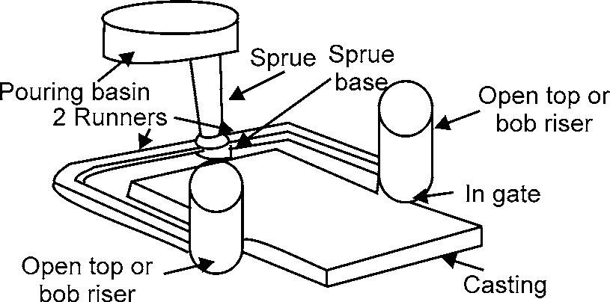

**Fig. 5.5:** Typical Gating System

Any gating system designed should aim at providing a defect free casting. This can be achieved by making provision for certain requirement while designing the gating. These are as follows:

1. The mould should be completely filled in the smallest time possible without having to raise metal temperature nor use higher metal heads.

[www.EngineeringEBooksPdf.com](http://www.EngineeringEBooksPdf.com/)

114 MANUFACTURING PROCESSES

1. The metal should flow smoothly into the mould without any turbulence. A turbulent metal flow tends to from dross in the mould.
2. Unwanted material such as slag, dross and other mould material should not be allowed to enter the mould cavity.
3. The metal entry into the mould cavity should properly controlled in such a way that aspiration of the atmospheric air is prevented.
4. A proper thermal gradient should be maintained so that the casting is cooled without any shrinkage cavities or distortions.
5. Metal flow should be maintained in such a way that no gating or mould erosion takes place.
6. The gating system should ensure that enough molten metal reaches the mould cavity. The gating system design should be economical and easy to implement and remove after casting solidification.
7. The gating system design should be economical and easy to implement

To have all these requirements together is a tall order, still a mould designer should strive to achieve as many of the above objective as possible. Before going into the mechanics of gating design, let as describe some of the functions and types of the various gating system elements.

### Elements of a Gating System

Gating systems refer to all those elements which are connected with the flow of molten metal from the ladle to the mould cavity. The various elements that are connected with a gating system are:

* pouring basin
* sprue
* sprue base well
* runner
* runner extension
* ingate
* riser

###### Pouring Basin

The molten metal is not directly poured into the mould cavity because it may cause mould erosion. Molten metal is poured into a pouring basin which acts as a reservoir from which it moves smoothly into the sprue. The pouring basin is also able to stop the slag from entering the mould cavity by means of a skimmer or skim core as shown Fig. 5.6(a), it holds back the slag and dirt which floats on the top and only allows the clean metal underneath it into the sprue. The pouring basin may be cut into the cope portion directly or a separate dry sand pouring basin may be prepared and used as show in fig. 5.6(b). The molten metal in the pouring basin should be full during the pouring operation. Oth- erwise, a funnel is likely to form through which atmospheric air and slag may enter the mould cavity.

CASTING 115

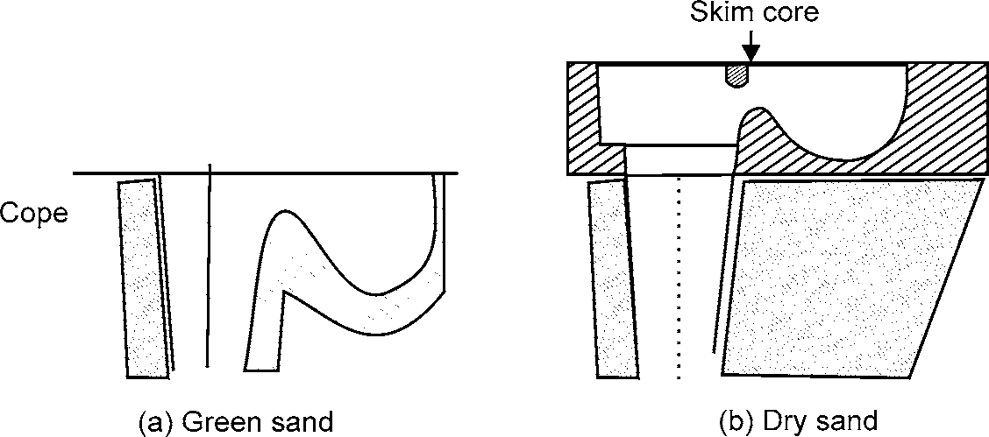

**Fig. 5.6:** Pouring Basin

One of the walls of the pouring basin is made inclined at about 45° to the horizontal. Molten metal is poured on this face such that metal momentum is absorbed and vortex formation is avoided. In some special cases the pouring basin may consist of partitions to allow for the trapping of the slag and maintaining constant metal height in the basin.

###### Sprue

Sprue is the channel through which the molten metal is brought into the parting plane where it enters the runners and gates to ultimately reach the mould cavity. The molten metal when moving from top of the cope to the parting plan gains in velocity and as a consequence requires a smaller area of cross section for the same amount of metal to flow at the top. If the sprue were to be straight cylindrical as shown in Fig. 5.7 then the metal flow would not be full at the bottom, but some low pressure area would be created around the metal in the sprue. Since the sand mould is permeable, atmospheric air would be breathed into this low pressure area which would then be carried to the mould cavity. To eliminate this problem of air aspiration the sprue is tapered to gradually reduce the cross-section as in moves away from the top of the cope as shown in Fig. 5.8

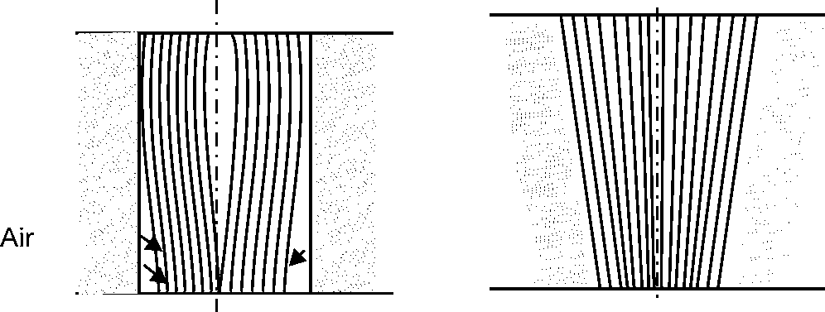

**Fig. 5.7:** Straight Spure **Fig. 5.8:** Tapered Spure

###### Sprue Base Well

This is a reservoir for metal at the bottom of the sprue to reduce the momentum of the molten metal. The molten metal as it moves down the sprue gains in velocity, some of which is lost in the sprue base well by which the mould erosion is reduced. This molten metal then changes direction and flows into the runners in a more uniform way.

###### Runner

It is generally located in the horizontal plane (parting plane) which connects the sprue to its ingates, thus letting the metal enter the mould cavity. The runners are normally made trap-

116 MANUFACTURING PROCESSES

ezoidal in cross section. It is a general practice for ferrous metals to cut the runners in the cope and the ingates in the drag.



Slag Runner



**Fig. 5.9:** Runner Full **Fig. 5.10:** Runner Partially Full

The main reason for this is to trap the slag and dross which are lighter and thus trapped in the upper portion of the runners. For effective trapping of the slag, runners should flow full as shown in Fig 5.9. When the amount of molten metal coming from the down sprue is more than the amount flowing through the ingates, the runner would always be full and thus slag trapping would take place. But when the metal flowing through the ingates is more than the flowing through the runners, then the runner would be filled only partially as shown in Fig 5.10 and the slag would then enter the mould cavity.

###### Runner Extension

The runner is extended a little further after it encounters the ingate. This extension is pro- vided to trap the slag in the molten metal. The molten initially comes along with the slag floating at the top of the ladle and this flow straight, going beyond the ingate and then trapped in the runner extension.

###### Gates

Also called the ingates, these are the opening through which the molten metal enters the mould cavity. The shape and the cross-section of the ingate should be such that it can readily be broken off after casting solidification and also allow the metal to enter quietly into the mould cavity.

Depending on the application, various types of gates are used in the casting design. They

are:

**Top gate:** This is the type of gating through which is the molten metal enters the mould

cavity from the top as shown in Fig 5.11. Since the first metal entering the gate reaches the bottom and hotter metal is at the top. A favourable temperature gradient towards the gate is filled very quickly. But as the metal falls directly into the mould cavity through a height, it is likely to cause mould erosion. Also because it causes turbulence in the mould cavity, it is prone to form dross and as such top gate is not advisable for those materials which are likely to form excessive dross.

CASTING 117

Pouring cup Strainer core

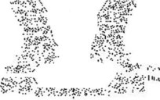

Mould cavity

*P*L

Cope Drag

**Fig. 5.11:** Top Gate

It is not suggested for non-ferrous material and is suggested only for ferrous alloys. It is suitable only for simple casting shape which is essentially shallow in nature. To reduce the mould erosion pencil gates are provided in the pouring cup. This type of gate requires minimum of additional runners to lead the liquid metal into the cavity, and as such provides higher casting yield.

**Bottom gate:** The gates which enter into the mould cavity near the bottom of the drag are called bottom drag. It is particularly used for to avoid or reduce erosion and gas entrapment and to prevent splashing, as shown in Fig 5.12(a)

**Horn gate:** A horn gate, as shown in Fig 5.12 (b) is a type of bottom gate. There is one disadvantage in its use that it has a tendency of producing a fountain effect in the casting. However, it is a means of bottom gating without the necessity of a core for the gate.

Cope



Cope

D



Flat gate

rag

Bottom gate

Drag

Cross runner

Finger gate

* 1. Bottom Gate

Horn gate

* 1. Horn Gate

**Fig. 5.12**

* 1. Branch Gate

**Branch gate:** A branch gate, as shown in Fig.5.12(c), is designed either to feed a single casting at several points or a number of individual casting.

## DEFECTS IN CASTING AND REMEDIES

The defects in a casting may be due to pattern and moulding box equipment, moulding sand, cores, gating system or molten metal. Some of the defects and their reason are discussed below:

1. **Mould shift:** It results in a mismatching of the top and bottom parts of a casting, usually at the parting line. It occurs due to following reasons:
   1. Misalignment of pattern parts, due to worn or damaged pattern, and
   2. Misalignment of moulding box or flask equipment.

This defect can be prevented by ensuring proper alignment of the pattern, moulding boxes, correct mounting of pattern on pattern plates.

118 MANUFACTURING PROCESSES

1. **Core shift:** It is an abnormal variation of the dimensions which are dependent on core position. It is caused by
   1. Misalignment of cores in assembling cored-moulds,
   2. Undersized or oversized core prints, and
   3. By using incorrect size of chaplet.

This defect can be eliminated by providing the core at the proper place and must be gripped properly in the sand.

1. **Swell:** It is an enlargement of the mould cavity by molten metal pressure resulting in localized or general enlargement of the casting.

It is due to the following reasons:

* 1. Insufficient ramming of sand,
  2. Insufficient weighting if the mould during casting, and
  3. Pouring of molten metal too rapidly or too hard.

The swells are avoided by the proper ramming of sand and uniform flow of molten metal into the mould.

1. **Fins and flash:** These are thin projections of metal not intended as a part of casting. These usually occur at the parting line of the mould or core sections. These are caused by:
   1. Excessive rapping of the pattern before it is withdrawn from the mould,
   2. Insufficient weight on the top part of the mould, and
   3. Loose clamping of the mould.

In order to avoid defect, sufficient weight should be placed on the top part of the mould so that the two parts fit tightly together.

1. **Sand wash:** It usually occurs near the ingates as rough lumps on the surface of a casting. The sand that has been washed away appears on the upper surfaces of the casting as rough holes or depressions. This is due to the following reasons:
   1. Soft ramming of sand,
   2. Weak sand,
   3. Poor pattern, and
   4. Insufficient draft.

This defect is avoided by the proper ramming of sand.

1. **Shrinkage:** It is crake in the casting or dishing on the surface of a casting which results from unequal contraction of the metal during solidification. This is due to the following reasons:
   1. Improper location and size of gates and runner,
   2. Inadequate risers,
   3. Lack of directional solidification,
   4. Incorrect metal composition, and
   5. Incorrect pouring temperatures.

CASTING 119

This defect can be eliminated by the use of feeders and chills at proper locations to promote directional solidification.

1. **Hot tear:** It is an internal or external ragged discontinuity in the metal casting resulting from hindered contraction occurring just after the metal has solidified. This defect is due to the following reasons:
   1. Abrupt changes in section, inadequate filleting of inside corners, and improper placement of chills.
   2. Poor collapsibility of mould and core material which will place extra stress on certain details.
   3. Improper pouring temperature.

In order to eliminate this defect, abrupt changes in section should be avoided. The pouring temperature should be correct and there should be even rate of cooling.

1. **Sand blow or blow hole:** It is an excessively smooth depression and the outer surface of a casting. This defect is also called blow hole. This defect is due to the following reasons:
   1. High moisture content in moulding sand,
   2. Low permeability of sand,
   3. Hard ramming of sand,
   4. Defective gating system, and
   5. Improper venting of sand.

This defect can be removed by proper venting, completely drying up the mould, selecting proper sand with required permeability and proper in-gate system for the flow of molten metal.

1. **Core blow:** It is an excessively smooth depression on the inner surface of a cored cavity or a gas pocket immediately above a cored cavity. This defect is caused by using insufficient baked cores.

Thus, cores should be baked sufficiently before using.

1. **Honeycombing or slag holes:** These are smooth depressions on the upper surface of the casting. They usually occur near the ingates. This defect is due to imperfect skimming of the metal or due to poor metal.

This defect can be avoided by preventing the slag from entering along with the molten metal.

1. **Scabs:** These are patches (i.e., slightly raised areas) of sand on the upper surface of casting. This defect is due to the following reasons:
   1. Uneven ramming of sand, and
   2. Slow or intermittent running of metal.

The proper ramming of sand and uniform flow of the molten metal into the mould can eliminate this defect. Another method to remove this defect is to mix additives such as wood flour, sea coal or dextrin into the sand.

120 MANUFACTURING PROCESSES

1. **Cold shuts and misruns:** These occur when the mould cavity is not completely filled and an incomplete casting result. This defect is due to the following reasons:
   1. Too small gates,
   2. Too many restrictions in the gating system,
   3. Pouring head is too low,
   4. Faulty venting of the moulds, and
   5. Metal lacking in fluidity.

In order to eliminate these defects, the casting should be designed keeping in mind the fundamental principles of gating and risering. The thin sections should be preheated and the molten metal should be poured at the correct temperature.

1. **Pour short:** It occurs when the mould cavity is not completely filled because of insuf- ficient metal. It is due to the following reasons:
   1. Interruptions during pouring operation, and
   2. Insufficient metal in the ladles being used to pour the metal.

In order to avoid this defect, the ladle should have sufficient molten metal at the correct temperature.

1. **Metal penetration:** It occurs when the alloy being cast tends to penetrate into sand grains and causes a fused aggregate of metal and sand on the surface of the casting. It is due to the following reasons:
   1. Soft rammed sand,
   2. Moulding sand and core sand being too coarse,
   3. Improper use of mould and core washes will cause penetration, and
   4. Excessive metal temperature or increased fluidity of metal.

This defect can be eliminated by removing the above mentioned reasons.

1. **Run-outs and bust-outs:** These permit drainage of the metal from the cavity and re- sult in incomplete castings. These are due to the following reasons:
   1. A pattern that is too large for a given flask or pattern placed too close to the flask edge results in a weak spot and cause run-out,
   2. The match plate surface that are out of parallel or uneven results in a poorly formed parting line and cause run-out,
   3. Inadequate mould weights or clamps will permit the cope to lift which results a run- out,
   4. Improper sealing of mould joints causes run-out,
   5. Excessive pouring pressures may cause run-out, and
   6. Misalignment of cope and drag may promote a run-out.

The corrective measures taken in respect of the above reasons will prevent this defect.

1. **Rough surface finish:** It is merely a lack of sufficient smoothness in the casting. It is due to the following reasons:
   1. Soft ramming of sand,

CASTING 121

* 1. Coarser sand,
  2. Hard pouring or too high metal fluidity, and
  3. Improper use of mould and core washes often promote rough casting surface. This defect can be avoided by using a proper mould and ramming of sand.

1. **Crush:** It is an irregularly shaped cavity or projection on the castings caused by the displacement of the sand at the mould joints or core prints, which usually occurs when the mould is being closed. It occurs due to the following reasons:
   1. Badly made mould joints,
   2. Excessive pressure on the sand surface, and
   3. Too large cores or too small core prints.

This defect can be eliminated by taking proper care in placing the cope over the drag. The sand in the cope should be rammed properly.

1. **Warpage:** It is unintentional and undesirable deformation that occurs during or after so- lidification. It is due to the following reasons:
   1. Continuous large flat surface on castings, indicating a poor design, and
   2. No directional solidification of casting.

This defect can be eliminated by modifying the casting design and proper directional solidification.

### Melting practices

After moulding, melting is the major factor which controls the quality of the casting. There are a number of methods available for melting foundry alloys such as pit furnace, rotary furnace, cupola furnace etc. the choice of the furnace depend on the amount and the type of alloy being melted. For melting cast iron, cupola in its various forms is extensively used basically because of its lower initial cost and lower melting cost. We will see more details of the cupola in the following article.

## CUPOLA

Cupola consists of a steel shell with its interior lined with heat resisting fire bricks. It consists of drop door at the bottom after closing of which a proper sand bed could be prepared. This sand bed provides the necessary refractory bottom for the molten metal and the coke. Immediately, above the sand bed is the metal tapping hole which is initially closed with clay called “bot” till the molten metal is ready for tapping. Above the metal tap hole normally in a position opposite to it is the slag hole through which the slag generated during the melting process is tapped.

Above the slag hole is the wind box which is connected to the air blowers supplying the requisite air at a given pressure and quantity. The air enters the cupola through the tuyeres. A little above the charging platform is the charging hole in the shell from where the charge consisting of a combination of pig iron, cock and fluxes, is put into the cupola. The refractory lining above the charge door need not necessarily be as that below, since it is not exposed to much heat, as represented in Fig. 5.13.

122 MANUFACTURING PROCESSES

Fire brick lining

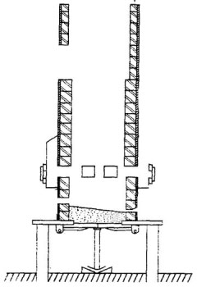

Charging door

Charging platfrom

Sheel Wind box

Tuyere openings

Slag spout

Tapping spout

Drop doors

Sand bottom

Floor level

**Fig. 5.13:** Cross-section of a Cupola

To operate the cupola, first, the drop doors at the bottom are closed and a sand bed with a gentle slope towards the hole is rammed. Then a cock bed of suitable height is prepared above the sand bottom and ignited through the tap of hole or any other hole. When the cock bed is properly ignited, alternate layers of charge, flux and cock are alternately fed into the cupola through the charge door maintaining the necessary proportions and rate of charging. The charge is then allowed to soak in the heat for a while, and the air blast is turned on. Within about 5 to 10 minutes, the molten metal is collected near the tap hole. When enough molten metal is collected in the well of the cupola, the slag is drained off through the slag hole before opening the tap hole. The molten metal is collected in the ladle and then transported to the moulds into which it is poured with a minimum time loss.

The charge needed to produce cast iron, essentially consists of pig iron, cast iron scrap when alloy cast iron is needed. The proportion of these depend on there chemical composition and on the final chemical composition of cast iron desired.

The fluxes are added in the charge to remove the oxides and other impurities present in the metal. The flux most commonly used is lime stone (CaCO3) in a proportion of about 2 to 4% of the metal charge. Some of the other fluxes that may also be used are dolomite, sodium carbonate and calcium carbide. The flux is expected to react with the oxides and form compounds which have low melting point and are also lighter. As a result, the molten slag tends to float on the metal pool and thus, can very easily be separated. Typical operation characteristics of cupola are presented in Table 5.3.

A variation of the cupola is called ‘hot blast cupola’. In this, the air supply is preheated to a temperature of 200 to 4000°C with the help of the hot gases coming out of the stack or by a separate

[www.EngineeringEBooksPdf.com](http://www.EngineeringEBooksPdf.com/)

CASTING 123

heat input. In either case, equipments gates complicate by the addition of the extra preheaters the air circulation equipment. The main advantage gained is that the amount of heat required by the cupola gates reduced. This in turn reduced the contact of the metal of the cock and air thus reducing the carbon and sulphur pickups as well as the oxidation losses. Because of the additional equipment and the extra care needed for operation, the hot blast cupolas are used only in shops that large amount of metal to be metal on a continuous basis.

**Table 5.3:** Cupola operation data

|  |  |  |  |  |  |  |  |  |  |
| --- | --- | --- | --- | --- | --- | --- | --- | --- | --- |
| ***Diameter height***  ***of melting zone, m*** | ***Melting rate tonnes/h, Metal: coke ratio***  ***10.01 08.01m3/h*** | | ***Blast rate kPa*** | ***Blast Pressure*** | ***Typical charge, kg***  ***Coke Iron Limestone*** | | | ***Bad height above from tuyeres, m*** | ***Shaft tuyeres to charge***  ***door sill, m*** |
| 0.50 | 1.97 | 1.57 | 1, 340 | 10.20 | 20 | 200 | 7 | 1.00 | 2.50 |
| 0.60 | 2.84 | 2.46 | 1, 940 | 10.50 | 28 | 284 | 9 | 1.00 | 3.00 |
| 0.80 | 5.11 | 4.36 | 3, 450 | 11.20 | 51 | 510 | 17 | 1.05 | 3.00 |
| 1.00 | 7.99 | 6.83 | 5, 380 | 11.70 | 80 | 800 | 26 | 1.05 | 3.50 |
| 1.20 | 11.50 | 9.79 | 7, 750 | 12.70 | 115 | 1150 | 38 | 1.10 | 4.00 |
| 1.40 | 15.60 | 13.33 | 10,600 | 13.40 | 157 | 1570 | 52 | 1.10 | 4.00 |
| 1.60 | 20.44 | 17.41 | 13,800 | 14.40 | 200 | 2040 | 67 | 1.10 | 4.50 |
| 1.80 | 25.88 | 22.05 | 17,450 | 15.40 | 260 | 2590 | 85 | 1.15 | 5.00 |
| 2.00 | 31.95 | 27.22 | 21,550 | 17.20 | 320 | 3200 | 106 | 1.15 | 5.00 |

**Charge Calculations:** It is very important in the foundry to know the final composition of the metal being obtained, so as to control it properly. The elements in the final analysis are essentially the sum total of what is contained in each of the charge ingredients, with some losses or pick up in the cupola. Out of the various elements, the ones that are relevant are carbon, silicon, manganese and sulphur.

As the charge comes through the coke bed, some amount of carbon is picked up by the metal depending on the temperature and the time when the metal is in contact with the coke. However, it may be reasonable to assume a pick-up of the order of 0.15% carbon.

Silicon is likely to get oxidized in the cupola and therefore, a loss of 10% of total silicon contained in the charge of normal. Under the worst condition, it may go as high as 30%. If the silicon content in the charge is not high, extra silicon can be added by inoculating the metal in the ladle with Ferro silicon.

Manganese is also likely to be lost in the melting process. The loss could be of the order of 15 to 20%. Loss of manganese in the final analysis, can be made up by the addition of ferromanganese.

Similar to carbon, sulphur is also likely to be picked up from cock during melting. The pick- up depends on the sulphur content of the cock, but a reasonable estimate could be 0.03 to 0.05%.

Examples are presented below for estimating the final analysis of the melt.

124 MANUFACTURING PROCESSES

###### Example 1.3

Estimate the final composition of the cast iron produced with the following charge compositions and proportions.

|  |  |  |  |  |  |
| --- | --- | --- | --- | --- | --- |
| ***Carbon %*** | ***Silicon %*** | ***Mangmanese %*** | ***Sulphur %*** | ***Phosphorous %*** | ***Charge %*** |
| Pig iron 13.50 | 2.50 | 0.40 | 0.01 | 0.40 | 40 |
| Pig iron 23.20 | 1.50 | 1.00 | 0.02 | 0.60 | 35 |
| CI scrap 3.20 | 1.20 | 0.50 | 0.10 | 0.40 | 25 |

Let us now analyse the total amount of elements present in 1 tone (1000 kg) of charge, assuming carbon pick-up as 15%, sulphur pick-up 0.05%, silicon loss as 10% and manganese loss as 20%.

|  |  |  |  |  |  |  |  |  |  |
| --- | --- | --- | --- | --- | --- | --- | --- | --- | --- |
| ***Charge mass (kg)*** | | ***Carbon***  ***%*** | ***kg*** | ***Silicon***  ***%*** | ***kg*** | ***Manganese***  ***%*** | ***kg*** | ***Sulphur***  ***%*** | ***kg*** |
| Pig iron 1 400 | | 3.50 | 14 | 2.50 | 10 | 0.40 | 1.60 | 0.01 | 0.04 |
| Pig iron 2 350 | | 3.20 | 11.2 | 1.50 | 5.25 | 1.00 | 3.50 | 0.02 | 0.07 |
| CI scrap 250 | | 3.20 | 8 | 1.20 | 3 | 0.50 | 1.25 | 0.10 | 0.25 |
| **Total** | **1000** | **33.2** | | **18.25** | | **6.35** | | **0.36** | |
| Charge, % | | 3.32 | | 1.825 | | 0.635 | | 0.036 | |
| Change in cupola | | + 0.15 | | – 0.183 | | – 0.127 | | + 0.050 | |
| Final analysis | | 3.47 | | 1.642 | | 0.508 | | 0.086 | |

The foundry engineer can actually control his final analysis by trying with various mixes of charge materials available in his foundry to obtain an economical melt. The following example presents one such case.

###### Example 1.4

In a foundry, it was required to obtain a cast metal with the following composition: carbon 3.10 to 3.60%; silicon 2.30 to 2.60%; manganese 0.60 to 0.80%; sulphur 0.08% maximum; and phosphorous

0.40 to 0.60%. If the following raw materials are available, estimate the best charge proportions.

|  |  |  |  |  |  |
| --- | --- | --- | --- | --- | --- |
|  | ***Carbon*** | ***Silicon*** | ***Manganese*** | ***Sulphur*** | ***Phosphorous*** |
| Pig iron 1 | 3.50 | 3.00 | 1.00 | 0.02 | 0.40 |
| Pig iron 2 | 3.20 | 1.50 | 0.50 | 0.01 | 0.80 |
| Pig iron 3 | 3.50 | 2.50 | 0.80 | 0.02 | 0.50 |
| Scrap 1 | 3.50 | 1.80 | 0.60 | 0.08 | 0.50 |
| Scrap 2 | 3.20 | 1.20 | 0.60 | 0.10 | 0.40 |
| Ferro silicon |  | 50.00 |  |  |  |

Looking at the raw materials available, pig iron 2 has got very low silicon content, and therefore it should not be used. Similarly, the scrap 2 which has low silicon and high sulphur may also be eliminated. So, the final choice are the pig iron 1 and 3 and scrap 1. Let the charge be of 40 of scrap with the pig irons in equal proportions of 30% each.

Let us do the analysis for 1000 kg with the carbon pick-up assumed as 0.15%, sulphur as 0.05%, the oxidation losses of silicon as 10% and that of manganese as 20%.

|  |  |  |  |  |  |  |  |  |  |  |
| --- | --- | --- | --- | --- | --- | --- | --- | --- | --- | --- |
| CASTING | | 125 | | | | | | | | |
|  | |  | | | | | | | | |
| ***Charge mass*** | | ***Carbon*** | |  | ***Silicon*** | ***Manganese*** | |  | ***Sulphur*** | |
| ***Kg*** | | ***% kg*** | | ***%*** | ***kg*** | ***% kg*** | | ***%*** | ***kg*** | |
| Pig iron1 300 | | 3.50 | 10.5 | 3.00 | 9.00 | 1.00 | 3.00 | 0.02 | | 0.06 |
| Pig iron 3 300 | | 3.50 | 10.5 | 2.50 | 7.50 | 0.80 | 2.40 | 0.02 | | 0.06 |
| Scrap 1 400 | | 3.50 | 14.0 | 1.80 | 7.20 | 0.60 | 2.40 | 0.08 | | 0.32 |
| Total | 1000 | 35.0 | | 23.70 | | 7.80 | | 0.44 | | |
| Charge % | | 3.50 | | 2.37 | | 0.78 | | 0.044 | | |
| Change in cupola | | + 0.15 | | – 0.237 | | – 0.156 | | + 0.05 | | |
| Final | | 3.65 | | 2.133 | | 0.624 | | 0.094 | | |
| Required max | | 3.2 to 3.6 | | 2.3 to 2.6 | | 0.6 to 0.8 | | 0.08 | | |

With the chosen change composition, the final analysis differs from the required one with carbon, silicon and sulphur percentages. To reduce the carbon and sulphur percentages, we may have to use pig iron 2 which may reduce the silicon percentage but that can be made up by adding suitable amount of ferrosilicon.

The reduction in sulphur that could be achieved by the addition of one kg of pig iron 2 for scrap 1 is

0.08 – 0.01

100 = 0.0007 kg

The reduction in carbon that could be achieved by the addition of one kg pig iron 2 for scrap 1 is

The excess sulphur present in 1000 kg is

1000  (0.094 – 0.080)

100

The excess carbon present in 1000 kg is

1000  (3.65 – 3.60)

100

= 0.14 Kg

= 0.50 Kg

To reduce the sulphur to the desirable limit, the amount of pig iron 2 to be substituted is

0.14

0.0007 = 200 Kg

To reduce the carbon to the desired limit, the amount of pig iron 2 to be substituted is

0.50

0.003 = 167 Kg

Hence, substitution of 200 kg pig iron would be sufficient to give the desired analysis. To confirm this let us do a fresh analysis,

126 MANUFACTURING PROCESSES

|  |  |  |  |  |  |  |  |  |  |
| --- | --- | --- | --- | --- | --- | --- | --- | --- | --- |
| **Charge mass, Carbon Silicon Manganese Sulphur Kg % kg % kg % kg % kg** | | | | | | | | | |
| Pig iron 1 | 300 | 3.50 | 10.50 | 3.00 | 9.00 | 1.00 | 3.00 | 0.02 | 0.06 |
| Pig iron 2 | 200 | 3.20 | 6.40 | 1.50 | 3.00 | 0.50 | 1.00 | 0.01 | 0.02 |
| Pig iron 3 | 300 | 3.50 | 10.50 | 2.50 | 7.50 | 0.80 | 2.40 | 0.02 | 0.06 |
| Scrap 1 | 200 | 3.50 | 7.00 | 1.80 | 3.60 | 0.06 | 1.20 | 0.08 | 0.16 |
| Total | 1000 |  | 34.4 |  | 23.10 |  | 7.60 |  | 0.30 |
| Charge % |  |  | 3.44 |  | 2.31 |  | 0.76 |  | 0.03 |
| Change in |  |  |  |  |  |  |  |  |  |
| Cupola |  |  | +0.15 |  | –0.231 |  | –0.152 |  | + 0.05 |
| Final |  |  | 3.59 |  | 2.079 |  | 0.608 |  | 0.08 |
| Desired max |  |  | 3.2 – 3.6 |  | 2.3– 2.6 |  | 0.6–0.8 |  | 0.08 |

It is not possible to increase silicon any further and, therefore, the only way out is to add ferrosilicon of requisite amount to make up the short fall.

Amount of silicon to be added for 1000 kg is

1000  2.300 – 2.079

100

= 2.21

This can be made up by adding 5 kg of ferrosilicon in place scrap 1.

5  50.0 –1.80

Extra silicon added =

100

= 2.41 kg

So, the final mix of the charge is

Pig iron 1 = 300 kg = 30 %

Pig iron 2 = 200 kg = 20 %

Pig iron 3 = 300 kg = 30 %

Scrap 1 = 195 kg = 19.5 % Ferro silicon = 5 kg = 0.5 %

In the previous example, we have proceeded with a trail and error method and have not considered the cost of various constituents of the charge. A more appropriate analysis would be to take into account the cost of each of the constituents of the charge and the chemical compositions. This can be done by formulating the linear programming problem and solving it by the simplex method.

## DIE CASTING

The die casting (also known as pressure die casting) may be defined as that casting which uses the permanent mould (called die) and the molten metal is introduced into it by means of pressure. The casting produced by die casting method require very little machining. The dies are usually made in two parts which must be locked securely before molten metal is forced into then under high pressures of 7 to 700 MPa. The pressure may be obtained by the application of compressed air or by hydraulically operated piston. The ferrous alloys are not yet commercially die-casted because of their high pouring temperature.



CASTING 127

Following are the two types of die casting machines commonly used for die casting.

###### Hot Chamber Die Casting Machine

The hot chamber die casting machine of the submerged type is shown in Fig 5.14. The molten metal is forced in the die cavity at pressures from 7 to 14 MPa. The pressure may be obtained by the application of compressed air, as shown in Fig 5.14(a) or by a hydraulically operated plunger, as shown in Fig 5.14 (b).

Air

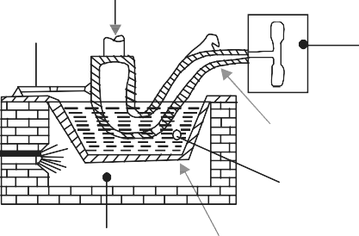

Operating link

Goose neck

Metal

Die

Firebox Metal pot

* 1. Operated by Direct Air Pressure

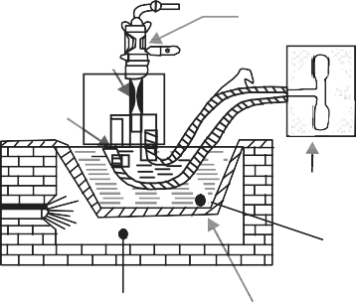Hydraulic cylinder

Plunger Port

Die

Metal

Firebox Metal pot

* 1. Operated by Hydraulically Operated Plunger.

**Fig. 5.14:** Hot Chamber Die Casting Machine

In the first method, the goose neck is lowered into the molten metal for filling it. It is then raised and connected to the die neck. A suitable mechanism is provided to raise and lower the goose neck. The compressed air at a pressure of about 2.5 to 5 MPa is now injected into the goose neck to force the molten metal into the die.

In the second method, the plunger acts inside a cylinder formed at the end of the goose neck, which is immersed in a pot of molten metal. A port is provided near the top of the cylinder to allow the entry of the molten metal. The downward stroke of the plunger pushes the molten metal through the goose neck into the die.

The hot chamber die casting machine is used for casting zinc, tin lead and other low melting alloys.



128 MANUFACTURING PROCESSES

###### Cold Chamber Die Casting Machine

Movable die

Core

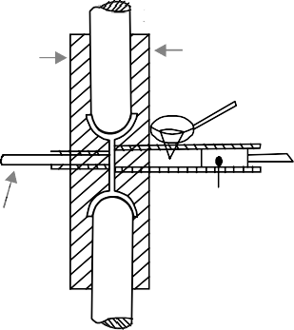Stationary die

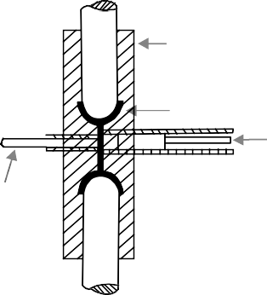Stationary die

Die casting

Ejector

Plunger

Ejector

(a) (b)

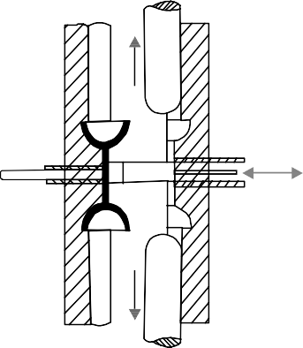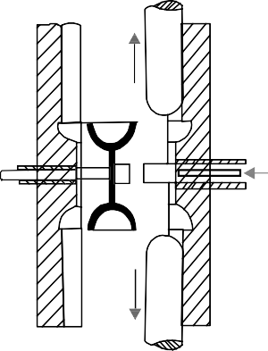

* 1. (d)

**Fig. 5.15:** Cold Chamber Die Casting Machine

In cold chamber die casting machine, the melting unit is usually separate and molten metal is transferred to injection mechanism by ladle. The pressure on the casting metal in cold chamber die casting machine may vary from 21 to 210MPa and in some cases may reach 700MPa. The greater pressures are required for semi-molten alloys to compensate for reduced fluidity resulting from low pouring temperatures. This process is used for casting aluminum, magnesium, copper base alloys and other high melting alloys. The cold chamber die-casting machine, as shown in Fig.5.15 (a), consists of a pressure chamber of cylindrical shape fitted with a piston or ram that is usually operated by hydraulic pressure. A measured quantity of molten metal is brought in a ladle form the melting pot to a chamber and forced into the closed die sections by applying hydraulic pressure upon the piston. The complete cycle is completed in the following four steps:

1. The metal is loaded in the chamber.
2. The plunger forces the metal into the die cavity, as shown in Fig.5.15 (b)
3. After the metal solidifies, the die is opened, as shown in Fig.5.15(c)
4. The casting, together with the slag of the excess metal is ejected form the die, as shown in Fig. 5.15 (d)

CASTING 129

Following are the advantages and disadvantages of die casting:

###### Advantages

1. The rapid and economical production of large quantities of identical parts can be achieved.
2. The parts having smooth surfaces and close dimensional tolerances may be produced, very little machining is required.
3. The pars having thin and complex shapes can be casted accurately and easily.
4. The die casting requires less floor area than is required by other casting processes.
5. The castings produced by die-casting process are less defective, owing to increased casting soundness.
6. The rapid cooling rate produced high strength and quality in many alloys.
7. The inserts, if required, can be casted easily in desired places.
8. The die retains its trueness and life for longer periods. For example, the life of a die for zinc base casting is up to one million castings, for copper base alloys up to 75,000 castings, and for aluminum base alloys up to 50,000 castings.

###### Disadvantages

1. The cost of equipment and die is high.
2. There is a limited range of non-ferrous alloys which can be used for die castings.
3. The die castings are limited in size.
4. It requires special skill in maintenance.

# OBJECTIVE QUESTIONS

1. An instrument to study the behaviour of moulding sand at high temperature
   1. Dilatometer (b) Pointometer

(c) Cinometer (d) None

1. The property of sand due to which it evolves a great amount of steam and other gases is called
   1. Permeability (b) Cohesiveness

(c) Adhesiveness (d) None

1. Green sand is a mixture of
   1. 30% sand and 70% clay (b) 50% sand and 50% clay

(c) 70% sand and 30% clay (d) 90% sand and 10% clay

1. The sand used for making cores is
   1. Oil sand (b) Loam sand

(c) Dry sand (d) None

1. Cores are used to
   1. Form internal cavities in the casting (b) Improve mould surface

(c) Form a part of a green sand mould (d) None

130 MANUFACTURING PROCESSES

1. Mould shift causes by
   1. Improper design of casting (b) Faulty riser design

(c) Improper use of chills (d) All of these

1. A casting defect which occur near the ingates as rough lumps
   1. Shift (b) Sand wash

(c) Swell (d) Scab

1. A casting defect which results in general enlargement of casting is known as
   1. Shift (b) Sand wash

(c) Swell (d) Scab

**ANSWERS**

|  |  |  |  |
| --- | --- | --- | --- |
| 1. (a) | 2. (b) | 3. (c) | 4. (a) |
| 5. (d) | 6. (d) | 7. (b) | 8. (c) |

# SHORT ANSWER QUESTIONS

1. Give cause and remedies of Hot tear casting defect. May-04
2. Briefly describe with neat sketch, process and applications of
   1. Die casting May-02
   2. Centrifugal casting May-02
3. What is draft allowance? How is it provided for patters?
4. Briefly discuss why draft allowance is important for pattern.
5. Explain the following,

(a) Permeability (b) Cohesiveness

(c) Adhesiveness and (d) Collapsibility

1. What do the various elements that comprise the gating system? What are the functions served by the pouring basin in a sand casting?
2. Explain why a sprue should be tapered?
3. Explain the defects in casting with their reasons. How these defects can be prevented?
4. What are advantages and disadvantages of die casting?

# LONG ANSWER QUESTIONS

1. Describe the various kinds of patterns in use. What are the allowances provided, When making a pattern? How do the patterns differ from the casting required. May-03

CASTING 131

1. Describe desirable properties of a moulding sand, and state what defects can arise due to absence /flack of these. Also mention other casting defect possible. May-02
2. Name the pattern allowances which can be quantitatively specified. Write brief note on each of them.
3. Describe the allowances given on pattern for shaking and distortion.
4. A cast iron cylinder of 450 mm out side diameter, 75 mm inside diameter,150 mm long is to be obtained by sand casting. Design requisite pattern assuming that the internal hole is to be finished by machining.
5. A master aluminium pattern is to be cast using a wooden pattern for hollow steel cylindrical piece with a flange of width 50 mm and diameter 250 mm. The cylindrical portion is 200 mm long with an outer diameter 150 mm and an inner diameter of 75 mm. If the face of the flange is to be machined, design the wooden pattern.
6. Sketch and describe the working of a hot chamber and cold chamber die casting machines.
7. Describe the operation of a cupola furnace for melting cast iron.
8. On a particular day, an iron foundry prepared the charge for cupola as 20% pig iron-1,25% pig iron-2,and 55% scrap iron. Find the final composition of the product melt, given the following composition for the charge elements. Assume suitable losses or gains in the cupola.

|  |  |  |  |  |  |
| --- | --- | --- | --- | --- | --- |
|  | **Carbon** | **%** | **Silicon %** | **Manganese %** | **Sulphur %** |
| Pig iron-1 | 3.20 |  | 1.70 | 0.80 | 0.03 |
| Pig iron-2 | 3.50 |  | 2.40 | 0.60 | 0.01 |
| Scrap iron | 3.25 |  | 2.30 | 0.65 | 0.08 |

❍ ❍

[www.EngineeringEBooksPdf.com](http://www.EngineeringEBooksPdf.com/)

**This page**

**intentionally left blank**

**MACHINING**

6

* 1. **LATHE: INTRODUCTION**

A lathe is probably the oldest machine tool, stemming from the early tree lathe, which was turned by a rope passed around the work a few times and attached to a sparingly branch overhead. The work was supported by two dowels struck in adjacent trees. The operator’s foot supplied the motion, which was intermittent and fluctuating. The tool was held in the operator’s hand. Later a strip of wood called a “lath” was used to support the rope and hence named as Lathe. From this crude beginning and over period of more than two centuries, the modern engine lathe has evolved. Until about 1770, lathes were useless for metal cutting because they lacked power and a holding device strong enough and accurate enough to guide the tool. For its development to the form in which we know it now, we owe much to Henry Mauldsley, who developed the sliding carriage and in 1800 built a screw cutting lathe. Nowadays, it has become a general purpose machine tool, employed in production and repair work, because it permits a large variety of operations to be performed on it.

* 1. **BASIC WORKING PRINCIPLE OF LATHE MACHINE**

Lathe removes undesired material from a rotating work piece in the form of chips with the help of a tool which is traversed across the work and can be fed deep in work. The tool material should be harder than the work piece and the latter held securely and rigidly on the machine. The tool may be given linear motion in any direction. A lathe is used principally to produce cylindrical surfaces and plane surface, at right angles to the axis of rotation. It can also produce tapers and bellows etc. Operation of turning is done on parts as small as those used by watches to huge parts weighing several tons.

A lathe basically consists of a bed to provide support, a headstock, a cross slide to traverse the tool, a tool post mounted on the cross slide. The spindle is driven by a motor through a gear box to obtain a range of speeds. The carriage moves over the bed guide ways parallel to the work piece and the cross slide provides the transverse motion. A feed shaft and lead screw are also provided to power the carriage and for cutting the threads respectively.

134 MANUFACTURING PROCESSES

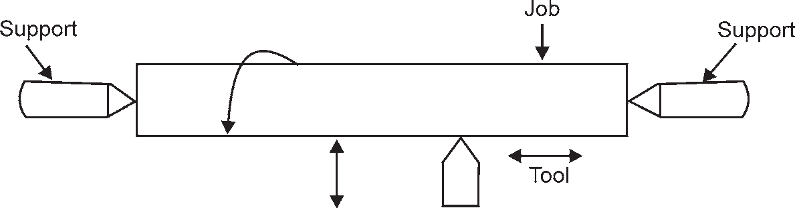

**Fig. 6.1**

* 1. **OPERATIONS PERFORMED ON LATHE MACHINE**

Th

|  |  |  |
| --- | --- | --- |
| e most common operations which can be performed on the lathe are | | |
| 1. Facing, | 2. | Turning, |
| 3.Taper turning, | 4. | Eccentric turning, |
| 5. Boring, drilling, | 6. | Reaming, |
| 7. Threading, | 8. | Knurling, and |
| 9. Scroll cutting etc. |  |  |
| In addition to it, with the help of special attachments, operations like | | |
| 1. Keyway cutting, | 2. | Cam and gear cutting, |
| 3. Shaping, | 4. | Milling, |
| 5. Fluting, and | 6. | Grinding can also be performed on this machine |
| These operations are discussed as follows: | | |

* + 1. **Facing**

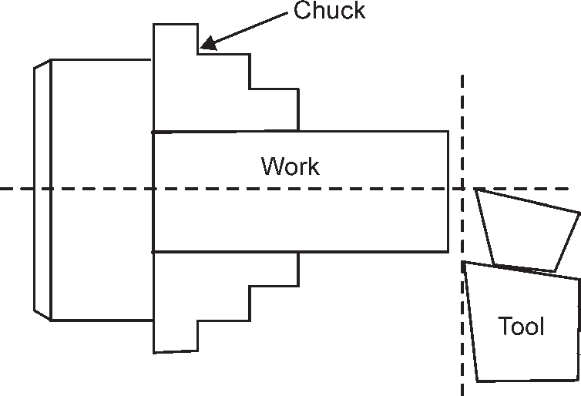

**Fig. 6.2:** Facing

This operation is almost essential for all works. In this operation, as shown in Fig. 6.2, the work piece is held in the chuck and the facing tool is fed from the centre of the work piece towards the outer surface or from the outer surface to the centre, with the help of a cross-slide.

* + 1. **Plain Turning**

It is an operation of removing excess amount of material from the surface of the cylindrical work piece. In this operation, as shown in Fig. 6.3 the work is held either in the chuck or between centres and the longitudinal feed is given to the tool either by hand or power.

MACHINING 135

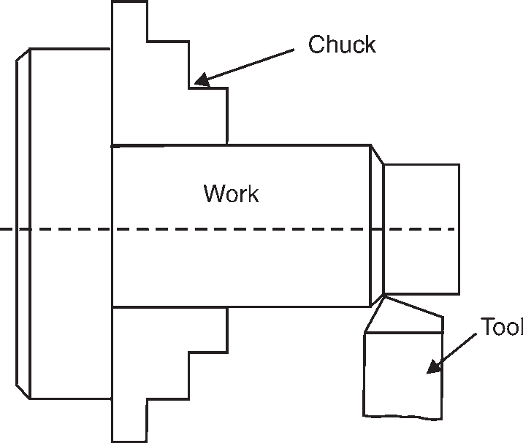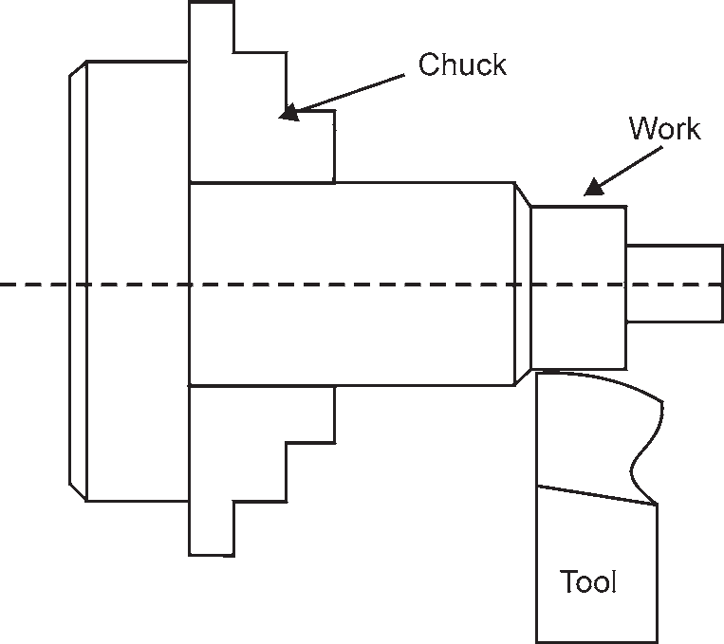

**Fig. 6.3:** Plain turning **Fig. 6.4:** Step turning

* + 1. **Step Turning**

It is an operation of producing various steps of different diameters in the workpiece, as shown in Fig. 6.4 This operation is carried out in the similar way as plain turning.

* + 1. **Taper Turning**

It is an operation of producing an external conical surface on a work piece. A small taper may be produced with the help of a forming tool or chamfering tool, but the larger tapers are produced by swiveling the compound rest, as shown in Fig. 6.5 at the required angle or by offsetting the tailstock or by taper turning attachment.

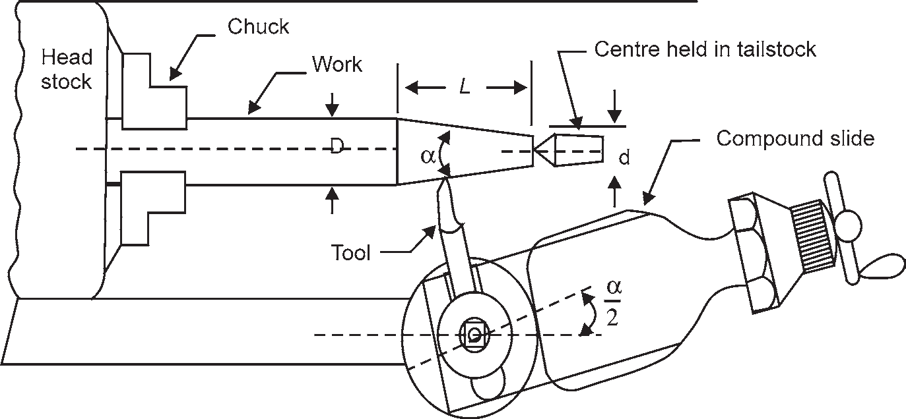

**Fig. 6.5:** Taper turning

Note. If *D* is the larger diameter, *d* is the smaller diameter and *L* is the length of taper, as shown in Fig. 6.5, then

Taper =  *D*  *d*

*L*

136 MANUFACTURING PROCESSES

* + 1. **Drilling**

It is an operation of making a hole in a work piece with the help of a drill. In this operation, as shown in Fig. 6.6, the work piece is held in a chuck and the drill is held in the tailstock. The drill is fed manually, in to the rotating work piece, by rotating the tailstock hand wheel.

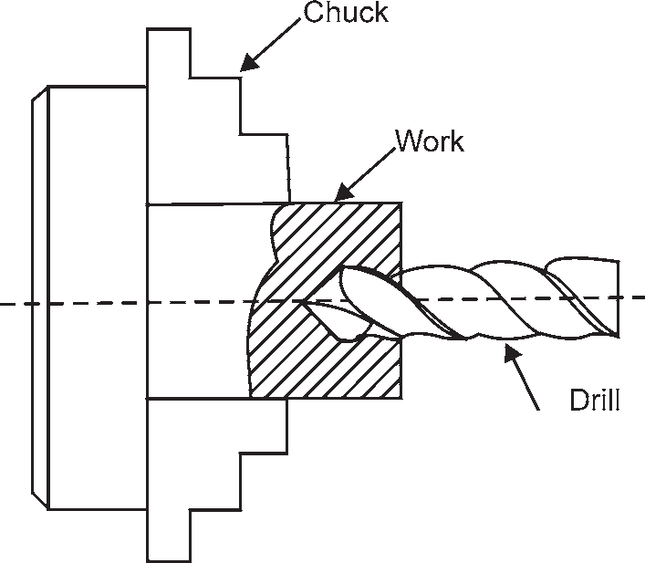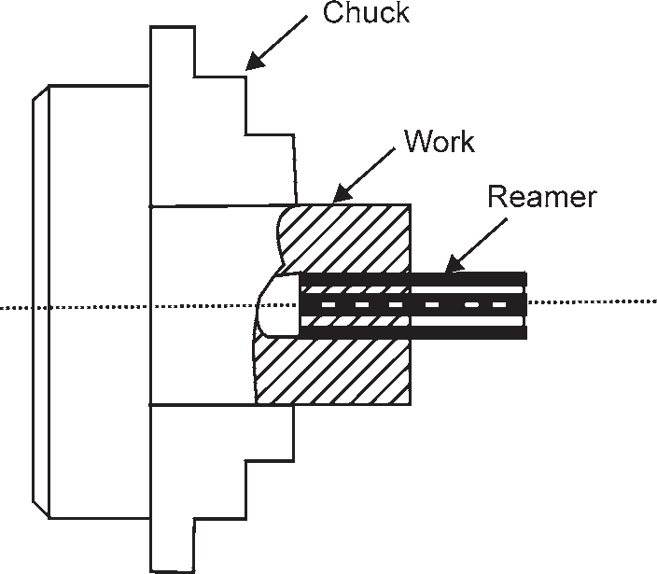

* + 1. **Reaming**

**Fig. 6.6:** Drilling **Fig. 6.7:** Reaming

It is an operation of finishing the previously drilled hole. In this operation, as shown in Fig. 6.7, a reamer is held in the tailstock and it is fed into the hole in the similar way as for drilling.

* + 1. **Boring**

It is an operation of enlarging of a hole already made in a work piece. In this operation, as shown in Fig. 6.8, a boring tool or a bit mounted on a rigid bar is held in the tool post and fed into the work by hand or power in the similar way as for turning.

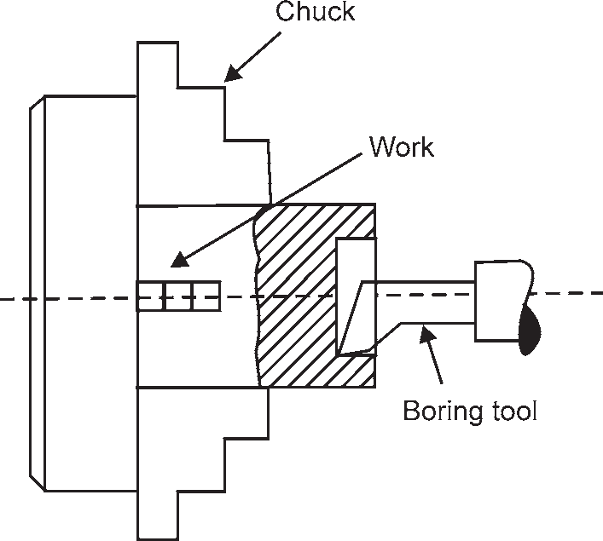

**Fig. 6.8:** Boring

MACHINING 137

* + 1. **Undercutting or Grooving**

It is an operation of reducing the diameter of a work piece over a very narrow surface. In this operation, as shown in Fig. 6.9 a tool of appropriate shape is fed into the revolving work up to the desired depth at right angles to the centre line of the work piece.

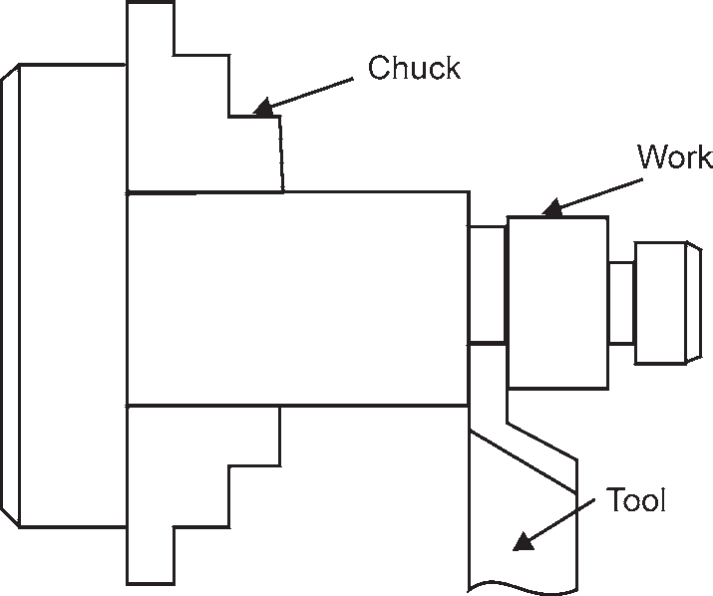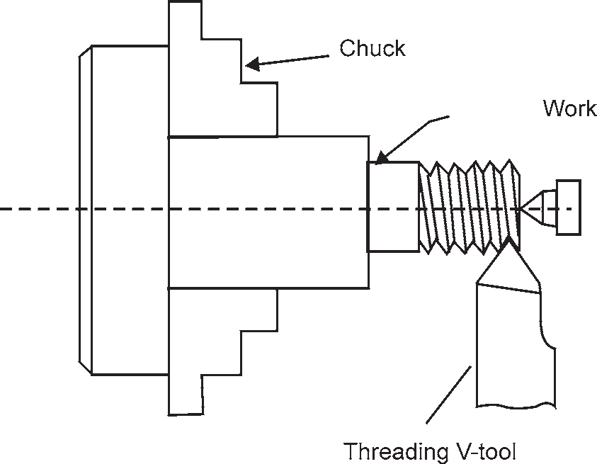

**Fig. 6.9:** Undercutting **Fig. 6.10:** Threading

* + 1. **Threading**

It is an operation of cutting helical grooves on the external cylindrical surface of work piece. In this operation, as shown in Fig 6.10 the work is held in a chuck or between centres and the threading tool is fed longitudinally to the revolving work. The longitudinal feed is equal to the Ditch of the thread to be cut.

* + 1. **Knurling**

It is an operation of providing knurled surface on the work piece. In this operation, as shown in Fig. 6.11, a knurled tool is moved longitudinally to a revolving work piece surface. The projections on the knurled tool reproduce depressions on the work surface.

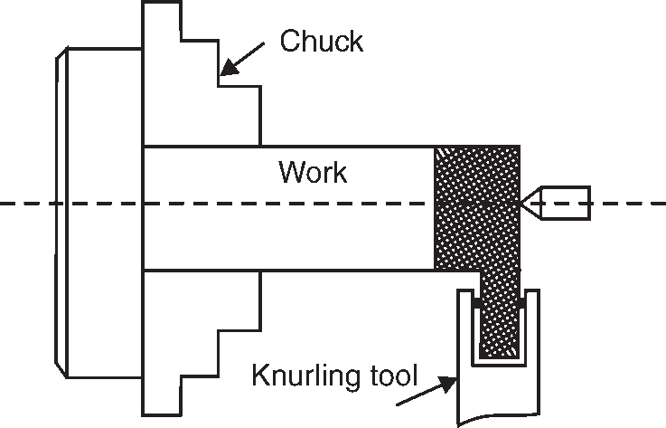

**Fig. 6.11:** Knurling

138 MANUFACTURING PROCESSES

* 1. **TERMS USED IN LATHE MACHINING**

The following terms are commonly used while machining a work piece on lathe.

1. **Cutting speed:** It is defined as the speed at which the metal is removed by the tool from the work piece. In other words, it is the peripheral speed of the work past the cutting tool. It is usually expressed in meters per minute.
2. **Feed:** It is defined as the distance which the tool advances for each revolution of the work. It is usually expressed in millimeters.
3. **Depth of cut:** It is defined as the depth of penetration of the tool into the work piece during machining. In other words, it is the perpendicular distance measured from the machined surface to the unmachined surface of the work piece. It is usually expressed in millimeters.
   1. **SHAPER**

The shaper (also called shaping machine) is a reciprocating type of machine tool used for producing small flat surfaces with the help of a single point tool reciprocating over the stationary work piece. The flat surface may be horizontal, inclined or vertical. The reciprocating motion of the tool is obtained either by the crank and slotted lever quick return motion mechanism or Whitworth quick return motion mechanism.

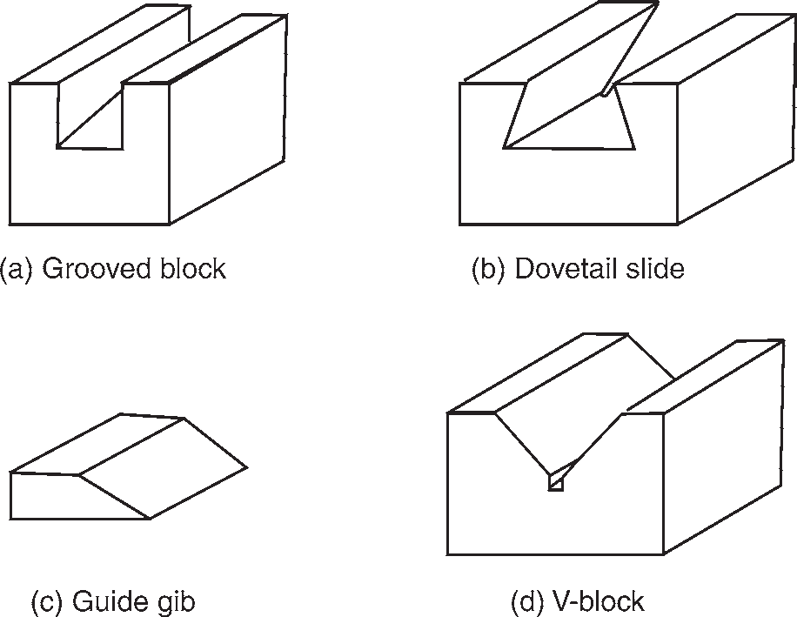

**Fig. 6.12:** Parts produced on a shaper

* + 1. **Principal Parts of a Shaper**

The principal parts of a shaper, as shown in Fig. 6.13 are as follows:

* + - 1. **Base:** It is a heavy structure of cast iron which supports other parts of a shaper.
      2. **Column:** It is a box-like structure made up of cast iron and mounted upon the base. It contains the driving mechanism and is provided with two machined guide ways on the top of it on which the ram reciprocates.
      3. **Ram:** It is a reciprocating member which reciprocates on the guide ways provided above the column. It carries a tool-slide on its head and a mechanism for adjusting the stroke length.

[www.EngineeringEBooksPdf.com](http://www.EngineeringEBooksPdf.com/)

MACHINING 139

* + - 1. **Tool head:** It is attached to the front portion of the ram with the help of a nut and a bolt. It is used to hold the tool rigidly, it also provides the vertical and angular movements to the tool for cutting.
      2. **Cross-rail:** It is attached to the front vertical portion of the column. It is used for the following two purposes:
         1. It helps in elevating the table over the column in the upward direction, and
         2. The table can be moved in a direction perpendicular to the axis of the ram over this cross rail.

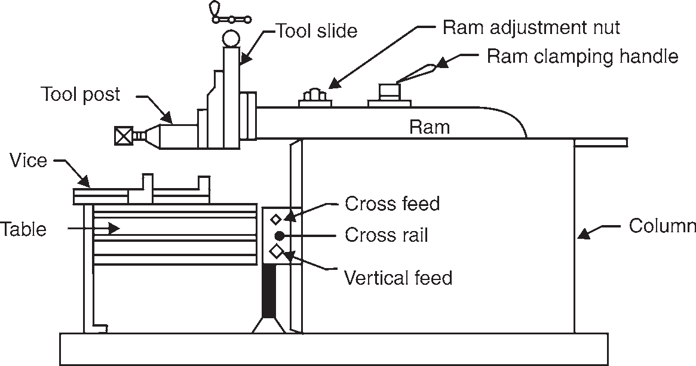

**Fig. 6.13:** Principal Parts of a Shaper

* + - 1. **Table:** It is used for holding the work piece. It can be adjusted horizontally and vertically with the help of spindles.
    1. **Working Principle and Operation of a Shaper**

We have already discussed that in a shaper, a single point cutting tool reciprocates over the stationary work piece. The tool is held in the tool post of the reciprocating ram and performs the cutting operation during its forward stroke. It may be noted that during the backward stroke of the ram, the tool does not remove material from the work piece. Both these strokes (i.e., forward and backward strokes) form one working cycle of the shaper.

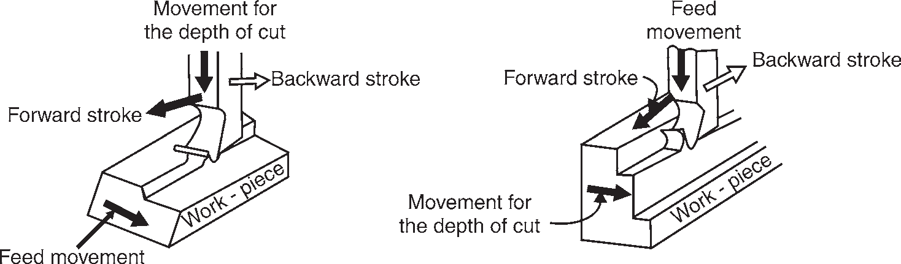

(a) Shaping in Horizontal Direction (b) Shaping in Vertical Direction

**Fig. 6.14:** Working Principle and Operation of a Shaper

140 MANUFACTURING PROCESSES

For shaping in horizontal direction, as shown in Fig, 6.14(a), the clamped work piece is fed against the reciprocating tool after every cutting cycle. The depth of cut is adjusted by moving the tool downward towards the work piece. For shaping in vertical direction, as shown in Fig. 6.14(b). The tool is fed vertically towards the work piece after every cutting cycle. The depth of cut is adjusted by moving the work piece sideways.

* + 1. **Classifications of Shapers**

The shapers are classified as follows:

1. According to the ram driving mechanism

According to the ram driving mechanism, the shapers are classified as follows:

* 1. **Crank shaper:** In a crank shaper, a crank and a slotted lever quick return motion mechanism is used to give reciprocating motion to the ram. The crank arm is adjustable and is arranged inside the body of a bull gear (also called crank gear).
  2. **Geared shaper:** In a geared shaper, the ram carries a rack below it, which is driven by a spur gear. This type of shaper is not widely used.
  3. **Hydraulic shaper:** In a hydraulic shaper, a hydraulic system is used to drive the ram. This type of shaper is more efficient than the crank and geared shaper.

1. According to position and travel of ram

According to the position and travel of ram, the shapers are classified as follows:

* 1. **Horizontal shaper:** In a horizontal shaper, the ram moves or reciprocates in a horizontal direction. This type of shaper is mainly used for producing flat surfaces.
  2. **Vertical shaper:** In a vertical shaper, the ram reciprocates vertically in the downward as well as in upward direction. This type of shaper is very convenient for machining internal surfaces, keyways, slots or grooves.

1. According to the direction of cutting stroke

According to the direction of cutting stroke, the shapers are classified as follows:

* 1. **Push-Cut shaper:** In a push-cut shaper, the ram pushes the tool across the work during cutting operation. In other words, forward stroke is the cutting stroke and the backward stroke is an idle stroke. This is the most general type of shaper used in common practice.
  2. **Draw-cut shaper:** In a draw-cut shaper, the ram draws or pulls the tool across the work during cutting operation. In other words, the backward stroke is the cutting stroke and forward stroke is an idle stroke.

1. According to the design of the table

According to the design of the table, the shapers are classified as:

* 1. **Standard or plain shaper:** In a standard or plain shaper, the table has only two movements i.e., horizontal and vertical, to give the feed. It can not be swiveled or tilted.
  2. **Universal shaper:** In a universal shaper, in addition to the above two movements, the table can be swiveled about a horizontal axis parallel to the ram and the upper portion of the table

MACHINING 141

can be tilted about the other horizontal axis perpendicular to the first axis. This type of shaper is mostly used in tool room work.

* + 1. **Specifications of a Shaper**

The shaper is specified as follows :

* + - 1. Maximum length of stroke is millimeters,
      2. Size of the table, i.e., length, width and depth of the table,
      3. Maximum vertical and horizontal travel of the table,
      4. Maximum number of strokes per minute,
      5. Power of the drive motor,
      6. Type of quick return mechanism.
      7. Floor space required, and
      8. Weight.
  1. **PLANER**

The planer (also called planing machine) is a machine tool used to produce plane and flat surface by a single point cutting tool. It is similar to a shaper but its size is very large and is adopted for producing flat surfaces of much larger work than a shaper. The fundamental difference between a planer and shaper is that in a planer, the tool remains stationary and the work reciprocates whereas in the shaper, the work remains stationary and the tool reciprocates.

* + 1. **Types of Planers**

The various types of planers commonly used are

* + - 1. Standard or double housing planer,
      2. Open side planer,
      3. Pit planer,
      4. Edge or plate planer, and
      5. Divided table planer.

Of all the above types of planers, the standard or double housing planer is most widely used in workshops. In this type of planer, as shown in Fig. 6.15, there are two housings (or columns), one on each side of the table. The housings are connected at the top by a cast iron support. The table reciprocates on accurate guide ways provided on a long heavy bed. The two tool heads which carry the tool are mounted on the cross rails. These tools may be fed either by hand or by power in crosswise or vertical direction.

142 MANUFACTURING PROCESSES

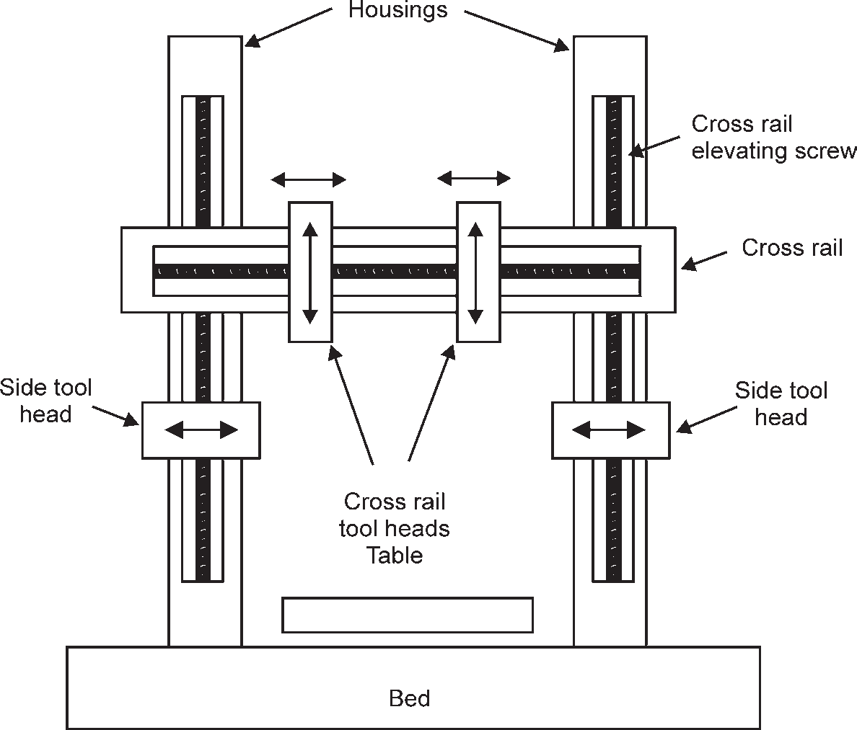

**Fig. 6.15:** Standards or double housing planer

In large planers, there are four tool heads, two on the cross rails and one each on the vertical face of the housings. They can also be moved either in a vertical or horizontal direction to apply the feed. All the four tool heads may be controlled and operated individually. On large work, all the tool heads are often operated simultaneously.

* + 1. **Principal Parts of a Planer**

The principal parts of a double housing planer, as shown in Fig. 6.16, are as follows:

* + - 1. **Bed:** The bed of a planer is a box like casting having cross ribs. It provides the foun- dation for the machine and supports the housing and all other moving parts. The up- per part of the bed is provided with precision Vee type guide ways on which the table slides.
      2. **Table:** The planer table is a heavy rectangular precision machined casting. It reciprocates along the ways of the bed and supports the work. The top face of the table is provided with T-slots and holes uniformly spaced for fixing the work and work holding devices over the table with the help of T-bolts, clamps etc. The table may be driven by rack and gear, by rack and double helical gear or by hydraulic system.
      3. **Housing:** The housings are rigid column-like castings placed on each side of the bed. The front face of the housings is accurately machined to provide precision ways. The hous- ings enclose the cross-rail elevating screws, vertical and cross-feed screws for the tool heads, counter balancing weights for the cross-rail etc.

MACHINING 143

* + - 1. **Cross-rail:** The cross-rail is mounted on the precision machined ways of the two housings. It may be raised or lowered on the housings to accommodate work of different heights on the table and to allow for the adjustment of the tools.
      2. **Tool heads:** The tool heads are mounted on the cross-rail or housings by means of a saddle which slides along the rail or housing ways. The saddle may be made to move transversely on the cross-rail to give cross feed. Two tool heads are provided on the cross-rail so that the two tools may remove the material from the work simultaneously. In addition to these two-tool heads, there are other two-tool heads which are mounted on each housing.
    1. **Size and Specifications of a Planer**

The planer size is generally given by the following:

* + - 1. Width of the table in mm,
      2. Maximum distance of the table to the cross-rail in meters, and
      3. Maximum stroke of the table in mm.

For example, a standard or double housing planer of size 750 mm × 350 mm × 2.5 m means that a planer can machine a work of width 750 mm, height 350 mm and length 2.5 m. The double housing planers are also available in size up to 3000 mm × 3000 mm × 18.25 m.

In addition to the above planer size, the following particulars are also given to specify the planer :

1. Length of bed,
2. Length of the table,
3. Type of drive,
4. Power of the motor, and
5. Number of speed and feed etc.
   * 1. **Planer Tools**

The planer tools are mostly made of high speed steel. The cemented carbide tipped tools are also used on planers for production work. The planer tools are similar to those used on shaper, but, as the depth of cut are heavier and cutting strokes are large, the planer tools are large in size. A planer tool many be classified as roughing or finishing and right hand or left hand type, Fig. 6.16 shows the various types of tools used on planers.

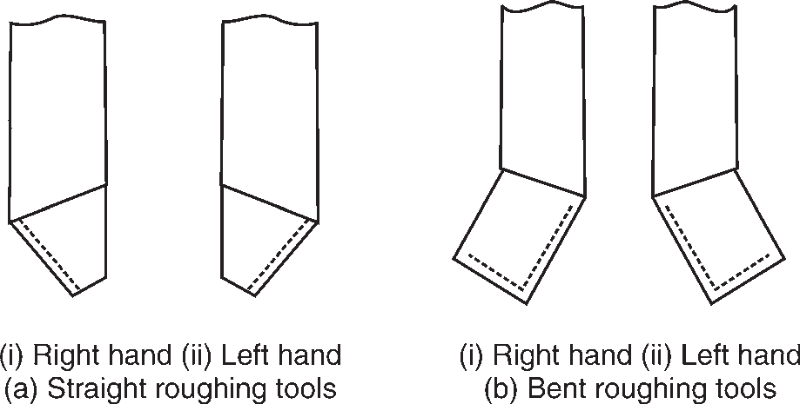

144 MANUFACTURING PROCESSES

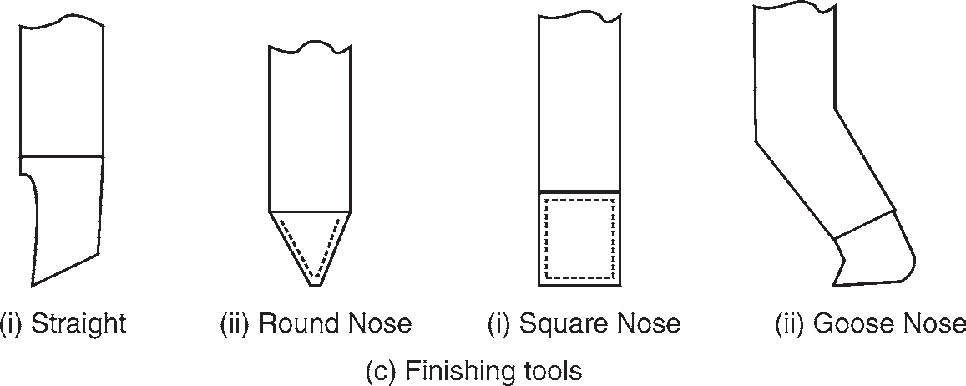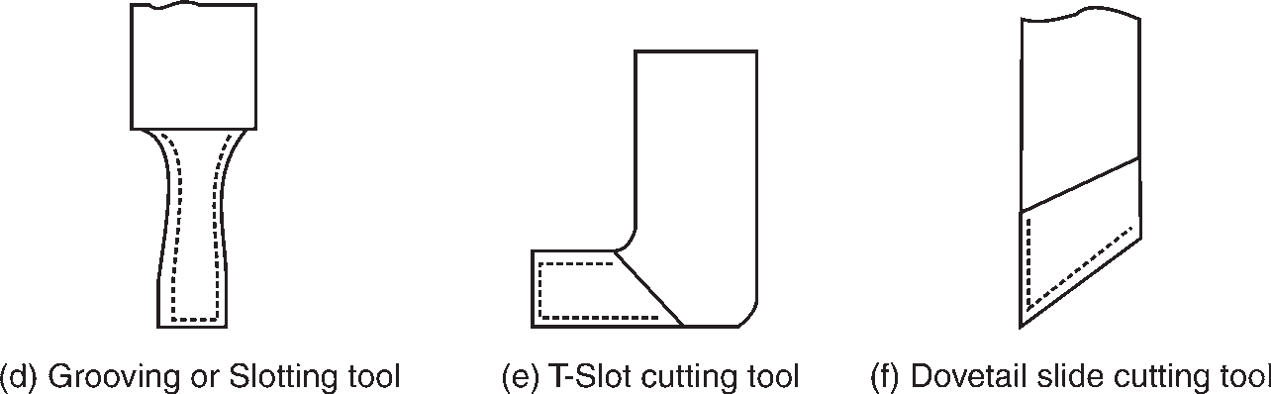

* + 1. **Work-holding Devices**

**Fig. 6.16:** Planer tools

Since the cutting forces in planing a work are quite heavy, therefore, it is essential that the work is connected rigidly to the table so that it does not shift its position during planing. The various work holding devices are vices, step blocks, stops, stop pins, jacks, V-blocks, T-bolts and clamps etc. Some of these devices are shown in Fig. 6.17.

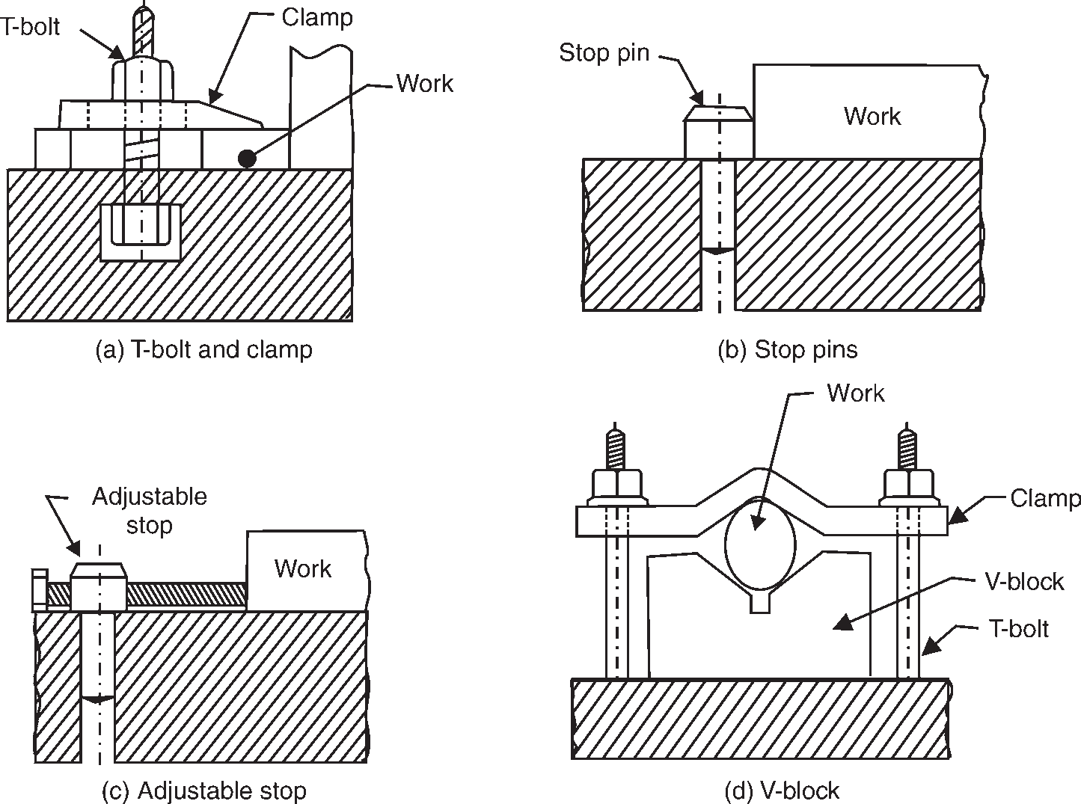

**Fig. 6.17:** Work holding devices for planer

MACHINING 145

* + 1. **Difference between a Planer and a Shaper**

Following are the main differences between a planer and a shaper:

**Planer Shaper**

* + - 1. It is a heavy duty machine tool. 1. It is a light duty machine tool.
      2. It requires more floor area. 2. It requires less floor area.
      3. It is adopted for large works. 3. It is used for small works.
      4. More than one cutting tool can be used at a time. 4. Only one cutting tool is used at a time.
      5. Tool is fixed and work moves. 5. Work is fixed and the tool moves.
      6. Planer table is either driven by gears or by hydraulic means. 6. It is normally driven by crank and slotted lever

quick return motion mechanism.

* + - 1. Heavier feeds are applied. 7. Lighter feeds are applied.
      2. It can take deep cuts. 8. It cannot take deep cuts.
      3. Work setting requires much of skill and takes longer time. 9. Work may be clamped easily and quickly.
      4. Tools used are of larger size. 10. Tools used are of smaller size.
  1. **DRILLING MACHINE**

The basic purpose of a drilling machine is to drill cylindrical holes in work pieces (metallic and non-metallic materials). The holes are cut out of the material with a cutting tool, which is known as drill. The drill is fixed in a rotating spindle and can be fed towards the work piece which may be fixed to the table or to the base of the machine. The speed of the spindle and the feed can be adjusted according to the work piece. Some examples of drilling work are shown in Fig. 6.18.

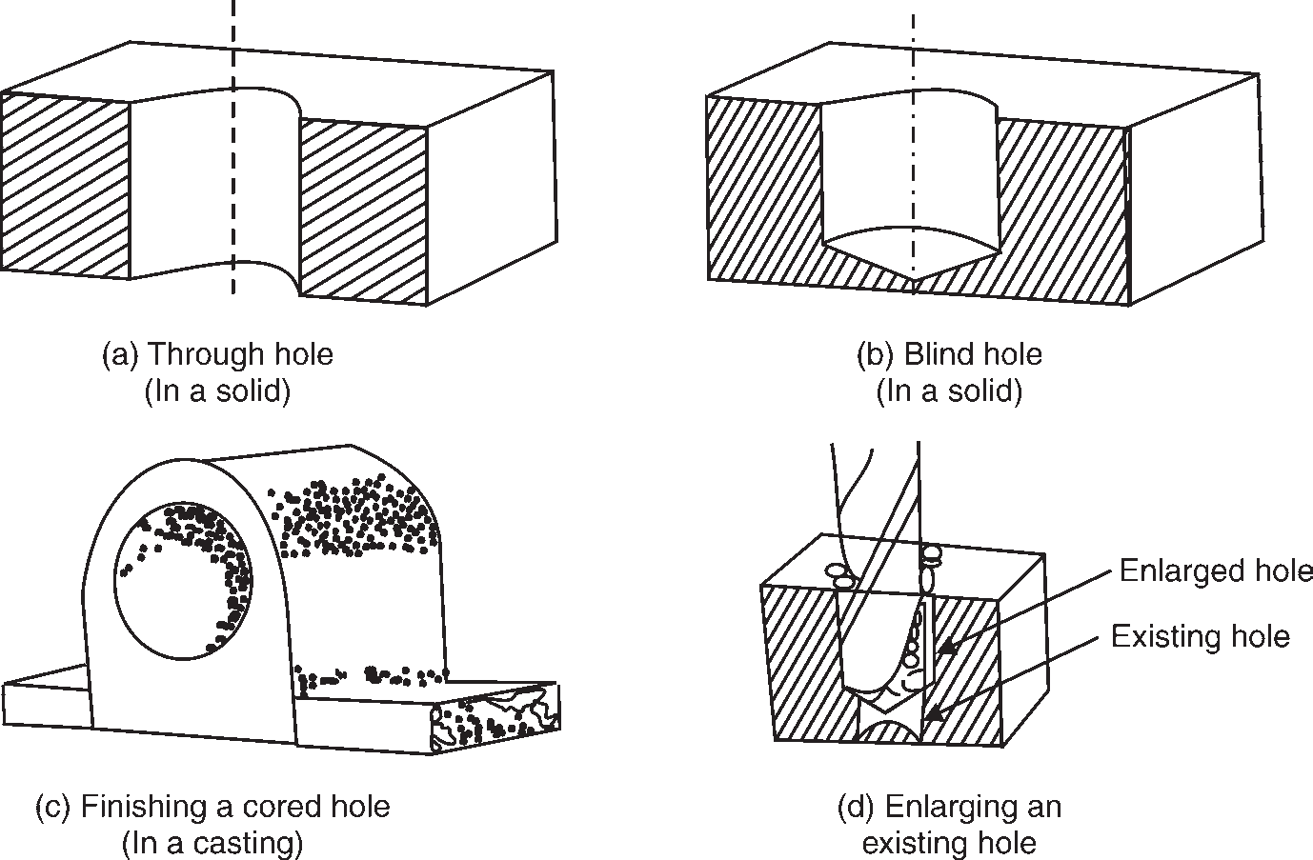

146 MANUFACTURING PROCESSES

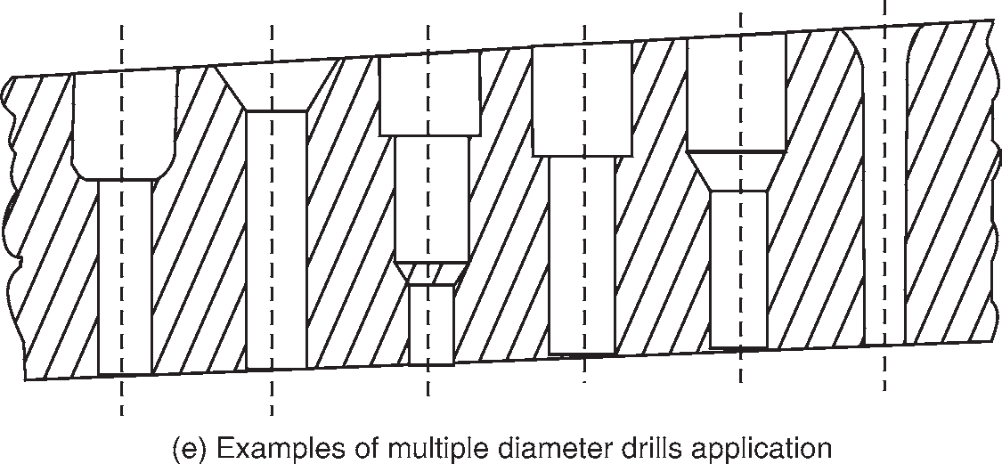

**Fig. 6.18:** Examples of drilling work

* + 1. **Working Principle of a Drilling Machine**

We have already discussed that a metal cutting operation that produces cylindrical holes or enlarges existing holes with an end cutting tool is called as drilling. The end cutting tool used for drilling holes in the work piece is called as twist drill and is provided with two cutting edges. In order to cut off chips, two motions are given to the drill simultaneously as shown in Fig. 6.19.

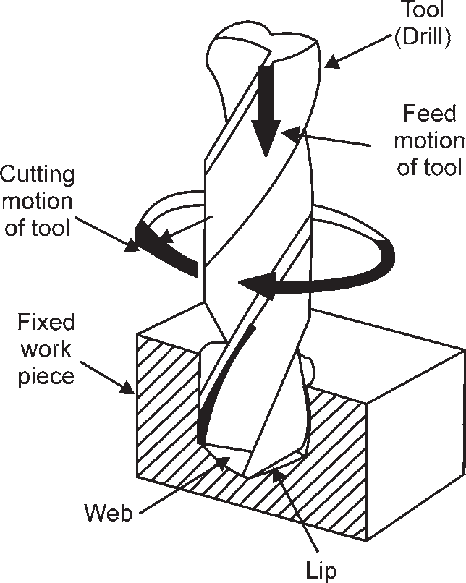

**Fig. 6.19:** Motions of a twist drill

* + - 1. **Rotary motion:** The rotary motion is called as main motion or cutting motion. In some cases, this motion is given to work pieces also (e.g., while drilling on the lathe). The cutting motion is generally measured in m/min. The highest cutting speed is on the periphery of the drill and it decreases towards the centre of the drill.
      2. **Liner motion towards the fixed work piece:** The motion is called as feed and it controls the thickness of the chip. In small bench type drilling machines, instead of giving feed to the drill, the work piece is moved towards the rotating drill by raising the table. The feed is generally measured in mm/rev. As the drill is provided with two cutting edges, the thickness of the chip is half the feed.

MACHINING 147

By the simultaneous double action of cutting (or main motion) and the feed, each cutting edge of the drill describes a spiral and thereby produces a constant flow of chips.

* + 1. **Size of a Drilling Machine**

Portable drilling machines are designated by the maximum diameter of drill they can hold. Sensitive and upright drilling machines are specified by the diameter of the largest work piece that can be accommodated which is twice the clearance between the centre line of the drill and the machine pillar or frame. The size of radial drilling machine is designated by the length of the radial arm and the column diameter.

* + 1. **Specification of a Drilling Machine**

A heavy duty drilling machine is specified by following parameters.

* + - 1. Drilling capacity
      2. Taper in spindle (Morse no.)
      3. Distance between spindle and column (maximum and minimum), in case of radial drilling machine
      4. Transverse of spindle
      5. Minimum distance between spindle and table
      6. Minimum distance between spindle and base plate
      7. Working surface of table (i.e., diameter)
      8. Range of spindle speeds
      9. Range of power feed per revolution
      10. Motor speed, and
      11. Motor power
    1. **Drilling Operations**

The most common operations which can be carried on a drilling machine are drilling, boring,

reaming, tapping,

counter boring, spot facing, and countersinking.

These operations are discussed as follows:

* + - 1. **Drilling:** It is an operation of producing a circular hole in a work piece by forcing a drill against it.
      2. **Boring:** It is an operation of enlarging a hole that has already been drilled by a single point tool, so as to make it we to the required size.
      3. **Reaming:** It is an operation of slightly enlarging a machined hole to proper size with a smooth finish. The reamer is an accurate tool and is not designed to remove much metal. The reaming allowance is usually 0.2 mm only. The reaming tool is shown in Fig. 6.20.

148 MANUFACTURING PROCESSES



**Fig. 6.20:** Reamer

* + - 1. **Tapping:** It is an operation of producing internal threads in a hole by means of a tool called tap. A tap is shown in Fig. 6.21.

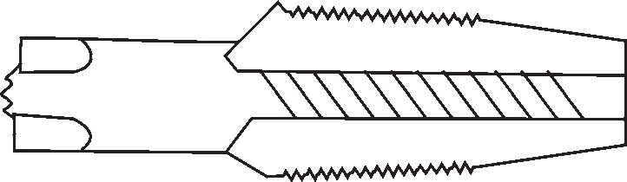

**Fig. 6.21:** Hand Tap

* + - 1. **Counter boring:** It is an operation of enlarging the mouth of a drilled hole to set bolt heads and nuts below the surface so that they may not project out from the surface level. It is done by a counter boring tool as shown in Fig. 6.22 which is similar to an end mill or a single blade ground to give two cutting edges and is guided by a pilot pin which fits into the drilled hole.

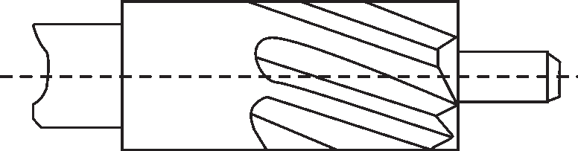

**Fig. 6.22:** Counter Boring Drill

* + - 1. **Spot facing:** It is an operation to finish off a small portion of rough surface around a drilled hole to provide smooth seat for bolt head. Spot facing tool is a single blade; as shown in Fig. 6.23 (which is little larger than the bolt head diameter) ground to give two cutting edges and is guided by a stem which runs in a pilot hole.

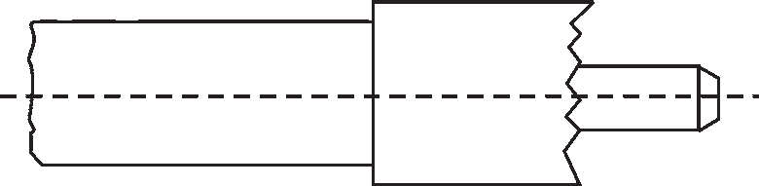

**Fig. 6.23:** Spot Facing Drill

* + - 1. **Counter sinking:** It is an operation to bevel the top of a drilled hole for making a conical seat for a flat head screw. Ordinary flat drill ground to correct angle is used for countersink- ing holes.. A counter sunk drill is shown in Fig. 6.24.

[www.EngineeringEBooksPdf.com](http://www.EngineeringEBooksPdf.com/)

MACHINING 149

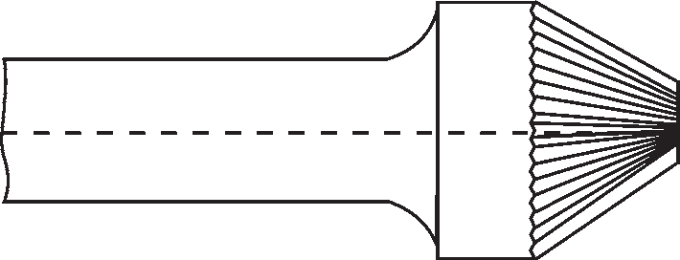

**Fig. 6.24:** Counter Sunk Drill

* 1. **MILLING**

Milling is the machine operation in which the removal of metal from the work piece takes place due to a rotating cutting tool(cutter) when the work is fed past it. The cutter has multiple cutting edges and rotates at a very fast rate. The rotating cutting tool known as the “Milling Cutter” is a multiple point tool having the shape of a solid revolution with cutting teeth arranged either on the periphery or on end or on both. The revolving cutter is held on a spindle or arbor and the work piece is clamped or bolted on the machine table or may be in a vise or a three jaw chuck or an index head held or a rotary table etc. The milling process is employed for producing flat contoured or helical surfaces, for making helical grooves, to cut teeth and toothed gears.

* + 1. **Working Principle of Milling**

Fig 6.25 illustrates the working principle employed in metal removing operation on a milling machine. The job or work piece is rigidly clamped on the table of the machine or in a chuck or an index head and a revolving multiteeth cutter is mounted either on a spindle or an arbor. The job is fed slowly past the cutter. The work can be fed in a vertical, longitudinal or cross direction. With the movement of the work piece, the cutter teeth remove metal from the job in the form of chips to produce the desired shape.

Generally, the size of a milling machine is denoted by the dimension i.e. length and breadth of the table. Other main specifications of the machine or placing an order are the H.P. of the driving motor, number of spindle speeds and feeds, the taper of spindle nose (Whether Morse Taper or Some other Taper) required floor area, gross weight of the m/c etc. Some manufacturers, however, denote these machine sizes by different numbers such as 0, 1, 2, 3, 4, 5 etc.

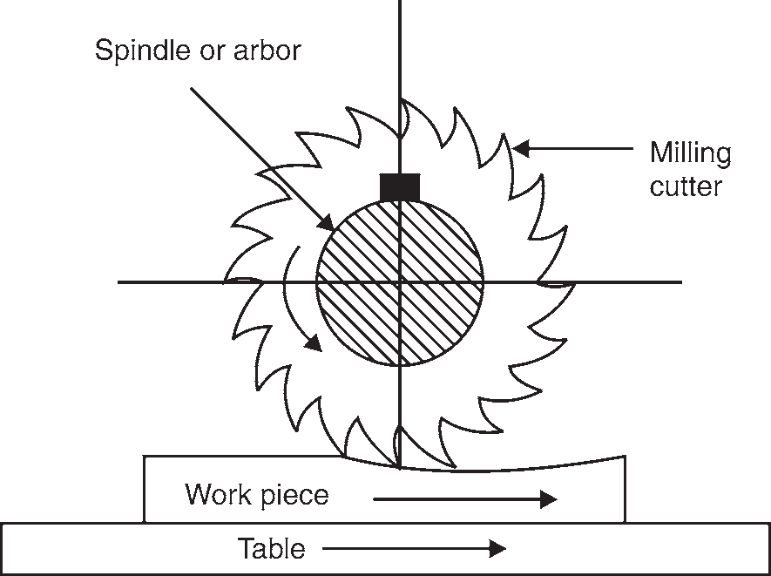

**Fig. 6.25:** Working Principle of Milling Machine

150 MANUFACTURING PROCESSES

* + 1. **Types of Milling Machines**

The milling machines are available in different shapes and sizes. These machines may be classified as follows:

1. Column and knee type milling machines
   1. Horizontal milling machines
   2. Vertical milling machines
   3. Ram type milling machines
2. Bed type milling machines
   1. Manufacturing or fixed bed type milling machines
   2. Horizontal bed type milling machines
   3. Vertical bed type milling machines
3. Planer type milling machines
4. Special purpose milling machines
   1. Rotary table milling machines
   2. Drum type milling machines
   3. Tracer controlled milling machines
   4. Thread milling machine
   5. Key-way milling machine
   6. Skin and spar milling machine
   7. Planetary milling machine

###### Column and Knee Type Milling Machines

These general purpose machines have two main structural elements A vertical column, and

A knee like casting.

The knee which is attached to a vertical column can slide in a vertical direction on the column so that the various heights of work pieces can be accommodated in the work table. The traversal movement of the work table is provided by mounting the table on the saddle which in turn is mounted on the knee. The table which is mounted on the saddle moves at right angles to the saddle. The work piece is positioned and clamped on the table. The horizontal, vertical column and knee type milling machines are illustrated in Figs. 6.26 and 6.27.

* 1. **Horizontal Milling Machines:** These machines can be further classified as plain or universal milling machines.

In a plain milling machine, the table cannot be swiveled in a horizontal plane. The table may be fed in a longitudinal, cross or vertical directions on a plain milling, machine.

In case of universal milling machine, the table can be swiveled up to 45° in a horizontal plane to the right or left. This arrangement makes the angular and helical milling operations by using the universal milling machine.

MACHINING 151

In addition to the three principal movements as incorporated in a plain milling machine, the table can be fed at an angle to the milling cutter.

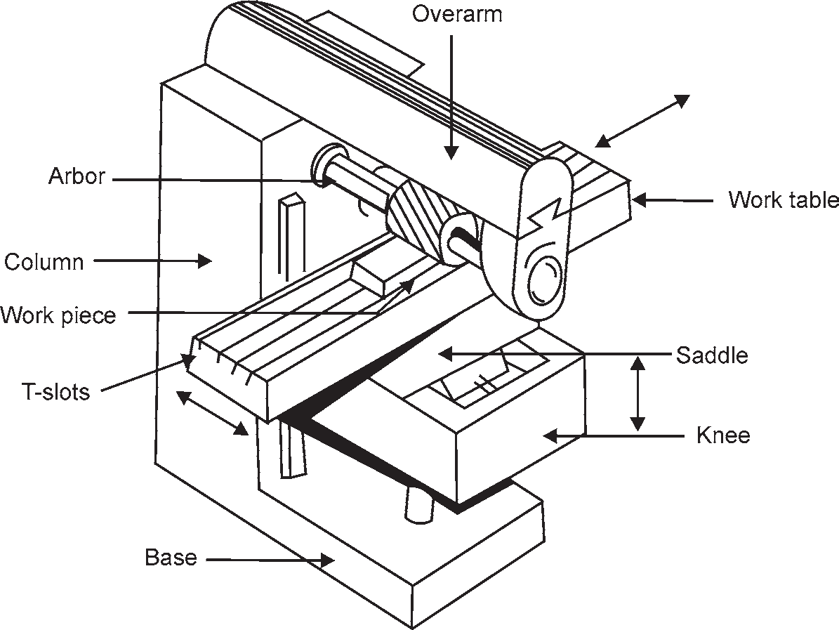

**Fig. 6.26:** Horizontal Spindle Column and Knee Type

* 1. **Vertical Milling Machines:** In vertical knee type milling machines, the position of the cutter spindle is vertical. Though it has the same table movements as in plain milling cutter, the spindle head swivel or it may be a combination of the sliding and swivel head type. These machines are suitable for end milling and face milling operations.

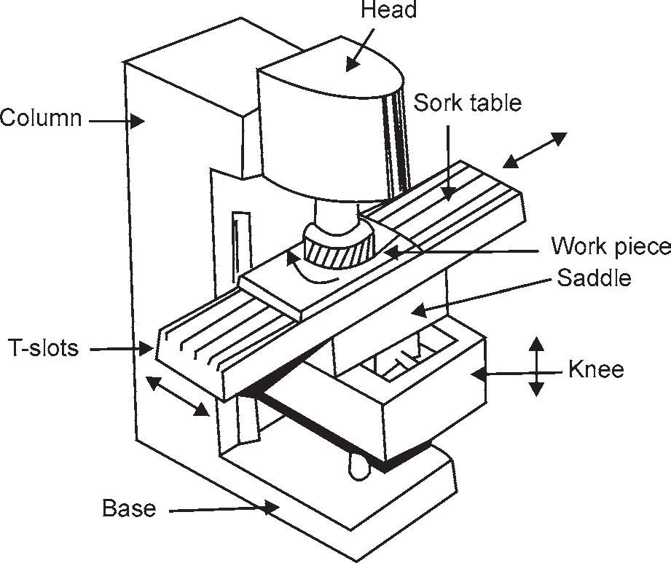

**Fig. 6.27:** Vertical Spindle Column and Knee Type

152 MANUFACTURING PROCESSES

* 1. **Ram Type Milling Machines:** In the ram type milling machines, the milling head is mounted at the front end of the ram through a single or double swivel joint which in turn is mounted on the top of the column. The ram can move forward and backward in a direction parallel to the saddle movement. These additional features enable the spindle axis to move in a horizontal, vertical and an angular direction. These ram type milling machines can be further classified as,
     1. Turret ram type milling machine
     2. Ram head milling machine

###### Bed Type Milling Machines

Bed type milling machines are comparatively heavier and rigid than column and knee type milling machines. In these machines, the table is mounted over a fixed bed in the place of a knee. The spindle head imparts the cross or vertical motion instead of a table. Depending on the number of spindle heads provided in these machines, they can be ‘named as simplex, duplex and triplex milling machines. Their types may be classified as horizontal or vertical, based on the orientation of the spindle axis.

* 1. **Manufacturing or Fixed Bed Type Milling Machine:** In addition to the manual adjustment of all slides in these machines, the automatic cycle of operation for feeding the table feature is incorporated to give an advantage in repetitive type of work. This automatic feeding cycle of the table includes the start, rapid approach, cutting feed, rapid traverse to the next job, quick return and stop. These machines are particularly suitable for large production work.
  2. **Horizontal Bed Type Milling Machines:** These machines are usually provided with the above said features. As the name implies, the spindle is mounted horizontally and it can be adjusted up or down a column fitted to the side of the bed. The available types of horizontal bed type milling machines are the simplex and duplex milling machine.
  3. **Vertical Bed Type Milling Machine:** The spindle is mounted vertically in these machines. All the other features in horizontal bed type milling machines are incorporated in this machine. The transverse movement can be obtained by mounting the head unit over a cross-arm.

###### Planer Type Milling Machines

As the name implies, the machines structure resembles a planer. The table which carries the work piece moves longitudinally and it is fed against a revolving cutter. This machine is distinguished from a planer machine by the variable table feeding movement and the rotating cutter features. These machines are used for heavy stock removal in large work pieces and for duplication of profiles and contours. These milling machines are illustrated in fig. 6.27.

MACHINING 153

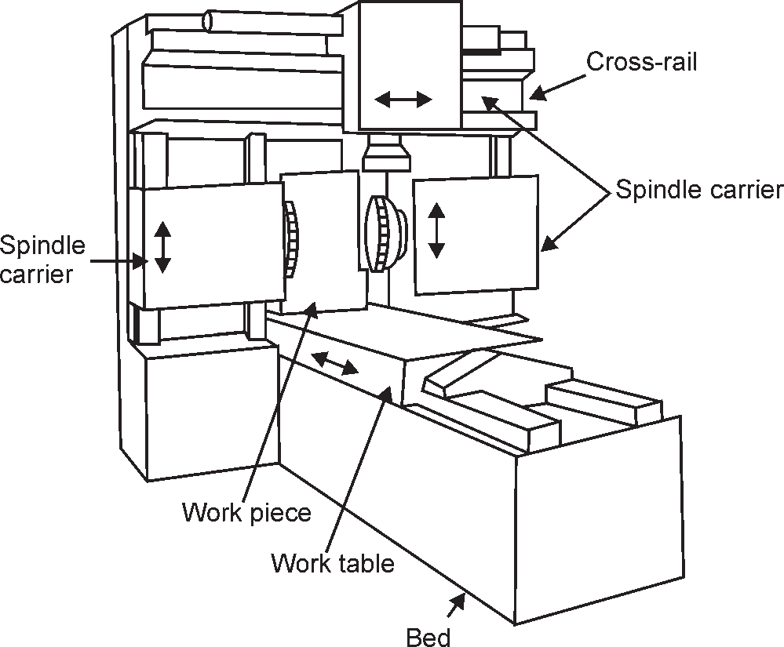

**Fig. 6.27 (a):** The Single Spindle Vertical Cutter and Two Horizontal Cutters Bed Type Milling Machine

###### Special Purpose Milling Machines

Special purpose milling machines have been developed to suit for specific kinds of work more easier than the conventional machines. Some of the common features incorporated from conventional machines are the provision for moving the work piece or tool in different directions and the spindle for rotating the cutter.

* 1. **Rotating Table Milling Machine:** These high-production machines have a circular table which rotates about a vertical axis. Their construction is a modification to a vertical milling machine. The rotary table milling machines are adapted for machining fiat surfaces by using face milling cutters. The cutters are mounted on two vertical spindles, one for roughing and the other for finishing the work. These machines can have two or more cutter spindles. The spindle head can be set at different heights along the vertical ways of the column and while the milling is in progress the operator can continuously load or unload the work pieces in the machine.
  2. **Drum Type Milling Machine:** The drum milling machines are adopted for the machining of two end faces of a work piece simultaneously in a continuous machining cycle. The drum which rotates in a horizontal axis is used for clamping the work pieces. The face milling cutters are mounted on a number of horizontal spindles and removes metal from the two end faces of the work piece. The parts are finished in one complete turn of the central drum.
  3. **Tracer Controlled Milling Machine:** It reproduces the complex shapes like mold cavities and core, cams, dies, etc., by tracing the shape of the master model or template. The shapes are reproduced in the work pieces by synchronized movements of the cutter and tracing element. This provides an automatic control to the feeding motion of the machine. The stylus traces the master or template to produce the coordinates of the cutter path which is used to produce the work piece shapes.

154 MANUFACTURING PROCESSES

* 1. **Thread Milling Machines:** This machine is used for cutting threads and worms. Threads produced by this thread milling operation give better finish and greater accuracy than the conventional thread cutting methods. The milling tools having single row of teeth or a num- ber of such rows used for these thread milling operations.
  2. **Key-Way Milling Machine:** The key-way milling machines are used for parts requiring the key-ways in a high degree of accuracy. These machines are used inlarge batch produc- tion. It uses an automatic cycle to machine the key-way which includes the horizontal move- ment of the work table, to feed of cutter, transverse movement of cutter, etc.
  3. **Skin and Spar Milling Machines:** The structure of both these machines resembles a planer machine in appearance. In ‘spar milling machine’, the work remains stationary and the rotating cutters are moved to and fro to perform the operations. In addition to the above said principle, the skin milling machine’ uses another design for the machining purposes in which the work piece is mounted on a table which is moved past the revolving milling cutters. The machines may have horizontal or vertical spindle axis. These machines are mostly used in aircraft industries.
  4. **Planetary Milling Machine:** These machines are so called because of their planetary (circular) path of the cutters during the operation. The work is held stationary while all the movements which are essential for the cutting are made by the revolving cutters and are the principal features that distinguish this machine from the normal method. The spindle types of both horizontal and vertical designs are available. The planetary milling machines are used for milling both internal and external threads and surfaces.

### Milling Machine Operations

The operations that can be performed on a milling machine are broadly classified as follows:

(1) Plain Milling (2) Face Milling (3) Angular Milling

(4) Staggered Milling (5) Form Milling (6) End Milling

Plain Milling

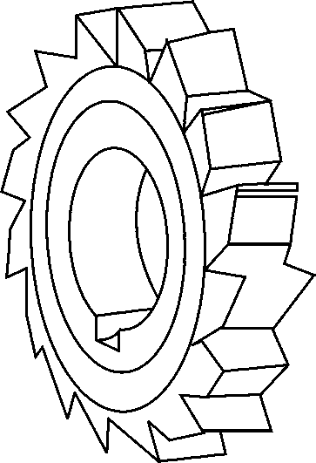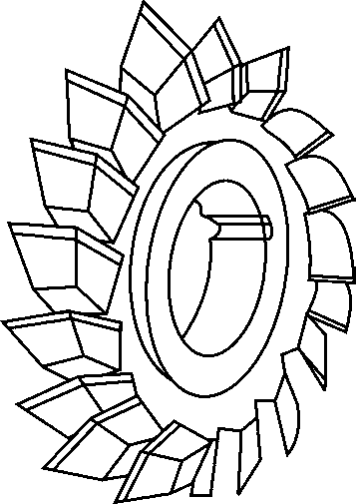It is also known by slab milling. A plain milling cutter is used to produce a plain, flat, horizontal surface parallel to the axis of rotation. The work is mounted on a table and the tool is secured properly on the spindle. The speed and feed of the machine is set up before starting the operation and the depth of cut is adjusted by rotating the vertical feed screw of’ the table.

**Fig. 6.28:** Plain Milling Cutter **Fig. 6.29:** Plain Side Milling Cutter

MACHINING 155

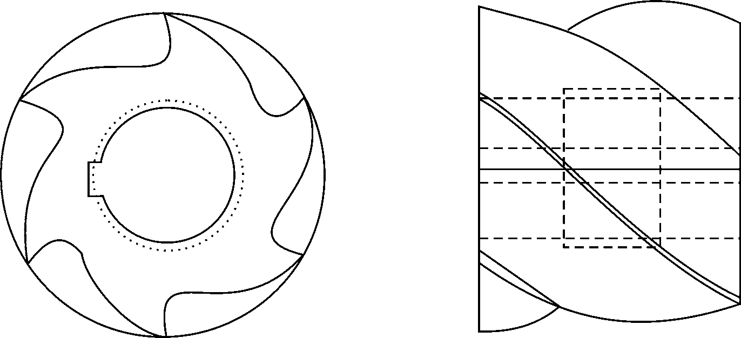

Face Milling

**Fig. 6.30:** Helical Plain Milling Cutter

The face milling operation is used for machining flat surfaces by a face milling cutter which is rotating in an axis perpendicular to the work surface. The depth of cut is adjusted by rotating the tables cross feed screw.

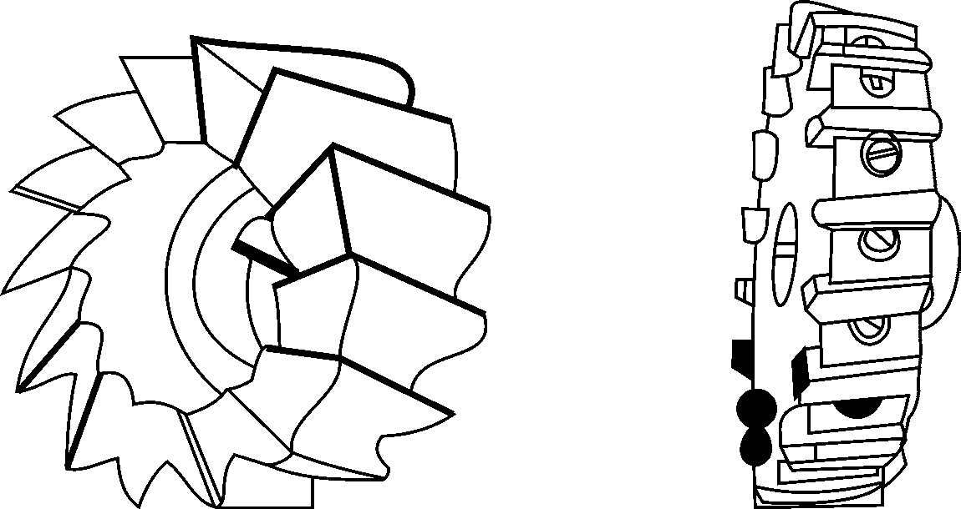

**Fig. 6.31:** Shell Type Face Milling Cutter **Fig. 6.32:** Built-up Type Face Milling Cutter

Angular Milling

The angular milling is the operation used for machining flat surfaces at an angle. Depending upon whether the machining has to be carried out in a single or two mutually inclined surfaces, a single or double angle cutter may be used. The V-blocks of any size can be machined by this operation.

156 MANUFACTURING PROCESSES

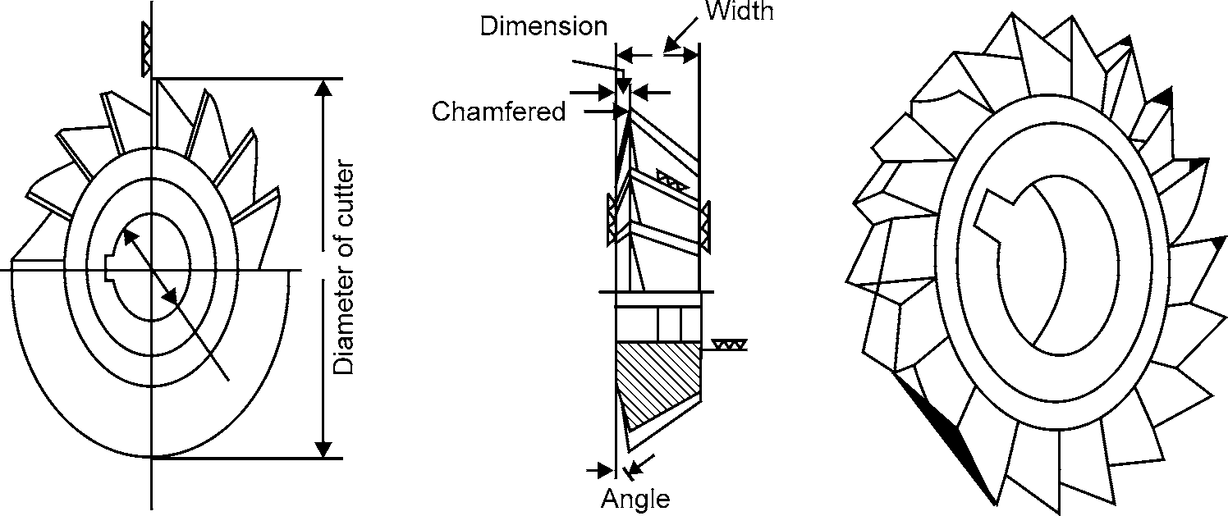

**Fig. 6.33:** Double Angle Milling Cutter **Fig. 6.34:** Single Angle Milling Cutter

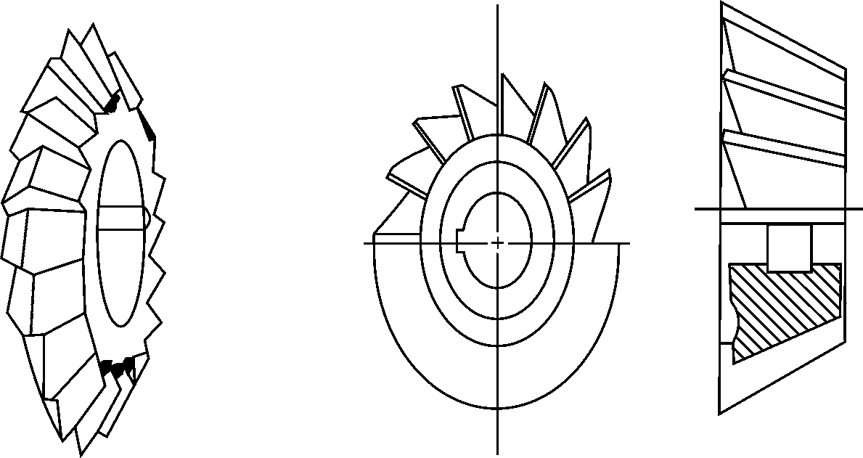

**Fig. 6.35:** Double Angle Milling Cutter **Fig. 6.36:** Single Angle Milling Cutter

Staggered Milling

These types of cutters are narrow and cylindrical having staggered teeth and with alternate teeth having opposite helix angles. These cutters are used for milling deep slots.

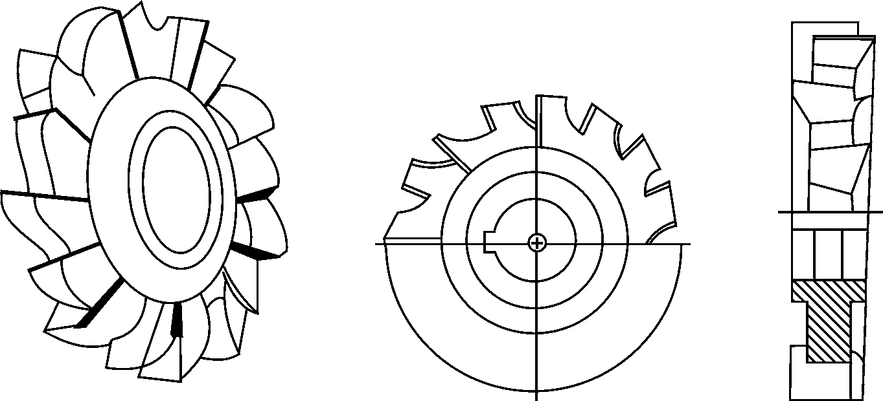

**Fig. 6.37:** Staggered Teeth Side Milling Cutter **Fig. 6.38:** Staggered Teeth Side Milling Cutter

MACHINING 157

Form Milling

These types of milling cutters are used to cut some profile or contour on the work piece. These can be used to cut convex, concave, corner rounding and gear tooth in the work piece.

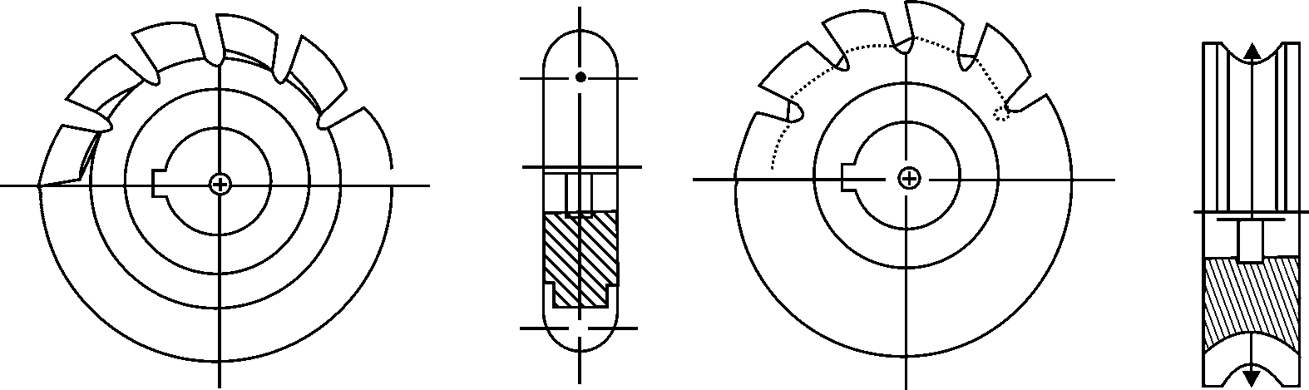

**Fig. 6.39:** Convex Milling End Cutter **Fig. 6.40:** Concave Angle Milling Cutter

End Milling

These types of cutters have teeth on the circumferential surface at one end. They are used for facing, profiling and end milling operations.



**Fig. 6.41:** Straight Shank and Milling Cutter **Fig. 6.42:** Two-lipped Taper Shank End Milling Cutter

Four-flute gas head end

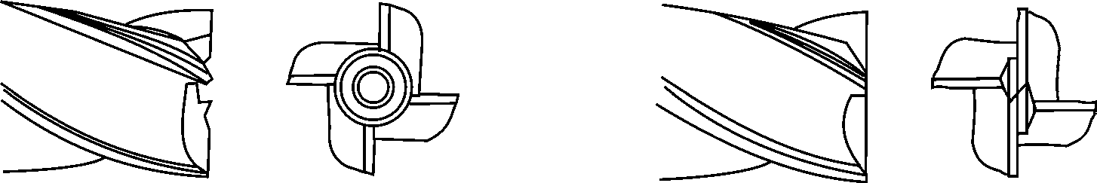

Center cutting

**Fig. 6.43:** End Teeth of Milling Cutters **Fig. 6.44:** End Teeth of Milling Cutters

## GRINDING

It is metal cutting process which makes use of an abrasive tool called the grinding wheel. It is made of abrasive grains having high hardness and heat resistance and is held together by a bonding material. The grinding process provides high accuracy and good surface finish so they are used for finishing operations. The material removal rate in this process is quite less, normally from

0.25 mm to 0.55 mm. Tolerances, as small as 0.002 can be maintained. The various cutting fluids generally used are as follows:

1. One per cent solution of soda ash with 0.15 per cent sodium nitrite.
2. A two percent water solution of powdered soap.

Cast iron and copper are ground without any coolant. Aluminum is ground by using kerosene with or without a mixture of mineral oil as a coolant.

158 MANUFACTURING PROCESSES

The process of grinding is dependent upon the following:.

* 1. Type of abrasive used in the wheel
  2. Size and distribution of grit in the wheel
  3. Amount and type of bonding material
  4. Volume of porosity: relative to abrasive and bonding material.
     1. **About Grinding Wheel**

1. Abrasive Material

Two types of material is used for wheel:

* 1. **Natural abrasives:** Natural abrasives include sand stone, diamond, corundum and emery. Diamond abrasive wheels are used sharpening carbide and ceramic cutting tools. They are also used for turning and dressing other types of abrasive wheels.

The principal component of corundum and emery is natural aluminum oxide (alumina). Co- rundum is composed of about 85% aluminum oxide and 75 % iron oxide. Emery contains (10%, aluminum oxide and 40% iron oxide).

* 1. **Artificial abrasives:** They include silicon carbide and aluminum oxide. Silicon carbide is made by heating silica sand, coke, salt and sawdust in an electric furnace at 23000C for hours resulting in a solid mass of silicon carbide. Upon cooling, this mass is removed from the furnace, crushed and graded as per the various sizes obtained.

Aluminum oxide abrasive is the crystalline form of aluminum oxide. It is produced in an arc furnace from bauxite, iron filings and coke. The mass of aluminum oxide is obtained which is crushed to the required size and segregated as per size.

1. Abrasive Grain Size

Abrasive materials are crushed in ball mills and segregated as per size. The selection of size of the abrasive grain required depends upon the following factors:

* 1. Amount of material to be removed
  2. Finish desired
  3. Hardness of material being ground

The coarse grit is used for more material removal where as the fine grit is used for small material removal rate. Sizes from 240 to 600 are used for lapping and honing applications.

1. Bonding

Bonding materials are used to hold the abrasive particles in place. There are six types of bonding material used. They are:

###### Bonds Symbol

Vitrified Bonds V

Resinoid Bonds B

Shellac Bonds E

Rubber Bonds R

Silicate Bonds S

Oxy-chloride Bonds O

MACHINING 159

1. Grade

This indicates the strength with which the bonding material holds the abrasive grains in the grinding wheel. Different grades in grinding wheels are shown below:

###### Material Grade

Soft A to H

Medium I to P

Hard Q to Z

The selection of a grinding wheel depends upon the nature of work, its composition, size and hardness. Hard wheels are used for softer material and vice versa.

1. Structure

It is the spacing between the abrasive gains or the density of the wheel. The structure of the grinding wheel is designated by a number. The higher the number, the wider is the spacing.

###### Structure Symbol

Dense 1 2 3 4 5 6 7 8

Open 9 10 11 12 13 14 15 or more

1. Specifications of A Grinding Wheel

The grinding wheel is specified as under 300 × 30 × 35W A36 M 55 17 Each element is to be indicated in a fixed order.

First element 300 is wheel diameter. Second element is thickness.

Third element is diameter.

Forth element is manufacturer’s symbol. Fifth element is abrasive used.

Sixth element is grain size. Seventh element is Grade. Eighth element is structure. Ninth element is type of bond.

Tenth element is optional for manufacturer.

* + 1. **Grinding Machine**

1. Cylindrical Grinders

These machines are used to produce external cylindrical surfaces. This machine has a head stock and a tail stock. The work piece is mounted between centers. The grinding wheel and work piece move in the opposite direction. The depth of the cut is given by the moving the wheel towards the work piece.

In cylindrical grinding, two types of grinding are carried out:

160 MANUFACTURING PROCESSES

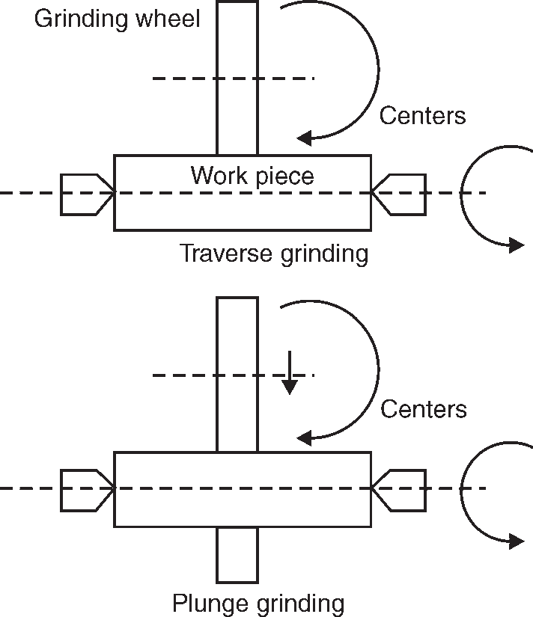

**Fig 6.45:** Working of Cylindrical Grinders

* 1. **Traverse grinding:** In traverse grinding, the work reciprocates as the wheel rotates. Here, work pieces of a large size can be ground with grinding wheels that are less thick.
  2. **Plunge grinding:** In plunge grinding, the wheel is fed into the rotating work piece but there is no reciprocating motion. This method is used for relatively short work pieces and especially in form grinding where some profile on the work piece is to be ground.

1. Surface Grinders

Surface grinders are used to produce flat surfaces. The basic machine has a grinding wheel above the work area which can be fed downward in very small increments into a work piece which is being moved to the left and the right and in and out. This allows the wheel to contact all areas of the surface of the work piece. The grinder is usually equipped with a magnetic plate used to hold the work piece.

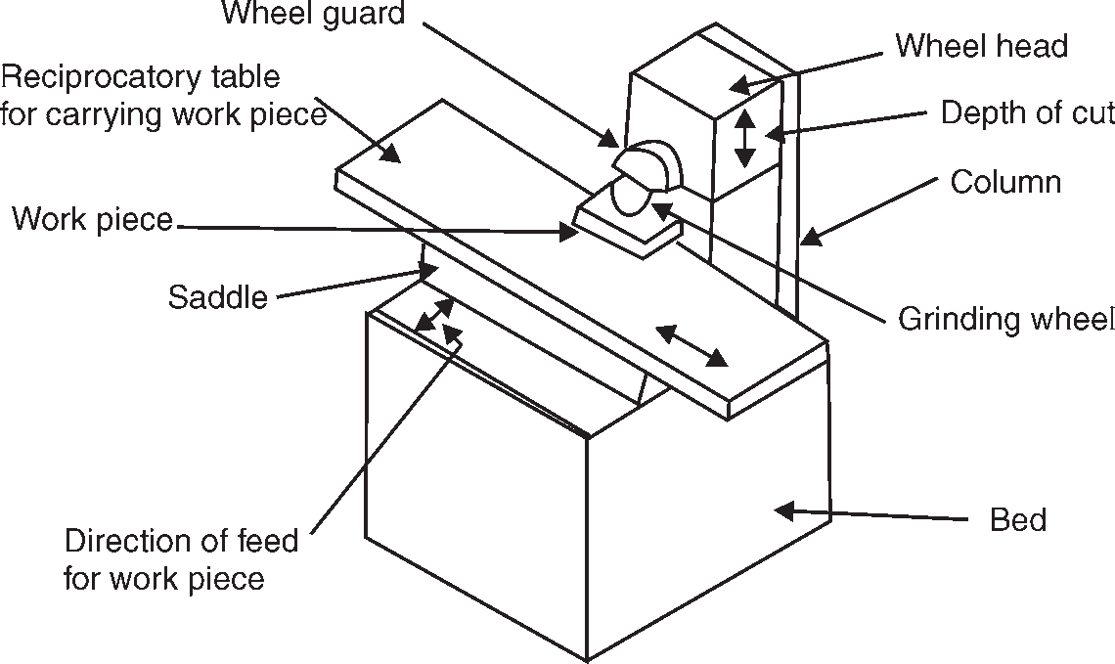

**Fig 6.46:** Main Parts of Surface Grinder

MACHINING 161

There are two types of surface grinders

1. Reciprocating surface grinders
2. Rotary surface grinders
3. Reciprocating Surface Grinders

Reciprocating surface grinders are of two types:

* 1. Horizontal wheel spindle and reciprocating table
  2. Vertical wheel spindle and rotary table

**Horizontal Wheel Spindle and Reciprocating Table:** These types of grinders have one reciprocating table and a horizontal spindle. The table can be given a reciprocating motion either manually by hand wheel or by hydraulic power. Depth of cut is achieved by lowering the grinding wheel with the help of a hand wheel. Feed to the grinding wheel is given by rotating the hand wheel.

**Vertical Wheel Spindle and Rotary Table:** These types of grinders are used in production type of work. In these machines, the wheel diameter should be more than the width of surface to be machined.

1. Rotary Surface Grinders

These are also of two types–horizontal spindle and vertical spindle.

In a horizontal spindle rotary table surface grinder, the work pieces are arranged in concentric circles on the table. The table is made to rotate under the revolving wheel. Both the wheel and the table rotate in opposite directions.

A vertical spindle rotary table surface grinder makes use of a cup shape wheel for finishing operation.

1. Centreless Grinding

This type of machine is used for grinding both external and internal cylindrical surfaces without mounting the work piece between centers in a chuck. This machine makes use of two grinding wheels. The larger grinding wheel does the actual grinding and the small grinding wheel is mounted at an angle to the plane of the grinding wheel. The small wheel is responsible for the feed of the work piece. The work piece with its both ends freely supported on a ‘V’ rotates between large and small wheels. The small wheel also called the regulating wheel does not perform grinding operations but only controls the speed of rotation and longitudinal motion of the work piece.

Advantages of Centreless Grinding:

The advantages of centreless grinding are as follows:

1. Chuck and centers are not required.
2. The work piece is rigidly supported during grinding, so there is no change of direction of work piece.
3. This process is fast.
4. Less skilled operator can carry out operation.
5. Wide range of components can be ground.
6. Large grinding wheels can be used so as to minimize wheel wear.

162 MANUFACTURING PROCESSES

* + 1. **Operation Performed on Grinding Machine**

1. **Polishing:** This process is used for removing scratch marks and tool marks on the work piece to give a good look. For this process, polishing wheels made of canvas, leather or paper are used. The work piece is brought in contact with the revolving wheel to remove the marks on the work piece.
2. **Buffing:** This is also a surface finishing process and is used to produce lustrous surface of attractive appearance. In this process, a very small amount of material is removed. The buffing wheel is made of felt, cotton and powered abrasives are applied on the surface of the wheel.
3. **Lapping:** This process is used for producing extremely accurate highly finished surfaces. Lapping is carried out by means of shoes called Laps. The Laps are made up of soft cast iron, copper, lead and brass. Fine abrasive particles are charged into the lap. Silicon carbide, aluminum oxide and diamond dust are the commonly used lapping powders. Oil and greases are used to spread the abrasive powders. The charged lap is rubbed against the work piece surface and the abrasive particles in the surface of the lap remove small amounts of material from the work piece surface. The material removed by lapping is usually less than 0.025 mm.

Lapping can be done either by hand or special machines. The lap has a series of grooves in it. These are provided for collecting the excess abrasive and chips. The surface of the lap is charged with a fine abrasive. The work piece is moved across the surface of the lap using reciprocating or rotary motion.

In machine lapping, two flat laps are used that are called upper and lower laps. The work pieces to be lapped are inserted between these two laps rotating in opposite direction. The work piece holder can accommodate a number of work pieces which are not clamped.

1. **Honing:** Honing is an abrasing process used for finishing internal cylindrical surfaces like drilled or bored holes. Honing stones are manufactured by bonding abrasives like alumi- num oxide or silicon carbide. Materials like sulphur, resin or wax are added to improve the cutting action.

Honing can be done manually or by machines. The preferred method is by using machines. The stones are held in a honing head. This head is directed to move in and out of the hole for carrying out operation. Honing is both a sizing and finishing operation and is generally used for removing the scratch marks produced by grinding. The material removal is less than 0.125 mm.

1. **Super finishing:** It is an abrasive process for removing scratches produced by machining and other surface irregularities. It is used for producing extremely high quality surface finish. The amount of material removal is 0.005 to 0.0025 mm. In super finishing, an abrasive stick is retained in a suitable holder and applied to the surface of the work piece with a light pressure. This process is normally carried out for finishing outer surfaces. The abrasive block reciprocates across the rotating work piece. These two motions produce a high degree of accuracy. The abrasive used are aluminum oxide for materials like alloy

MACHINING 163

and high speed steels. Silicon carbide abrasives are used for materials like cast iron, aluminium, brass. Bonded diamond dust is used for finishing carbide tools.

**OBJECTIVE QUESTIONS**

1. The size of lathe is specified by
   1. Height of the centers from ground (b) Swing of lathe

(c) Tool post of the lathe (d) Weight of the lathe

1. Single point cutting tool is made by
   1. High-speed steel (b) Aluminium

(c) Mild steel (d) All

1. Study rest is
   1. Used when a lathe is not provided foundations
   2. An additional support provided for long jobs.
   3. Used in thread cutting operation.
   4. Used in taper turning operation.
2. In thread cutting operation the saddle is moved by
   1. Head stoke (b) Tail stoke

(c) Tool post (d) Lead screw

1. Bed of lathe is generally made by:
   1. Cast iron (b) Mild steel

(c) High speed steel (d) None

1. For metal removal, single point cutting tools are used in case of
   1. Drilling (b) Milling

(c) Shapers (d) None

1. The shaping process is very slow but it is mostly used because of
   1. Easy of operation (b) Short set up time

(c) Inexpensive tooling (d) All of above

1. The shaper is specified by
   1. Maximum height of machine (b) Maximum length of stroke

(c) Weight of machine (d) All of above

1. In shaper the ram should move
   1. Slower during return stroke (b) Faster during return stroke
2. At the same speed during return stroke
3. All of above
4. Which of the following operation can be performed by the drilling machine.
   1. Drilling (b) Reaming

(c) Boring (d) All of above

164 MANUFACTURING PROCESSES

1. The operation of finishing a predrilled hole is known as
   1. Boring (b) Reaming

(c) Counter boring (d) Spot facing

1. The planer is differs from shaper mainly as
   1. The table is stationary while the tool is moving
   2. The table is moving while the tool remains stationary
   3. Table and tool are stationary
   4. The table is moving and the tool is also moving
2. Cutting tool used in shaper is
   1. Single point (b) Multi point

(c) Double point (d) None of above

1. During machining of shaper
   1. The cutting tool is stationary
   2. Both move opposite to each other
   3. Both tool and job are in motion
   4. The job is stationary
2. Stroke of ram of shaper is adjusted by
   1. Changing the pinion
   2. Changing the position of the crank pin
   3. Changing the position of lead screw
   4. None of above

**ANSWERS**

|  |  |  |  |  |  |
| --- | --- | --- | --- | --- | --- |
| 1. (b) | 2. (a) | 3. (b) | 4. (d) | 5. (a) | 6. (c) |
| 7. (d) | 8. (b) | 9. (b) | 10. (d) | 11. (b) | 12. (b) |
| 13. (a) | 14. (d) | 15. (b) |  |  |  |

**SHORT ANSWER QUESTIONS**

1. What are the types of lathes you are familiar with? State their applications. Dec-04
2. Differentiate between turret lathe and capstan lathe. Dec-06
3. How does a turret lathe differ from a capstan lathe? What special tooling is associated with the turret lathe? Dec-02
4. With the help of a suitable sketch, describe the geometry of a twist drill and also explain, how drill sizes are designated? Dec-02
5. Explain the constructional features of a dividing head used in milling. Dec-03

MACHINING 165

1. Differentiate the following:
   1. Horizontal and Vertical Milling Machine. Dec-06
2. Describe any four types of bonds for bonded abrasives on a grinding wheel. Dec-05
3. Explain centreless grinding. Dec-06
4. What are the main difference between cylindrical and centre less grindings? Dec-03
5. What is the working principle of lathe?
6. How a centre lathe is specified?
7. Name the various operations that can be performed on a centre lathe.
8. Describe the basic difference between shaper and planer.
9. How is a drilling machine specified?
10. What is the working principle of Planer type milling machine?
11. Describe different types of milling machine.
12. With neat sketch describe the horizontal milling machines.
13. What do you meant by Grinding?
14. Write short notes on
    1. Cylindrical Grinders (ii) Surface Grinders

**LONG ANSWER QUESTIONS**

1. What are the differences between an automatic lathe and a capstan lathe? Given an example of a component suitable for a capstan lathe with dimensions. Dec-05
2. List the different type of lathes available giving salient features of each. What are the uses of (i) lead screw (ii) feed rod (iii) tail stock (iv) half nut (v) compound slide in a lathe.

Dec-05

1. What are the main differences between a shaper and a planer? Which are the drive mechanisms used in shaper ? Discuss anyone in brief. Dec-02
2. How does shaper differ from planer in terms of their operation and type of work pieces?

Dec-03, 04

1. Define milling. What are the various work holding devices used in milling. Explain their relative applications and disadvantages. Dec-04
2. What is a universal milling machine? Draw at least one part which cannot be machined on a horizontal milling machine. List various types of milling cutters available and draw any two.

Dec-05

1. How are grinding wheels specified? Take a suitable example and explain what the different terms in specification of a wheel by international standard, stand for. Dec-05

166 MANUFACTURING PROCESSES

1. How are grinding wheels specified? Clearly differentiate between grade and structure of a grinding wheel. Dec-02,06
2. What is the classification method that could be used for grinding machines? Give the applications of each variety of grinding machines. Dec-04
3. Describe briefly the Facing, Plain Turning, Taper turning, Drilling and Threading operation in a lathe.
4. Describe with a neat sketch, the main parts of a shaper machine.
5. Discuss the working principle and operations of a shaper.

13 What is the working principle of Milling machine.

1. Describe main operation performed in milling machine.
2. Explain the various operations that can be performed on a Grinding machine.

❍ ❍

**WELDING**

7

## IMPORTANCE OF WELDING

In most of the modern fabrication works welding science has numerous applications in different forms, covering a fairly wide range of such work.

Welding is an alternative method for casting or forging and as a replacement for bolted and riveted joints. It is also used as a repair medium, i.e., to reunite metal at a crack to build up a small part that has broken off such as gear tooth or to repair a worm surfaces such as bearing surfaces.

The following are the main key features of welding:

1. The welding structures are normally lighter than riveted or bolted structures.
2. The welding joints provide maximum efficiency, which is not possible in other type of joints.
3. The addition and alterations can be easily made in the existing structure.
4. A welded joint has a great strength.
5. The welding provides very rigid joints.
6. The process of welding takes less time than other type of joints.

## BASIC CONCEPT OF WELDING

Welding is a process of joining two similar or dissimilar metals with the help of heat or pressure or by some other means. The cost of welding is very less as compared to other processes and forms a strong joint.

For this reason it is largely used in the following fields of engineering:

1. Manufacturing of machine tools, auto parts, cycle parts, etc.
2. Fabrication of farm machinery & equipment.
3. Fabrication of buildings, bridges & ships.
4. Construction of boilers, furnaces, railways, cars, aeroplanes, rockets and missiles.
5. Manufacturing of television sets, refrigerators, kitchen cabinets, etc.

A weld will inherit the common drawback of brittleness, which is a disadvantage. The emphasis in welding technique should, therefore, be preventing this brittleness to the maximum possible extent.

168 MANUFACTURING PROCESSES

## CLASSIFICATION OF WELDING PROCESSES

Many types of welding processes have been developed depending upon the field of their applications (Table 7.1). But the welding is broadly divided into following two groups.

1. **Forge or Pressure Welding (**Under pressure without additional filler metal)
   1. Friction welding
   2. Electric resistance welding
   3. Blacksmiths forge welding
   4. Cold pressure welding
2. **Fusion or non-pressure welding** (With additional filler material)
   1. Gas welding (Heat created by Gas)
   2. Electric arc welding (Heat created by electrically)
   3. Thermite welding (Heat created by chemical Reaction)

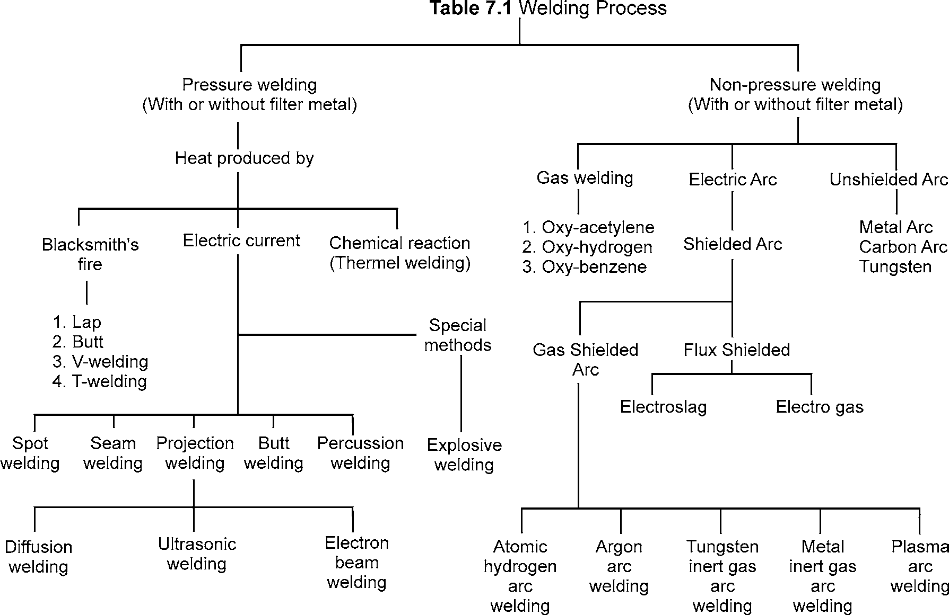

## GAS WELDING

Gas welding is the process in which a gas flame is used to raise the temperature of the metals to be joined. The metals are heated up to melting. The metal flows and on cooling it solidifies. A filler metal may be added to the flowing molten metal to fill up cavity made during the end preparation.

WELDING 169

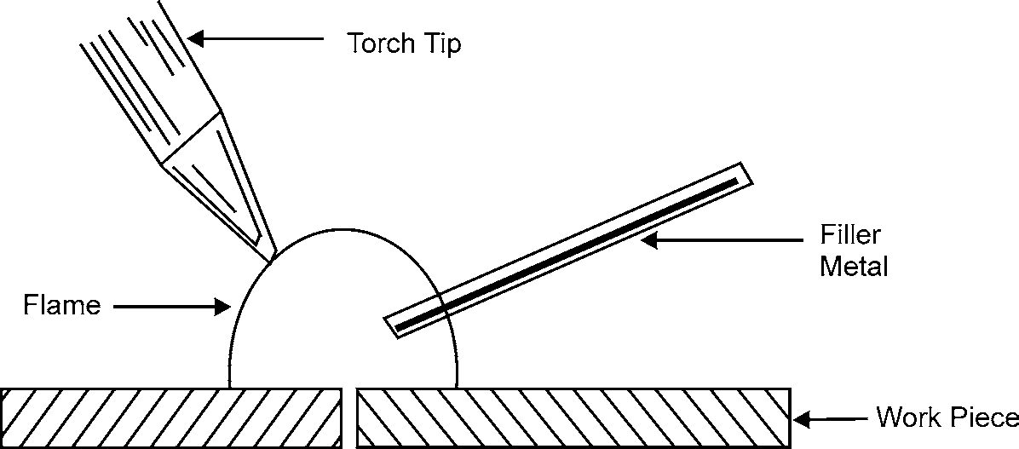

**Fig. 7.1:** Gas Welding

Many combinations of gases are used in gas welding. But the most common of these is oxygen and acetylene.

### Oxy-acetylene Welding

The process of oxy-acetylene welding can be used for almost all metals and alloys for engineering purposes. A high temperature flame (3200°C) can be produced by this method. There are two systems of oxygen-acetylene welding.

* + - 1. **High Pressure System:** In this process the oxygen and acetylene are taken for use from high pressure cylinders.
      2. **Low Pressure System:** In this system oxygen is taken from high pressure cylinder and the acetylene is produced by the action of Calcium carbide and water.

CaC2 + 2H2O = Ca (OH)2 + C2H2

1. Apparatus

Apparatus used for oxy-acetylene (high pressure) welding is shown in the fig. 7.2 and consists of the following:

* 1. Oxygen cylinder
  2. Acetylene cylinder
  3. Pressure gauges
  4. Valves
  5. Hose pipes
  6. Torch
  7. Welding tip
  8. Pressure regulators
  9. Lighter
  10. Goggles

170 MANUFACTURING PROCESSES

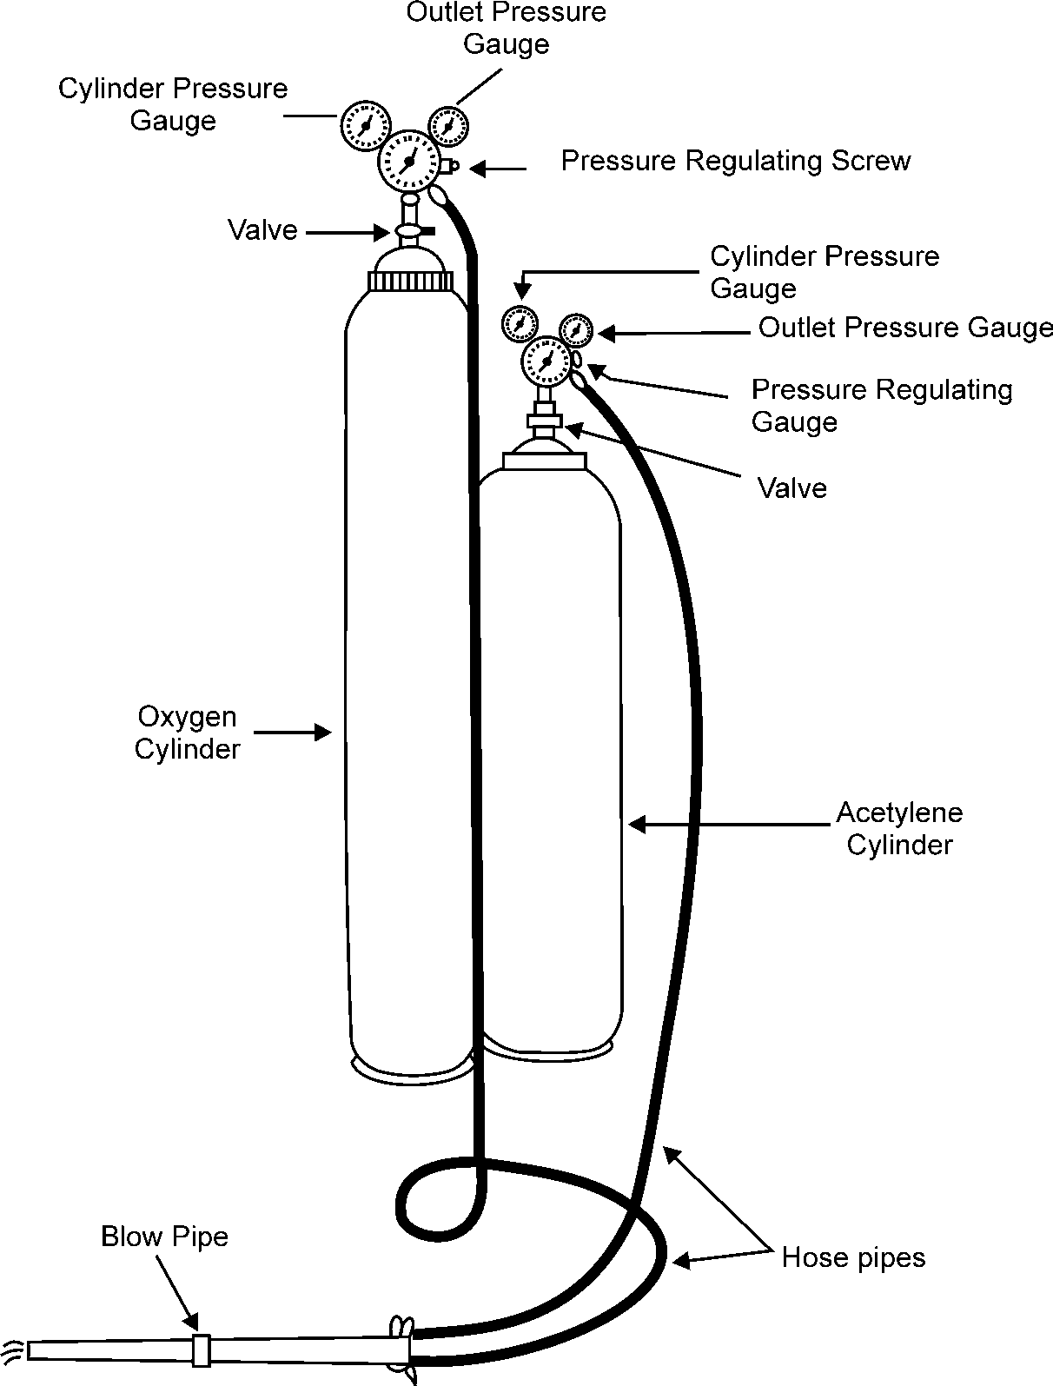

**Fig. 7.2:** Apparatus for Gas Welding

1. Principle of Oxy-acetylene Welding

A very hot flame is produced by burning of the gases coming through the torch tip. The edges to be welded are heated up to melting. A filler metal is also added to complete the welding. This molten metal mixture when solidifies on cooling forms a welded joint.

Oxygen cylinder and acetylene cylinder are filled with gases. Both the cylinders are attached with pressure gauges, regulators and cylinder valves. The cylinder containing oxygen is painted black whereas the acetylene cylinder is painted maroon. Hose pipes, are provided with each cylinder. These pipes are connected to welding torch.

1. Welding Process

To start welding, the acetylene control valve is turned first. When acetylene comes out of the nozzle, it should be ignited with spark lighter. It will give a yellow-colored smoke flame. After it, oxygen cylinder valve is opened and supply is increased until a most suitable flame is obtained. Then the

WELDING 171

flame is focused on the edges to be welded. Flux and filler metal are also added with the heat of flame. The edges and filler metal melt and a joint are formed after cooling of the molten metal. The joint may be formed with or without using filler metal.

1. Applications

Oxy-acetylene welding is particularly used for sheet metal work. All the metals can be welded with proper filler metals. Same equipment may be used for cutting purposes.

1. Advantages of Oxy-acetylene Welding

The main advantages of oxy-acetylene welding are given below:

* 1. Equipment is cheap as compared to other welding process.
  2. It can be used for welding of all types of metals.
  3. Maintenance of equipment is very less.
  4. It is a portable process.
  5. It can be used far cutting of metals of small thickness.
  6. It is specially used for sheet metal work.

1. Disadvantages
   1. It takes long time for heating the job as compared to the arc welding.
   2. The heat affected area is more.
   3. This is prone to corrosion and brittleness.
   4. Gases are expensive and difficult to store.

### Types of Gas Flames

There are three types of gas flames:

1. Oxidizing Flame 2. Carburising Flame 3. Neutral Flame
2. **Oxidizing Flame:** When the volume of oxygen gas is more than the volume of acetylene mixed into the torch. This flame is used for welding brass and is also used for cutting the metals.
3. **Carburising Flame:** When the volume of acetylene mixed is more than oxygen, carburising flame is formed. This flame is used for welding nickel, monel etc.
4. **Neutral Flame:** It is known as balanced flame. Oxygen and acetylene gases are mixed in equal volumes. Neutral flame is used for normal welding of steel, cast iron etc.

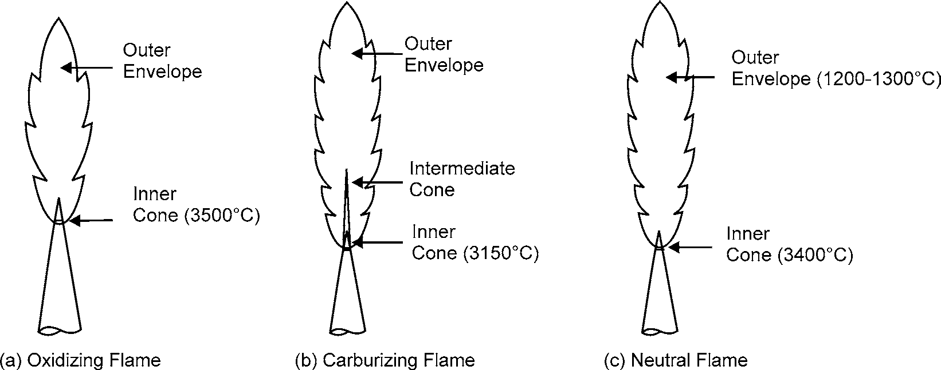

**Fig. 7.3:** Types of Flames

172 MANUFACTURING PROCESSES

### Gas Welding Techniques

There are two types of gas welding techniques:

1. Left ward welding
2. Right ward welding
3. **Left Ward Welding:** In this welding the tip of the torch is held at 60 to 70°C to the plates. And the filler rod is inclined at 30 to 40°C in opposite direction. In this method, the plate edges are heated immediately after the molten metal. The torch tip and filler rod are moved slowly in the direction towards left. The technique is illustrated in the Fig. 7.4.

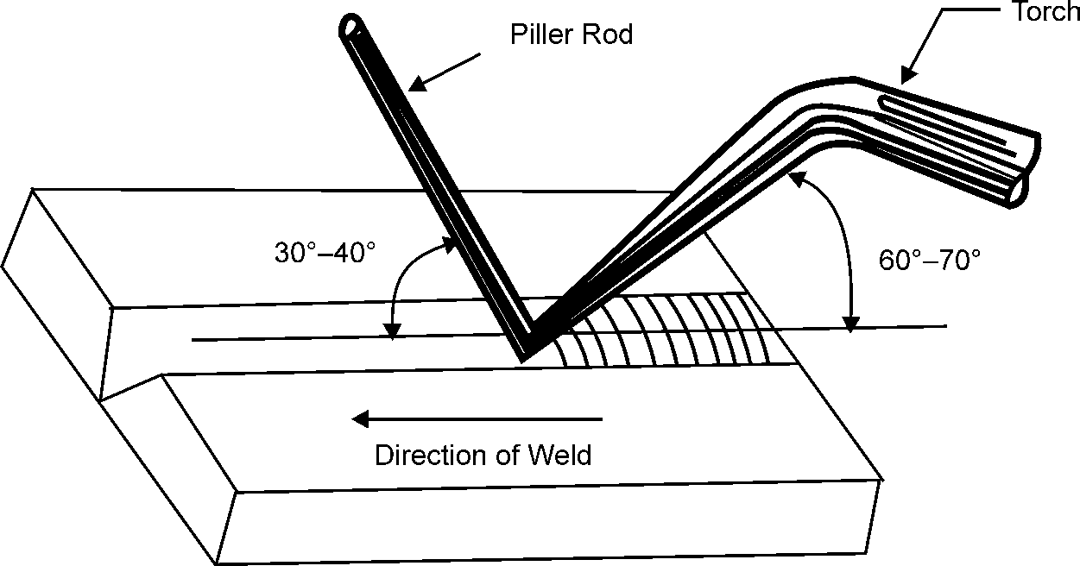

**Fig. 7.4:** Leftward Welding

1. **Right Ward Welding:** In right ward welding the torch is kept at 40 to 50°C to the job to be welded. Torch is moved towards right as shown in the Fig. 7.5. Right ward welding is done for heavy sections only.

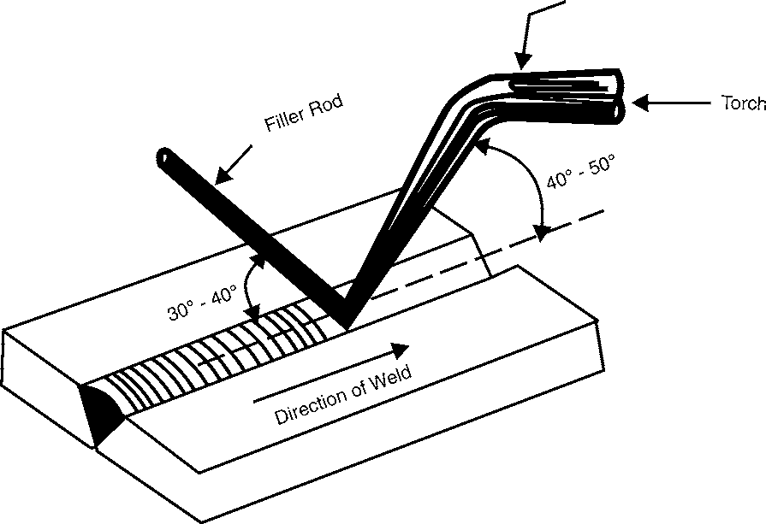

### Flux

**Fig. 7.5:** Rightward Welding

The chemicals which deoxidize the metal surface and provide inert atmosphere around the molten metal are known as fluxes.

WELDING 173

The main function of flux is given below:

1. To prevent oxides on the hot surfaces.
2. To reduce the viscosity of molten metal.
3. It maintains a steady arc in case of arc welding. Fluxes are available as liquid, powder, paste and gas.

Powder flux is sprinkled on the surfaces to be welded or the filler rod is dipped into the powder. Liquid & paste fluxes are sprayed on the surfaces to be welded.

Gas fluxes are used to form inert atmosphere around the joint to be welded

### Filler

The rod which provides additional metal in completing the welding is known as filler. The composition of filler metal should be the same as that of the metals to be welded.

### Gas Welding Equipment

Details of Gas welding equipment are as under:

1. **Oxygen Cylinder:** As shown in Fig 7.6. Cylinder is made up of steel in capacity range 2.25 to 6.3 m3. The cylinders are filled with oxygen at about 150 kg/cm2 at 21°C. A safety valve is also provided on it. The cylinder can be opened or closed by a wheel which operates a valve. A protector cap is provided on the top of a cylinder to safeguard the valve.

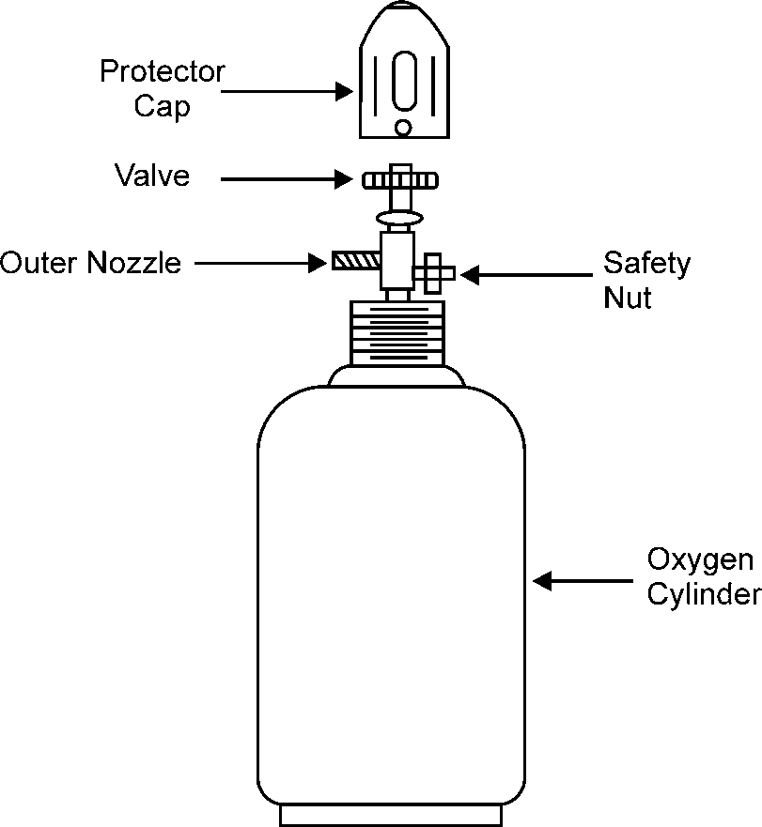

**Fig. 7.6:** Oxygen Cylinder

1. **Acetylene Cylinder:** As shown in Fig. 7.7. Acetylene cylinders are also made up of steel. Gas is filled at a pressure of 18-20 kg/cm2. The capacity of the cylinder is about 10m3. Regulator valve and safety valve are mounted on cylinder. Safety plugs are also provided on the bottom of the cylinder. When filled into the cylinder, the acetylene is dissolved in acetone.

174 MANUFACTURING PROCESSES

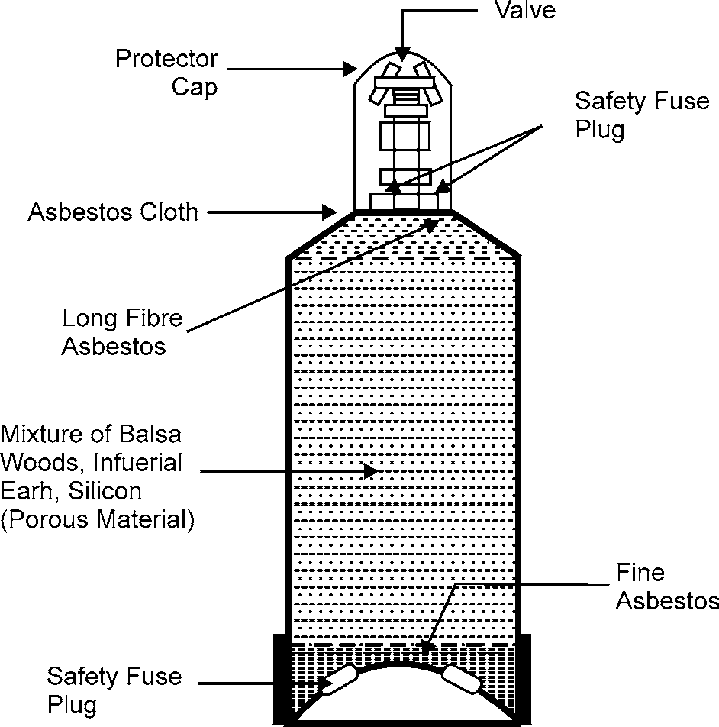

**Fig. 7.7:** Acetylene Cylinder

1. **Regulator:** Regulator is used to control the flow of gases from high pressure cylinder. A simple type of regulator is shown in the Fig. 7.8.

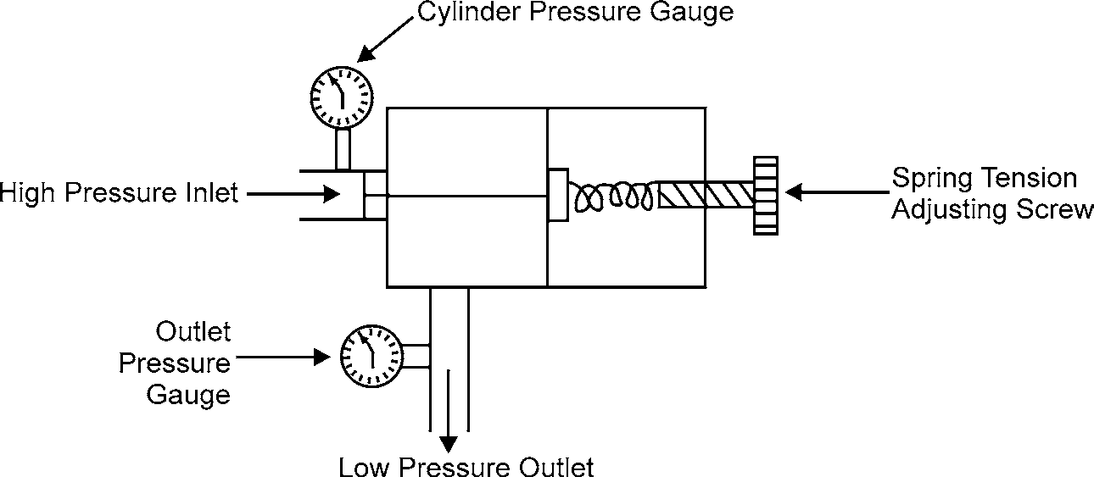

**Fig 7.8:** Regulator

1. **Torch:** Torch is a device used to mix acetylene and oxygen in the correct proportion and the mixture flows to the tip of the torch. Refer Fig. 7.9. There are two types of torches:
   1. Low pressure or injector torches
   2. Medium pressure or equal pressure torches

WELDING 175

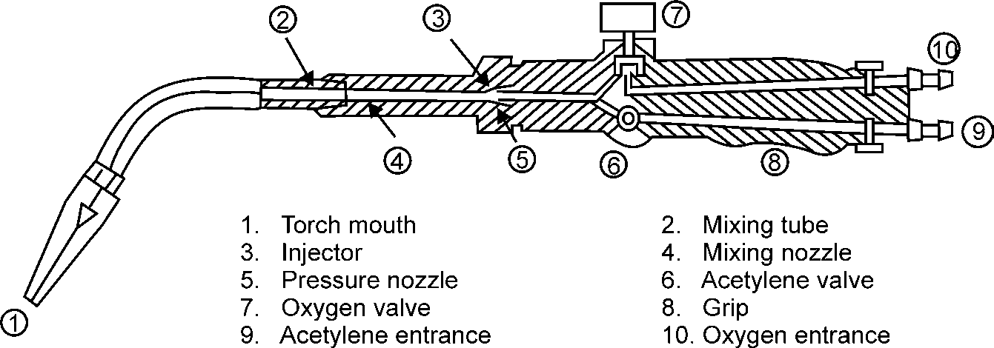

**Fig. 7.9:** Welding Torch

1. **Low Pressure or Injector Torch:** These torches are designed to use acetylene at low pressure. The pressure is kept very low up to 0.7 kg/cm2. But the oxygen pressure is very high.
2. **Medium Pressure or Equal Pressure Torch:** In this type of torch the acetylene is taken at a pressure equal to 1 kg/cm2, the oxygen is always supplied at high pressure. Both types of torches are provided with two needle valves. One regulates the flow of oxygen and the second valve controls the flow of acetylene. A mixing chamber is provided to mix the gases.
3. **Torch Tips:** For different types of jobs, different tips are used. The size of the tip is specified by the outlet hole diameter. More than one hole is also provided in tips. The tip is screwed or fitted on the front end of the torch. Various types of tips are shown in the Fig. 7.10.

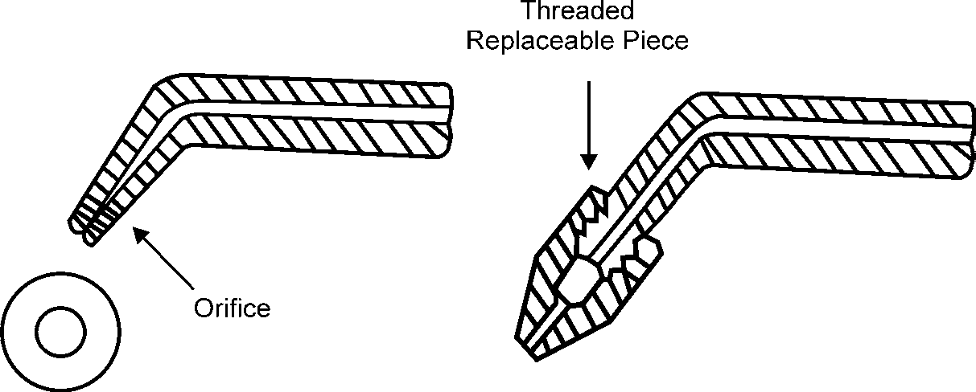

**Fig. 7.10:** Torch Tips

1. **Goggles:** Gas flames produce high intensity light & heat rays, which are harmful to naked eye. To protect the eyes from these rays, goggles are used. Goggles also protect the eyes from flying sparks.



**Fig. 7.11:** Goggles

176 MANUFACTURING PROCESSES

1. **Lighter:** For starting the flame, the spark should be given by a lighter. Match sticks should not be used, as there is risk of burning hand.
2. **Fire Extinguishers:** Fire extinguishers are used to prevent the fire that may break out by chance. Sand filled buckets and closed cylinders are kept ready to meet such accidents.

### Difference between High Pressure and Low Pressure Gas Welding

***High Pressure Welding Low Pressure Welding***

1. Acetylene is available in cylinders 1. Acetylene is generated by the action of water and

Calcium Carbide.

1. Pressure is very high in the acetylene cylinder. 2. Pressure is low. It ranges from 0.03 to 0.14 kglcm2. Minimum Pressure is 18 kg/cm2 Pressure No need of pressure regulator on acetylene regulators are used on both cylinders cylinder
2. Oxygen and acetylene gases are mixed in mixing 3. Injector is used to mix acetylene with oxygen chamber used for heavy work. used for light work.

### Safety Precautions in Gas Welding

The following safety precautions must be observed while working in welding shop:

1. Always handle the gas cylinders with care.
2. The adjusting screw on the regulator must be fully released before opening a cylinder valve.
3. Never use matchsticks for lighting a torch.
4. Never lubricate the regulator valve with oil or grease, it may cause explosion.
5. Always use goggles while working.
6. Proper ventilation must be provided in the shop.
7. Acetylene cylinders should be stored in up right position.
8. Do not open acetylene cylinders near sparks or fire.
9. Never remove torch tips with pliers.
10. The cylinder should be leak proof.
11. Always use protective caps over the valves.
12. Keep in mind the location of the fire extinguishers.

## ELECTRIC ARC WELDING

The welding in which the electric arc is produced to give heat for the purpose of joining two surfaces is called electric arc welding.

### Principle

Power supply is given to electrode and the work. A suitable gap is kept between the work and electrode. A high current is passed through the circuit. An arc is produced around the area to be welded. The electric energy is converted into heat energy, producing a temperature of 3000°C to 4000°C. This heat melts the edges to be welded and molten pool is formed. On solidification the welding joint is obtained.

WELDING 177

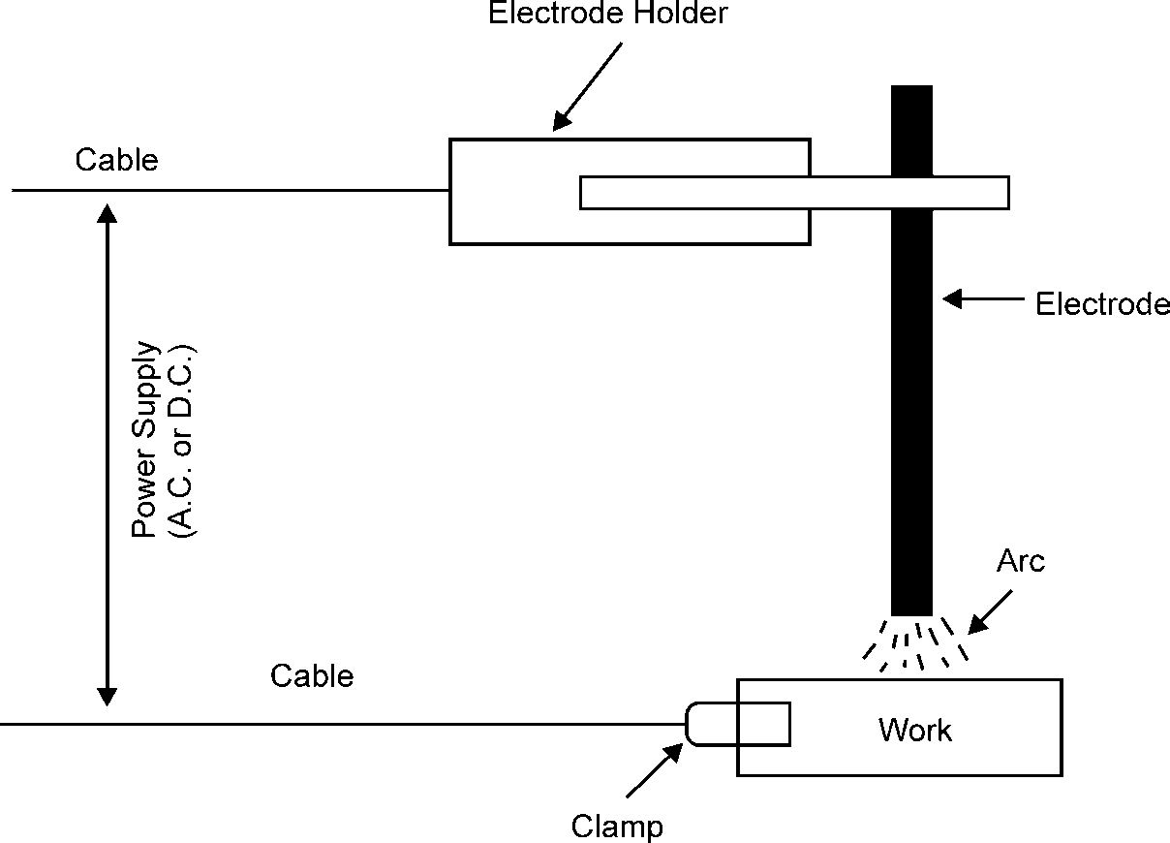

### Electric Power for Welding

**Fig. 7.12:** Arc Welding

AC current or DC current can be used for arc welding. For most purposes, DC current is preferred. In D.C. welding, a D.C. generator or a solid state rectifier is used. D.C. machines are made up to the capacity range of 600 amperes. The voltage in open circuit is kept around 45 to 95 volts and in closed circuit it is kept 17 to 25 volts. D.C. current can be given in two ways:

* + - 1. Straight polarity welding.
      2. Reverse polarity welding.

In straight polarity welding work piece is made anode and the electrode is made cathode as shown in the fig 7.13. Electrons flow from cathode to anode, thus, heat is produced at the materials to be welded.

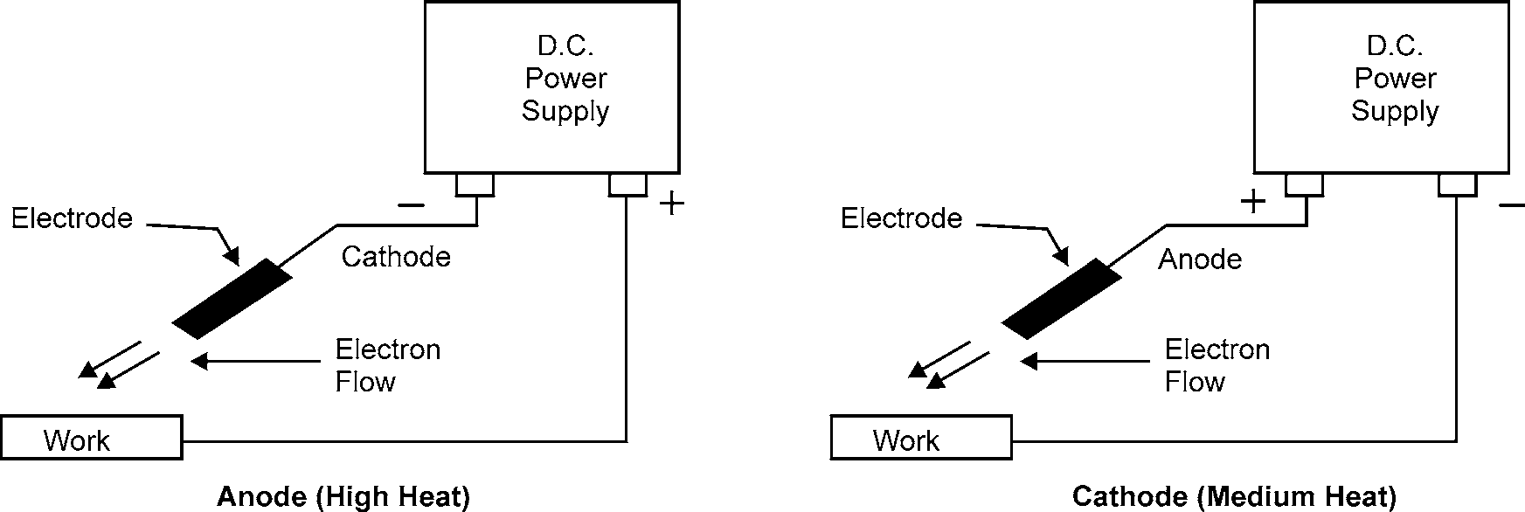

**Fig. 7.13:** Straight Polarity Welding **Fig. 7.14:** Reverse Polarity Welding

In reverse polarity system the work is made cathode and the electrode is made anode. This welding is done specially for thin section.

178 MANUFACTURING PROCESSES

AC welding has the advantage of being cheap. Equipment used is simpler than DC welding. A transformer is used to increase the current output at the electrode. The current varies from 150 to 1000 amperes depending upon the type of work.

### Effect of Arc Length

Arc length is the distance from the tip of the electrode to the bottom of the arc. It should vary from 3 to 4 mm. In short arc length, the time of contact will be shorter and will make a wide and shallow bead. The penetration is low as compared to long arc lengths.

### Equipment used for Arc Welding

Various equipments used for arc welding are as under:

###### D.C. Welding Equipment

* 1. AC Motor - Generator set
  2. Diesel Engine - Generator set
  3. Transformer - Rectifier welding set

###### AC Equipment

* 1. Welding transformer set

###### Equipment accessories

* 1. Leads
  2. Holder
  3. Connectors
  4. Ground Clamps

###### Operator’s tool

* 1. Chipping hammer
  2. Wire brush
  3. Arc shield
  4. Closed shoe

The details of the above equipment and accessories are described below:

1. **AC Motor Generator:** In this a generator is driven by a suitable AC motor. The average voltage of the generator is 25 volt. The current ranges from 25 to 100 amperes. The voltage in the generator is variable. The voltage can be set to the desired value with the help of rheostat.
2. **Diesel Engine Generator Set:** In this set, the drive is given by a diesel engine. Rest of the system is same as in case of A.C. motor generator. Diesel engine generator sets are used in the areas when electricity is not available.
3. **Transformer Rectifier Set:** It allows the current to flow through it only in one direction because it has a one way valve or solid rectifier installed on the electrode side of the secondary coil. The set can supply straight polarity and reverse polarity power supply. The rectifier, are of two types

|  |  |  |
| --- | --- | --- |
| WELDING |  | 179 |
| (a)  (b) | Silicon diode Selenium plate |  |

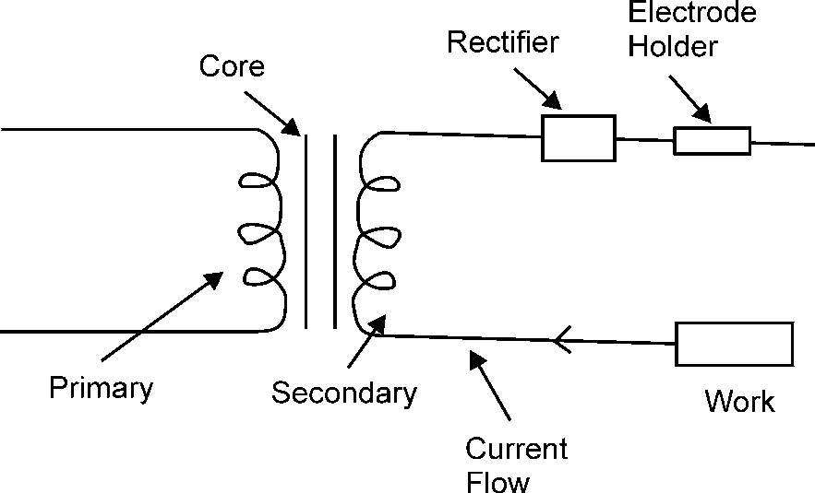

**Fig. 7.15:** Transformer Rectifier Set

1. **Welding Transformer Set:** It is used to step down the voltage supply. It consists of a primary and secondary circuit. The input is given to primary winding. By electromagnetic induction the current flows through the secondary coil. The output can be controlled as per requirement.

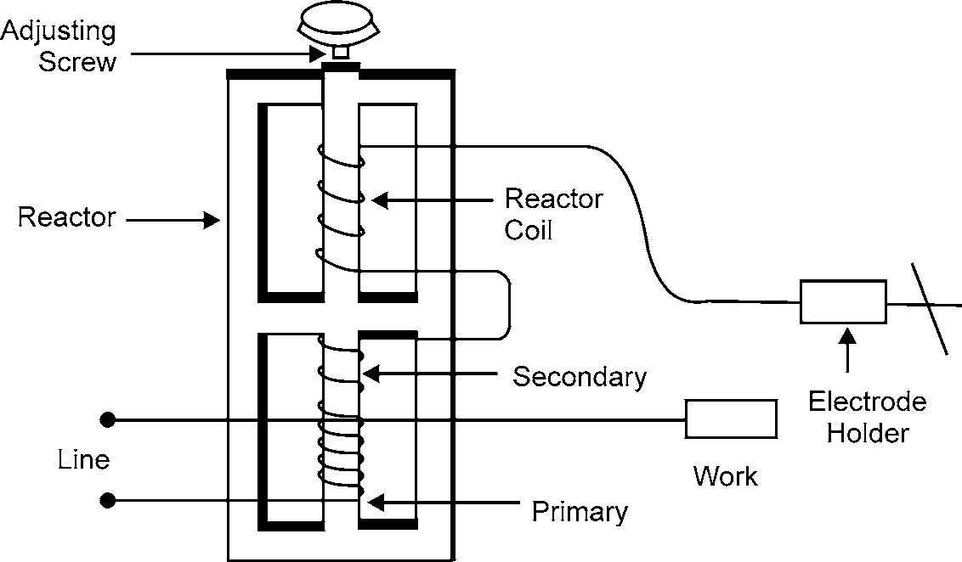

**Fig. 7.16:** Welding Transformer Set

1. **Cables or Leads:** These leads are made up of copper or aluminium wire. The wires are insulated with rubber & cloth fibre. A heavy insulation is necessary for these cables.
2. **Face Shield:** When arc is produced around the job, infrared rays and ultraviolet rays are produced. To protect the face and eyes from these dangerous rays, a shield is necessary.
3. **Other Accessories & Tools:** Other accessories & tools used for arc welding are shown in the fig 7.17.

180 MANUFACTURING PROCESSES

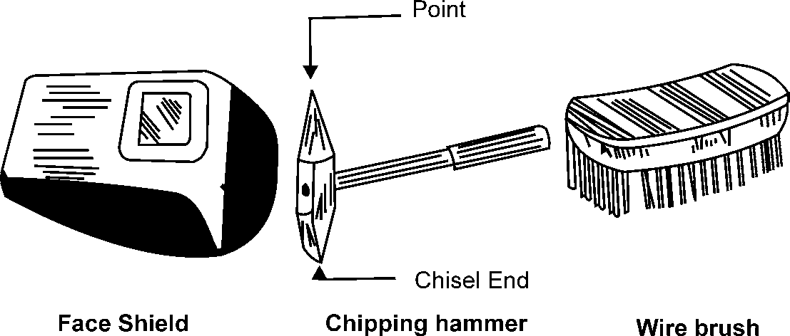

### Welding Positions

**Fig. 7.17:** Other Accessories

In horizontal position it is very easy to weld. But many times it is impossible to weld the job in horizontal position. Other positions are classified as under:

* + - 1. Flat Position
      2. Horizontal Position
      3. Vertical Position
      4. Overhead Position
         1. **Flat Position:** In flat positions the work piece is kept in nearly horizontal position. The surface to be worked is kept on upper side. The welding is done as illustrated in the fig 7.18.

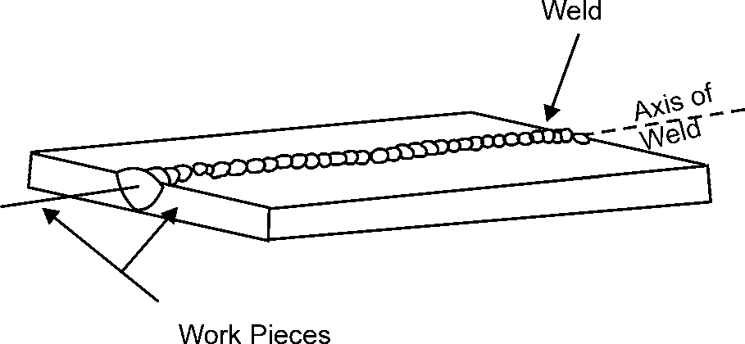

**Fig. 7.18:** Flat Position

* + - * 1. **Horizontal Position:** In this position, the work piece is kept as in the fig 7.19. Two surfaces rest one over the other with their flat faces in vertical plane. Welding is done from right side to left side. The axis of the weld is in a horizontal plane and its face in vertical plane.

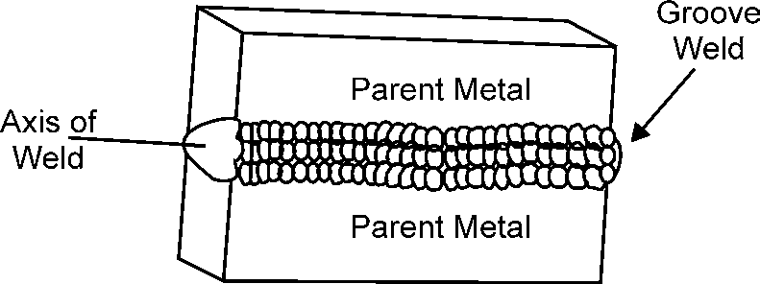

**Fig. 7.19:** Horizontal Position

WELDING 181

* + - * 1. **Vertical Position:** In this position, the axis of the weld remains in approximate vertical plane. The welding is started at the bottom and proceeds towards top. Welding process is illustrated in figure.

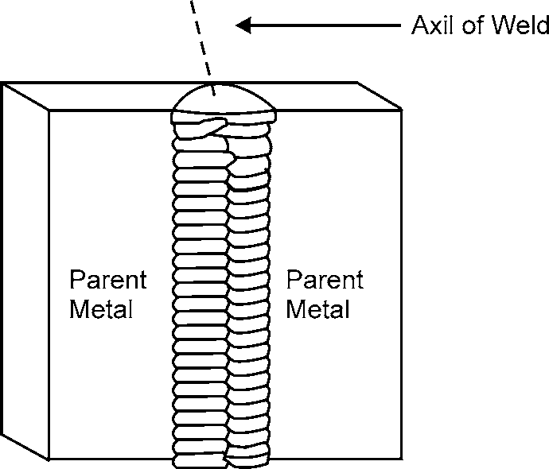

**Fig. 7.20:** Vertical Position

* + - * 1. **Overhead Position:** As shown in the figure, the work piece remains over the head of the welder. The work piece and the axis of the weld remain approximate in horizontal plane. It is the most difficult position of welding.

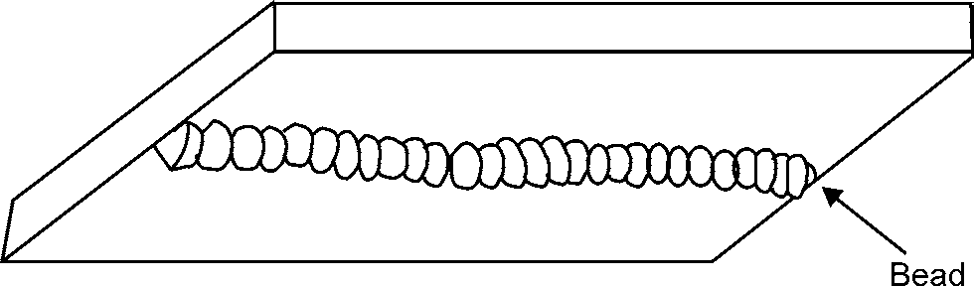

**Fig. 7.21:** Overhead Position

### Types of Electrodes

Electrodes are of two types

1. **Coated electrodes:** Coated electrodes are generally applied in arc welding processes. A metallic core is coated with some suitable material. The material used for core is mild steel, nickel steel, chromium molybdenum steel, etc. One end of the coated core is kept bare for holding.
2. **Bare electrodes:** Bare electrodes produce the welding of poor quality. These are cheaper than coated electrodes. These are generally used in modern welding process like MIG welding.

### Electrode Size

Electrodes are commonly made in lengths 250 mm, 300 mm, 350 mm, 450 mm, and the diameters are 1.6 mm, 2 mm, 2.5 mm, 3.2 mm, 4 mm, 7 mm, 8 mm and 9 mm.

### Functions of Coatings

The coating on an electrode serves the following functions:

1. To prevent oxidation.

182 MANUFACTURING PROCESSES

1. Forms slags with metal impurities.
2. It stabilizes the arc.
3. Increases deposition of molten metal.
4. Controls depth of penetration.
5. Controls the cooling rate.
6. Adds alloy elements to the joint. Specifications of electrodes.

### Electrode Classification and Coding

According to ISI coding system, an electrode is specified by six digits with profile letter M. For example IS: 815-1956

These six digits & M indicate the following matter:

**M:**It indicates that it is suitable for metal arc welding.

**First Digit:** First digit may be from 1 to 8, which indicate the type of coating on the electrode.

**Second Digit:** It denotes the welding position for which electrode is manufactured. It varies from 1 to 6.

**Third Digit:** It denotes the current to be used for an electrode. It is taken from 0 to 7.

**Fourth Digit:** Fourth digit is from 1 to 8. Each digit represents the tensile strength of welded joint.

**Fifth Digit:** It carries any number from 1 to 5. This digit denotes a specific elongation in percentage of the metal deposited.

**Sixth Digit:** It carries any number from 1 to 5 and denotes impact strength of the joint.

## COMPARISON BETWEEN AC AND DC WELDING

***S.No. A.C. welding D.C. welding***

1. Equipment is cheaper and simpler in operation. 1. Equipment is costlier and complicated in

operation.

1. In AC transformer there is no moving part, 2. DC generator set has many moving parts and its therefore it is easy to maintain. maintenance cost is higher than AC transformers.
2. It can be operated at large distances from power 3. In DC the voltage drop is very high. Therefore, sources as the voltage drop is negligible. shorter cables are used.
3. Only coated electrodes can be used in 4. Both coated and bare electrodes can be used. AC welding.
4. Less problem of arc blow. 5. More problem of arc blow.
5. It can not be used for welding non-ferrous metals 6. Almost all the metals can be welded.
6. It can be used only when AC current is available 7. An engine generator can be used in case of

non-availability of AC power.

## TYPES OF JOINTS

Basic types of welding joints are classified as under:

1. Butt Joint

In this type of joint, the edges are welded in the same plane with each other. V or U shape is given to the edges to make the joints strong. Some examples of butt joints are shown in the figure.

WELDING 183

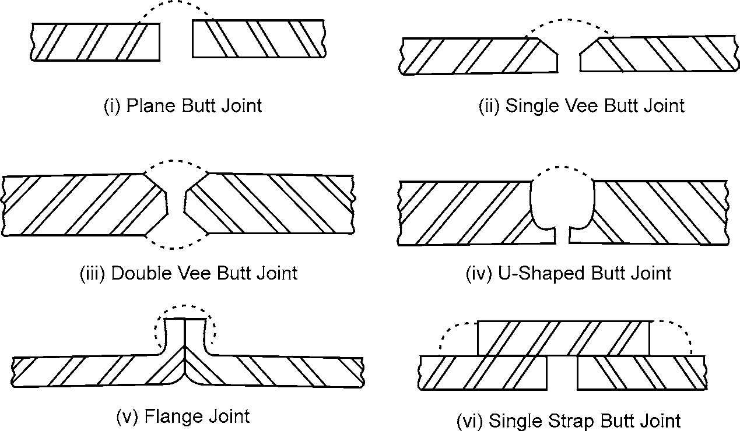

1. Lap Joint

**Fig. 7.22:** Different Types of Butt Joints

This type of joint is used in joining two overlapping plates so that the corner of each plate is joined with the surface of other plate. Common types of lap joints are single lap, double lap or offset lap joint. Single welded lap joint does not develop full strength as compared to double welded lap.



(vii) Lap joint (Single or double fillet) (viii) Joggled lap joint (Single or double fillet)

1. T-Joint

**Fig. 7.23:** Different Types of Lap Joints

When two surfaces are to be welded at right angles, the joint is called T-Joint. The angle between the surfaces is kept 90°.

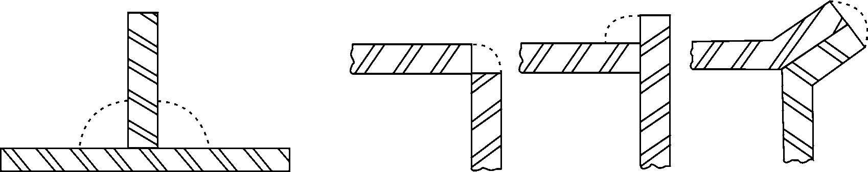

**Fig. 7.24:** T-joint **Fig. 7.25:** Corner Joint

1. Corner Joint

In this joint, the edges of two sheets are joined and their surfaces are kept at right angle to each other. Such joints are made in frames, steel boxes, etc.

184 MANUFACTURING PROCESSES

1. Edge Joint

In this joint two parallel plates are welded edge to edge.

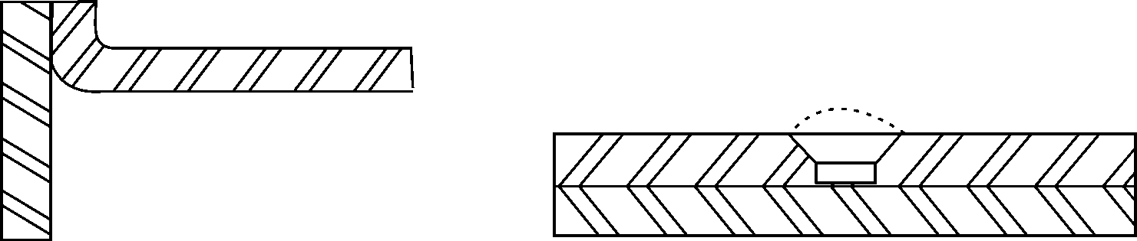

**Fig. 7.26:** Edge Weld Joint **Fig. 7.27:** Plug or Rivet Butt Joint

( f ) Plug Joint

Plug joints are used in holes instead of rivets and bolts.

## ELECTRIC RESISTANCE WELDING

The electric resistance welding is commonly used. It can be applied to any metals. Electric current passes through the materials being joined. The resistance offered to the flow of current results in raising the temperature of the two metal pieces to melting point at their junction. Mechanical pressure is applied at this moment to complete the weld. Two copper electrodes of low resistance are used in a circuit.

The mechanical pressure or force required after the surfaces are heated to a plastic temperature is approximately 0.3 N/m2 at the welded surface.

This method of welding is widely used in modern practice for making welded joints in sheet metal parts, bars and tubes etc.

### Parameter Affecting Resistance Welding

Successful application of Resistance welding process depends upon correct application and proper control of the following factors.

1. **Current:** Enough current is needed to bring the metal to its plastic state of welding.
2. **Pressure:** Mechanical pressure is applied first to hold the metal pieces tightly between the electrodes, while the current flows through them called **weld pressure**, and secondly when the metal has been heated to its plastic state, to forge the metal pieces together to form the weld, called **forge pressure**.
3. **Time of Application:** It is the cyclic time and the sum total of the following time period allowed during different stages of welding
   1. **Weld Time** Time period during which the welding current flow through the metal pieces to raise their temp.
   2. **Forge Time** Time period during which the forge pressure is applied to the metal pieces.
   3. **Hold Time** Time period during which the weld to be solidify.
   4. **Off Time** The period of time from the release of the electrodes to the start of the next weld cycle.

WELDING 185

1. **Electrode contact area:** The weld size depends on the contact area of the face of the electrodes

## TYPES OF RESISTANCE WELDING

1. Spot welding 2. Butt welding

3. Flash welding 4. Seam welding

5. Projection welding 6. Percussion welding

### Spot Welding

Spot welding is used to lap weld joints in thin metallic plates (up to 12.7 mm thick) for mechanical strength and not for tightness.

The metallic plates are overlapped and held between two copper electrodes. A high current, depending upon plate thickness, at a very low volt-age (4-12 volts), is passed between the electrodes. The contact resistance of the plates causes to heat rapidly to a plastic state. Mechanical pressure is applied. Supply is cut-off for the metal to regain strength. The pressure is released. The process is repeated at another portion of the plates.

Thus, spot joints at regular interval depending upon the strength required are obtained. The electrodes are water cooled to avoid overheating and softening of the tips.

Spot welding is mainly used in the manufacture of automobile parts refrigerators, metallic toys, racks, frames, boxes, radio chassis, etc.

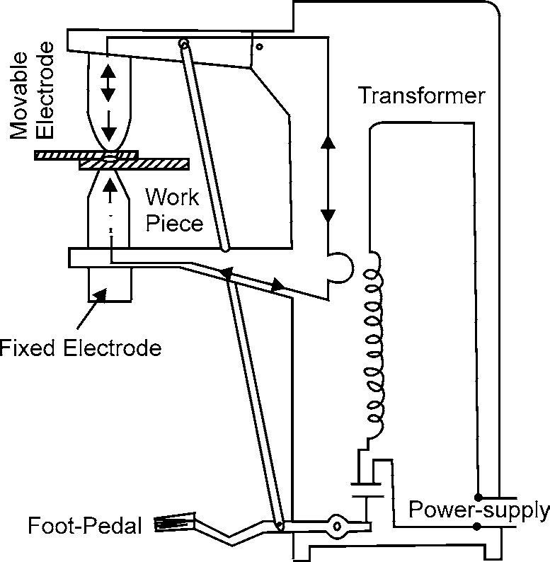

### Seam Welding

**Fig. 7.28:** Spot Welding

The metallic plates are held by two copper roller electrodes with one roller driven by motor so that the plates are moved between the rollers at a suitable speed. The high current is passed between the electrodes holding metallic plates pressed together with suitable force and pushes together to travel between the revolving electrodes as showing in Fig. 7.29. The plates between the electrodes get heated to welding (fusion) heat and welded continuously under constant pressure of rotating electrodes. This is a quicker operation than spot welding and gives a stronger joint.

186 MANUFACTURING PROCESSES

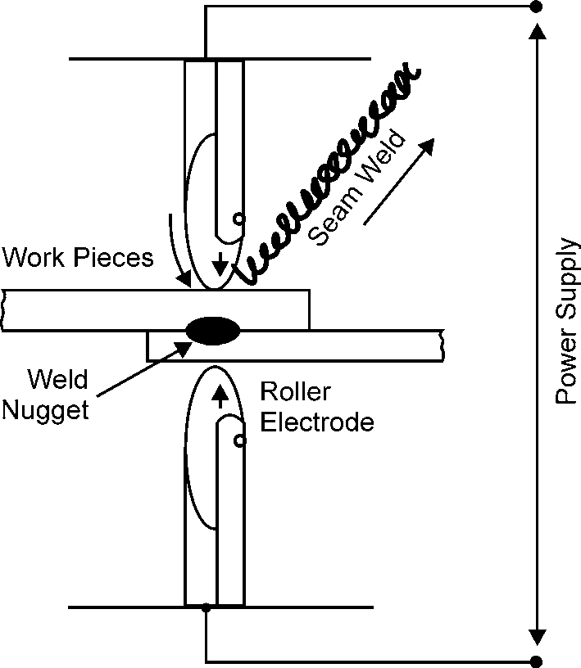The process is employed for pressure tight joints on oil drums, tanks and boiler water pipes, refrigeration parts, motorcar body, utensils, stoves, etc.

**Fig. 7.29:** Seam Welding

### Butt Welding (Upset Welding)

The pieces to be welded are held edge to edge in copper clamps. The ends are brought together under a light pressure. A heavy welding current is switched on. The resistance between the contacting faces causes a rise in temperature to the fusion point. A further mechanical pressure is applied to obtain a welded joint. The current is switched off.

This process is mainly used on non-ferrous materials for joining bars, rods, wires, tubing, etc.

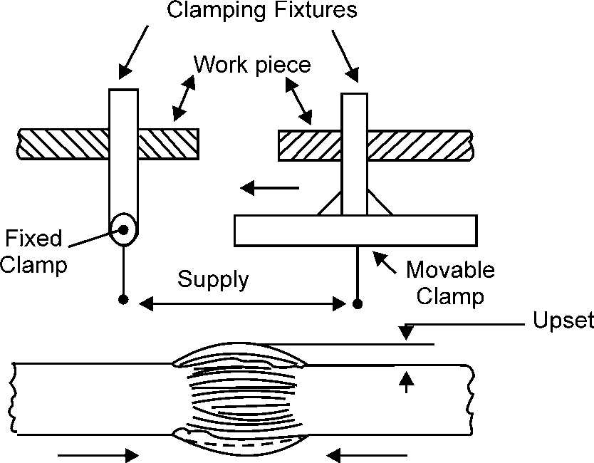

### Flash Welding

**Fig. 7.30:** Butt (upset) Welding

The current is switched on and the ends of the workpieces to be welded are slowly brought closer. An arc is produced between the contacting faces of the workpieces and intense heat is generated.

WELDING 187

The faces are brought rapidly together under high pressure (350 to 1650 kg/cm2). The current is then switched off and the weld is forged, as shown in Fig. 7.31.

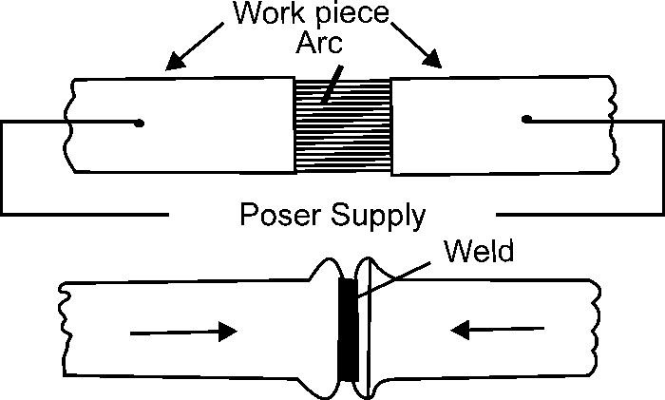

**Fig. 7.31:** Flash Welding

The main advantages of flash welding over upset welding are:

1. It is much quicker
2. Current consumption is less
3. The weld joint is stronger
4. The end faces of workpieces need not be prepared, which is a primary requirement in butt welding.

The main disadvantages of flash welding over upset welding are:

1. During flashing, particles of molten metal are thrown out, which may enter into the sideways and insulation, etc. These needs periodic maintenance of machine and replacement of insulation.
2. Operator has to take enough care against possible fire hazard due to flashing.
3. Additional stock has to be provided to compensate the loss of metal during flashing and upsetting. This adds to the cost of product.

Steel and ferrous alloys are most easily welded. The materials that cannot be flash welded are lead, tin, zinc, bismuth and their alloys and copper alloys.

### Projection Welding

There are raised projections in the workpiece at all points where a weld is desired as shown in Fig. 7.32. As the current is switched on the projection are melted and the workpieces pressed together to complete the weld. The melted projections form the welds. This method enables production of several spot welds simultaneously.

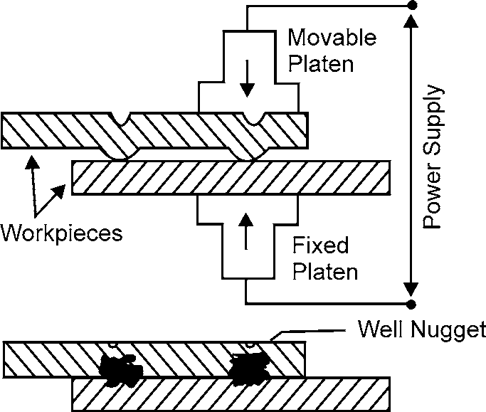

**Fig. 7.32:** Projection Welding

188 MANUFACTURING PROCESSES

### Percussion Welding

The pieces to be welded are moved closer at a fast speed after switching on the current. When the pieces are 0.16 mm apart, an arc is caused bringing them to fusion temperature. The percussion blow of the two pieces with sufficient force, completes the welding and extinguishes the arc. It is used for joining thin wires of dissimilar metals such as copper to nichrome and copper to stainless steel.

## SOLDERING

Soldering is a process of joining two metals by using another low temperature metal alloy. The metal used for the joining purpose is called solder. Solders are of two types:

1. Hard solder (alloy of copper and zinc)
2. Soft solder (alloy of tin and lead)

Process

The surfaces to be joined are cleaned and are placed on each other. A flux is employed to prevent oxidation. Zinc chloride is commonly used for this purpose. The soldering iron is heated either electrically or by some external heat. Then the hot end is dipped into the flux and solder is pressed against the surfaces to be joined. A joint is formed by melting the solder.

Applications

Soldering is widely used for sheet metal work and in radio and television work for joining wires.

Advantages

1. Joining cost is low
2. Equipment is very simple and cheap
3. Good sealing in fabrication as compared to other processes like rivet, spot weld and bolts
4. It provides a positive electrical connection
5. Due to low operating temperature the properties of base metal are not affected

Disadvantage

1. Joints formed are weak

## BRAZING

The process of joining two metal surfaces by heating and adding a non-ferrous alloy with melting point above 400°C is known as **brazing process.**

The surfaces to be joined are cleaned from all oil, dirt or oxides. Then both the surfaces are placed in joining position. Flux is sprinkled or placed on it. The heat is given to the surface and the filler metal. The molten filler metal flows to the surfaces to be joined. On cooling, brazing joint is formed. The filler metals used are copper, copper alloy, silver alloy and aluminium alloys. In brazing, the filler metal melts but the surfaces to be joined remain unmelted.

The various methods used to melt the filler metal and flux are:

1. **Gas Torch Brazing:** It is a commonly used process in which oxy-acetylene torch is used.
2. **Furnace Brazing:** The surfaces to be joined are placed in a furnace already hot.

WELDING 189

1. **Dip Brazing:** The surfaces to be joined are dipped in molten filler metal.
2. **Electrical Brazing:** In electric brazing heat is produced by resistance or induction method.

Applications

Brazing is used for electrical items, radiators, heat exchangers, pipes & pipe fittings and tool tips.

Advantages

1. It is useful for joining dissimilar metals.
2. Thin sections can be easily joined.
3. Good finish is obtained on joint.
4. Less skill is required.
5. Cost of operation is less as compared to other welding processes.

Disadvantages

1. Low strength.
2. Not applicable for hardened steel and aluminium alloys.

## DIFFERENCE BETWEEN SOLDERING AND BRAZING

***Brazing Soldering***

1. Filler metal has the melting point above 400°C. 1. Filler metal has the melting point below 400°C.
2. More stable joints can be made. 2. Less stable joints can be made.
3. High pressure and temperature do not affect the 3. Joints are affected by high temperature and joint. pressure.
4. Equipment cost is more. 4. Equipment cost is very low.

# OBJECTIVE QUESTIONS

1. Pressure (kg/cm2) applied in electric resistance welding is in the range of:
   1. 150–65 (b) 65–150

(c) 250–550 (d) 600–850

1. Tip of the electrodes used in spot welding are made of:
   1. Soft Iron (b) Mild steel

(c) Copper (d) Aluminium

1. Oxyacetylene welding mostly employs flame
   1. Oxidizing (b) Carburising

(c) Neutral (d) Reducing

1. Welding is usually used to join the ends of two pipes of uniform cross section.
   1. Upset welding (b) Flash welding

(c) Spot (d) Projection

190 MANUFACTURING PROCESSES

1. If *t* is the thickness of the plates to be spot welded then the electrode tip diameter should be equal to
   1. *t* (b) 2



¯

(c) (d*)* 2*t*



¯

1. Which of the following is multi spot-welding process
   1. Projection welding (b) Seam welding

(c) Both (a) and (b) (d) Neither (a) nor (b)

1. Which of the following is continuous spot welding process?
   1. Projection welding (b) Seam welding

(c) Both (a) and (b) (d) Neither (a) nor (b)

1. Neutral flame cannot be used for welding
   1. Cast iron (b) Mild steel

(c) Copper and aluminium (d) none of these

1. Carburising flame is normally used to weld
   1. Copper alloys (b) Stainless steel

(c) Phosphor bronze (d) Stelite

1. Lap joint is preferred for plates having thickness
   1. Greater than 10.5 mm (b) Greater than 5 mm

(c) Less than 3 mm (d) 5–10 mm

1. Use of more acetylene with less volumes of oxygen in an oxyacetylene torch produces a flame.
   1. Neutral (b) Oxidising

(c) Carburising (d) None of these

1. Which type of flame is used for welding brasses /bronzes?
   1. Carburising (b) Oxidising

(c) Neutral (d) None of these

1. During the welding the current intensity depends upon
   1. Thickness of plate (b) Method of edge preparation

(c) Electrode diameter (d) Nature of metal

1. During polarity welding, the work is connected to the positive and the electrode holder is negative

(a) Straight (b) Reverse

(c) Both (a) and (b) (d) Neither (a) nor (b)

1. Heat generated in the work piece in case of the resistance welding depends upon
   1. Magnitude of welding current (b) Time current is allowed to flow
2. Resistance of current conducting path
3. All (a), (b) and (c)

|  |  |  |  |  |  |
| --- | --- | --- | --- | --- | --- |
| WELDING |  |  |  |  | 191 |
|  |  | **ANSWERS** |  |  |  |
| 1. (c) | 2. (b) | 3. (d) | 4. (a) | 5. (b) | 6. (a) |
| 7. (b)  13. (b) | 8. (d)  14. (a) | 9. (d)  15. (d) | 10. (c) | 11. (c) | 12. (b) |

# SHORT ANSWER QUESTIONS

1. What are the different types of power sources used in arc welding? What are the advantages and limitations of each? (May-06)
2. How is an arc obtained in arc welding? How do you specify an electric arc welding power source? Explain. (May-05)
3. Distinguish between Gas welding and gas cutting. (Dec-05, May-07)
4. Briefly explain the projection welding process. Also, give its advantages and disadvantages.

(Dec-03)

1. What do you say about the following (write briefly) :
   1. When to go for gas welding and when for arc welding if you have both the choices?

Dec-00

* 1. What is the purpose of coating over the commercial arc welding-electrodes and what is the material used for coating it? Dec-00
  2. What is Heat Affected Zone (HAZ) of the weld joint and what is its significance?

Dec-00

1. Draw neat labeled sketches and write usefulness of: Blow pipe / Torch. Dec-00
2. Sketch and explain the equipment used in resistance welding. May-01
3. Sketch, differentiate and describe the following briefly. May-01
   1. Neutral flame (ii) Carburizing flame

(iii) Oxidizing flame

1. What is Welding? Classify the welding process. Explain Butt welding and Seam welding.

Dec-01

1. Write short notes on Soldering Dec-01, May-02
2. Write short notes on Gas flame. Dec-01
3. Why are electrodes coated in arc welding process? What are the ingredients of coating material? May-02
4. List various sheet metal operations. Also indicate the tools used to carry out those operations.

May-02

1. What are the different methods of welding? Describe, with the help of a neat sketch, the principle of Gas Welding. Dec-02

192 MANUFACTURING PROCESSES

1. Write short notes on Neutral flame and carburizing flame. Dec-02
2. Write short notes on Spot welding. Dec-02
3. Write short notes on Butt welding. Dec-02
4. Write short notes on Soldering. Dec-02
5. List various types of welding. What is edge preparation? What are the various welding positions? C.O.-02
6. Compare A.C. and D.C. welding, giving suitable example and their uses and advantages?

C.O.-02

1. What are the various sheet-metal operations? List the operations done in making a funnel from sheet metal. C.O.-02
2. What do you understand by Resistance Welding ? Name the various types of Resistance Welding. Explain any one type of Resistance Welding, giving suitable sketches. Dec-03
3. List various tools used in Sheet-metal shop. Differentiate between the following: Dec-03
   1. Punching and Blanking (ii) Notching and Nibbling

(iii) Bending and Folding.

1. Describe Seam welding. May-03
2. Describe Spot welding. May-03
3. Describe Projection welding. May-03
4. What are different sheet-metal joints? Discuss any two of very commonly used sheet-metal joint. May-03

# LONG ANSWER QUESTIONS

1. Briefly describe the oxy-acetylene welding equipments. Why is neutral flame extensively used in oxy-acetylene welding? (May-04)
2. Describe the type of flames obtained in an oxy-acetylene gas welding process. Also give their applications. (Dec-02)
3. Draw the different types of flames used in gas welding. How would you identify these flames? What are the specific uses of each of these flames? (Dec-05)
4. With the help of a neat sketch explain the process of resistance spot welding. How heat balance is obtained on spot welding process. (May-06)
5. Why is the current used on resistance spot welding larger than for resistance seam welding? What are the advantages of projection welding. (Dec-05)
6. Distinguish between seam welding and spot welding. Explain, whether dissimilar metals can be welded by resistance welding. If so, give the necessary precautions. (Dec-02)

WELDING 193

1. Explains with the help of a diagram the various parts of any oxyacetylene flame with temperatures and mention its usefulness. Dec-00
2. Compare A.C. welding with D.C. welding. Describe relative advantages/disadvantages and application of each. Dec-00
3. Describe briefly, with neat sketches, the principle and working of Resistance Welding classify various resistance welding processes and mention the application. Dec-00
4. Give development of the surfaces for making of Funel consisting of a conical part (of diameter *D*1 and *D*2 and length L1) and a cylindrical piece of (diameter *D*2 and length *L*2) joined at ends. You may take *D*1 = 50 mm, *D*2 = 15 mm, *L*1 = 60 mm, *L*2 = 70 mm. Use suitable scale to draw the development of surface. Dec-00
5. Describe, in brief, the process of oxyacetylene welding. Also draw and label a neat sketch of the equipment used in oxyacetylene welding. May-01
6. Name the different equipment used in electric arc welding. What are the general precaution to be observed during electric arc welding? Compare A.C. and D.C. welding. Dec-01
7. What is the difference between three types of flames used in gas welding? Illustrate your answer giving neat labelled sketch. Also give uses of different types of flame. May-02
8. Giving neat sketches of equipments used in Oxyacetylene Welding, explain Gas Welding. What is the procedure adopted for storing acetylene in cylinders? Dec-03
9. Give a list of equipments normally used in general in Oxyacetylene welding process: Also, specify their uses in brief. May-03
10. State the important functions of flux coatings of electrodes used in minual metal arc welding processes. Also, give the main ingredients of flux coatings used in arc welding processes.

May-03

❍❍

[www.EngineeringEBooksPdf.com](http://www.EngineeringEBooksPdf.com/)

**This page**

**intentionally left blank**

**MANUFACTURING**

8

## IMPORTANCE OF MATERIALS

A vast range of materials are available today at the disposal of engineer. A proper selection has to be made to suit the requirements. A large variety of steels to suit any application, plastics to resist attack by acids and capability of fabrication into a variety of shapes, ceramics to withstand high temperatures, metals to stand up to the environment in a nuclear reactor, semi-conductors for use in computer circuits are available. Effective design in engineering calls for our ability to put them to the best use by selecting the right material for a given job. We have to understand why different materials behave differently in service and the principles involved. By careful selection and treatment it is possible to impart different properties.

It is important for us to understand all these principles in order to be able to make best use of materials available to us. To achieve the optimum blend of properties, an engineer may have to make use of a variety of metals, organic materials, and ceramics.

The selection of a material for a particular application involves consideration of factors like service requirements (strength, the manner in which load is applied-steady/fluctuating sudden, wear, corrosion resistance, electrical properties, aesthetic considerations, etc.), manufacturing requirements (ease of machining, finish desired, fabrication technique to be adopted, casting, moulding, welding etc., method of forming-hot or cold, method of jointing various sub-assemblies, need of heat treatment to achieve or restore properties), cost of raw material. More than often, one may have two or three possible solutions in selection of an appropriate material. The final decision then should be based on preference and experience of designer and user and considerations like ease of repair on occurrence of faults, availability of repair facilities, skill of personnel, useful life, etc.

## MANUFACTURING

Manufacturing is an industrial activity that changes the form of raw materials to create products. To be profitable, an enterprise establishes and nurtures a manufacturing system that facilitates the flow of information to coordinate inputs, processes and outputs. Development of modern manufacturing, for example, is dependent on research in materials that may require a variety of new production processes. Such demands implementation of robust manufacturing processes and

196 MANUFACTURING PROCESSES

systems. Manufacturing encompasses the design and fabrication of goods by means of various production methods and techniques. Manufacturing began around 5000 to 4000 BC with the production of various articles of wood, ceramic, stone and metal. The word manufacturing is derived from the Latin, manu factus, or literally “made by hand”. The word production is also used interchangeably with the word manufacturing.

Generally, the higher the level of manufacturing in a country, the higher the standard of living of its people. Manufactured products are also used to make other products; examples include large presses to form sheet metal for car bodies, metal working machinery used to make parts for other products and sewing machines for making clothing.

## IMPORTANCE OF MANUFACTURING

Manufacturing may produce discrete products, meaning individual parts or pieces of parts or it may produce continuous products. Nails, gears, steel balls, beverage cans and engine blocks are example of discrete products. Metal or plastic sheet, wire, hose and pipe are continuous products that may be cut into individual pieces and thereby become discrete products. Because a manufactured item has undergone a number of changes during which raw material has become a useful product, it has added value, defined as monetary worth in terms of price. For example, clay has a certain value when mined. When the clay is used to make a ceramic dinner plate, cutting tool, or electrical insulator, value is added to the clay; similarly, a wire coat hanger or a nail has added value over and above the cost of a piece of wire.

## MANUFACTURING TOWARDS TECHNOLOGICAL & SOCIO-ECONOMIC DEVELOPMENTS

The economic aspects of material selection are as important as the technological considerations of properties and characteristics of materials. The cost and availability of raw and processed materials and manufactured components are major concerns in manufacturing. If raw or processed materials or manufactured components are not commercially available in the desired shapes, dimensions, and quantities, substitutes or additional processing will be required, which can contribute significantly to product cost. For example, if we need a round bar of a certain diameter and it is not available from the supplier, then we will have to purchase a larger rod and reduce its diameter by a process such as machining, drawing through a die or grinding.

Reliability of both supply and demand affects cost. Most countries import numerous raw materials that are essential for production. In addition, various costs are involved in processing materials by different methods. Some methods require expensive machinery, others require extensive labour and still others require personnel with special skills, a high level of formal education, or specialized training.

## CLASSIFICATION OF MANUFACTURING PROCESSES

Most of the metals used in industry are obtained as ores. These ores are subjected to a suitable reducing process which give the metal in a molten form. This molten metal is poured into moulds to give commercial casting, called ingots. These ingots are further subjected to one or more

MANUFACTURING 197

processes to obtain usable metal products of different shapes and sizes. All the further processes used for changing the ingots into usable products can be classified as follows:

### Primary Shaping Processes

These processes are of two types. Some of these finish product to its usable form whereas others do not, and require further working to finish the component to the desired shape and size. Casting needs remelting of ingots in cupola or some other foundry furnace and then pouring of this molten metal into metal or sand moulds to obtain the castings. The products obtained through this process may or may not be required to undergo further operation; depending upon the function they have to perform. Same in the case with forging than casting. Many operations like cold rolling, die casting, metal spinning and wire drawing etc., lead to the production of directly useful articles. The common operations are:

* + - 1. Casting (2) Forging

(3) Power metal forming (4) Gas cutting

(5) Rolling (6) Crushing

(7) Bending (8) Drawing

(9) Shearing (10) Spinning

(11) Electroforming

### Machining Processes

A fairly large number of components are not finished to their usable shapes and sizes through the primary processes. These components are further subjected to one or more of the machining operation called **SECONDARY PROCESSES**, to obtain the desired shape and dimensional accuracy. Thus, the components undergoing these secondary operations are basically the roughly finished products through primary operation.

The secondary operation are mainly necessary when a very close dimensional accuracy is required or some such shape is desired to be produced which is not possible through primary operations.

These operations require the use of one or more machine tools, various types of cutting tools and cutters, job-holding devices, marking and measuring instruments, testing devices and gauges etc. of which a combined application leads to the desired dimensional control. The common machining performed for this purpose are the following:

* + - 1. Turning (2) Threading

(3) Drilling (4) Boring

(5) Planning (6) Shaping

(7) Slotting (8) Sawing

(9) Broaching (10) Grinding

### Joining Processes

These processes are used for joining metal parts and in general fabrication work. Such requirement usually occurs when larger lengths of standard section are required. In such cases, smaller lengths are joined together to give the desired length. Also when steam or watertight joints are needed,

198 MANUFACTURING PROCESSES

these processes are applied. These processes also enable temporary or permanent type of fastening. Most of the processes are require heat for joining of metal pieces. The common processes falling in this category are:

* + - 1. Welding (2) Soldering

(3) Brazing (4) Riveting

(5) Screwing (6) Pressing

### Surface Finishing Processes

These process should not be misunderstood as metal removing processes, in any case as they are primarily intended to provide a good surface finish to the metal surface, although a very negligible amount of metal removal or addition does take place. Thus, these processes will not affect any appreciable variation in dimensions. The common processes are as following:

* + - 1. Buffing (2) Polishing

(3) Lapping (4) Super finishing

(5) Sanding (6) Electroplating

(7) Belt Grinding (8) Metal Spraying

## PLANT LOCATION

Various factors affecting the location of plant.

1. **Nearness to Raw Materials:** It will reduce the cost of transportation of raw material from vender’s end to the plant. Especially, those plants which consumes raw materials in bulk or raw material is heavy & cheap but losses a good amount of its weight during processing must be located close to the source of raw materials.
2. **Transport Facility:** A lot of money is spend in transportation of raw materials and finished good. Depending upon the size of raw material and finished good, a suitable method of transportation should be selected. One point should be kept in mind that the cost of transpor- tation should remain fairly small in proportion to the total cost. Otherwise, it will affect the profitability.
3. **Nearness to Market:** It reduces the cost of transportation and also damaging of finished goods in the way. A plant near the market can provide quick service to the customers.
4. **Availability of Labour:** Stable labour force of right kind and of adequate size (Number) and at reasonable rates with its proper attitude towards work should be available. The pur- pose of management is to face less boycotts. Strikes and to achieve lower labour cost per unit of production.
5. **Availability of Fuel and Power:** The electric power should remain available continuously in proper quantity and at reasonable rates.
6. **Availability of Water:** Depending upon the nature of plant water should be available in adequate quantity and of proper quality. A chemical industry should not be located at that site which has water crises.

MANUFACTURING 199

Other factor affecting the location of plant:

|  |  |  |
| --- | --- | --- |
| 1. Climatic condition | 2. | Financial and other aids |
| 3. Community attitudes | 4. | Land |
| 5. Housing facilities | 6. | Security facilities |
| 7. Facilities for expansion | 8. | Presence of related industries |
| 9. Existence of hospitals | 10. | Market centres |
| 11. Schools | 12. | Banks |
| 13. Post office | 14. | Clubs etc. |

## PLANT LAYOUT

Plant layout is such a systematic and effective functional arrangement of different departments, machines, equipment and services of an organization that will facilitate the processing of the proposed or undertaken product in the most efficient and economical manner in the minimum possible time.

### Objectives of Plant Layout

The main objective of plant layout is given below.

* + - 1. The material has to move a minimum distance.
      2. There is a smooth flow of the product in the plant.
      3. The entire space of the plant is fully utilized.
      4. The layout provides safety and satisfaction to the plant worker.
      5. It facilitates an effective supervision.
      6. Minimize material handling.
      7. Reduce the manufacturing cost.
      8. Afford economically but output quantity and quality.
      9. Maintain high turn over of work in process.
      10. Reduce investment in equipment.
      11. Make effective and economical use of floor space.
      12. Reduces work delay and stoppages.

### Advantage of a Good Layout

The advantage of a good plant layout is given below.

* + - 1. The floor area is effectively and economically utilized.
      2. The rate of production is increased with less men and m/c hours used per unit of production.
      3. The material handling time is minimized.
      4. The usual production delays are avoided.
      5. The overall production time is reduced.
      6. A fairly large amount of paper work is eliminated.
      7. The indirect expenses are considerably reduced.
      8. A better utilization of labour is provided.

200 MANUFACTURING PROCESSES

* + - 1. A better supervision is provided and confusion reduced.
      2. It promotes better planning and effective control.
      3. It provides a better and easier maintenance of plant and machinery.

### Important Consideration

When a large industrial undertaking planned a number of important considerations is made before taking a final decision. The common factors effecting this decision are:

1. Availability of space
2. Availability of power
3. Availability of water
4. Availability of raw material
5. Marketing facilities for the planned product
6. Effect of ancillary industries
7. Availability of skilled and unskilled labour locally
8. Local taxes and similar other economic consideration

Now, the next step is to plan the internal layout of the factory with the following considerations:

1. Specification of material, and product
2. Manufacturing process
3. Type of production
4. Material handling facilities
5. Service facilities
6. Lighting and ventilation

Now, the internal arrangement of the equipment of different shops is decided next. This is called Shop Layout

1. Size and type of equipment
2. Number of machine to be installed
3. Floor area required for working on each machine
4. Power requirements for the machine
5. Sequence of operation to be followed
6. Requirement of factory service
7. Proper supervision and control
8. Safe working condition
9. Provision of stores within the shop, for tools, instruments, finished parts

## TYPES OF PLANT LAYOUT

Different plant layouts are as follows:

### Fixed Position Layout

In this type of layout the major part of an assembly or material remains at a fixed position. So, the location of the major component or material is not disturbed till the product is ready for dispatch.

MANUFACTURING 201

This type of layout is mostly adopted for extremely large items manufactured in very small numbers, i.e., ship, aeroplanes.

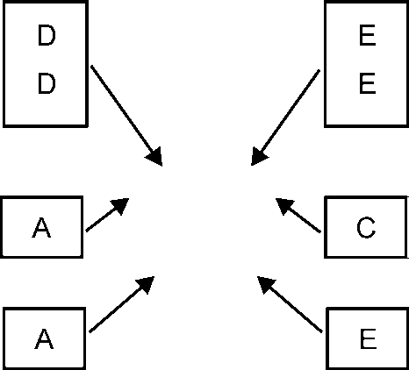

Merits/Advantages

**Fig. 8.1**

The main merits of fixed position layout are given as:

1. Minimum movement of material, men and tooling during process.
2. The type of product and the related processes can be easily changed without any change in the layout.
3. Handling of major assembly is reduced.
4. Highly skilled operators are allowed to complete their works at one point and responsibility for quality is fixed on one person.
5. Frequent change in product design and in sequence of operation is possible.
6. It is more flexible almost in all respects.

Demerits/Disadvantages

The main demerits of fixed position layout are given as:

1. Equipment handling cost is high
2. Labour and equipment is not fully utilized

### Process or Functional Layout

In this type of layout, similar machines or operation are grouped together. So, that all the operation of same type are performed at the same place always.

For example, all the lathes machine may be grouped together, all drilling machine in one area.

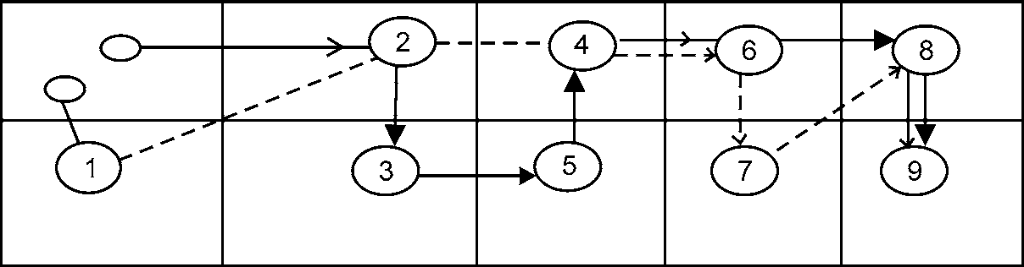

|  |  |  |  |
| --- | --- | --- | --- |
| 1. Forging | 2. Turning | 3. Milling | 4. Shaping |
| 5. Broaching  9. Finished Parts Stores | 6. Drilling | 7. Heat Treatment | 8. Inspection |
|  |  | **Fig. 8.2** |  |

202 MANUFACTURING PROCESSES

Advantages

The main merits of Process/Functional layout are given as:

1. Fewer machines needed. Hence, smaller capital investment required.
2. Worker monotony broken, because they are required to handle different varieties of jobs. Hence, the works become more interesting.
3. The product quality is better, because the worker do same type of job.
4. The available machinery and equipment are better utilized.
5. Permits easier maintenance.

Disadvantages

The main disadvantages of Process/Functional layout are given as:

1. Requires more floor area for layout.
2. Requires large inprocess inventory.
3. Material handling time and therefore the corresponding cost is higher.
4. Production control is relatively difficult.
5. Material handling process cannot be easily automated.
6. Total job completion time is more.

### Line Production or Product Layout

In this type of layout, all the machine are arranged in a line according to the sequence of operations. It is an ideal form of layout in which the handling time is minimum.

This type of layout is commonly used in continuous production, which involves a continuous flow of material from raw material stage to the finished product stage.



|  |  |  |  |
| --- | --- | --- | --- |
| 1. Raw Material | 2. Forging | 3. Turning | 4. Drilling |
| 5. Milling | 6. Grinding | 7. Inspection  **Fig. 8.3** | 8. Finished product. |

Advantages

The main advantages of line layout are given as:

1. Relatively less floor area required.
2. Production planning and control is easier and better coordinated.
3. Smaller inprocess inventory needed.
4. Workflow is continuous and smooth.
5. Overall product completion time is less.
6. Less inspection, less work in process.
7. Easier control

MANUFACTURING 203

Disadvantages

The main disadvantages of line layout are given as:

1. Less flexibility in layout.
2. Higher capital investment needed.
3. The rate of production is largely governed by the rate of the slowest machine.
4. Greater boredom due to highly respective nature of works.

### Combination Layout or Group Layout

Because of the much advantages and disadvantages associated with both the Process Layout as well as Product Layout, the best result can be obtained, by combining the advantageous features of both these layouts into a single one. And this is known as Combination Layout. In this type of layout a set of machinery or equipment is grouped together in a section and so on.

Advantages

The main advantages of Group layout is given as:

1. Reduction in machine setup time and cost.
2. Reduction in material handling cost.
3. Simplification of production planning function.

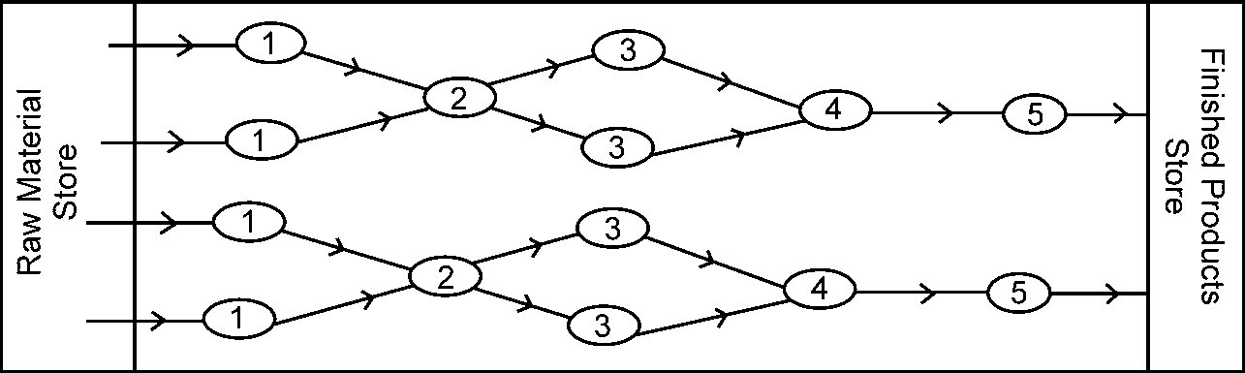

1. Forging Hammers 2. Inspection 3. Grinding

1. Heat Treatment 5. Final Inspection

**Fig. 8.4**

Disadvantages

The main disadvantages of Group layout are given as:

1. Chance of the existing layout to group layout is time consuming and costly.
2. Inclusion of new components in the existing component families requires through analysis.
3. Components that are processes on more than machine may create problems.

## SHOP LAYOUT

The technique for achieving an economical arrangement of manufacturing processes in conjunction with the plant services is called **SHOP LAYOUT**. Its main objective is to make efficient use of various machines, and equipment in a particular shop so as to facilitate the processing of the product in the most efficient and economical manner in the minimum possible time. Different types of shop layout are:

204 MANUFACTURING PROCESSES

### Fitting Shop Layout

This shop is equally significant as the other shops, and forms an essential part of almost all workshops. The various operations performed in a fitting shop are marking and measuring, hack sawing, filing, scraping, drilling and tapping. The fitting shop plays a very important role in all the engineering concerns dealing with the manufacturing or repairing works. The final finishing is done by hand operation in filling shop.

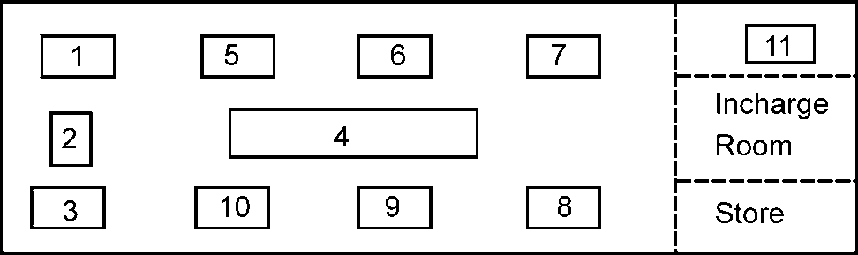

|  |  |  |  |
| --- | --- | --- | --- |
| 1. Grinder | 2. Power saw | 3. Bench drill | 4. Marking table |
| 5-10. Working tables | 11. Inspection table |  |  |

### Welding Shop Layout

**Fig. 8.5**

The various operation performed in a welding shop are joining and cutting metal parts by application of heat. It is very useful shop in fabrication, erection and maintenance works.

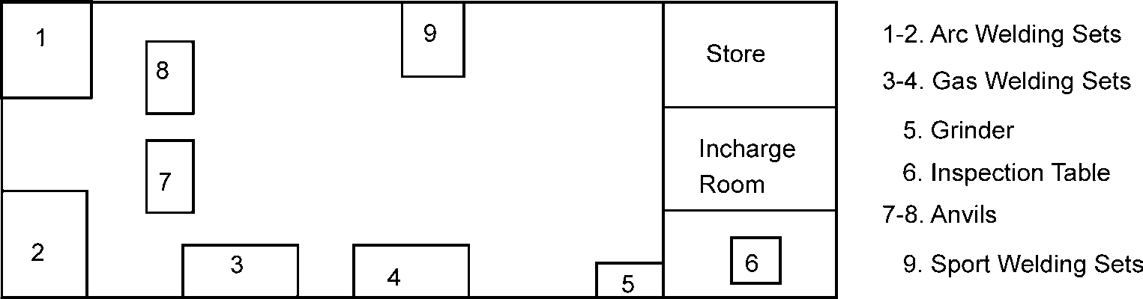

### Forging Shop Layout

**Fig. 8.6**

Here various forging operation like upsetting , drawing out, bending, cutting, punching and drifting, swaging and forge welding can be performed.

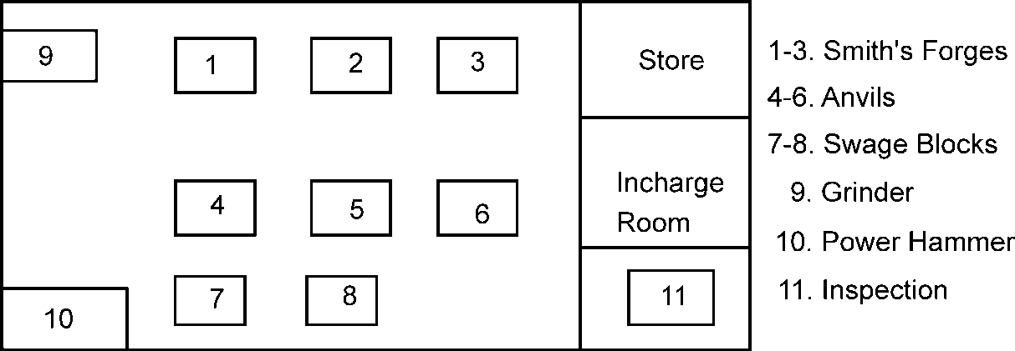

**Fig. 8.7**

MANUFACTURING 205

### Machine Shop Layout

It is actually the life of all good workshops and involves the maximum initial investment as compared to other shops. All the common machining operations like plain turning, step, radius and taper, shaping, turning, knurling, grooving, drilling, boring, milling, grinding and other similar operations can be successfully performed in this shop.

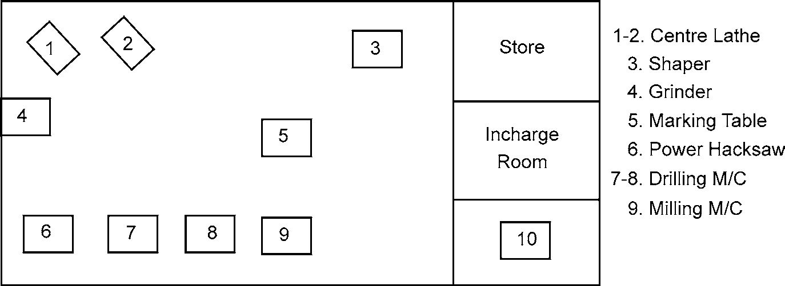

**Fig. 8.8**

## TYPES OF PRODUCTION

The production systems vary from factory to factory and from product to product. However, one of the most important issues is production volume that is proposed to be produced. The most common types of production systems are:

1. Job order production
2. Batch order production
3. Continuous production
4. **Job Order Production:** This type of production system is characterized by the low production volume which is related with the manufacture of products to meet the specific consumer requirements. This is usually concerned with special projects, special equipment or machinery to perform specialized and specific tasks-large turbo generators, boilers, processing equipment, material handling equipment and ship buildings etc. are examples of this production group.

Job order production can be of following three types as per regularity of manufacture i.e:

1. Small number of products produced once only.
2. Small number of pieces produced intermittently when the need arises.
3. Small number of pieces produced periodically at known time intervals.

There is little scope for improvement of manufacturing technique, if the order is to be executed once only by introducing intricate method studies, special tools, jigs and fixtures etc. However, if the order is of a repetitive nature, tooling and jigging as well as special purpose inspection gauges should be carefully considered to reduce unproductive time and to accelerate work oriented activities.

1. **Batch Order Production:** This type of production is suited for medium volume lot of the same variety either to meet a specific order or to satisfy the demand of the market. When the production of a specific batch is terminated, the plant facilities are available for the production of other similar products as per market demand.

206 MANUFACTURING PROCESSES

Batch order production can be of the following types:

1. A batch produced only once.
2. A batch produced repeatedly at irregular intervals when the need arises.
3. A batch produced periodically at known intervals to satisfy continuous demand.

Batch production is a very common feature in the industry. Machine tool manufacturing, press work, forging and casting processes, some glass manufacturing and chemical processes very often operate on batch basis.

1. **Continuous Production:** This type of production is the specialized manufacturing of iden- tical products/goods for which the equipment/ machinery is fully engaged. Production rate is generally very high. Continuous production is justified only when the production rate can be sustained by the market. In this type of production, full advantage should be taken of repeti- tive operations in the design of production aids such as special tools, fixtures, positioners, material handling system and -inspection devices etc.

There are two types of continuous production such as:

1. Mass Production
2. Flow production

**Difference between mass and flow production:** In mass production, a large quantity of identical products is produced but in spite of advancements in automation and mechanization, no special purpose tooling and equipment is needed for one type of product alone. Both the plant and equipment are flexible enough to deal with other products involved in the same production processes. Hence, without major modifications, the equipment can be utilized for manufacturing other products in view of a change in demand.

In flow production, the plant, its equipment and lay out are primarily designed to manufacture the product in question. Notable examples are household machinery automobiles, engines and chemical plants etc. A decision to switch over to a different kind of product may not only result in extensive tooling but also to the basic changes in layout and equipment policy especially when special purpose equipment and complex materials handling systems are involved.

## PRODUCTION AND PRODUCTIVITY

A manufacturing plant or a factory is designed for a certain production which may be expressed in terms of number of products per unit time, i.e., number of cars per day or per month or per year. The production may also be expressed in terms of value of production, i.e., a turnover of Rs. two thousand crores per year.

The productivity is the efficiency or effectiveness of a manufacturing process and may be expressed as production output for a given input. The input may be machines, materials or men. Therefore, we can have labour productivity, machine productivity, material productivity or energy productivity depending upon the input resource which we want to optimize. The productivity consists of increasing the production with or without increasing the corresponding input (i.e., machine hours, man-hours, quantity of material or fuel/power consumption.)

MANUFACTURING 207

# OBJECTIVE QUESTIONS

1. Process layout is employed for
   1. Batch production (b) Continuous type of product

(c) Effective utilization of machines (d) All of above

1. The most important objective behind plant layout is
   1. Overall simplification (b) Economy in space

(c) Maximum travel time in plant (d) To avoid any bottlenecks

1. The process layout is best suited where
   1. Specialization exists
   2. Machines are arranged according to sequence of operation
   3. Few no of non-standardized units are to be produced.
   4. Units are to be produced
2. In which of the following layouts, the lines need to the balanced.
   1. Processes layout (b) Product layout

(c) Fixed position layout (d) Plant layout

1. Which of the following layout is suited for job production
   1. Process layout (b) Product layout

(c) Fixed position layout (d) Plant layout

1. For ship vessel industry which of the following layout is best suited
   1. Process layout (b) Product layout

(c) Plant layout (d) Fixed position layout

1. Which of the layout is suited for mass production?
   1. Process layout (b) Product layout

(c) Fixed layout (d) All of above

1. Layout suitable for automobile manufacturing unit is:
   1. Process layout (b) Product layout

(c) Combination layout (d) All of above

1. A product layout is preferred for:
   1. Batch production (b) Continuous type of production

(c) Effective machine utilization (d) All of above

1. The product layout should be used when there is
   1. Low volume of production on individual items
   2. Adequate time and motion study is difficult to make
   3. Large volume of production on individual items
   4. All of above

**ANSWERS**

|  |  |  |  |  |
| --- | --- | --- | --- | --- |
| 1. (a) | 2. (a) | 3. (c) | 4. (b) | 5. (b) |
| 6. (d) | 7. (b) | 8. (b) | 9. (b) | 10. (c) |

208 MANUFACTURING PROCESSES

# SHORT ANSWER QUESTIONS

1. Differentiate between product and process layouts. Give any two examples of each. Dec-01
2. Write notes on plant layout. May-02
3. Write notes on classification of manufacturing process. May-02
4. Write notes on primary shaping processes. C.O.-02
5. Write notes on types of plant layout. Dec-03
6. Write notes on classification of manufacturing processes. Dec-03
7. Write short notes on primary shaping processes. May-03
8. Write short notes on surface finishing processes. May-03
9. What is plant layout? Explain in brief. May-03
10. How selection of materials is important in manufacturing.
11. Explain manufacturing system.
12. What are the major classifications of basic manufacturing process?
13. Indicate the criteria for economical production.
14. Explain why the understanding of manufacturing processes is essential for better products.
15. Describe various factor effecting the Plant location.
16. Define Plant layout and list the objective of good plant layout.
17. What do you understand by the term plant layout and shop layout?
18. What is the difference between joining and assembly process.
19. What is the difference between process and Product layout?
20. Explain different types of production system.
21. Differentiate between production and productivity.

# LONG ANSWER QUESTIONS

1. Classify various manufacturing processes. Differentiate between Production and Productivity.

Dec-00

1. Define plant layout and list objectives of plant layout. Dec-02, C.O.-02
2. How do you classify the different types of layout? Explain the principle of product layout with neat sketch.

❍ ❍

**NON-METALLIC MATERIALS**

9

## WOOD

Wood is available in nature in the form of trees. Useful part of the tree is cut and is used for carpentry work. Trunk is the most useful parts of the tree.

### Timber

The wood is obtained from fully grown trees cut and is prepared for engineering purposes. This wood is known as timber. The following technical terms relating to timber are follows:

1. **Standing or Stationary Timber:** It is the timber available from a living tree.
2. **Rough Timber:** It is the timber obtained after felling a tree.
3. **Converted Timber:** It is the timber, which has been sawn into various market sizes such as beams, battens, planks etc.
4. **Dressed Timber:** It is the timber, which has been sawn, placed and worked to the required condition.
5. **Structural Timber:** It is the timber used in framing and load bearing structures.

### Advantages of Timber/ Wood

1. It is easily available and can be quickly transported by the simple means.
2. Easy to work on it.
3. Lighter in weight and stronger than most of the material used in construction work.
4. Low Cost.
5. It is quite suitable for sound proof construction.
6. It is non-conductor of heat.
7. Good response to polishing and painting.
8. Very suitable for doors, windows and furniture work.
9. Good strength.

210 MANUFACTURING PROCESSES

### Common Type of Wood

All trees are broadly divided into two classes according to their mode of growth.

1. Endogenous
2. Exogenous
   1. Conifers or Evergreen Trees (Soft Wood)
   2. Deciduous or Broad-leaf Trees (Hard Wood)
3. **Endogenous Trees:** Endogenous Trees are those which grow inwards in a longitudinal fibrous mass such as palm, bamboo, cane and coconut, banana etc. Even though the stem of trees of this class is light and tough yet it is too flexible and slender to furnish material suitable for engineering work, with the exception of bamboo.
4. **Exogenous Trees:** Exogenous Trees are those which grow outward from the centre add- ing almost concentric and distinct layer of fresh wood each year in the form of annual ring. Since one ring is added to the tree every year so the number of annual rings in the stem of a tree indicates its age in years.

It is timber obtained from this class of trees that is extensively used in engineering works.

These trees are further divided into

* 1. Conifers or evergreens, and
  2. Deciduous or broad-leaf trees.

**Conifers or evergreen trees** are those which yield soft wood such as Deodar, Kail, Cheer, Pine, Walnut, Fir, Semal and Toon etc.

**Deciduous or broad-leaf trees** are those which yield hard wood such as Sal, Teak, Shisham, Oak, Beach, Ash, Ebony, Mango, Neem and Babool. It is the hard wood which is used mostly in engineering works.

For commercial purposes, generally, the wood may be divided into two classes namely SOFTWOOD, HARDWOOD another type of wood is PLYWOOD.

1. **Soft Wood:** Soft wood are light in weight and colour. The soft wood is obtained from trees having needle shaped leaves or conifers. The various soft woods are Kail, Pine, Deodar, Cheer, Walnut and Semal. It is widely used for building construction.
2. **Hard Wood:** These woods are heavy strong and dark in colour. The fibres are fine grained, compact, properly bounded and often found very straight. So, hard wood are nearly equally strong both along and across the fibres and can resist axial stress as well as transverse strain, shocks and vibrations quite satisfactorily. The various hard woods are Shisham, Teak, Babool, Neem, Mango, Oak, and Beach. Widely used for doors, furniture and joinery.

### Difference between Softwood and Hardwood

***Soft Wood Hard Wood***

1. It is light in color and weight. 1. It is dark in color and heaver in weight.
2. It has straight fibres and fine texture 2. Its fibres are quite close and compact.
3. It has a good tensile resistance but it weak 3. It has both good tensile as well as shears resistance. across the fibres.
4. It is easy to be worked 4. It is hard and difficult to be worked.

NON-METALLIC MATERIALS 211

1. Annual rings are distinct 5. Annual rings are non-distinct.
2. It splits easily 6. It does not splits easily
3. It is weaker and less durable 7. It is strong and durable
4. It can not withstand high temperature 8. It is not easily combustible.

Ex. Spruce, Deodar, Cheer, Kail and Walnut Ex: Shisham, Sal, Teak, Oak, Mahagony and Babul

### Plywood

Plywood is made up of three layers. Out of these the central layer called core is usually thicker and of relatively inferior wood than the face veneers. The veneers glued at the top and bottoms are known as FACE-PLYS. The surface grains of adjacent layers are kept at right angles to each other. This arrangement prevents the plywood from warping and shrinkage. In case of 5-plywood two more plys are incorporated. They are known as cross-bands. The outer plys in the plywood are always called FACE PLYS and the total no of plys, including the core is always an odd number i.e., 3, 5, 7 and 9 etc. The common method of joining the ply for obtaining the plywood is the following.

1. Cold pressing method
2. Hot pressing method

### Advantages of Plywood

1. It is lighter in weight than a solid stock of the same thickness.
2. It is much stronger than solid stock of the same thickness.
3. It can be obtained in very large size which is impossible in solid wood.
4. It can be easily worked and bent into shape of different design.
5. Nails and screws can be driven close to the edge of plywood without any danger of splitting.
6. Top veneers can be given fine decorative effect to give attractive appearance.

## USE OF WOOD

Wood as a forest product had been in use by mankind for building and household works right from the beginning of civilization. Even today the wood is an important and preferred material for several applications in buildings such as doors, windows and paneling of walls, roofs and floors for decoration and insulation against heat and sound. Quality furniture’s, cabinet works and show cases are still made from wood only. In terms of strength to weight ratio, wood is generally stronger and lighter than many other alternative engineering materials. Besides being cheaper and readily available, wood is handled easily and converted into different usable forms with the help of simple tools and cheaper labour. When protected and treated properly, the life of wood can be increased considerably. There are some treatments that make the wood fire resistant. Such treated wood is used for decoration purposes in prestigious buildings.

In short wood is used for the following categories of works:

1. For construction purposes
2. Railway sleepers
3. Bridge
4. For furniture and cabinet making.
5. For light packing cases.

212 MANUFACTURING PROCESSES

1. For heavy packing cases (For machinery and similar stores).
2. For manufacturing agricultural implements and tool handles.
3. For making turnery articles and toys etc.
4. For manufacturing veneers and plywoods.

## CEMENT CONCRETE

Cement concrete is a simple material in appearance with a very complex internal nature. In contrast to its internal complexity, versatility, durability, and economy of concrete have made it the most used construction material in the world. This can be seen in the variety of structures it is used in, from highways and bridges to buildings and dams.

Concrete is a mixture of Portland cement, water, and aggregates, with or without admixtures. The Portland cement and water form a paste that hardens as a result of a chemical reaction between the cement and water. The paste acts as glue, binding the aggregates (sand and gravel or crushed stone) into a solid rocklike mass. The quality of the paste and the aggregates dictate the engineering properties of this construction material. Paste qualities are directly related to the amount of water used in relation to the amount of cement. The less water that is used, the better the quality of the concrete educed water content results in improved strength and durability and in reduced permeability and shrinkage. As the fine and coarse aggregates make up 60 to 75% of the total volume of the concrete (Figure 9.1), their selection is important. The aggregates must have adequate strength and resistance to exposure conditions and must be durable.

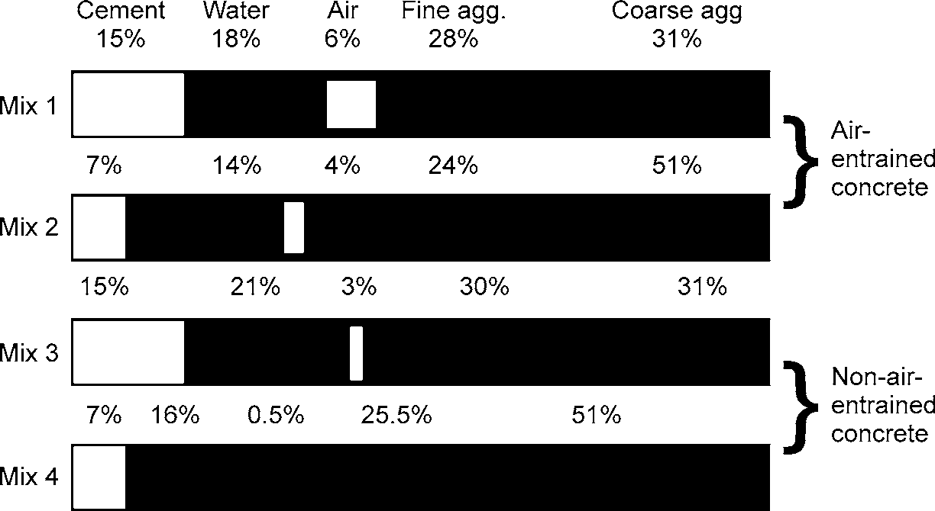

**Fig. 9.1:** Range of Proportions of Materials Used in Concrete

### Cement Concrete Properties

1. **Strength:** Concrete gains strength by the reaction between cement and water called hydra- tion. Portland cement is primarily calcium silicate cement. The calcium silicate combines with water and forms calcium silicate hydrate, which is responsible for the primary engi- neering properties of concrete, such as setting, hardening, strength, and dimensional stability. The compressive strength of concrete increases with age as long as an appropriate moisture content and temperature are available.

NON-METALLIC MATERIALS 213

In order to maintain this increase in strength, concrete must be properly cured. Curing means that not only will a favorable temperature be present, but also moisture loss will not be permitted or extra water will be provided at the surface.

The compressive strength of concrete is directly related to the water/cement ratio. A de- crease in water/cement ratio results in higher strength.

Although concrete is very strong in compression, it is weak in tensile strength.

1. **Density:** The density of concrete varies with the relative density of the aggregate, the amount of air present in the paste, and the amount of water and cement in the mixture.
2. **Permeability:** Concrete permeability is a function of the permeability of the paste and aggregate and the interface between them. Decreased permeability improves the resistance of concrete to saturation, sulfate attack, chemical attack, and chloride penetration. Paste permeability has the greatest influence on concrete permeability. Paste permeability is directly related to the water/cement ratio and the degree of hydration or length of moist curing. A low water cement ratio and an adequate moist-curing period result in concrete with low permeability.
3. **Abrasion Resistance:** Abrasion resistance is directly related to the compressive strength of the concrete. The type of aggregate and the surface finish also have a strong influence on abrasion resistance. A hard aggregate, such as granite, would provide more abrasion resistance than a soft limestone aggregate.
4. **Volume Change and Crack Control:** As the concrete shrinks, tensile stresses develop that can exceed the tensile strength of the concrete, resulting in crack formation. The primary factors affecting volume change are temperature and moisture changes. Concrete expands slightly as temperature rises and contracts as temperature falls. Concrete expands slightly with a gain in moisture and contracts with a loss in moisture. The amount of shrinkage is directly related to the amount of water in the concrete. Higher water content results in higher shrinkage.

Drying-shrinkage is an inherent and unavoidable property of concrete; therefore, properly positioned reinforcing steel is used to reduce crack widths or joints are used to predetermine or control the location of cracks. Shrinkage control joints should be spaced about 25 to 30 times the thickness of a concrete slab on ground.

1. **Deformations and Creep:** Concrete will deform a small amount when a load is placed on it. When concrete is loaded, the deformation caused by the load can be divided into two parts: a deformation that occurs immediately, such as elastic strain, and a time-dependent deformation that begins immediately but continues at a decreasing rate for as long as the concrete is loaded.

This latter deformation is called creep. The amount of creep is dependent on the magnitude of the stress, the age and strength of the concrete when the stress is applied, and the length of time the concrete is stressed. Creep is of little concern for normal concrete pavements, bridges, and small buildings; however, creep should be considered in design for very tall buildings or very long bridges.

214 MANUFACTURING PROCESSES

## CERAMICS

Ceramics are non-metallic solids, made of inorganic compounds such as oxides, nitrides, borides, silicides and carbides for which the interatomic bonds are either totally ionic or predominately ionic or having some covalent character. Common ceramics includes rocks, minerals, glass, glass fiber, metallic compounds, fire clays, abrasives etc.

The term ceramics comes from the Greek word “KERAMIKOS” which means ‘burnt stuff’ indicating that the desirable properties are achieved through higher temperature heat treatment process called firing. The Science of Ceramics is processing of earthly materials by heat. All the early ceramics products were made from clay because the ware could be easily formed. It was then dried and fired to develop the permanent structure.

Other forming methods used for ceramic materials are injection moulding, sintering and hot pressing. In other cases, the formed materials are allowed to harden on the job by addition of water as in case of cements.

Ceramic materials are more stable with respect to thermal and chemical environments than their components. Ceramics offer more resistance to slip, are generally harder and always less ductile than their metallic or polymeric counter parts. The dielectric, semi-conductive and magnetic characteristics of selected ceramics are especially valuable to the scientists and engineers who design or utilize devices for electronics circuits. All these materials are compounds of metals and non-metals.

### Classification of Ceramic Materials

Ceramic materials are classified as

1. Naturally occurring ceramics; which includes rocks and their products such as gravel, sand, clay etc. Most of the rocks contain silica, alumina and oxides of sodium, calcium, magne- sium, iron, titanium etc. Silica is about 60% and alumina is about 15% of the total mass of rocks. Other ceramic materials are clay, quartz,
2. Ceramics, produced from minerals by the action of heat by different technique, are called *clay products*. They form important class of engineering materials e.g., bricks, mortar, tiles, porcelain, cement, glass china ware, lime, gypsum, plaster etc.
3. Refractory ceramic materials can withstand action of heat without appreciable softening, have high melting point. These include fire clay and high alumina clay. The most commonly used refractory materials are based on alumina--silica composition-other refractory materials are dolomite, zircon, magnesite silicon carbide. Refractory materials posses high melting point, high thermal shock resistance, high wear resistance, high hardness, high thermal conductivities, high chemical resistance and low thermal expansion.
4. Glass ceramic materials usually contain magnesium or lithium ions. Silica is ideal glass forming material, which has high melting point.
5. They are hard and have greater impact strength. They soften at very high temperature. Ceramic glasses are non-porous. Different types of glasses are available such as pure silica glass (99.8% SiO2), soda lime glass (Na2O CaO, 6SiO2,), lead glass (15-30% PbO) etc.

NON-METALLIC MATERIALS 215

### Processing of Ceramics

The manufacture of ceramics includes shaping with or without the application of pressure and consolidation by firing. The characteristics of the ceramic and its cost depend on the process, which must be used. The simplest (and cheapest) is compaction and sintering.

Compaction may be carried out by a variety of processes, which may involve the addition of a binder or lubricant or may include the application of pressure. ‘Sintering’, in its pure sense, implies the densification of an assembly of particles at high temperatures by solid-state diffusion processes. This process is relatively slow, needs very high temperature and a dense impervious body is achieved only with difficulty. Ceramics other than oxides may require a protective atmosphere.

Verifications (or liquid-phase sintering) is achieved by incorporating a component, which melts to a viscous liquid during sintering and solidifies (in the case of a clay-based ceramic) to a glassy phase. The term ‘well vitrified’ indicates that a dense impervious body has been achieved.

‘Reaction bonding’ is achieved by arranging for two or more components of a compacted body to react to form both a desired phase and a bond between particles. The reacting components may all be solid or one of them may be gaseous or liquid and introduced during the sintering process. ‘Self- bonding’ is bonding the major constituent of a ceramic with its constituents formed by reaction during sintering.

‘Hot pressing’ is achieved by the application of pressure during sintering. There are two variants. Hot pressing as commonly understood consists in applying pressure unidirectional by a plunger acting on material in a rigid container. Hot hydrostatic pressing consists in submitting the material contained in a membrane to hydrostatic pressure during heating. Both processes produce material of a higher density and superior quality more quickly than can be achieved by sintering but they are substantially more expensive and component shape is restricted.

Pyrolysis is the process whereby a ceramic is deposited from a gaseous environment onto a (usually) heated substrate. This process is usually employed to deposit coatings or produce thin- walled components of graphite or silicon carbide from carbon or silicon-containing gas.

### Applications of Ceramics

Existing and potential applications include automotive, biomedical, power generation, heat exchangers, wear materials, aerospace and military applications, cutting tools, and various other technologies. Material selection is governed by the environmental conditions of each application.

Ceramics have a wide range of applications in manufacturing technology and even wider applications in domestic use. If they are to achieve the really widespread engineering application that their properties appear to merit they must find this in some field such as the automotive industry. Some components, including oxygen sensors, catalyst supports, diesel glow plugs, rocker arm pads, pre-combustion chambers and turbocharger rotors have already been standardized, usually

for high efficiency and military engines.

The major problem is that, depending on fabrication procedure, the cost of a ceramic component is from five to fifteen times that of the presently used steel component so that a substantial improvement in performance or a marked reduction in cost is required to justify the use of the ceramic. The potential advantage of materials such as sialons, which combine excellent properties and a relatively inexpensive manufacturing route (sintering), is evident.

216 MANUFACTURING PROCESSES

### Properties of Ceramics

The main properties of ceramics are low fracture toughness compared with metals. Conversely, ceramics excel at high-temperature behavior; have low density/weight ratios, high stiffness, and chemical inertness. At the present level of technology, there is a trade-off between high strength and high toughness. To get a high-strength material usually requires a fine-grain-sized ceramic, while a tough ceramic material often has elongated grains or reinforcement phases that are usually quite large.

## RUBBER

Various types of rubber are as follows:

### Natural Rubber (India Rubber)

It is present as an emulsion in the latex of certain plants growing in Ceylon, Singapore, Malaya and Mexico etc. Latex is tile Milky colloidal fluid oozing from vertical grooves having an upward inclination cut around the trunk of the rubber trees. Pots are tied to the trunk of trees for collection of latex. Crude rubber is obtained from the latex by its coagulation with acetic acid, alcohol, alum or lime etc. Coagulation of latex is achieved even by heating. In certain cases the latex is mixed with appropriate compounding materials and then precipitated directly from the solution to the shapes required. More modern methods are used these days for obtaining rubber from the latex.

Crude rubber becomes hard and brittle in winter and soft and sticky in summer. It is, therefore subjected to following treatments to improve and modify its properties.

1. Compounding

To crude rubber are added certain compounds to modify its properties. The compounds that are added are vulcanizing agents, plasticizers, accelerators, fillers, hardners, reinforcing agents and pigments.

**Vulcanizing agents** are substances like sulphur which when added to crude rubber reduce its plasticity while maintaining its elasticity.

These are essential for vulcanization of rubber.

**Plasticizers** are materials like vegetable oils, rosin and wax etc. that soften the crude rubber.

**Accelerators** are substances like white lead, lime, magnesia etc. which when added hasten the process of vulcanization and reduce the requirements of sulphur.

**Fillers** are substances like lamp black, oxide of iron or zinc, china clay, magnesia, and silica etc. that modify the properties of rubber and at the same time reduce its cost. Substances that increase tensile strength of rubber are called reinforcing agents. Lamp black and zinc oxide are both fillers and reinforcing agents.

**Hardners** are substances like barium sulphate, calcium carbonate and sealing wax that give hardness to rubber and increase its tensile strength. Hard rubber withstands high temperature better.

**Pigments** are substances like ferric oxide, lithophone and lead chromate etc. that are added to give desired colour to rubber. Compounded rubber is hard, tough, weather and water resistant.

1. Calendering

Calendering is the operation of passing rubber between large steel rollers kept at controlled

NON-METALLIC MATERIALS 217

temperatures and pressures. The rollers press rubber into sheets of desired thicknesses and sizes.

1. Vulcanization

Vulcanization treatment of rubber with sulphur or compounds resulting in a change in the properties of rubber is known as *Vulcanization*. Vulcanization renders it useful for all seasons. Vulcanization with 1 to 5 per cent sulphur produces soft rubber whereas with 30 per cent sulphur produces hard rubber. Increasing sulphur gives harder and less flexible product. Full vulcanization requiring about 45 per cent sulphur will give rise to a fully rigid product known as Ebonite.

Sulphur is absorbed by rubber when they are heated together at 1350C to 1600C. To accelerate the process of vulcanization accelerators may be used. Vulcanization makes natural rubber much less sensitive to change of temperature, more elastic and strong, more durable and resistant to action of water, base and dilute acids. It is a bad conductor of heat, resistant to abrasion, tough and shock absorbent. It can be moulded to any shape.

### Reclaimed Rubber

Rubber waste and worn out rubber articles are treated for reuse and the rubber so obtained is called reclaimed rubber. Worn out rubber and rubber waste is cleared of all metal or other matter and heated with alkali solution in closed steel vessels. Separate fabric contents and free sulphur. The treated rubber is washed with clean water and then dried to get what is called the reclaimed rubber. Reclaimed rubber may be mixed with some raw rubber. Reclaimed rubber is cheaper, is of uniform composition, more durable, more easily compounded, vulcanized and moulded. However, it has low elasticity, low tensile strength and poor resistance to friction.

### Sponge Rubber

It can be obtained by adding sodium-bicarbonate during vulcanization. Small pores are left on evaporation of moisture from within the rubber. This rubber has better heat and sound insulating properties.

### Synthetic Rubber

Important varieties of synthetic rubber are obtained from petroleum, coal tar and alcohol. Properties of synthetic rubber, though similar to those of natural rubber can have wider variations. Synthetic rubber has better resistance to light rays, weather, acids, oils and greases etc. Synthetic rubbers are getting more popular than natural rubbers and have wider uses.

### Various Types of Synthetic Rubber

The synthetic rubbers or elastomers are any Vulcanisable rubber-like polymers which can be stretched at least twice its length on loading in tension and returns to its original dimensions as soon as the load is released. Though there are many types of synthetic rubbers, yet the following are commonly used;

1. **Styrene rubber:** It is the most important type of synthetic rubber, which is produced by copolymerization of butadiene (75% by weight) and styrene (25% by weight). It resembles natural rubber in processing characteristics as well as quality of finished products. It possesses high abrasion resistance, high load bearing capacity and resilience. It is mainly used for manufacturing motor tyres.

218 MANUFACTURING PROCESSES

1. **Nitrile rubber:** It is a copolymer of butadiene and acrylonitrile. It possesses excellent resistance to heat, sunlight, oils, acids and salts. It is used for making conveyor belts, aircraft components, tank-lining, hoses, gaskets, printing rollers, adhesives and automobile parts etc.
2. **Polychloroprene rubber:** It is made by polymerization of chloroprene, a chlorinated butadiene. It is popularly known by its trade name Neoprene. It is resistant to oils, heat and light. Its general properties are improved by compounding it with metallic oxides such as ZnO or MgO. It is used for making hoses, gaskets, tubes for carrying corrosive gases and oils, conveyor belts, adhesives etc.
3. **Butyl rubber:** It is made by copolymerization of iso-butylene with small amount (usually 1 to 5%) of isoprene. It has excellent resistance to heat, abrasion, and chemicals. It has also good electrical insulating properties. It is used for making cycle and automobile tubes, hoses, conveyor belts, tank linings, insulation for high voltage wires and cables etc.
4. **Polysulphide rubber:** It is made by the reaction between sodium polysulphide and ethylene dichloride. It possesses extremely good resistance to mineral oils, fuels, solvents and sunlight. It is used for making hoses, gaskets, cable coverings, oil tank linings etc.

## PLASTICS: INTRODUCTION

The plastics are synthetic organic materials which can be moulded into any desired shape when subjected to heat and pressure. These materials are prepared from natural or synthetic resins with or without the moulding compounds. These moulding compounds are mixed with the granular resins before moulding.

The plastics, are mostly used in the manufacture of aeroplane and automobile parts. They are also used for making safety glasses, laminated gears, pulleys, self-lubricating bearings.

### Raw Material for Plastics

In general, the plastics are compounds of carbon with other elements such as oxygen, hydrogen and nitrogen. The carbon combines with itself and other elements and forms more complicated compounds.

The raw material for plastic compounds are various agricultural products and numerous minerals and organic materials including petroleum, coal, gas, limestone, silica and sulphur. The natural resins are wax, shellac, pitch, bitumen resin, rubber etc. The synthetic resins, for the plastic materials, are produced by linking together a large number of small molecules of synthetic resin (known as monomers or monoliths) which forms large or long-chain molecules known as polymers (poly means many and mers means units or parts). The process by which monomers are combined to form polymers is known as polymerization. The following two methods are used to achieve polymerization.

1. Addition polymerization, and
2. Condensation polymerization.

In addition polymerization, two or more similar monomers directly react to form polymers. The condensation polymerization takes two or more dissimilar monomers that react to form polymers plus the by-product water.

### General Properties of Plastics

The following are the general properties of plastics due to which it is widely used in engineering practice.

NON-METALLIC MATERIALS 219

1. Lightness in weight. The specific gravity varies from 1 to 2.4.
2. Easy workability. The plastics can be easily casted, moulded, drilled, machined etc.
3. Highly resistant to corrosion.
4. Highly resistant to abrasion.
5. Good thermal and electrical insulators.
6. Good strength and rigidity.
7. Absorbent of vibrations and sound.
8. Good resistant to most of the chemicals.
9. Impermeable to water.
10. Low fabrication cost.
11. Good dimensional stability.
12. Can be made transparent or coloured.

### Type of Plastics

The plastics are broadly classified in the following two groups:

1. Thermosetting plastics, and
2. Thermoplastic materials.
3. **Thermosetting plastics:** The thermosetting plastics (also known as heat-setting materials) are those plastics which are formed into shape under heat (in the temperature range of 1270C to 1770C) and pressure and results in a permanently hard product. The heat first softens the resins and when special chemicals are added, it becomes hard by a chemical change known as polymerization. The reheating does not soften them again. The thermosetting plastics are soluble in alcohol and other organic solvents when they are in thermoplastic stage. This property is utilized in making paints and varnishes from plastics. These plastics are hard, strong and durable. These are manufactured in a variety of beautiful colours.
4. **Thermoplastic materials:** The thermoplastic materials (also known as cold-setting materials) are those plastics which do not become hard with the application of heat and pressure and no chemical change occurs. They remain soft at elevated temperatures and become hard on cooling. They can be remelted repeatedly by the successive application of heat. These plastics are better than thermosetting plastics because they can be used again and again. The scrap obtained from the moulding operations and rejected articles can be shaped into granules and reused to make first quality products. These plastics are used for makings toys and other ordinary purposes.

### Types of Thermosetting Resins

The following are the various types of thermosetting resins :

* + - * 1. **Phenolic resins:** The most important of the phenolic resins is phenol formaldehyde. It is obtained by condensing the phenol with formoldehyde in the presence of a catalyst. It is popularly known by its trade name of Bakelite, after the name of its inventor Dr. L. Bakelite.

It is a hard, rigid and scratch resistant material. It is highly resistant to heat, water, non-oxidizing

220 MANUFACTURING PROCESSES

Notes:

acids, salts and many organic solvents. It possesses excellent electrical insulating property. It is one of the cheapest material of all the thermosetting resins.

It is used in manufacturing handles for cooking pots, knobs, toilet seats, bottle caps, dials, telephone parts, cabinets for radio and television, electrical components like switches, plugs, switch boards etc. It is also used as a binder in paints and varnishes and as an adhesives for grinding wheel.

1. *The phenol is carbolic acid, obtained as a by-product during distillation of organic substances such as wood or coal.*
2. *The phenolic resins are used with a variety of fillers to modify the properties. For example, wood flour for general purpose, asbestos for heat resistance and mica for electrical insulation,*
3. *The phenolic resins may be moulded by compression or transfer moulding methods.*
   * + - 1. **Amino resins:** The two important amino resins are urea formaldehyde and melamine formaldehyde. These are condensation products obtained by the reaction of urea or melamine with formaldehyde. The amino resins can be produced in a wide range of colours and are hard, rigid and durable. They possess good electrical properties and are heat and scratch resistant.

The urea formaldehyde is widely used in domestic electrical fittings such as switch covers, plug tops, socket bases and lamp sockets. It is also used for cabinets, toilet seats, buttons and clock cases.

The melamine formaldehyde, due to good flowability of melamine, is principally used for moulded cups, plates, saucers, bowls etc.

Both the resins are used as coatings and adhesives.

Notes:

1. *The urea is obtained by mixing liquid carbon dioxide and liquid ammonia under heat and pressure.*
2. *The melamine is obtained from calcium carbide. ‘*
   * + - 1. **Furane resins:** The furane resins are obtained when waste farm products such as cotton seeds, rice hulls, corncobs are processed with certain acids. These resins are dark in color, water resistant and have good electrical properties. These are used as core sand binders and as hardening additives for gypsum plaster.
         2. **Silicon resins:** The silicon resins differ from most other resins which are based on the carbon atom. The silicon resins have silicon and oxygen chains which are linked various organic groups such as methyl side groups.

The silicon resins may be in the form of liquids, semi-solids (like greases), rubbers and solids. The liquid silicones or silicon oils possesses great wetting power for metals, low surface tension and show very small changes in viscosity with temperature. These are used as high temperature lubricants, anti-foaming agents, water-repellent finishes for leather and textiles heat transfer media, damping and hydraulic fluids. They are also used in cosmetics and polishes.

NON-METALLIC MATERIALS 221

Note:

The silicones in the semi-solid form (i.e., silicon greases) are modified silicon oils and are obtained by adding fillers like silica, carbon black etc. These are particularly used as lubricants in situations where very high and low temperatures are encountered.

The silicones in the rubber form have high abrasion resistance, stability at high temperatures and remain flexible even at very low temperatures. They are mostly used in gaskets, insulations and as additives in other rubbers.

The solid silicones possesses good electrical insulating properties and outstanding heat resistance. They are mostly used in high voltage insulators, high temperature insulating foams and mouldings which require high thermal stability.

*The silicon resins can be processed by compression or transfer moulding, extrusion and casting.*

* + - * 1. **Epoxy resins:** The epoxy resins are obtained from certain special types of organic chemicals, specifically epichlorohydrin and bisphenol (double phenol). These are cured or cross-linked by the addition of a hardner. The cured epoxy resins have low shrinkage, good flexibility, excellent chemical resistance and electrical insulating properties.

These are used for surface coatings, adhesives for glass and metals, and laminating materials used in electrical equipments. The moulds made from epoxy resins are employed for the production of components for aircrafts and automobiles.

* + - * 1. **Polyester resins:** The polyester resins are obtained by the reaction between a dihydric alcohol and a dibasic acid. They are divided into the following three groups:

Saturated polyesters,

Unsaturated polyesters, and

Alkyds.

The saturated polyesters are obtained by reacting glycol with saturated dibasic acid. They are a good fibre forming materials and are converted into commercial fibres. Such fibres have high scratch resistance, high crease and wrinkle resistance. They are mostly used for making synthetic fibres like terylene, dacron etc.

The unsaturated polyesters are made by reacting glycol with unsaturated dibasic acid (like maleic anhydride). They have good flexural strength and can withstand temperatures up to 1450C. They are good resistance to water but posseses low resistance to acids and alkalies. These are generally used in safety helmets, air-craft battery boxes, motor car body components etc.

The alkyds are produced by reacting polyhydric alcohol (like glycerol) with polybasic acid (like phthalic anhydride) in correct proportions in the presence of heat and catalyst (CO2 gas). The alkyd resins are modified either by oil (drying or non-drying) or fatty acids.

The drying oil-modified alkyds are used as a coating material in numerous formulations. The acid or oil modified alkyds are hard, dimensionally stable and resistance to corrosion and acids. They are used for making good insulators, aircraft and automobile parts, sheets, rods, tubes, switches, gears, circuit-break insulators etc.

222 MANUFACTURING PROCESSES

* + - * 1. **Polyurethanes:** The polyurethanes are obtained, commercially, by treating di-isocynate and diol. They have excellent resistance to abrasion and solvents. These are used as coatings, films, foams, adhesives and elastomers.

### Types of Thermoplastic Resins

The following are the various types of thermoplastic resins:

1. Cellulose derivatives

The cellulose derivatives are as follows:

1. **Cellulose nitrate:** It is obtained by reacting cellulose with nitric acid in the presence of sulphuric acid which acts as a dehydrating agent. It is known by its trade name celluloid. It is a hard and brittle material. It is available in a wide variety of beautiful colours. It has good resistance to moisture but is highly inflammable. It is used for making spectacle frames, pen bodies, tooth brushes, radio dials, drawing instruments, table-tennis balls, toys and toilet articles. Since it is soluble in many solvents, therefore it is widely used for making lacquers.
2. **Cellulose acetate:** It is obtained by reacting cellulose with acetic acid in the presence of sulphuric acid. It is stable, transparent, wear resistance and strong. It can be easily moulded and extruded. It is lighter than cellulose nitrate and has a tendency to absorb moisture. It is used for making toys, knobs, flashlight cases, radio panels, film for recording tape etc. The cellulose acetate in the extruded sheet form, is known as cellophane. It is used for packaging, curtains, drapers and wrapping.
3. **Cellulose acetate-butyrate:** It is obtained by reacting cellulose with acetic acid and butoric acid. It is similar to cellulose acetate and can be produced in all colors. It is well-suited for injection moulding and extrusion. It has low moisture absorption, toughness and good stability against heat and light. It is used for steering wheels, football helmets, goggle frames, insulating tapes, pipes and tubes for gas and water etc.
4. **Ethyl cellulose:** It is obtained by reacting sodium cellulose with ethyl chloride under pressure and subsequent precipitation in water, followed by purification. It is strong, tough, moisture resistant and good insulators. It is used as a base for coating materials, jigs and fixtures, forming dies and moulded components.
5. **Cellulose propionate:** It is a stable and tough thermoplastic. It has low tendency for moisture absorption and can be easily moulded. It is used for fountain-pens, flashlight cases, telephones and safety glasses.
6. Polystyrene

It is obtained by polymerization of styrene (dissolved in ethyl benzene) in the presence of benzoyl peroxide. It is hard, brittle and low in impact resistance. It is available in colors from clear to opaque. It is resistant to water and most chemicals. It has dimensional stability and insulating ability. It is widely used in moulding of articles like toys, combs, buttons, radio and television parts, refrigerator parts, battery cases, high frequency electric insulators, lenses, indoor lighting panels etc.

NON-METALLIC MATERIALS 223

1. Polyethylene

It is also known as polythene and is obtained by polymerization of ethylene. It may be of low density or high density depending upon the process used in its manufacture. It is resistant to moisture and most chemicals. It is flexible at room and low temperatures and is capable of being heat sealed. Since it is one of the inexpensive plastics, therefore, it is made in large amounts than any other plastics. The low density polythene is widely used as film, bags and sacks for packaging or houseware, dustbins and toys. The more rigid high density polythene is used for large moulded containers, bottles, milk crates and for better quality houseware.

1. Polypropylene

It is obtained by polymerizing propylene in the presence of Zieglor-Natta catalyst. It is one of the lightest plastics available. It has excellent electrical properties, high impact and tensile strength. It is resistant to heat and chemicals. It is used for hospital and laboratory equipment, toys, furniture, television cabinets and electrical insulation.

1. Acrylic resins

It is light in weight and has good light transmitting power. It is moisture resistant and easy to fabricate. It can be cut, sawn or turned. It possesses excellent optical properties and acts as a good electric insulator. The plastics made from the acrylic resin are for safety glasses, roof lights, light fittings, signs, etc.

1. Vinyl resins

The most important plastics made from vinyl resins is polyvinyl chloride. The other types of plastics made from vinyl resins are polyvinyl acetate, polyvinyl butyrates and polyvinylidene chloride.

The polyvinyl chloride (PVC) is obtained by heating a water emulsion of vinyl chloride in the presence of small amount of benzoyl peroxide or hydrogen peroxide in an autoclave under pressure. The PVC may be rigid or flexible. The rigid or unplasticized PVC; is a hard thermoplastic, non-burning and weather resistant. It is mostly used for rain water pipes and fittings, roofing sheets, electrical conduit, safety helmets, refrigerator components, gramophone records, and bottles for edible oils etc. The flexible or plasticized PVC is a soft thermoplastic. It is used for garden hose, insulation of cables and wires, rain coats, table clothes and curtains etc.

The polyvinyl acetate (PVA) is obtained by heating vinyl acetate in the presence of benzoyl peroxide or acetyl chloride as catalyst. Since the articles made from PVA are distorted under the influence of compressive or tensile forces, so it is not used for moulding purposes. However, it is used for making paints, lacquers, plastic emulsions, coatings, wrapping paper etc.

The polyvinyl butyrates (PVB) is a clear tough resin and is used as adhesive for safety glass, sealing fuel tanks and flexible moulded products.

The polyvinylidene chloride, (also known as Saran) is a stiff plastic like PVC and is used for film wraps.

1. Polymides

It is popularly known by its trade name Nylon. It is produced by the reaction of a diamine with an organic acid. There are various grades of nylons, but the most commonly used nylons is nylon 6/6, which is obtained by reacting hexamethylenediamine with adipic acid.

224 MANUFACTURING PROCESSES

It is a crystalline thermoplastic, though and stiff. It is translucent and whitish in colour. It possesses high temperature stability and good abrasion resistance. It has excellent wear properties and can be used for applications without lubrication. It is widely used for light engineering components such as gears, bushes, bearings etc.

1. Polytetrafluoroethylene (PTFE)

It is obtained by polymerization of water emulsion of tetrafluoro ethylene, under pressure, in the presence of benzoyl peroxide as catalyst. It is popularly known by its trade name Teflon or Fluon. It has extreme toughness, high softening point (about 350°C), very low coefficient of friction, extremely good electrical and mechanical properties. It can be machined, punched and drilled. It is used for making gaskets, packings, pump parts, tank linings, non-lubricating bearings, chemical-carrying pipes and containers, electrical insulators, and for coating and impregnating glass fibres, asbestos fibres and clothes.

1. Polymethyl methyacrylate (PMMA)

It is obtained by polymerization of methyl methacrylate (ester of methyl acrylic acid), in the presence of acetyl peroxide or hydrogen peroxide. It is an acrylic polymer. It is popularly known by its trade name Lucite or Plexiglass. It is a hard, fairly rigid material with a high softening point of about 130-140°C, but it becomes rubber-like at a temperature above 65°C. This property of PMMA makes it easy to fabricate. It has good light transmitting power and possesses excellent optical properties. It is widely used for making lenses, aircraft light fixtures, bomber noses, gun turrets, cockpit canopies, automotive appliances, wind screens etc.

1. Acrylonitrile-butadiene-styrene (ABS)

It has high impact strength, resistance to low temperatures and chemicals. It can be produced with a high glass finish in a wide range of colors. It is used in place of PVC and polystyrene where greater toughness is required. The applications of ABS include instrument panels on cars, sailing and rowing boats, cameras, electrical hand tool housings, telephone hand sets, liners for refrigeration and for gas pipes. The sheets of ABS can be produced with a grained finish for use in the manufacture of suitcases, machine guards and furniture.

## COMPOSITE MATERIALS

A composite is a combination of two or more constituents to form a material with one or more significant properties superior to those of its components. Combination is on a macroscopic scale in distinction to alloys or compounds, which are microscopic combinations of metals, polymers or ceramics.

The idea that a better combination of properties can be achieved is called the principle of combined action.

### Phase of Composite

Usually (but not invariably) a composite consists of a matrix, which is relatively soft and ductile containing filler, which is harder but may have low tensile ductility. The use of composites has persisted ever since tools of wood or bone (which are naturally occurring composites) were used by primitive humans. The earliest human-made composite was probably straw-reinforced mud for

NON-METALLIC MATERIALS 225

building. The Egyptians invented plywood, an early example of the improvement (which continues to the present day) of the natural composite, wood.

Usual composites have just two phases:

* matrix (continuous)
* dispersed phase (particulates, fibers)

### Classification of Composite

1. **Particle-reinforced composites:** These are the cheapest and most widely used. They fall in two categories depending on the size of the particles:

**Large-particle composites,** which act by restraining the movement of the matrix, if well- bonded. Example Concrete, Cermets, Reinforced rubber

**Dispersion-strengthened composites:** Use of very hard, small particles to strengthen metals and metal alloys. The effect is like precipitation hardening but not so strong. Particles like oxides do not react so the strengthening action is retained at high temperatures.

The matrix bears the major portion of the applied load and the small particles hinder dislocation motion, limiting plastic deformation.

1. **Fiber-reinforced composites:** In many applications, like in aircraft parts, there is a need for high strength per unit weight (specific strength). This can be achieved by composites consisting of a low-density (and soft) matrix reinforced with stiff fibers.

The strength depends on the fiber length and its orientation with respect to the stress direction. The efficiency of load transfer between matrix and fiber depends on the interfacial bond.

1. **Polymer matrix composites:** Largest and most diverse use of composites due to ease of fabrication, low cost and good properties. These are in three categories:

**Glass-fiber reinforced composites (GFRC)** are strong, corrosion resistant and lightweight, but not very stiff and cannot be used at high temperatures. Applications include auto and boat bodies, aircraft components.

**Carbon-fiber reinforced composites (CFRC)** use carbon fibers, which have the highest specific module (module divided by weight). CFRC are strong, inert, allow high temperature use. Applications include fishing rods, golf clubs, aircraft components.

**Kevlar, and aremid-fiber composite** can be used as textile fibers. Applications include bullet-proof vests, tires, brake and clutch linings.

1. **Laminar composites:** Sheets (panels) with different orientation of high strength directions are stacked and glued together, producing a material with more isotropic strength in the plane. Examples are plywood and modern skis.
2. **Sandwich Panels:** Strong, stiff end sheets are bonded to lightweight core structure, for instance honeycomb which provides strength to shear. It is used in roofs, walls, and aircraft structures.

226 MANUFACTURING PROCESSES

# OBJECTIVE QUESTIONS

1. Which of the following process affect the change in properties?
   1. Hot working (b) Soldering

(c) Brazing (d) Painting

1. It is not a hard wood
   1. Teak (b) Shisham

(c) Deodar (d) Sal

1. In exogenous trees, the growth of tree is
   1. Outward (b) Inward

(c) Upward (d) Downward

1. Which of the following is an exogenous tree?
   1. Bamboo tree (b) Teak tree

(c) Palm tree (d) Cane tree

1. Which of the following are thermosetting resins
   1. Amino resins (b) Phenotic resins

(c) Cellulose derivatives (d) Both a and b

1. Which of the following are thermosetting resins
   1. Silicon resins (b) Polyamides

(c) Cellulose derivatives (d) Both b and c

1. Polyvinylchloride (PVC) is a
   1. Thermoplastic (b) Thermosetting

(c) None (d) All of above

1. The long plastic rods, tubes and sheets are made by
   1. Compression moulding (b) Injection moulding

(c) Blow moulding (d) Extrusion moulding

**ANSWERS**

1. (a) 2. (c) 3. (a) 4. (b)

1. (d) 6. (d) 7. (a) 8. (d)

# SHORT ANSWER QUESTIONS

1. Explain ceramic and its type.
2. Compare ceramic and non-ceramic phase.
3. How many types the ceramic materials may classify?
4. What is the basic structure of ceramic?

NON-METALLIC MATERIALS 227

1. Explain various properties and application of ceramic material.
2. Explain electrical behaviour of ceramic products.
3. How you can manufacture a ceramic product.
4. Define wood, what are its advantages.
5. What is difference between wood and timber?
6. Write and explain common types of wood.
7. What is the difference between soft wood and hard wood?
8. What are the uses of wood?
9. Write short notes on cement concrete.
10. Explain various properties and application of cement concrete.
11. Explain various types of rubber.
12. Explain synthetics rubber and its types.
13. How you define Plastics. What are its general applications?
14. Classify and explain various types of plastics.

# LONG ANSWER QUESTIONS

1. Differentiate between thermoplastic and thermosetting plastics. (Dec-03)
2. Explain composite materials, why we manufacturing composite materials?
3. What are the different types of composite materials briefly explain?

❍ ❍

[www.EngineeringEBooksPdf.com](http://www.EngineeringEBooksPdf.com/)

**This page**

**intentionally left blank**

**MISCELLANEOUS PROCESSES**

10

## HISTORY OF POWDER METALLURGY

Archaeological evidence suggests that powder metallurgy originated in Persia around 2500 BC, while sociological evidence indicates that ancient African tribes may have had similar technology to produce iron powder which was then compaction bonded. The Incas in South America processed platinum over 400 years ago using powder metallurgy techniques. One of the first significant modern commercial uses of metal powder processing was Coolidge’s manufacture in 1910 of tungsten filaments for Edison’s light bulb. Metal powders also find a number of other applications. Iron powder is used as a food additive in breakfast cereals, zinc is used in pharmaceuticals, aluminium as a paint pigment and silver is a major ingredient in dental amalgams.

In the process of making a part by powder metallurgy, powders of metals or metal oxides are blended together sometimes with additional binders, fluxes, or lubricants. The final mixture is poured into a die and forced together by high pressure. The part may be heated while pressing or placed in a furnace afterward. Surface melting causes the grains of metals to alloy and bond, producing a solid part.

Powder metallurgy has several advantages over normal alloying processes. Dissimilar metals that would normally segregate due to differences in density or melting point can be forced to alloy. Additional metals that do not bond can be caught in the matrix and influence the bulk properties of the material. Varying the temperature or pressure during fabrication can also affect material properties. Parts can be forged to final or almost final shape eliminating costly machining.

Powder metallurgy is useful in making parts that have irregular curves, or recesses that are hard to machine. It is suitable for high volume production with very little wastage of material. Secondary machining is virtually eliminated. Powder metallurgy processing is a useful approach for producing a wide range of both developmental and commercial materials. Some materials including tungsten carbide cutting tools, high performance aluminum composites for aerospace applications, and mechanically alloyed nickel-base super alloys cannot be readily produced using any other technique. Powder processing is also useful for producing small lots of new materials, since existing, commercial powders can often be blended together to produce the desired composition, avoiding the costs and facilities required for custom melting. Powder metallurgy is also capable of producing a wide range of product forms, ranging from billets to perform to near-net-shape parts.

230 MANUFACTURING PROCESSES

## MAIN CHARACTERISTICS OF POWDERS

### Morphology

The morphology of powders can be critical in determining both flow characteristics as well as playing an important role in the heat and momentum transfer to the powder during spraying. Generally, the morphology of powders can be described as irregular, blocky or spherical. Irregular powders are characterized by the presence of a wide range of shapes from cubic like structures through the needles. Blocky powders tend to have shapes where the largest and smallest dimensions of the powder particles are quite close. Spherical powders are broadly spherical in shape.

### Powder Size Range and Distribution

In general, powders are designated in terms of a simple size range. Historically, these are often quoted in terms of the mesh size used in traditional sieving classification. The mesh number actually defines the number of wires used per inch in a “standard” sieve. The symbols + and – are also used to denote respectively, powder which is either retained by or passes through a particular sieve. While sieves may still be used for classification of powders, measurement of size is frequently carried out by instruments using laser light scattering. These plot, the size of the powder particles in terms of an “equivalent” diameter of a projected sphere. For spherical powder this is quite accurate but for irregular shapes (i.e., most material) the sizes given will always be larger than the “actual”

sizes. The plot is usually drawn in terms of percentage finer than.

Since in most thermal spray processes, spray parameters are optimized so that the majority of powder particles reach the appropriate state it is clear that any significant shift in size distribution will have important consequences. Finer than usual powders will become overheated and vapourize and oxidise while coarser material will be insufficiently melted or accelerated. As a result, more and more end users are paying particular attention to the distribution of powder on a lot by lot basis.

The particle size distribution is important to the end user in the following ways:

* + - 1. Direct impact on finished product quality
      2. Ease and efficiency of tilling a die
      3. Wide size distributions allow voids between larger particles to be filled with smaller particles
      4. Porosity-fine particles leave smaller pores easily closed during the sintering process
      5. An excess of tines has negative effects on flow properties
      6. Caking, environmental contamination, pyrophoricity
      7. Balancing the properties needs dynamic process control

### Powder Flowability

The flowability of powders is very important in all thermal spray processes. Poor flow leads at the very least to inconsistencies in the powder feed rate and thus coating build-up rates. Generally, Hall Flow is used to characterize powders. The Hall Flow is measured by timing the flow of a sample of powder through a standard orifice. Hall Flow is affected by both powder morphology and size range. Generally, the more irregular shape and the finer the powder the worse is the flow.

MISCELLANEOUS PROCESSES 231

### Chemical Composition

Obviously, although the general chemical specification can be set, there can be wide variations in chemistry from lot to lot of powder. These variations can often be blended out by mixing different lots together. However, there can also be problems in that while the average chemistry is correct e.g., less than 0.05% Fe, this impurity can be formed by clumps of iron particles present due to a mechanical treatment during sizing.

**The Powder Metallurgy Process**

Raw Materials

Mixing

Forming

Sintering

Optional Operations

Finished Product

**Fig. 10.1:** Powder Metallurgy Process

**Elemental or Alloy**

**Metal Powders**

**Mixing**

**Additives (graphite)**

**die lubricants**

**Finished Product**

Machining Heat Treating Steam Treating

Plastic Impregnation Plating

Tumbling

Oil Impregnation Shot Peening

**Optional Finishing Steps**

Repressing

Coining Sizing Resintering Forging Rerolling

Metal Infiltration

**Optional Manufacturing Steps**

Atmosphere Vacuum

High Temperature

**Sintering**

Die Compacting Isostatic

Rolling

Injection Moulding Slip Casting

Isostatic Extrusion

Die Compacting Spraying Pressureless- sintering

**Cold Compaction**

**Hot Compaction**

232 MANUFACTURING PROCESSES

### Sprayability

Regardless of how and what is specified in the resultant powder product, the sprayability of the powder is often the only sure way of ensuring that the product is consistent. There is strong evidence that for sensitive materials, the only way to ensure that the powder is suitable to carry out a spray trial prior to use. Here, coating characteristics are used to check the performance of each lot prior to release.

## POWDER METALLURGY PROCESS

Powder Metallurgy is a highly developed method of manufacturing reliable ferrous and non-ferrous parts. Powdered metals used are brass, bronze, stainless steel, and iron.

The basic steps of Powder Metallurgy are:

1. Powder production
2. Blending and mixing elemental or alloy powders
3. Compaction in a die
4. Sintering, and
5. Secondary or finishing operations. This process can be seen in Fig. 10.1.

### Production of Metal Powder

The chief raw materials used in the production of powder metallurgy components are the metal powders. Several techniques have been developed which permit large production rates of powdered particles, often with considerable control over the size ranges of the final grain population. These consist of fine, high purity metal powders produced by processes such as

1. Atomization,
2. Mechanical comminution,
3. Chemical reduction,
4. Electrolytic techniques, and
5. Agglomeration
6. ***Atomization***

#### Atomization is the process used commercially to produce the largest tonnage of metal powders. In water and gas atomization (Fig. 10.2 and Fig. 10.3, respectively) the raw material is melted then the liquid metal is broken into individual particles. To accomplish this, the melt stock, in the form of elemental, multi-element metallic alloys, or high quality scrap, is melted in a furnace. After the bath is molten and homogenous, it is transferred to a tundish which is a reservoir used to supply a constant, controlled flow of metal into the atomizing chamber. As the metal stream exits the tundish, it is struck by a high velocity stream of the atomizing medium (water, air, or an inert gas). The molten metal stream is disintegrated into fine droplets which solidify during their fall through the atomizing tank. Particles are collected at the bottom of the tank. Alternatively, centrifugal force can be used to break up the liquid as it is removed from the periphery of a rotating electrode or spinning disk/cup (Fig. 10.4).

MISCELLANEOUS PROCESSES 233

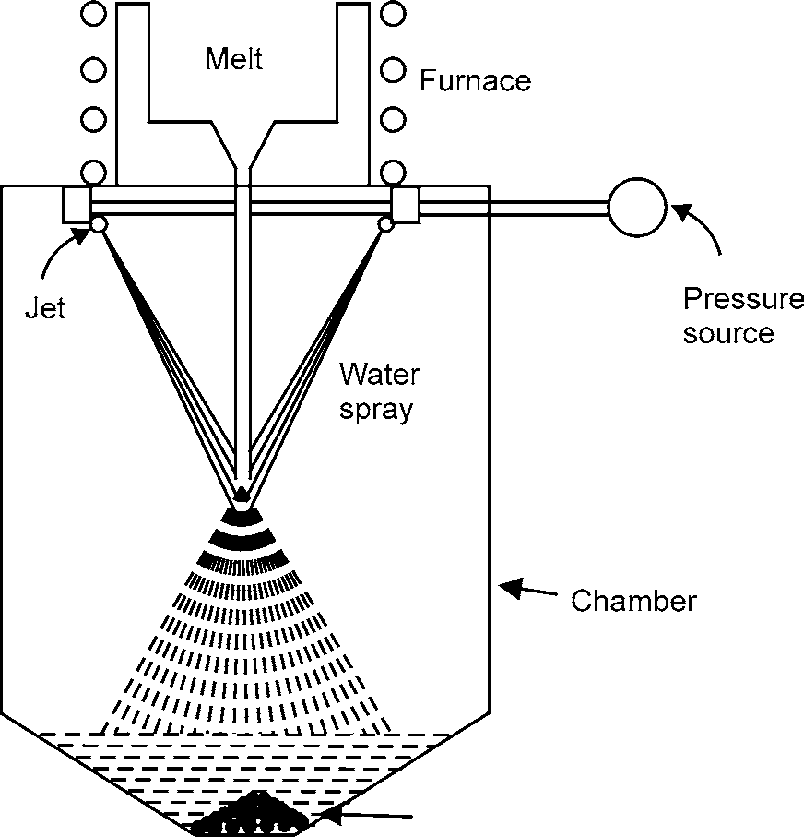

Powder

**Fig. 10.2:** Water Atomization Process

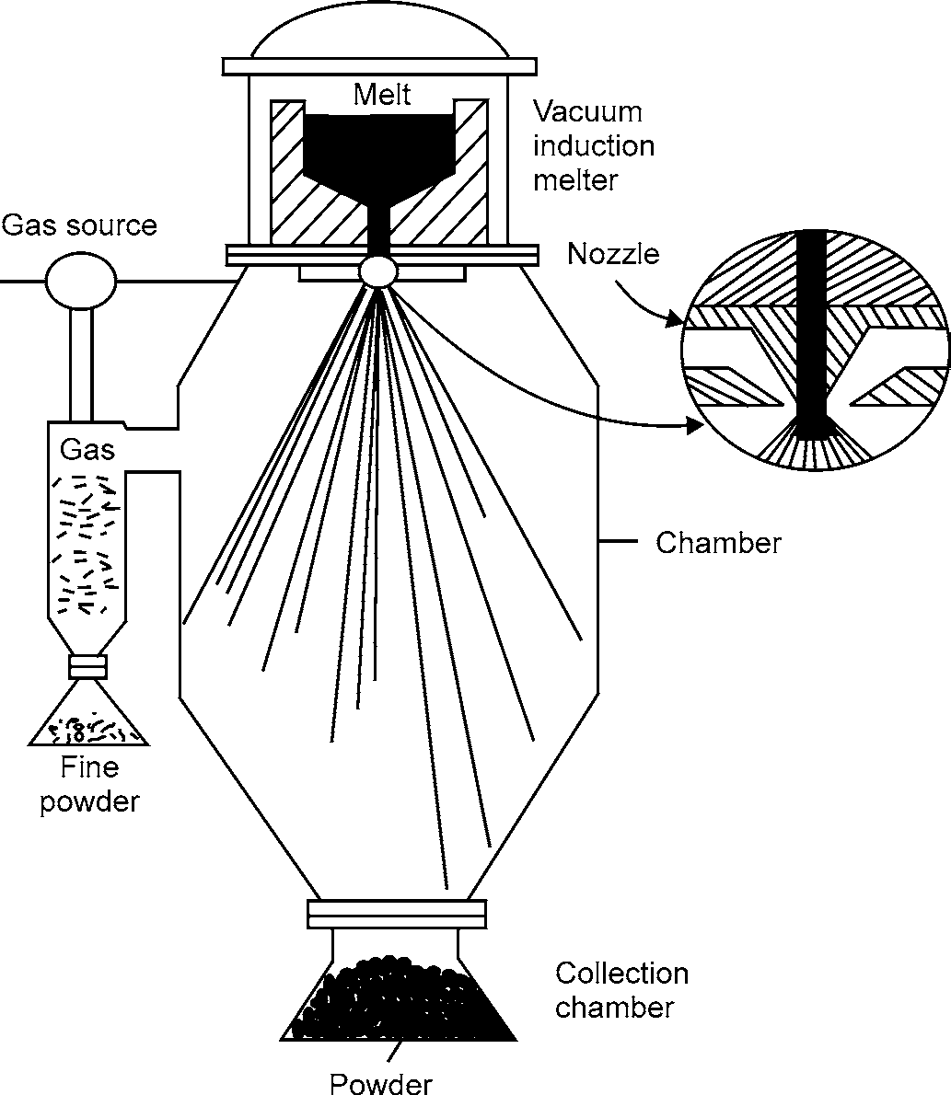

**Fig. 10.3:** Vertical Gas Atomizer

234 MANUFACTURING PROCESSES

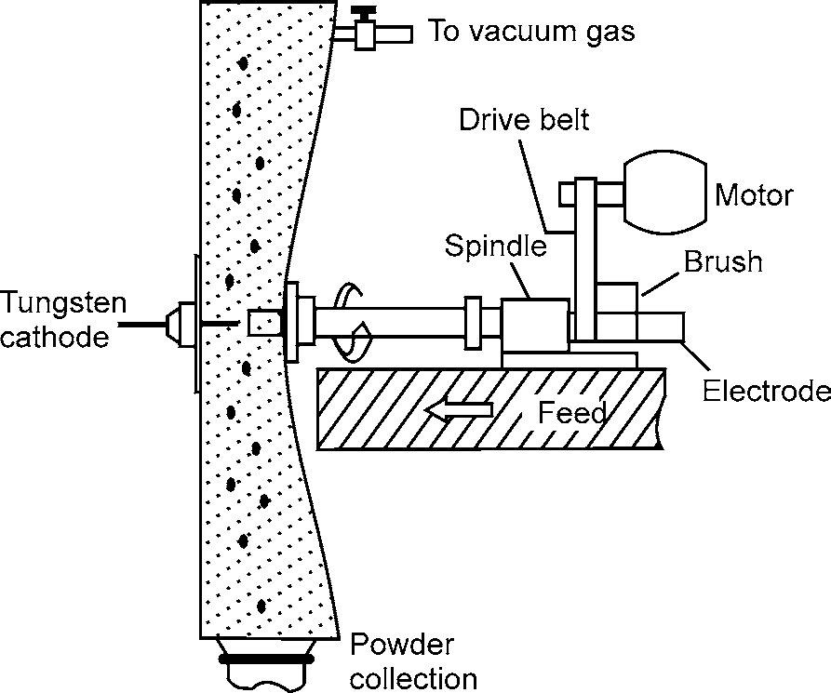

**Fig. 10.4:** Centrifugal Atomization by the Rotating Electrode Process

Additional alloying can be performed in the liquid metal bath after the original charge has become molten. Also, the bath can be protected from oxidation by maintaining an inert gas atmosphere as a cover over the liquid metal. Alternatively, the top of the furnace can be enclosed in a vacuum chamber. The furnace type and degree of protection are determined by the chemical composition of the bath and the tendency of the metal of oxidizes.

1. *Mechanical Comminution Methods*

Mechanical Comminution methods such as milling, lathe turning, and chipping, comprise the second powder manufacturing group. Such methods are used to produce hard and brittle powders that would be used in alloying, blending, and work hardening, or as oxide powders. Milling (Fig.I0.5) is the primary method for reducing the size of large particles and particle agglomerates. Ball, hammer, vibratory, attrition, and tumbler mills are some of the commercially available comminuting devices. During milling, forces act on the feed metal to modify the resultant particles. Impact, attrition, shear and compression all influence powder particle size and shape. Lathe turning is a technique used for materials such as magnesium for creating coarse particles from billets. These particles are reduced in size subsequently by milling or grinding.

1. *Chemical Methods*

Chemical methods constitute the final manufacturing group. Included are the production of metal powders by the reduction of metallic oxides, precipitation from solution (hydrometallurgy), and thermal decomposition carbonyl).

Materials used for subsequent oxide reduction are iron ore (magnetite), mill scale, and metallic materials oxidized far oxide reduction. In the case of iron ore, a refractory tube is filled with a combination of iron ore and a mixture consisting of coal, coke, and limestone. The tube is then passed through a kiln at - I200°C. The mixture decomposes, producing a reducing atmosphere inside the tube and the magnetite ore is converted to metallic Fe.

MISCELLANEOUS PROCESSES 235

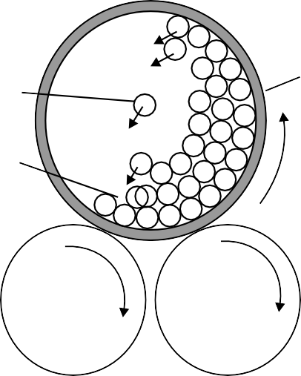

Jar

Balls

Material

Driver rollers

**Fig. 10.5:** Particle Size Reduction by Jar Milling-Schematic

Mill scale and oxidized metallic products are annealed to reduce bath the oxygen and carbon contents. FeO, Fe2O3 or Fe3O4, are reduced in the presence of a reducing atmosphere. In addition, the carbon within the particles is removed via the formation of CO and CO2.

Hydrometallurgical manufacturing and thermal decomposition comprise alternative chemical methods. Precipitation of a metal from a solution can be accomplished by using electrolysis, cementation, or chemical reduction. This is done either from a solution containing an ore, or by means of precipitation of a metal hydroxide followed by heating which results in decomposition and reduction.

1. Electrolytic Deposition

Electrolytic deposition involves the precipitation of a metallic element at the cathode of an electrolytic cell (Fig. 10.6). The most common application is in the production of copper powder.

Fe � Fe++ + 2e– Cu � Cu++ + 2e–

Anode

DC

Bath

Electrolyte (Eg. So 2– )

4

Cathode

Fe++ � 2e– + Fe Cu++ � 2e– + Cu

**Fig. 10.6:** Electrolytic Cell Operation for Deposition of Powder-Schematic

236 MANUFACTURING PROCESSES

1. Crushing

Crushing, milling and grinding are generally used in the production of ceramic powders. However, it is also used to manufacture some metals and metal alloys.

The most common use is in the manufacture of alumina and zirconia powders. The feed oxide is melted using graphite electrodes which then is allowed to solidify into a large block. The block is then broken up and sized. This route is also known as the “Bake and Bash” method. The powders produced are very dense but they also have a coarse, irregular, and blocky morphology.

For metal alloys such as CuNiln, rolling is sometimes used to produce a flake product. This is then broken up to produce a powder.

Cryogenic milling is used to break down some metals which become brittle at low temperatures. When used in the manufacture of molybdenum powder, this method is known as the Cold stream process. Here bulk material is cooled with liquid nitrogen and projected in two opposing streams. In the crossover point of these two streams the material is broken down and the process is continued until the desired size distribution is obtained.

Metal alloy powders can also be made by the hydride-dehydride method. In this process, metal alloys (usually in ingot form) are hydrided to produce brittle phases and the broken down in, for example, a ball mill. When the material is of a suitable size range the material is dehydrided in a vacuum furnace to leave a metal or metal alloy powder. This method is used in the manufacture of titanium and titanium alloy powders. The powder is generally blocky in form and can contain high levels of hydrogen and oxygen.

1. Agglomeration

The most common method of agglomeration is where the constituents are physically mixed together with an organic binder. The solvent is then driven off and the resultant material sized. The binder should be burnt off during spraying. This process is used in the manufacture of NiAI, AISi-polyester powders.

The use of spray drying has become another common method for the agglomeration of powders. Here, slurry is formed with the constituents and this is then fed into a rotary spray head. The slurry then forms an atomized cloud which is solidified by an opposing warm air stream to produce a powder. This method is used for ceramics such as zirconia and cermets such as WC-cobalt. The powder is largely spherical, but in the spray dried state can be porous and easily erumlded. The material is often densified and stabilized by sintering and/or spray densification.

There are also methods of mechanical agglomeration (e.g., the Hosakawa method) where for example a hard constituent is mechanically driven into a softer matrix particle to form a composite powder. Indeed, simple ball grinding can be used to mechanically alloy two or more constituents together.

Although sintering can be used as part of the spray drying process, it can also be used alone as a method to manufacture powders. The constituents are mixed together and heated to get some solid state diffusion going and then the resultant product is crushed.

These manufacturing techniques result in powders with different characteristics and appearance, for use in specific applications. Water atomization usually produces irregularly shaped particles free of internal porosity, whereas the shape of gas atomized particles is spherical, also without internal

MISCELLANEOUS PROCESSES 237

porosity. Metal powders produced by oxide reduction are irregular in shape, have a large surface area, and usually contain a substantial amount of internal porosity. Particles fabricated by milling or other mechanical methods exhibit a spectrum of shapes, depending on the relative ductility or brittleness of the feed material. The milling of agglomerated particles can cause the agglomerates to break up, sometimes with little effect on the shape of the individual particles. Powder particles produced chemically can have shapes ranging from spherical to angular. Electrolytic powders are of high purity with a dendritic morphology.

### Mixing of Powders

The purpose of mixing is to provide a homogeneous mixture and to incorporate the lubricant. Powders of the same chemistry but possibly different particle sizes are intermingled so as to reduce porosity. The mixing is done in shaking/rotating containers called blenders. Some lubricants that are commonly used are stearic acid, stearin, metallic stearates, specially zinc stearate, and increasingly, other organic compounds of a waxy nature. The main function of the lubricant is to reduce the friction between the powder and the surfaces of the tools (e.g., die walls, core rods) along which the powder must slide during compaction. This helps with getting desired uniformity of density from the top to the bottom of the compact. It also makes it easier to eject the compact, which minimizes the tendency to form cracks. The lubricant must be selected carefully, as it may affect both green (unsintered) and sintered strengths. This is especially true if any residue is left after the organic part has decomposed.

Over-mixing can occur and should be avoided. This increases the apparent density of the mix. Over-mixing also further reduces the green strength of the subsequent compacts probably by completely coating the whole surface of the particles, thereby reducing the area of metal-to-metal contact on which the green strength depends.

### Forming (Briquetting or Compacting)

Forming is a critical operation in the powder Metallurgy process since the final shape and mechanical properties are essentially determined in this stage. The level and uniformity of the as-pressed density determine properties and shape. If the parts are processed to provide a high density, the physical properties will be similar to those in cast or wrought iron products. Lower density will result in lower physical properties.

Forming can be performed by multiple sub-processes in either hot compaction or cold compaction. In the hot compaction category are Isostatic, Extrusion, Die Compacting, Spraying, and Pressure less-sintering. In the cold compacting category are Die Compacting, Isostatic, Roiling, Slip Casting, and Injection Moulding. In Die Compacting the mixed powders are pressed to shape in a rigid steel or carbide die under pressures of 150-900 MPa. This is the equivalent of 50 compact cars stacked vertically placing pressure on the metal. The compaction method is shown in Fig.

10.7. The method is similar to forming processes the die is a cavity in the shape of the lower half of the part, and the powder is poured into the cavity. The upper portion of the shape is made by the punch, which is pressed down on the powder to achieve the required compaction. Metal injection moulding may also be used in some cases to force-flow the metal powder through the die in a manner similar to plastic injection moulding.

238 MANUFACTURING PROCESSES

Feed shoe

Die

Lower punch

Filling

Feed shoe

Upper punch

Die

Lower punch

Pressing

(A) (B)

Compact

Ejection

(C)

**Fig. 10.7:** Compaction Method

In the forming stage the powder particles are brought together and deformed at the points of contact. This cold-welding of the powder grains within the mass is how the compacts maintain their shape. The amount of compression experienced by the powder during the forming process will dictate its green density. This in turn will control the amount of shrinkage/growth the powder compact will undergo during the sintering process. It will also influence the physical properties of the final component. In order to withstand the ejection from the die and subsequent handling before the sintering stage, the compacts must be relatively strong. This process is also known as Briquetting.

### Sintering

Sintering is the key stage of a powder metal part. Powder metal parts are also called “sintered parts.” Sintering is the means by which powder particles are welded together and a strong metal part is produced. The ISO definition states. “The thermal treatment of a powder or compact at a temperature below the melting point of the main constituent, for the purpose of increasing its strength by bonding together of the particles.” In this stage, the part acquires the strength needed to fulfill the intended role as an engineering component.

After compaction the components pass through a sintering furnace. This typically has two heating zones, the first removes the lubricant, and the second higher temperature zone allows diffusion and bonding between powder particles. The furnace used is usually a continuous belt furnace which is shown in Fig. 10.8, or a vacuum furnace. The operation is almost invariably carried out under a protective atmosphere, because of the large surface areas involved.

MISCELLANEOUS PROCESSES 239

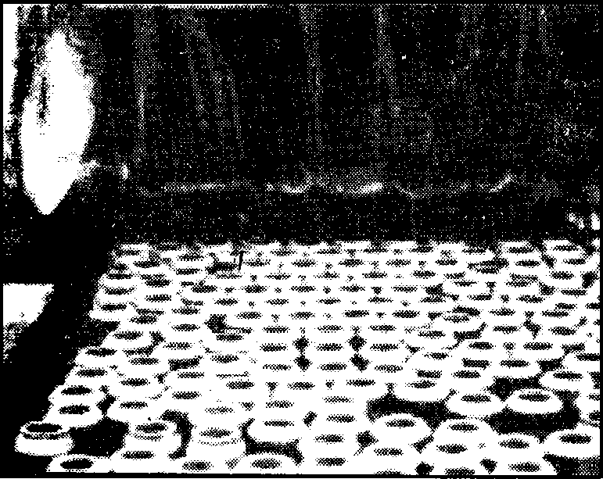

**Fig. 10.8:** Continuous Belt Furnace

The parts are heated to their sintering temperature; which is dependent on the type of metal. Control over heating rate, time, temperature and atmosphere is required for reproducible results. Table 10.1 shows the various sintering temperatures.

**Table 10.1:** Sintering Temperature of Various Metals

***Sintering Temperatures (Centrigrade)***

|  |  |  |
| --- | --- | --- |
| Iron/Steel | 1100 | - 1300 |
| Aluminium alloys | 590 | - 620 |
| Copper | 750 | - 1000 |
| Brass | 850 | - 950 |
| Bronze | 740 | - 780 |
| Hardmetals | 1200 | - 1600 |

The Sintering temperatures are between 60 and 90% of the melting-point of the particular metal or alloys. At these elevated temperatures, the atoms are free to diffuse. Also, recrystallization occurs and the interparticle boundaries become grain boundaries. Neck-like junctions are formed between particles as recrystallization takes place and can be seen in Fig. 10.9.

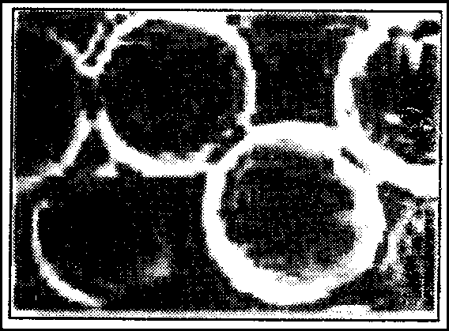

**Fig. 10.9:** Recrystallization During Sintering

In many cases all of the powder used is present in the finished product, scrap losses will only occur when secondary machining operations are necessary. Inevitably, there will be some touch- up to be made on some parts and hence secondary operations are performed.

[www.EngineeringEBooksPdf.com](http://www.EngineeringEBooksPdf.com/)

240 MANUFACTURING PROCESSES

### Secondary Operations

Secondary operations are performed to increase density, improve surface finish and accuracy, or accomplish additional shaping of the sintered part.

Secondary operations include:

**Repressing:** pressing the sintered part in a closed die to increase density and improve properties.

**Coining:** press working operation on a sintered part to press details into its surface.

**Sizing:** pressing a sintered part to improve dimensional accuracy.

**Machining:** creates geometric features that cannot be achieved by pressing, such as threads, side holes, and other details.

**Forging:** hot forming partial shapes.

**Heat treating:** for additional hardening.

**Steam treating:** to obtain an oxide surface coating.

**Plating:** to obtain specific surface finish and colour.

**Joining:** to assemble related parts with typical joining methods, welding, brazing, etc.

**Impregnation:** the P-M part has tiny capillary pores all over, which can be impregnated by oil or other lubricant. This gives rise to self-lubricated parts that require no grease to be applied during use. This is commonly used to manufacture universal joints using P-M. Common products are oil-impregnated bearings, gears, and similar components.

**Infiltrations:** the pores can also be filled by a metal of lower melting point e.g., sintered steel parts can be infiltrated by copper or bronze. This adds to the strength and the hardness of the part.

## APPLICATIONS OF POWDER METALLURGY

Because of its versatility, the Powder Metallurgy process is being used to produce many thousands of different parts in most product and equipment manufacturing industries. The applications of Powder Metallurgy parts in these industries fall into two main groups. The first includes applications in which the part is impossible to make by any other method. Powder Metallurgy is the only way of forming vital metals such as tungsten carbide, dispersion-strengthened materials, super alloys and self-lubricating bearings. Porous bearings and many types of magnetic cores are exclusively Powder Metallurgy products.

The second group of uses consists of mechanical and structural parts that compete with other types of metal forms, such as machined parts, castings, and forgings. Examples of such Powder Metallurgy products include lock hardware, garden tractors, snowmobiles, automobile engines and transmissions, auto brake and steering systems, washing machines, power tools and hardware, sporting arms, copiers and postage meters, off-road equipment, hunting knives, hydraulic assemblies, x-ray shielding, oil and gas drilling well-head components, fishing rods, surgical instruments, gears (shown in Fig. 10.12), cam shafts, and wrist watches.

The advantages of Powder Metallurgy show why these everyday products are made with Powder Metallurgy technology. The parts can be made in complex shapes, and they can be mass- produced. They used less energy and raw material. This cuts down on cost, which then makes it a superior process for a consumer driven market.

MISCELLANEOUS PROCESSES 241

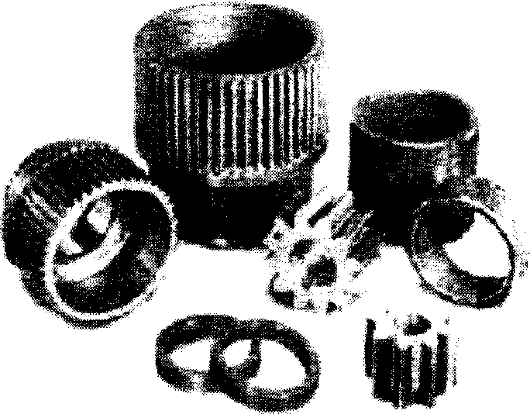

**Fig. 10.12:** Powder Metal Parts

Metal powders are also found in a number of other applications. Iron powder is used as a carrier for toner in electrostatic copying machines. Americans consume about two million pounds of iron powder annually in iron enriched cereals and bread. Iron powder is also used in hand warmers and waterproof cements. Zinc is used in pharmaceuticals. Copper powder is used in anti-fouling paints for boat hulls and in metallic pigmented inks for packaging and printing. Aluminium powder is used in solid fuels for rockets such as the booster rockets for the space shuttle program. Silver is used as a major ingredient in dental amalgams.

In brief, powder metallurgy is used in the manufacture of parts for: **Automobile industry:** motors, gear assemblies, brake pads **Abrasives:** polishing and grinding wheels

**Manufacturing:** cutting and drilling tools (using hard metals)

**Electric and magnetic devices:** magnets, soft magnetic cores, batteries

**Medical and dental:** prostheses, amalgams **Aerospace:** motors, heat shields, structural parts **Welding:** solder, electrodes

**Energy:** electrodes, fuel cells

**Other:** porous filters, bearings, sporting goods etc.

## PLASTIC

Plastic or Polymers are classified into two categories:

1. Thermoplastics
2. Thermosets

### Thermoplastics

Thermoplastic polymers soften when heated and can be reshaped, the new shape being retained on cooling. The process can be repeated many times by alternate heating and cooling with minimal degradation of the polymer structure.

### Thermosets

Thermosetting polymers (or thermosets) cannot be softened and reshaped by heating. They are plastic and moldable at some state of processing, but finally set to a rigid solid and cannot be resoftened. Thermosets are generally stronger and stiffer than thermoplastic.

242 MANUFACTURING PROCESSES

## PLASTIC/POLYMER PROCESSING

### Melt Processing

Melt processing is the most important, most economical way of shaping plastics. It can be used for those thermoplastics with melting point and viscosity low enough not to subject die materials to excessive temperatures and stresses.

* + - 1. **Melt Processing of Thermoplastics**: The raw material to be processed is usually supplied in the form of regular shape and even-size granules, because this makes quantity metering easier and quicker and leads to more uniform and predictable heating. One technique, which has been developed, recently is to pultrude impregnated continuous-fibre rovings to produce a lace, which is chopped into 10 mm lengths**.** This produces a 10 mm fibre reinforcement, which has greatly improved properties compared with normal short- fibre reinforcement. Whatever form of raw material is used, it is essential that it should be dried thoroughly before use. The most important processing procedures involve the use of a screw pump. The equipment used for ‘injection moulding’ is shown in Figure 10.13(a). The granules are fed into a heated cylinder by a screw, which first recedes to provide space for the material and then advances to inject it into a relatively cool mould in which it sets. When the plastic has set the mould is opened and the moulding removed. Figure 10.13(b) shows an ‘extruder’ which will produce rod tube or filament that can be quenched and drawn, sheet or strip in conjunction with a casting drum or three-roll stack (see Figure 10.13(c)) or coated wire.

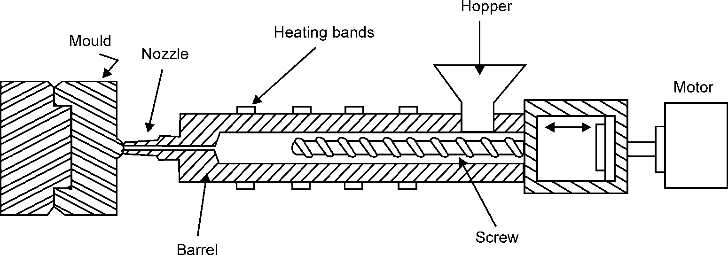

**Fig. 10.13 (a**)**:** Screw Injection Molder

MISCELLANEOUS PROCESSES 243

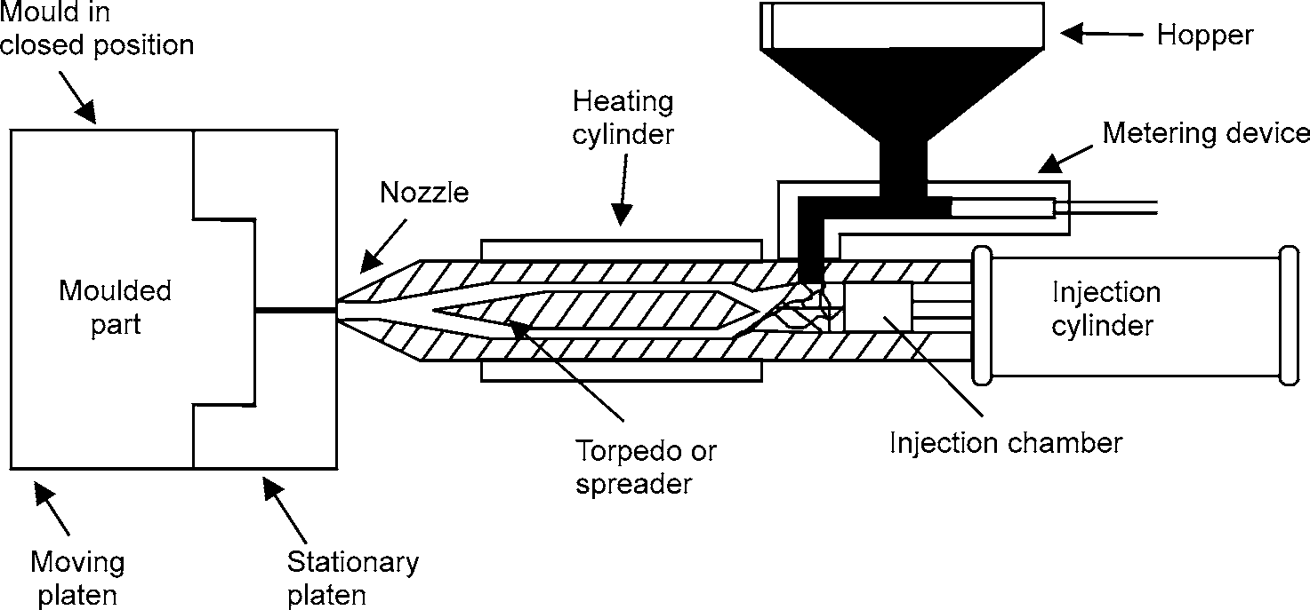

**Fig. 10.13 (b):** Injection Moulding Machine (Plunger Type) Screw Extruder

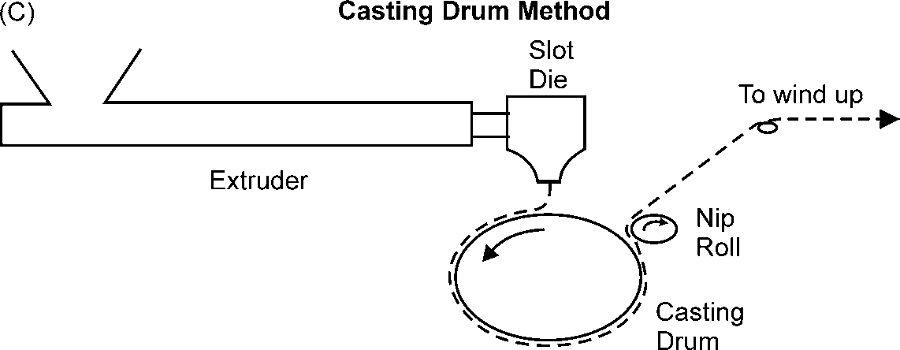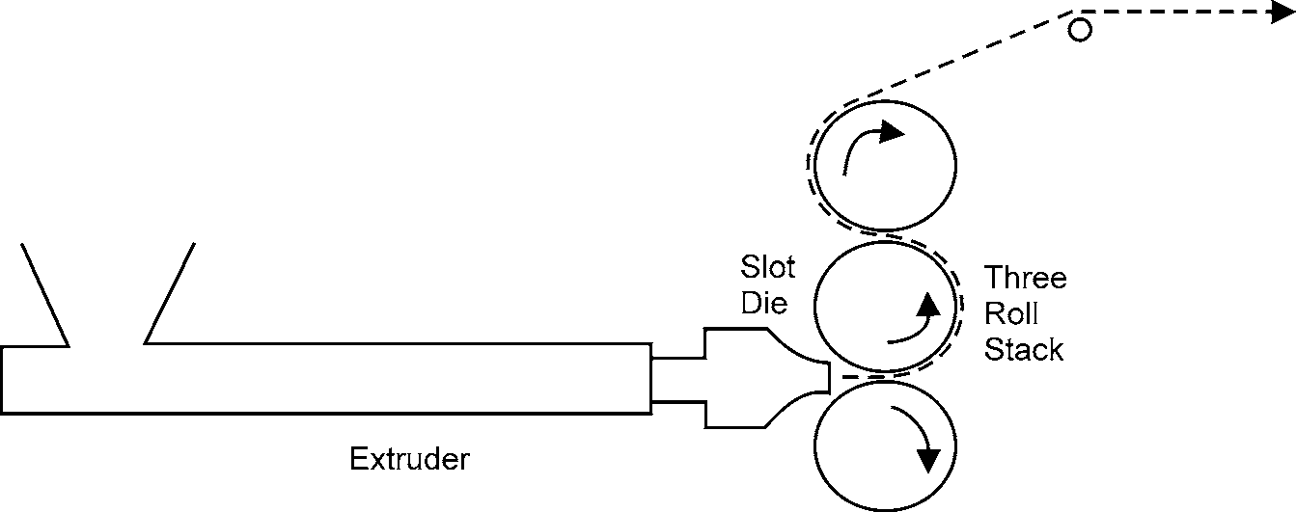

**Fig. 10.13 (c)** and **(d):** Techniques Used to Produce Film

Bottles may be produced by ‘extrusion blow moulding’ (see Figure 10.14(a)) in which a rod is extruded against a ‘blow pin spigot’. After extrusion a mould is closed on the extruded parison which is still above softening point and the bottle is blown.

Procedures which do not involve extrusion are:

1. **Calenderizing:** Flattening material out to sheet between rolls (Figure 10.14(b)). (This pro- cess is used extensively for plasticized PVC because problems have arisen in extrusion.)

244 MANUFACTURING PROCESSES

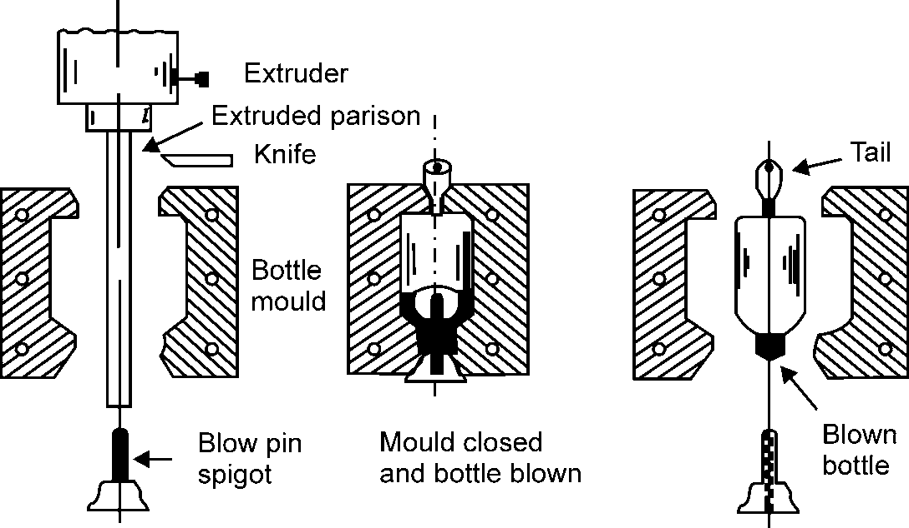

**Fig. 10.14 (a):** Extrusion Blow Moulding

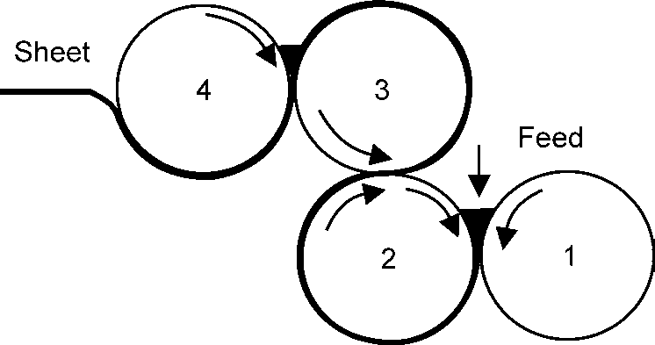

**Fig. 10.14 (b):** Calendering; Flattening out Molten Material into Sheet between Moulds

1. **Centrifugal casting:** This involves filling a mould with (preferably) powder, spinning, heat- ing to melt the powder, cooling slowly and removing the hollow casting.
2. **Compression moulding:** This process is more usually employed for thermosetting plastics but it can be used for thermoplastics, preferably in the form of powder. The compression moulding cycle involves compacting the polymer in the mould, heating above melting point and then applying a heating compression/relaxation technique typically, 3.5MPa for one minute, release, then 7MPa for one minute, release, then 14MPa for 10 minutes and cool at 400/minute to removed included air.
   * + 1. **Melt Processing of Thermosets:** Because a fully cross-linked thermoset will not melt, melt processing must be carried out on an ‘A’-stage resin, a low molecular weight cross- linkable polymer which may be compounded with a hardener and/or accelerator. The heat of the mould normally initiates cross-linking and shaping must be completed before cross-link- ing has occurred to such an extent that it prevents flow. This clearly raises problems in extrusion or injection moulding, because any material remaining in the extruder will set and become difficult to remove. Extrusion of thermosets must therefore be a discontinuous pro- cess in which a high-pressure reciprocating ram forces the thermoset through the die. The most commonly used process is compression moulding, illustrated in Figure 10.15. The mould is heated to approximately 170°C and the material softens and flows to fill the mould before casting. The moulding material may be powder, a dough moulding compound (DMC), a sheet moulding compound (SMC) or a preform moulding.

MISCELLANEOUS PROCESSES 245

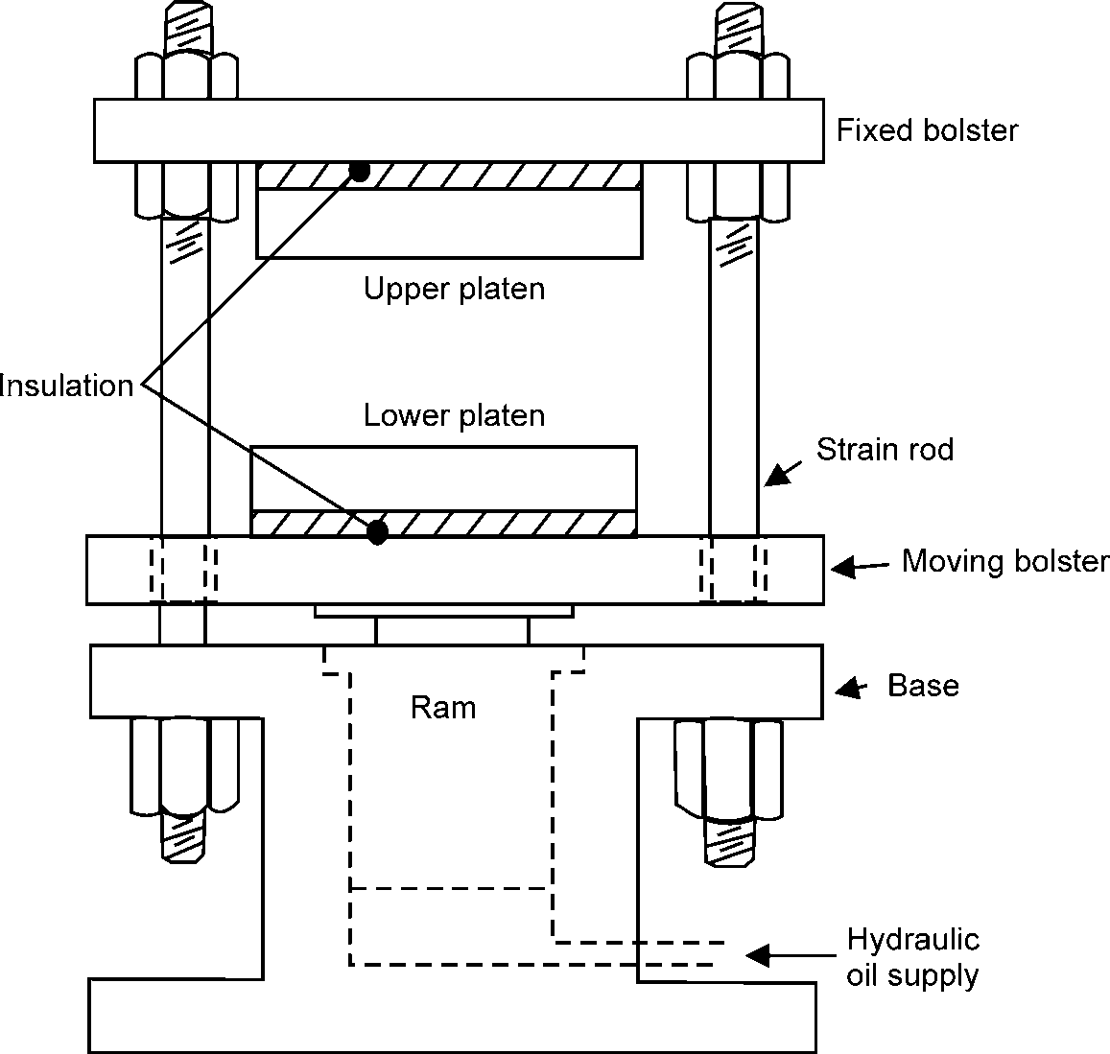

* + - * 1. Compression Moulding Press (Upstroke Type)

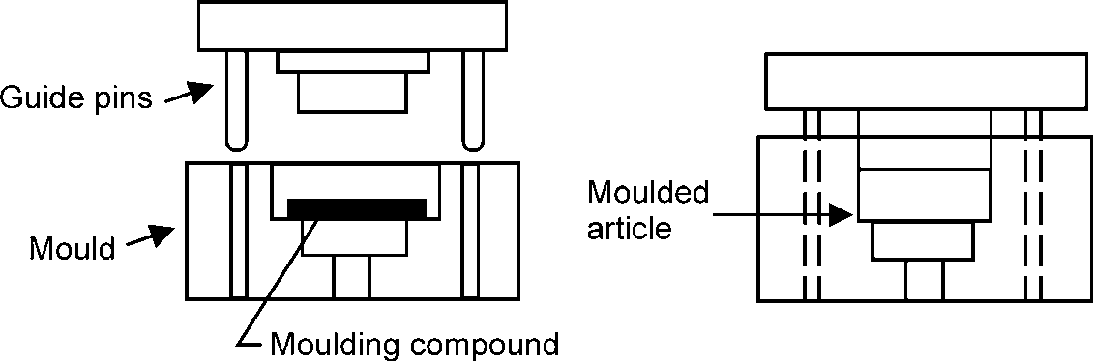

* + - * 1. Mould open (c) Mould closed

**Figure 10.15:** Typical Process for the Compression Moulding of Thermosetting Plastics.

## GALVANIZING

It is mainly used to apply coatings of low melting metals such as zinc, tin, cadmium, aluminium or lead on iron, steel and copper which have relatively higher melting temperatures. In this method, the article is cleaned and dipped in a bath of molten metal. It is then taken out from the bath and finished properly. The most common processes of galvanizing are hot dipping and tin plating as discussed below:

### Hot Dip Galvanizing

It is a process of providing thin layer of zinc coating (highly corrosion resistant) on iron or low carbon steel by dipping them in a bath of molten zinc. It improves the resistance against corrosion

246 MANUFACTURING PROCESSES

due to atmosphere and water. Since zinc is anodic to iron or steel (which serves as cathodic), therefore the zinc coating (also called anodic coating) is obtained by electrochemical reaction between the zinc and the iron or steel. The process is carried out as follows:

First of all, the work is cleaned by pickling with dilute sulphuric acid, to remove any scale, rust and impurities. After washing and drying, it is dipped in a bath of molten zinc maintained at a temperature of about 450°C. The surface of the bath is kept covered with a molten flux layer usually of zinc ammonium chloride to prevent oxide formation. The duration of immersion in a zinc bath depends upon the size of the work to be coated. It is then taken out from the bath and passed through a pair of rollers to remove any excess of zinc. Finally, the work is cooled and dried.

The galvanizing process is widely used for sheeting’s for roofs and walls of building, structural parts, pipes, containers, fencing materials, nails, wires etc.

**Note.** Since zinc gets dissolved in dilute acids to form highly toxic compound, therefore, the galvanized utensils should not be used for preparing and storing foodstuffs especially acidic ones.

### Tinplating or Tinning

It is a process of providing a thin layer of tin coating on the iron or steel sheets. In this process, the metal sheet is first treated with dilute sulphuric acid (pickling) to remove any oxide film. It is then fluxed by passing through a bath of zinc chloride. The flux helps the molten tin to adhere to the metal sheet. Now the sheet is dipped into a tank of molten tin which is maintained at a temperature of approximately 320°C. This process gives a coating thickness of about 0.003 mm. Finally, the sheet is passed through a series of rollers to remove any excess of tin and produce a thin layer of uniform thickness on the sheet.

The tin plating or tinning is generally done on metal sheets used for manufacturing containers for storing foodstuffs, ghee, oils, kerosene and packing food materials. The tinned copper sheets are employed for making cooking utensils and refrigeration equipments.

## ELECTROPLATING

It is the process of depositing a very thin layer of metal coating, on the base metal, by passing a direct current through an electrolyte solution containing some salt of the coating metal. Now a days, the electroplating (sometimes known as electrodepositing) is one of the best methods for the commercial production of a metallic coating.

In this process, the article to be electroplated is first immersed in hot alkaline solution to remove oil and grease. It is then treated with dilute hydrochloric acid or sulphuric acid to remove scale and oxides. It may be noted that hydrochloric acid is used for nickel and copper plating, while sulphuric acid is used for chromium plating. The cleaned article is made to act as cathode whereas the coating metal as an anode. The cathode and anode are dipped in a solution containing some salt of the coating material i.e., electrolyte, as shown in Fig 10.16.

MISCELLANEOUS PROCESSES 247

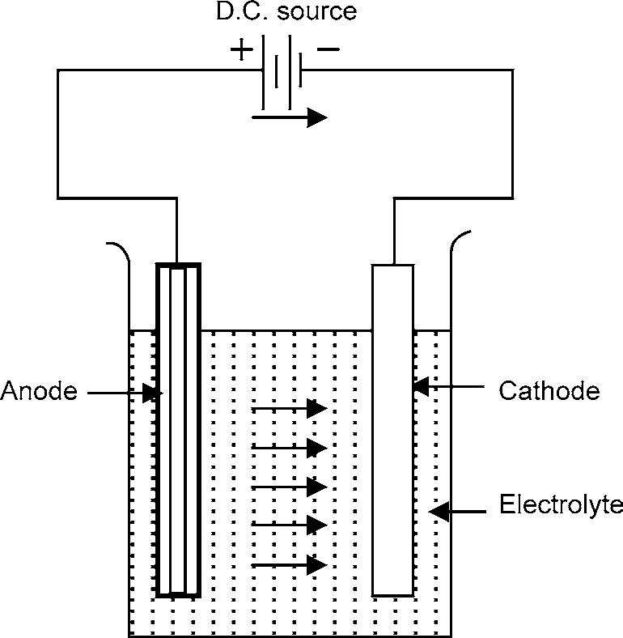

**Fig. 10.16:** Electroplating

When direct current is passed, the coating metal ions migrate to the cathode and get deposited there. Thus, a thin layer of coating metal is obtained on the article, which is made as cathode. The thickness of coating can be 0.005 mm or more. The commonly used metals, which are used for electroplating are copper, nickel, chromium, silver, gold, cadmium and tungsten.

The electroplating is extensively used for decorative purposes and for protecting iron and steel articles from corrosion.

# OBJECTIVE QUESTIONS

1. The process of providing a thin layer of zinc coating on iron and steel is called
   1. Electroplating (b) Galvanizing

(c) Metal cladding (d) None

1. The powder metallurgy technique is used
   1. For producing parts from hard materials
   2. In fabrication of non-ferrous products
   3. In producing friction materials
   4. All of the above
2. The magnesium powder for pyrotechnic applications are produced by
   1. Machining (b) Crushing

(c) Atomisation (d) Milling

1. For turning all thermoplastics, the back rake angle of tool should be about
   1. 10° (b) 20°

(c) 30° (d) 40°

248 MANUFACTURING PROCESSES

1. The long plastics rods, tubes and sheets are made by
   1. Extrusion moulding (b) Injection moulding

(c) Blow moulding (d) None of these

1. The process of producing film or thin sheets by squeezing a thermoplastics materials between the revolving cylinders, is known as:
   1. Lamination (b) Contact moulding

(c) Calendaring (d) Pressure bag moulding

**ANSWERS**

1. (b) 2. (d) 3. (a) 4. (b) 5. (a) 6. (c)

# SHORT ANSWER QUESTIONS

1. Write short notes on Manufacture of components by powder-metallurgy process.

(May-03)

1. Write short notes on Pre-sintering. (May-04)
2. Describe the processes of:

(i) Injection moulding (ii) Extrusion of plastics (May-03)

1. List few components, which cannot be manufactured by powder metallurgy.
2. What are the principal advantages of fine powders as compared to coarse powders?
3. Discuss the different methods of producing metal powders.
4. What are the consequences of excessive blending on the powder metallurgy process?
5. Why is sintering usually accomplished in a controlled atmosphere?
6. Explain the metallic coating technique –Electroplating
7. What are plastics? Name two broad classifications of plastics.
8. Distinguish between thermoplast and thermoset.
9. What are the common properties of plastics.
10. Explain the metallic coating technique–Galvanizing.
11. Name five common thermoplastics and four common thermosetting plastics.

# LONG ANSWER QUESTIONS

1. How powder metallurgy is different from other manufacturing processes? Give two examples of the products manufactured by powder metallurgy process. Also give advantages of this process. (May-05)
2. Mention advantages/disadvantages and applications of powder metallurgy. Describe briefly each step involved in powder metallurgy manufacturing processes. (May-02)
3. Explain briefly injection moulding process and compression moulding process. What are the benifit of injection moulding process over the compression moulding process of plastics.
4. Enlist some of the metal coating that can be applied by the hot dip process. Explain.

❍ ❍

# EXAMINATION PAPER—B. TECH.

(Only for the candidates admitted/ Readmitted in the session 2008–09)

**(SEM. I) EXAMINATION, 2008–09 MANUFACTURING PROCESSES**

*Time* : 2 *Hours* Total Marks 50

Note : Be precise and scientific in writing.

##### SECTION–A

**Attempt all the questions:**

1. This section contains 10 questions. (objective/fill in the blanks types). Choose / Fill the correct answer.
   1. Manufacturing is the process of converting raw material into
   2. The ductility of a piece of chalk is
   3. The % of carbon in medium carbon steel varies
      1. Less than 0.20 (ii) 0.10 to 0.30

(iii) 0.30 to 0.60 (iv) More than 0.60.

* 1. Stainless steel comes under the category of
     1. Non-ferrous metal and alloy (ii) Ferrous metal and alloy

(iii) Polymer (iv) Composite

* 1. Bronze is an alloy of
     1. Aluminium and zinc (ii) Aluminium and nickel

(iii) Copper and tin (iv) Copper and zinc

* 1. Forging of metal is a
     1. Machining process (ii) Welding process

(iii) Joining process (iv) Metal forming process.

* 1. Metal forming is the process in which
     1. Removal of metal takes place.
     2. Shaping of metal by forces applied through various dies and tools.
     3. Some additional materials are joined to the raw material.
     4. Material addition, through melting and pouring
  2. Blow holes are the common defects found in

|  |  |  |
| --- | --- | --- |
| (i) Welding | (ii) | Machining |
| (iii) Forming | (iv) | Casting |
| Finishing is the operation best done by | | |
| (i) Milling machine | (ii) | Shaper machine |
| (iii) Planar machine | (iv) | Grinding |

* 1. ​

250 MANUFACTURING PROCESSES

* 1. Swing is the one of specifications of
     1. Lathe machine (ii) Shaper machine

(iii) Drilling machine (iv) Grinding machine

##### SECTION–B

1. Attempt any **three** questions. **All** questions carry **equal** marks:
   1. Explain the following terms:
      1. Ductility (ii) Stiffness

(iii) Brittleness (iv) Fatigue

(v) Malleability

* 1. Draw rough sketch of the stress strain diagrams of
     1. Ductile material and (ii) Brittle material Briefly explain, what do you understand by Toughness.
  2. Explain
     1. Mould and (ii) Pattern. Describe the two important pattern allowances.
  3. With the help of sketch, explain the basic components of lathe machine and various operations performed on it.
  4. With the help of sketch, define the following operations
     1. Forging (ii) Rolling

(iii) Drawing (iv) Extrusion

##### SECTION–C

**Note:** Attempt any **four** questions. **All** questions carry **equal** marks.

1. Answer any **one** part of the following:
   1. Based on % of carbon, classify carbon steels. How do stainless steel become stainless?
   2. What are the major uses of copper? What are the alloying elements in brass and bronze, respectively and also write its uses.
2. Answer any **one** part of the following :
   1. Differentiate between hot and cold working of metals. Bring out the advantages and disadvantages of each of these techniques. Explain with neat sketch the rolling of steel bar.
   2. Define the following terms with sketch as used in sand casting:
      1. Core (ii) Core-prints

(iii) Sprue (iv) Runner

(v) Riser

EXAMINATION PAPER & SOLUTION 251

1. Answer any **one** part of the following:
   1. With the help of schematic sketch, describe the basic working principle and important parts of shaper machine. Also describe the difference in operation between shaper and planer.
   2. Explain fusion as it relates to welding operations. How will you classify the welding processes? Explain the features of neutral, reducing, and oxidizing flames.
2. Answer any **one** part of the following:
   1. Discuss the role and importance of materials and manufacturing for the growth of any nation. Explain the production and productivity.
   2. Explain briefly the following with suitable examples:
      1. Electroplating (ii) Galvanizing

(iii) Plant layout (iv) Ceramics

❍ ❍

# SOLUTION

##### SECTION–A

|  |  |  |  |  |
| --- | --- | --- | --- | --- |
| **Ans. 1.** | **(a)** | Finished Product | **(b)** | Approximately Zero |
|  | **(c)** | (iii) | **(d)** | (ii) |
|  | **(e)** | (iii) | **(f)** | (iv) |
|  | **(g)** | (ii) | **(h)** | (iv) |
|  | **(i)** | (iv) | **(j)** | (iv) |

**SECTION–B**

**Ans. 2. (a)** (i) **Ductility:** Ductility of a material is its ability to draw out into thin wire on application of the load. Mild steel is a ductile material.

* + 1. **Stiffness:** The resistance of a material to deflection is called stiffness or rigidity. Steel is more stiffer than Aluminium.
    2. **Brittleness:** The brittleness of a material is the property of breaking without much permanent distortion. Ex.: Glass, Cast Iron.
    3. **Fatigue:** The fatigue strength of a material is the maximum stress at which failure may occur after a certain number of cyclic load applications.
    4. **Malleability:** Malleability of a material is its ability to be flattened into thin sheets without cracking by hot or cold working. Ex.: Copper, Tin, Aluminium etc.

**(b)** (i) Ductile material

252 MANUFACTURING PROCESSES

Proportionality Limit Elastic Limit



Upper Yield Point C

Maximum or Ultimate Point

D

Stress ()

B C*'*

A Lower Yield

Point

Fracture or E

Breaking Strength

Plastic Zone Elastic Zone

Area = Modulus of Resilience

O Strain (e) 

**Fig. 1:**  – e Diagram for Ductile Material

(ii) Brittle material

High Carbon Steel

Cast Iron

Concrete

Strain (e)

Stress ()

**Fig. 2:**  – e Diagram for Brittle Material

**Toughness:**

The toughness of a material is its ability to withstand both plastic and elastic deformations. It is a highly desirable quality for structural and machine parts to withstand shock and vibration. Manganese steel, wrought iron, mild steels are tough materials.

For Ex: If a load is suddenly applied to a piece of mild steel and then to a piece of glass the mild steel will absorb much more energy before failure occurs. Thus mild steel is said to be much tougher than a glass.

**Ans. 2. (c)** (i) **Mould:** Mould is a cavity out of sand by means of a pattern made by the process of Moulding. The molten metal is poured into the moulds to produce castings.

1. **Pattern:** Pattern is a replica of the final object to be made by casting process, with some modifications. The main modifications are:
   1. The addition of pattern allowances,

EXAMINATION PAPER & SOLUTION 253

* 1. The provision of core prints,
  2. Elimination of fine details which cannot be obtained by casting and hence are to be obtained by further processing.

**Two Important Pattern Allowances Pattern Allowances**

The dimensions of the pattern are different from the final dimensions of the casting required. This is required because of various reasons. These are as follows.

**Finish or Machining Allowance**

The finish and accuracy achieved in sand casting are generally poor and therefore when the casting is functionally required to be of good surface finish or dimensionally accurate, it is generally achieved by subsequent machining. Also, ferrous materials would have scales on the skin which are to be removed by cleaning process. Hence extra material is to be provided which is to be subsequently removed by machining or cleaning process. This depends on dimensions, the type of casting material and the finish required. This may range from 2 to 20 mm. The machining allowance provided would ultimately have to be removed by machining. Hence the cost of providing additional machining allowance should be carefully examined before finalizing.

**Shake Allowance**

Before withdrawal from the sand mould, the pattern is rapped all around the vertical faces to enlarge the mould cavity slightly which facilitates its removal. Since it enlarges the final casting made, it is desirable that the original pattern dimensions should be reduced to account for this increase. There is no sure way of quantifying this allowance, since it is highly dependent on the foundry personnel and practices involved.

It is a negative allowance and is to be applied only to those dimensions which are parallel to the parting plane. One way of reducing this allowance is to increase the draft which can be removed during the subsequent machining.

**Ans. 2. (d)** A simple lathe comprises of a bed made of grey cast iron on which headstock, tailstock, carriage and other components of lathe are mounted. Fig. 3 shows the different parts of engine lathe or central lathe. The major parts of lathe machine are given as under:

1. Bed
2. Headstock
3. Tailstock
4. Carriage
5. Feed mechanism
6. Thread cutting mechanism

254 MANUFACTURING PROCESSES

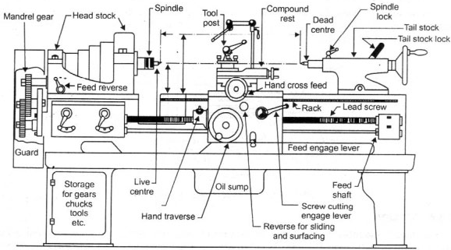

Head stock

Feed reverse

Hand cross feed

Rack

Lead screw

Spindle

Feed engage lever

Live centre

Oil sump

Feed shaft

Screw cutting engage lever

Hand traverse

Reverse for sliding and surfacing

Tool post

Dead centre

Tail stock

Tail stock lock

Spindle lock

Compound rest

Storage for gears chucks tools etc.

Mandrel gear

Guard

**Fig. 3:** Different Parts of Engine Lathe or Central Lathe

1. **Bed**

The bed of a lathe machine is the base on which all other parts of lathe are mounted. It is massive and rigid single piece casting made to support other active parts of lathe. Generally cast iron alloyed with nickel and chromium material is used for manufacturing of the lathe bed.

1. **Headstock**

The main function of headstock is to transmit power to the different parts of a lathe. It comprises of the headstock casting to accommodate all the parts within it including gear train arrangement.

1. **Tailstock**

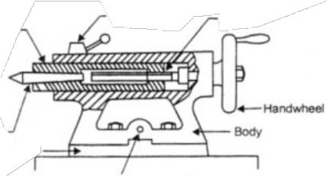Fig. 4 shows the tailstock of central lathe, which is commonly used for the objective of primarily giving an outer bearing and support the circular job being turned on centres. Tailstock can be easily set or adjusted for alignment or non-alignment with respect to the spindle centre and carries a centre called dead centre for supporting one end of the work. Both live and dead centres have 60° conical points to fit centre holes in the circular job, the other end tapering to allow for good fitting into the spindles. The dead centre can be mounted in ball bearing so that it rotates with the job avoiding friction of the job with dead centre as it important to hold heavy jobs.

Barrel lock Screw

Barrel

Centre

Base

Body

Handwheel

Lateral adjustment screw

**Fig. 4:** Tailstock of Central Lathe

EXAMINATION PAPER & SOLUTION 255

1. **Carriage**

Carriage is mounted on the outer guideways of lathe bed and it can move in a direction parallel to the spindle axis. It comprises of important parts such as apron, cross-slide, saddle, compound rest, and tool post. The lower part of the carriage is termed the apron in which there are gears to constitute apron mechanism for adjusting the direction of the feed using clutch mechanism and the split half nut for automatic feed. The cross-slide is basically mounted on the carriage, which generally travels at right angles to the spindle axis. On the cross-slide, a saddle is mounted in which the

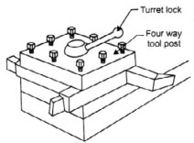

Turret lock

Four way

tool post

**Fig. 5:** Tool Post of Centre Lathe

compound rest is adjusted which can rotate and fix to any desired angle. The compound rest slide is actuated by a screw, which rotates in a nut fixed to the saddle.

The tool post is an important part of carriage, which fits in a tee-slot in the compound rest and holds the tool holder in place by the tool post screw. Fig. 5 shows the tool post of centre lathe.

1. **Feed Mechanism**

Feed mechanism is the combination of different units through which motion of headstock spindle is transmitted to the carriage of lathe machine. Following units play role in feed mechanism of a lathe machine:

* 1. End of bed gearing 2. Feed gear box

3. Lead screw and feed rod 4. Apron mechanism

The gearing at the end of bed transmits the rotary motion of headstock spindle to the feed gear box. Through the feed gear box the motion is further transmitted either to the feed shaft or lead screw, depending on whether the lathe machine is being used for plain turning or screw cutting.

The feed gear box contains a number of different sizes of gears. The feed gear box provides a means to alter the rate of feed, and the ration between revolutions of the headstock spindle and the movement of carriage for thread cutting by changing the speed of rotation of the feed rod or lead screw.

The apron is fitted to the saddle. It contains gears and clutches to transmit motion from the feed rod to the carriage, and the half nut which engages with the lead screw during cutting threads.

1. **Thread Cutting Mechanism**

The half nut or split nut is used for thread cutting in a lathe. It engages or disengages the carriage with the lead screw so that the rotation of the lead screw is used to traverse the tool along the workpiece to cut screw threads. The direction in which the carriage moves depends upon the position of the feed reverse lever on the headstock.

**Operations Performed on Lathe Machine**

The most common operations which can be performed on the lathe are:

|  |  |  |
| --- | --- | --- |
| 1. Facing, | 2. | Turning, |
| 3. Taper turning, | 4. | Eccentric turning, |
| 5. Boring, drilling, | 6. | Reaming, |
| 7. Threading,  9. Scroll cutting etc. | 8. | Knurling, and |

256 MANUFACTURING PROCESSES

In addition to it, with the help of special attachments, operations like

* 1. Key-way cutting, 2. Cam and gear cutting,

3. Shaping, 4. Milling,

1. Fluting, and
2. Grinding can also performed on this machine. These operations are discussed as follows:

**Facing**

This operation is almost essential for all works. In this operation, as shown in Fig. 6, the workpiece is held in the chuck and the facing tool is fed from the centre of the workpiece towards the outer surface or from the outer surface to the centre, with the help of a cross-slide.

Chuck

Tool

Work

**Fig. 6:** Facing

**Plain Turning**

It is an operation of removing excess amount of material from the surface of the cylindrical work- piece. In this operation, as shown in Fig. 7, the work is held either in the chuck or between centres and the longitudinal feed is given to the tool either by hand or power.

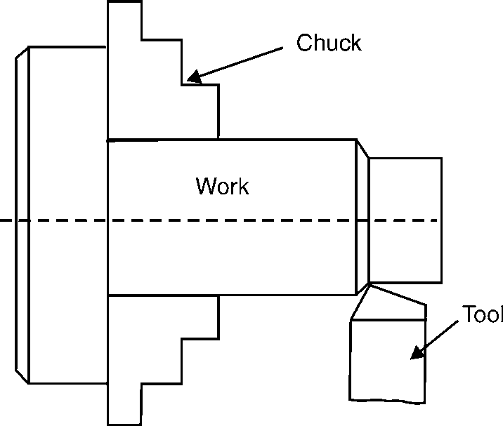

Chuck

Work

Tool

**Fig. 7:** Plain Turning **Fig. 8:** Step Turning

EXAMINATION PAPER & SOLUTION 257

**Step Turning**

It is an operation of producing various steps of different diameters in the workpiece, as shown in Fig. 8. This operation is carried out in the similar way as plain turning.

**Taper Turning**

It is an operation of producing an external conical surface on a workpiece. A small taper may be produced with the help of a forming tool or chamfering tool, but the larger tapers are produced by swiveling the compound rest, as shown in Fig. 9 at the required angle or by offsetting the tailstock or by taper turning attachment.

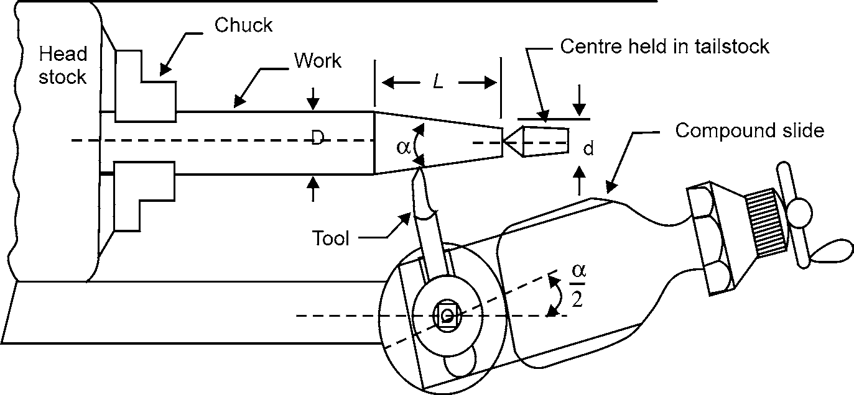

**Fig. 9:** Taper Turning

Note. If D is the larger diameter, d is the smaller diameter and L is the length of taper, as shown in Fig. 9 then

**Drilling**

r ­¤r 

b  £ j

It is an operation of making a hole in a work piece with the help of a drill. In this operation, as shown in Fig. 10 the work piece is held in a chuck and the drill is held in the tailstock. The drill is fed manually, in to the rotating work piece, by rotating the tailstock hand wheel.



Chuck

Work

Drill



Chuck

Work

Reamer

**Fig. 10:** Drilling **Fig. 11:** Reaming

258 MANUFACTURING PROCESSES

**Reaming**

It is an operation of finishing the previously drilled hole. In this operation, as shown in Fig. 11, a reamer is held in the tailstock and it is fed into the hole in the similar way as for drilling.

**Boring**

It is an operation of enlarging of a hole already made in a workpiece. In this operation, as shown in Fig. 12, a boring tool or a bit mounted on a rigid bar is held in the tool post and fed into the work by hand or power in the similar way as for turning.

Chuck



Work

Boring tool

**Fig. 12:** Boring

**Undercutting or Grooving**

It is an operation of reducing the diameter of a work piece over a very narrow surface. In this operation, as shown in Fig. 13 a tool of appropriate shape is fed into the revolving work up to the desired depth at right angles to the centre line of the work piece.

Chuck

Work

Threading V-tool

**Fig. 13:** Undercutting **Fig. 14:** Threading

Chuck

Work

Tool

**Threading**

It is an operation of cutting helical grooves on the external cylindrical surface of workpiece. In this operation, as shown in Fig. 14, the work is held in a chuck or between centres and the threading

EXAMINATION PAPER & SOLUTION 259

tool is fed longitudinally to the revolving work. The longitudinal feed is equal to the Ditch of the thread to be cut.

**Knurling**

It is an operation of providing knurled surface on the workpiece. In this operation, as shown in Fig. 15, a knurled tool is moved longitudinally to a revolving workpiece surface. The projections on the knurled tool reproduce depressions on the work-surface.

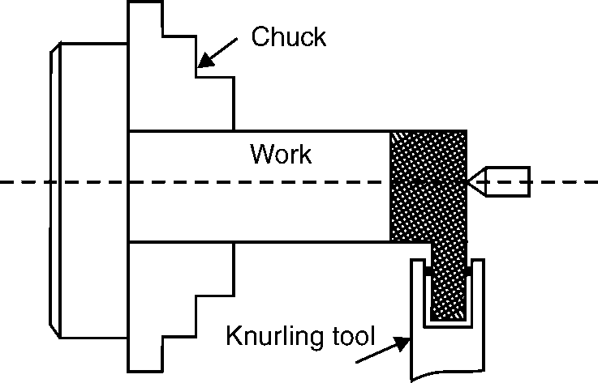

**Fig. 15:** Knurling

**Ans. 2. (e) Solution:**

1. **Forging**

Forging can be defined as a method of shaping heated metal by compression. The forging process evolved from the manual art of simple blacksmithing. The special tools that a blacksmith use are various kinds of dies, swages and fullers.

Modern forging uses machine driven impact hammers or presses which deform the workpiece by controlled pressure. The forging process is superior to casting in that the parts formed have denser microstructures, more defined grain patterns, and less porosity, making such parts much stronger than a casting. Forgings usually have great strength, as compared with other methods of producing products.

Forging is classified into three categories:

* 1. Open-die Forging (Hand Forging, Power Forging),
  2. Impression-die and
  3. Closed-die Forging.



**Fig. 16:** Open Die Forging

260 MANUFACTURING PROCESSES

1. **Rolling**

It is the process of reducing the thickness or changing the cross-section of a long workpiece by compressive forces applied through a set of rolls. One effect of the hot working rolling operation is the grain refinement brought about by recrystalli- zation, which is shown in Fig. 17. Coarse grain structure is broken up and elongated by the rolling action because of the high temperature, recrystallization starts immediately and small grains begin to form. These grains grow rapidly

A O



B

B*'*

Original A*'*

coarse grain structure

Elongated grain

Recrystallization taking place

until recrystallization is complete. Growth continues at high temperatures, if further work is not carried

**Fig. 17:** Hot-rolling Process

on, until the low temperature of the recrystalline range is reached.

1. **Drawing**

To manufacture long slender products (wire, tube), material is drawn through a die. The material is deformed by compression, but the deformation force is supplied by pulling on the deformed end of the wire or rod. This is termed ‘indirect compression’. Most drawing is done cold.

**Wire drawing** is an operation to produce wire of various sizes within certain specific tolerances. The process involves reducing the diameter of rods or wires by passing them through a series of wire drawing dies with each successive die having smaller bore diameter than the one preceding it (see Fig. 18). The drawing force must not exceed the strength of the drawn wire. Typically this means that the maximum reduction (as area, not diameter) attainable is less than 50%. In practice reduction is usually limited to 20–30% to avoid frequent breakage. The final wire size is reached as the wire passes through the last die in the series.



 Direction of wire drawing  Wire drawing dies with

reducing bore diameter

**Fig. 18:** Wire Drawing

**Tube drawing** normally makes tubes to size from hollow ‘tube shells’ produced by extrusion. They are then cold drawn to size by a succession of passes, with inter stage anneals as required and supplied either in straight lengths or coil. Fig. 19 shows a typical tube drawing process with a floating plug.

EXAMINATION PAPER & SOLUTION 261

Draw die

Starting wall

Starting I.D.

Finish wall

Starting O.D.

Finish I.D.



Finish O.D.

**Fig. 19:** Tube Drawing

Floating plug

1. **Extrusion**

Extrusion is the process that forces metal to flow through a shape-forming die. The metal is plastically deformed under compression in the die cavity. Extrusion produces only compressive and shear forces in the stock without any tensile force, which makes high deformation possible without tearing the metal. It is a hot-working process which, like forging, rolling, etc., uses the good deformability of heated metallic materials for shaping them.

A metal billet heated to the appropriate temperature is fed into the cylindrical container of the extrusion press and is forced by the action of a ram through a steel die whose orifice has the desired shape to produce the solid or hollow section (Fig. 20). The metal emerges from the die as a continuous bar, which is cut to the required lengths. Extrusion products are therefore essentially linear in character, in the sense that shaping is confined to the cross-section only. The process is therefore eminently suitable for the production of bar-like and tubular objects.



**Fig. 20:** Extrusion Process

The cross-sections that can be produced vary from solid round, rectangular, to L shapes, T shapes, tubes and many other different types. Extrusions, often minimize the need for secondary machining, but are not of the same dimensional accuracy or surface finish as machined parts. However, this process can produce a wide variety of cross-sections that are hard to produce cost-effectively using other methods.

Extrusion differs from drawing in that the metal is pushed, rather than pulled under tension.

Extrusion processes can be carried on hot or cold.

[www.EngineeringEBooksPdf.com](http://www.EngineeringEBooksPdf.com/)

262 MANUFACTURING PROCESSES

##### SECTION – C

**Ans. 3. (a) Solution:**

The factors affecting the properties of carbon steels are carbon contentand the microstructure. Carbon has a strengthening and hardening effect. It lowers ductility, machinability, weldability, corrosion resistance, thermal and electrical conductivity and magnetic permeability. Carbon steel does not contain more than 0.5% of silicon and 1.5% of manganese. Most of the steel produced now-a-days is PLAIN CARBON STEEL.

The plain carbon steels varying from 0.05% carbon to 1.5% carbon are divided into the following types:

|  |  |
| --- | --- |
| ***Plain Carbon Steel*** | ***Approximate % of Carbon*** |
| Dead Mild Steel (Low Carbon Steel) | 0.05–0.15 % carbon |
| Mild Steel | 0.10–0.30 % carbon |
| Medium Carbon Steel | 0.30–0.50 % carbon |
| High Carbon Steel | 0.50–0.90 % carbon |
| High carbon Steel (Tool Steel) | 0.90–1.50 % carbon |

**Stainless Steel become Stainless**

In Stainless steel the principal alloying element is **chromium** while some other element like nickel, manganese, etc. can also be present in small amount.

Chromium reacts with the oxygen to form a strong layer of chromium oxide on the surface of the metal which is responsible for offering the resistance to corrosion. Stainless steels carrying more than 12% chromium are known as **true stainless steels**. As this steel cannot be stained easily, so it is called stainless steel.

**Ans. 3. (b) Major Uses of Copper:**

Copper is used for the following:

1. Electrical parts.
2. Heat Exchangers.
3. Screw machine products.
4. For making various copper alloys, such as brass and bronze.
5. Copper may be cast, forged, rolled and drawn into wires.
6. Copper in the form of tubes is used widely in mechanical engineering.
7. It is used for making useful alloys with tin, zinc, nickel and aluminium.

**Alloying Elements in Brass and Uses**

All brasses are basically alloys of copper and zinc. There are two main type of brass.

* 1. Alpha brass (upto 37% Zn) for cold working.
  2. Alpha beta brass (33% to 46% Zn) for hot working.

EXAMINATION PAPER & SOLUTION 263

**Composition of various types of brasses and their uses according to Indian standards**

|  |  |  |  |
| --- | --- | --- | --- |
| *qL l¬L* | *g«£¨ « q¯ «£ r£ b¤®¨¦« ¯¨¬«* | *a¬ª­¬®¨¯¨¬« ¨« C* | *nr¬­¤r¯¨¤®  «£ s®¤®* |
| OL | `¤¯  ¡r ®® | a° [ SNJ x« [ SN | g¯ ¨® § r£  «£ ¡r¨¯¯©¤J °®¤£ ¥¬r ¡r µ¨«¦ ®¬©£¤rL |
| PL | a r¯r¨£¦¤ ¡r ®® | a° [ UNJ x« [ QN | g¯ ¢¬«®¨®¯ ¦¬¬£ £°¢¯¨©¨¯´  «£ ®¯r¤«¦¯§L g¯ ¨®   ¢¬©£  ²¬rk¨«¦ ¡r ®® °®¤£ ¥¬r ¢¬©£ r¬©©¤£ ®§¤¤¯®J ²¨r¤  £r ²¨«¦J £¤¤­ £r ²¨«¦J ­r¤®®¨«¦  «£ ¯°¡¤ ª «°¥ ¢¯°r¨«¦L a ­® ¬¥ ¤©¤¢¯r¨¢ © ª­ ¡°©¡®J §¤ £  © ª­ r¤¥©¤¢¯¬r®J p £¨ ¯¬r ®§¤©©®L |
| QL | w¤©©¬² ¡r ®® Fk°«¯µ ª¤¯ ©G | a° [ TNJ x« [ RN | e¬¬£ ¢¬rr¬®¨¬« r¤®¨®¯ «¢¤L g¯ ¨® ®°¨¯ ¡©¤ ¥¬r §¬¯  ²¬rk¨«¦ ¡´ r¬©©¨«¦J ¤³¯r°®¨¬«  «£ ®¯ ª­¨«¦J ¢ ®¯¨«¦  ­°ª­ ­ r¯®J ± ©±¤®J ¯ ­®  «£ ¬¯§¤r ®¨ª¨© r ¨¯¤ª®L |
| RL | j¤ £¤£ ¡r ®® | a° [ TPLSJ x« [ QTJ n¡ [ OLS | r§¤®¤  r¤ °®¤£ ¥¬r ­© ¯¤®J ¯°¡¤®J ­ r¯® ¬¥ ¢¬«£¤«®¤rL |
| SL | _£ª¨r ©¯´ ¡r ®® | a° [ UNJ x« [ PWJ q« [ O | g¯ ¨® r¤®¨®¯ «¢¤ ¯¬ ®¤ ² ¯¤r  ¢¯¨¬«Y q¬ ¨¯ ¨® ²¨£¤©´  °®¤£ ¥¬r ª r¨«¤ ¢ ®¯¨«¦J ª r¨«¤ ¥¨¯¯¨«¦L _©®¬ °®¤£ ¥¬r  ­© ¯¤®J ¯°¡¤® ¡¬©¯®J  «£ «°¯®J ² ®§¤r®J  ©®¬ °®¤£ ¨«  ¢¬«£¤«®¤r ­© «¯L ¤¯¢L |
| TL | l ± © ¡r ®® | a° [ SWJ x« [ RNJ q« [ O | g¯ ¨® r¤®¨®¯ «¢¤ ¯¬ ®¤ ² ¯¤r  ¢¯¨¬«Y q¬ ¨¯ ¨® ²¨£¤©´  °®¤£ ¥¬r ª r¨«¤ ¢ ®¯¨«¦J ª r¨«¤ ¥¨¯¯¨«¦L |
| UL | l¨¢k¤© ¡r ®® Fe¤rª « ®¨©±¤rG | a° [ TN - RSJ x« [ QS - PN J l¨ [ S - QS | g¯ ¨® °®¤£ ¥¬r ± ©±¤®J ­©°ª¡¨«¦ ¥¨¯¯¨«¦J  °¯¬ª¬¡¨©¤  ¥¨¯¯¨«¦®J ¯´­¤²r¨¯¤r ­ r¯®  «£ ª°®¨¢ © ¨«®¯r°ª¤«¯®L |
| VL | q¨©¨¢¬« ¡r ®® | VN a°J OT x«  «£ RS q¨ | u¨£¤©´ °®¤£ ¥¬r r¤¥r¨¦¤r ¯¬r®  ©®¬ °®¤£  ®   ¢§¤ ­¤r  ®°¡®¯¨¯°¯¤ ¥¬r ­§¬®­§¬r ¡r¬«µ¤L |
| WL | e¨©£¨«¦ ¡r ®® | a° [ VSCJ x« [ OSC | g¯ ¨® ±¤r´ ¦¬¬£ a¬©£ u¬rk¨«¦  ©©¬´  «£ ¨® °®¤£ ¥¬r j¤²¤©©¤r´J £¤¢¬r ¯¨±¤ ²¬rkL g¯ ¨® ¢¬ªª¤r¢¨ ©©´   ± ¨© ¡©¤  ® ¢¬©£ r¬©©¤£ ®¯r¨­J ²¨r¤ ¬r ®§¤¤¯L g¯ ¢¬©¬°r  ± r¨¤® ¥r¬ª r¤£ ¯¬ ¡r¨¦§¯ ´¤©©¬²  ¢¢¬r£¨«¦ ¯¬ ¯§¤ C ¬¥ x«L |
| ONL | b¤©¯  ¡r ®® | TN a°J QU x«J Q ¨r¬« | g¯ ¢ « ¡¤ ¤ ®¨©´ §¬¯ ²¬rk¤£J ¥¬r¦¤£J r¬©©¤£L g¯ § ®  ¥ ¨r©´ ¦¬¬£ ¯¤«®¨©¤ ®¯r¤«¦¯§  ¥¯¤r §¬¯ ²¬rk¨«¦  «£  ¢ ®¯¨«¦L g¯ § ® ¦¬¬£ ¢¬rr¬®¨¬« r¤®¨®¯ «¢¤J ¢ «  ®°¨¯ ¡©´ r¤­© ¢¤ ®¯¤¤© ¢ ®¯¨«¦®L |
| OOL | dr¤¤ ¢°¯¯¨«¦  ¡r ®® | TN a°J QU x«  «£ Q n¡ | g¯ ¨® ®­¤¢¨ ©©´ °®¤£ ¨« ª ¢§¨«¨«¦ ²¬rkL |
| OPL | a©¬¢k ¡r ®® | TS a°J QR x«  «£ O n¡ | r§¤ ©¤ £ ¢¬«¯¤«¯ ¨ª­r¬±¤® ¨¯® ¡¤ r¨«¦ q° ©¨¯¨¤®  «£ ª ¢§¨« ¡¨©¨¯´L k¬®¯©´  ± ¨© ¡©¤ ¨« ®¯r¨­ ¥¬rª  «£ ¨®  ²¨£¤©´ °®¤£ ¨« ª k¨«¦ ®ª ©© ¦¤ r®  «£ ­¨«¨¬«® ¥¬r  ¢©¬¢k ²¬rkL |

264 MANUFACTURING PROCESSES

**ALLOYING ELEMENTS IN BRONZE and USES**

Bronze is basically an alloy of copper (75% to 95%) and tin (5% to 25%). It possesses superior mechanical properties and corrosion resistance than brass.

|  |  |  |  |
| --- | --- | --- | --- |
| *qL l¬L* | *g«£¨ « q¯ «£ r£ b¤®¨¦« ¯¨¬«* | *a¬ª­¬®¨¯¨¬« ¨« C* | *nr¬­¤r¯¨¤®  «£ s®¤®* |
| OL | n§¬®­§¬r `r¬«µ¤ | a° [ WRLOTJ q« [ SLSTJ n [ NLPR | n§¬®­§¬r ¨«¢r¤ ®¤® ¯§¤ ®¯r¤«¦¯§J £°¢¯¨©¨¯´  «£ ¦¬¬£  ¢ ®¯¨«¦ ­r¬­¤r¯¨¤®L r§¤  ©©¬´ ­¬®®¤®®¤® ¦¬¬£  ²¤ r¨«¦ r¤®¨®¯ «¯ q° ©¨¯´  «£ §¨¦§ ¤© ®¯¨¢¨¯´L r§¤ ª¤¯ © ¨® r¤®¨®¯ «¯ ¯¬ ® ©¯ ² ¯¤r ¢¬rr¬®¨¬«L g¯ ¨® °®¤£ ¥¬r  ¡¤ r¨«¦Y ­°ª­ ­ r¯®J ©¨«¨«¦®  «£ ­r¬­¤©©¤r®L _©®¬  °®¤£ ¥¬r ²¬rª ²§¤¤©®J ¦¤ r®J «°¯® ¥¬r ª ¢§¨«¤ ©¤ £  ®¢r¤²®J ®­r¨«¦®L |
| PL | e°« k¤¯ © | a° [ VVJ q« [ ONJ x« [ P | g¯ ¨® ¥¬r¦¤£ ²§¤«  ¯  ¡¬°¯ TNNÝ¢Lr§¤ ª¤¯ © ¨® ±¤r´  ®¯r¬«¦  «£ r¤®¨®¯ «¯ ¯¬ ¢¬rr¬®¨¬« ¡´ ² ¯¤r  «£   ¯ª¬®­§¤r¤L s®¤£ ¥¬r `¬¨©¤r ¥¨¯¯¨«¦J ¡°®§¤®J ¡¤ r¨«¦®J  ¦© «£®  r¤ ª £¤ ¬¥ ¦°« ª¤¯ ©L |
| QL | `¤©© k¤¯ © | a° [ VSJ q« [ ONJ  x« [ S | g¯ ¢ « ¡¤ r¤ £¨©´ ¢ ®¯  «£ ¨® ¦¤«¤r ©©´ °®¤£ ¥¬r  ¢ ®¯¨«¦ ¬¥ ¡¤©¯®L |
| RL | q¨©¨¢¬« `r¬«µ¤ | a° [ WQLUSJ q¨ [ RJ k« [ OLPSJ d¤ [ O | g¯ § ® §¨¦§   ®¯r¤«¦¯§J ¯¬°¦§«¤®®  «£ ¢¬rr¬®¨¬« r¤®¨®¯ «¢¤L  k¬®¯ ²¨£¤©´ °®¤£ ¥¬r ª k¨«¦ ¢ ®¯¤£  r¯¨¢©¤® ©¨k¤  ¡¬¨©¤r ­ r¯®J ª r¨«¤ ¥¨¯¯¨«¦  «£ ®¯¬±¤ ­ r¯®L |
| SL | k «¦ «¤®¤ `r¬«µ¤ | a° [ SQLSJ x« [ QVJ q« [ OLSJ d¤ [ PJ  _© [ OLSJ k« [ QLS | g¯ § ® ®°­¤r¨¬r ª¤¢§ «¨¢ © ­r¬­¤r¯¨¤®  «£ §¨¦§  ¢¬rr¬®¨¬« r¤®¨®¯ «¢¤L g¯ § ® ­¬¬r r¤®­¬«®¤ ¯¬ ¢¬©£  ²¬rk¨«¦L s®¤£ ¥¬r ®°¢§ ­ r¯® ²§¤r¤ §¨¦§ ®¯r¤«¦¯§  «£  ¢¬rr¬®¨¬« r¤®¨®¯ «¢¤  r¤ £¤®¨r¤£J ®°¢§  ® ¨« ®§¨­  «£ r°££¤r®J ¡°®§¤®J ¥¤¤£ ­°ª­®J ²¬rª ¦¤ r®L |
| TL | _©°ª¨«¨°ª `r¬«µ¤ | a° [ VVJ d¤ [ QJ  _© [ W | g¯ ­¬®®¤®®¤® ¦¬¬£ ®¯r¤«¦¯§J §¨¦§ ¢¬rr¬®¨¬« r¤®¨®¯ «¢¤   «£ ¦¬¬£ §¤ ¯ r¤®¨®¯ «¢¤L u¨£¤©´ °®¤£ ¨« ª k¨«¦  ²¬rª ¦¤ rJ ²§¤¤©®J ± ©±¤ ®§¤¤¯®J e°« ®©¨£¤J  «£  ¡¤ r¨«¦J ¢¬«£¤«®¤r ¡¬©¯J ­°ª­ ¢¬ª­¬«¤«¯J ¯°¡¤®J   ¨r ­°ª­®J ¡°®§J r¬©©¤r®L |

**Ans. 4. (a)**

|  |  |
| --- | --- |
| *f¬¯ ²¬r ¨«¦* | *a¬©£ ²¬r ¨«¦* |
| OL f¬¯ ²¬rk¨«¦ ¨® £¬«¤  ¯   ¯¤ª­¤r ¯°r¤  ¡¬±¤ r¤¢r´®¯ ©©¨µ ¯¨¬« ¡°¯ ¡¤©¬² ¨¯® ª¤©¯¨« ¦ ­¬¨«¯L g¯ ¢ « ¯§¤r¤¥¬r¤ ¡¤ r¤¦ r£¤£  ®  ®¨ª°©¯ «¤¬°® ­r¬¢¤®® ¬¥ £¤¥¬rª ¯¨¬«  «£ r¤¢¬±¤r´L  PL f r£¤«¨«¦ £°¤ ¯¬ ­© ®¯¨¢ £¤¥¬rª ¯¨¬« ¨®  ¢¬ª­©¤¯¤©´ ¤©¨ª¨« ¯¤£ ¡´ r¤¢¬±¤r´  «£ r¤¢r´®¯ ©©¨µ ¯¨¬« L  QL gª­r¬±¤ª¤«¯ ¬¥ ª¤¢§ « ¨¢ © ­r¬­¤r¯¨¤® ®°¢§   ® ¤©¬«¦ ¯¨¬« J r¤£°¢¯¨¬« ¬¥  r¤   «£ ¨ª­ ¢¯  ± ©°¤®L  RL l¬ ¤¥¥¤¢¯ ¬« °©¯¨ª ¯¤ ¯¤«®¨©¤ ®¯r¤«¦¯§J ´¨¤©£  ­¬¨«¯J ¥ ¯¨¦°¤ ®¯r¤«¦¯§  «£ § r£«¤®®L | OL a¬©£ ²¬rk¨«¦ ¨® £¬«¤  ¯ ¯¤ª­¤r ¯°r¤ ¡¤©¬² r¤¢r´®¯ ©©¨µ ¯¨¬« ¯¤ª­¤r ¯°r¤L q¬ «¬   ­­r¤¢¨ ¡©¤ r¤¢¬±¤r´ ¢ « ¯ k¤ ­© ¢¤ £°r¨« ¦  £¤¥¬rª ¯¨¬«L  PL f r£¤«¨«¦ ¨® «¬¯ ¤©¨ª¨« ¯¤£ ®¨«¢¤ ²¬rk¨« ¦  ¨® £¬«¤ ¡¤©¬² r¤¢r´®¯ ©©¨µ ¯¨¬« ¯¤ª­¤r ¯°r¤L  QL b¤¢r¤ ®¤® ¤©¬«¦ ¯¨¬«J r¤£°¢¯¨¬« ¬¥  r¤  ¤¯¢L  RL g«¢r¤ ®¤ ¨« °©¯¨ª ¯¤ ¯¤«®¨©¤ ®¯r¤« ¦¯§J ´¨¤©£  ­¬¨«¯  «£ § r£«¤®®L |

*Contd.*

EXAMINATION PAPER & SOLUTION 265

|  |  |
| --- | --- |
| ***Hot working*** | ***Cold working*** |
| SL n¬¬r ®°r¥ ¢¤ ¥¨«¨®§ £°¤ ¯¬ ¬³¨£ ¯¨¬«  «£  ®¢ ©¨«¦L  TL p¤¥¨«¤ª¤«¯ ¬¥ ¢r´®¯ ©® ¬¢¢°r®L  UL b°¤ ¯¬ §¬¯ ²¬rk¨«¦ ¢r ¢k®  «£ ¡©¬²§¬©¤®   r¤ ²¤©£¤£ °­L  VL l¬ ¨«¯¤r« © ¬r r¤®¨£° © ®¯r¤®® £¤±¤©¬­¤£L  WL d¬r¢¤ r¤q°¨r¤£ ¥¬r £¤¥¬rª ¯¨¬« ¨® ©¤®®L ONL j¨¦§¯ ¤q°¨­ª¤«¯ ¨® °®¤£ ¨« §¬¯ ²¬rk¨«¦L  OOL b¨¥¥¨¢°©¯ ¯¬ § «£©¤   §¬¯ ²¬rk¤£ ª¤¯ ©L  OPL f¬¯ ²¬rk¨«¦ ­r¬¢¤®®¤®  r¤ §¬¯ ¥¬r¦¨«¦J §¬¯ r¬©©¨«¦J §¬¯ ®­¨««¨«¦J §¬¯ ¤³¯r°®¨¬«J §¬¯  £r ²¨«¦J  «£ §¬¯ ­¨¤r¢¨«¦J n¨­¤ ²¤©£¨«¦L | SL e¬¬£ ®°r¥ ¢¤ ¥¨«¨®§ ¨® ¬¡¯ ¨«¤£L  TL ar´®¯ ©©¨µ ¯¨¬« £¬¤® «¬¯ ¬¢¢°rL er ¨«®  r¤  ¬«©´ ¤©¬«¦ ¯¤£L  UL n¬®®¨¡¨©¨¯´ ¬¥ ¢r ¢k ¥¬rª ¯¨¬«  «£ ­r¬­ ¦ K  ¯¨¬« ¨® ¦r¤ ¯L  VL g«¯¤r« ©  «£ r¤®¨£° © ®¯r¤®®¤®  r¤ £¤±¤©¬­¤£  ¨« ¯§¤ ª¤¯ ©L  WL d¬r¢¤ r¤q°¨r¤£ ¥¬r £¤¥¬rª ¯¨¬« ¨® §¨¦§L  ONL f¤ ±´  «£ ­¬²¤r¥°© ¤q°¨­ª¤«¯ ¨® °®¤£ ¥¬r  ¢¬©£ ²¬rk¨«¦L  OOL c ®¨¤r ¯¬ § «£©¤ ¢¬©£ ­ r¯®L  OPL a¬©£ ²¬rk¨«¦ ­r¬¢¤®®¤®  r¤ a¬©£ r¬©©¨«¦J a¬©£ ¤³¯r°®¨¬«J nr¤®® ²¬rk Fbr ²¨«¦J qq°¤¤µ¨«¦J `¤«£¨«¦J  «£ q§¤ r¨«¦GL |

**Advantages of Cold Working**

1. Cold working increases the strength and hardness of the material due to the strain hardening which would be beneficial in some situations. Further there is no possibility of decarburisation of the surface.
2. Since the working is done in cold state, hence no oxide formation on the surface and consequently, good surface finish is obtained.
3. Greater dimensional accuracy is achieved.
4. Easier to handle cold parts and also economical for small sizes.
5. Better mechanical properties are achieved.

**Disadvantages of Cold Working**

1. Only small sized components can be easily worked as greater forces are required for large sections. Due to large deforming forces, heavy and expensive capital equipment is required.
2. The grain structure is not refined and residual stresses have harmful effects on certain properties of metals.
3. Many of the metals have less ductility e.g., carbon steel and certain alloy steels, cannot be cold worked at room temperature. It is therefore, limited to ductile metals and the range of shapes produced is not as wide as can be obtained by machining.
4. Tooling costs are high and as such it is used when large quantities of similar components are required.

**Advantages of Hot Working**

1. Porosity in the metal is largely eliminated. Most ingots contain many small blow holes. These are pressed together and eliminated.
2. Impurities in the form of inclusions are broken up and distributed throughout the metal.
3. Coarse or columnar grains are refined. Since this hot work is in the recrystalline temperature range, it should be continued until the low limit is reached to provide a tine grain structure.
4. Physical properties are generally improved owing principally to grain refinement. Ductility and resistance to impact are improved, strength is increased, and greater homogeneity is developed in the metal. The greatest strength of rolled steel exists in the direction of metal flow.
5. The amount of energy necessary to change the shape of steel in the plastic state is far less than that required when the steel is cold.

266 MANUFACTURING PROCESSES

**Disadvantages of Hot Working**

1. Because of the high temperature of the metal, there is rapid oxidation or scaling of the surface with accompanying poor surface finish.
2. Difficult to achieve close tolerances due to scaling.
3. Some metals cannot be hot worked because of their brittleness at high temperatures.
4. Hot working equipment and maintenance costs are high.

**Ans. 4. (b) Solution:**

* 1. **Core**

Cores are compact mass of core sand that when placed in mould cavity at required location with proper alignment does not allow the molten metal to occupy space for solidification in that portion and hence help to produce hollowness in the casting. The environment in which the core is placed is much different from that of the mold. In fact the core has to withstand the severe action of hot metal which completely surrounds it. Cores are classified according to shape and position in the mold. There are various types of cores such as horizontal core (Fig. 21), vertical core (Fig. 22), balanced core (Fig. 23), drop core (Fig. 24) and hanging core (Fig. 25).

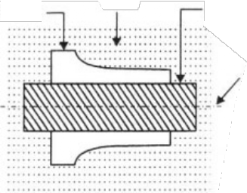

Mold cavity

Sand

Baked core

Parting line

**Fig. 21:** Horizontal Core

Sand

Parting Line

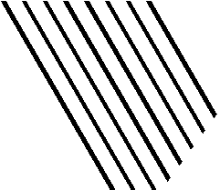

Mould Cavity

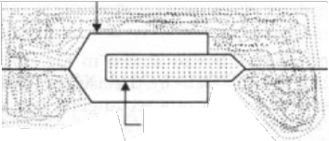

Dry sand core

Cope

Drag

Core Mould

**Fig. 22:** Balanced Core **Fig. 23:** Vertical Core

EXAMINATION PAPER & SOLUTION 267

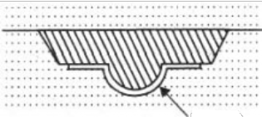

Mould

**Fig. 24:** Drop Core **Fig. 25:** Hanging Core

* 1. **Core-prints**

When a hole blind or through is needed in the casting, a core is placed in the mould cavity to produce the same. The core has to be properly located or positioned in the mould cavity on pre- formed recesses or impressions in the sand. To form these recesses or impressions for generating seat for placement of core, extra projections are added on the pattern surface at proper places. These extra projections on the pattern (used for producing recesses in the mould for placement of cores at that location) are known as core prints. Core prints may be of horizontal, vertical, balanced, wing and core types. Horizontal core print produces seats for horizontal core in the mould. Vertical core print produces seats to support a vertical core in the mould. Balanced core print produces a single seat on one side of the mould and the core remains partly in this formed seat and partly in the mould cavity, the two portions balancing each other. The hanging portion of the core may be supported on chaplets. Wing core print is used to form a seat for a wing core. Cover core print forms seat to support a cover core.

* 1. **Sprue**

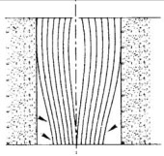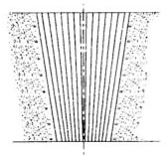Sprue is the channel through which the molten metal is brought into the parting plane where it enters the runners and gates to ultimately reach the mould cavity. The molten metal when moving from top of the cope to the parting plan gains in velocity and as a consequence requires a smaller area of cross-section for the same amount of metal to flow at the top. If the sprue were to be straight cylindrical as shown in Fig. 26 then the metal flow would not be full at the bottom, but some low pressure area would be created around the metal in the sprue. Since the sand mould is permeable, atmospheric air would be breathed into this low pressure area which would then be carried to the mould cavity. To eliminate this problem of air aspiration the sprue is tapered to gradually reduce the cross-section as in moves away from the top of the cope as shown in Fig. 27.

Air

**Fig. 26:** Straight Sprue **Fig. 27:** Tapered Sprue

268 MANUFACTURING PROCESSES

* 1. **Runner**

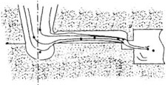It is generally located in the horizontal plane (parting plane) which connects the sprue to its ingates, thus letting the metal enter the mould cavity. The runners are normally made trapezoidal in cross- section. It is a general practice for ferrous metals to cut the runners in the cope and the ingates in the drag.

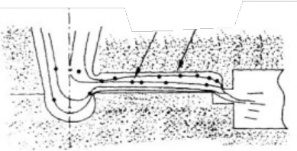

Slag

Runner

**Fig. 28:** Runner Full **Fig. 29:** Runner Partially Full

The main reason for this is to trap the slag and dross which are lighter and thus trapped in the upper portion of the runners. For effective trapping of the slag, runners should flow full as shown in Fig 28. When the amount of molten metal coming from the down sprue is more than the amount flowing through the ingates, the runner would always be full and thus slag trapping would take place. But when the metal flowing through the ingates is more than the flowing through the runners, then the runner would be filled only partially as shown in Fig. 29 and the slag would then enter the mould cavity.

* 1. **Riser**

It is a passage in molding sand made in the cope portion of the mold. Molten metal rises in it after filling the mould cavity completely. The molten metal in the riser compensates the shrinkage during solidification of the casting thus avoiding the shrinkage defect in the casting. It also permits the escape of air and mould gases. It promotes directional solidification too and helps in bringing the soundness in the casting.

**Ans. 5. (a) Solution:**

**Shaper Machine**

The shaper (also called shaping machine) is a reciprocating type of machine tool used for producing small flat surfaces with the help of a single point tool reciprocating over the stationary work piece. The flat surface may be horizontal, inclined or vertical. The reciprocating motion of the tool is obtained either by the crank and slotted lever quick return motion mechanism or Whitworth quick return motion mechanism.

(a) Grooved block (b) Dovetail slide (c) Guide gib (d) V-block

**Fig. 30**

**Working Principle of a Shaper**

We have already discussed that in a shaper, a single point cutting tool reciprocates over the stationary workpiece. The tool is held in the tool post of the reciprocating ram and performs the

EXAMINATION PAPER & SOLUTION 269

cutting operation during its forward stroke. It may be noted that during the backward stroke of the ram, the tool does not remove material from the workpiece. Both these strokes (i.e., forward and backward strokes) form one working cycle of the shaper.

Forward stroke

Movement for the depth of cut

Backward stroke



Forward stroke

Feed movement

Backward stroke



Movement for the depth of cut

Feed movement

(a) Shaping in horizontal direction (b) Shaping in vertical direction.

**Fig. 31:** Working Principle and Operation of a Shaper

For shaping in horizontal direction, as shown in Fig. 31(a), the clamped workpiece is fed against the reciprocating tool after every cutting cycle. The depth of cut is adjusted by moving the tool downward towards the workpiece. For shaping in vertical direction, as shown in Fig. 31(b). The tool is fed vertically towards the workpiece after every cutting cycle. The depth of cut is adjusted by moving the workpiece sideways.

**Important Parts of a Shaper**

The principal parts of a shaper, as shown in Fig. 32 are as follows:

* + 1. **Base:** It is a heavy structure of cast iron which supports other parts of a shaper.
    2. **Column:** It is a box-like structure made up of cast iron and mounted upon the base. It contains the driving mechanism and is provided with two machined guideways on the top of it on which the ram reciprocates.
    3. **Ram:** It is a reciprocating member which reciprocates on the guideways provided above the column. It carries a tool-slide on its head and a mechanism for adjusting the stroke length.
    4. **Tool head:** It is attached to the front portion of the ram with the help of a nut and a bolt. It is used to hold the tool rigidly. It also provides the vertical and angular movements to the tool for cutting.



Tool post

Tool slide

Ram adjustment nut

Ram clamping handle

Ram

Vice

Table

Cross feed Cross rail

Column

Vertical feed

Base

**Fig. 32:** Principal Parts of a Shaper

270 MANUFACTURING PROCESSES

1. **Cross-rail:** It is attached to the front vertical portion of the column. It is used for the following two purposes:
2. It helps in elevating the table over the column in the upward direction, and
3. The table can be moved in a direction perpendicular to the axis of the ram over this cross rail.
4. **Table:** It is used for holding the workpiece. It can be adjusted horizontally and vertically with the help of spindles.

**Difference in Operation between Shaper and Planer**

Following are the main differences between a planer and a shaper:

|  |  |
| --- | --- |
| *n© «¤r* | *q§ ­¤r* |
| OL g¯ ¨®   §¤ ±´ £°¯´ ª ¢§¨«¤ ¯¬¬© PL g¯ r¤q°¨r¤® ª¬r¤ ¥©¬¬r  r¤ L  QL g¯ ¨®  £¬­¯¤£ ¥¬r © r¦¤ ²¬rk®L  RL k¬r¤ ¯§ « ¬«¤ ¢°¯¯¨«¦ ¯¬¬© ¢ « ¡¤ °®¤£  ¯    ¯¨ª¤L  SL r¬¬© ¨® ¥¨³¤£  «£ ²¬rk ª¬±¤®L  TL n© «¤r ¯ ¡©¤ ¨® ¤¨¯§¤r £r¨±¤« ¡´ ¦¤ r® ¬r ¡´  §´£r °©¨¢ ª¤ «®L  UL f¤ ±¨¤r ¥¤¤£®  r¤  ­­©¨¤£L VL g¯ ¢ « ¯ k¤ £¤¤­ ¢°¯®L  WL u¬rk ®¤¯¯¨«¦ r¤q°¨r¤® ª°¢§ ¬¥ ®k¨©©  «£ ¯ k¤®  ©¬«¦¤r ¯¨ª¤L  ONL r¬¬© °®¤£  r¤ ¬¥ © r¦¤r ®¨µ¤L | OL g¯ ¨®   ©¨¦§¯ £°¯´ ª ¢§¨« ¤ ¯¬¬©L PL g¯ r¤q°¨r¤® ©¤®® ¥©¬¬r  r¤ L  QL g¯ ¨® °®¤£ ¥¬r ®ª ©© ²¬rk®L  RL m«©´ ¬«¤ ¢°¯¯¨«¦ ¯¬¬© ¨® °®¤£  ¯   ¯¨ª¤L  SL u¬rk ¨® ¥¨³¤£  «£ ¯§¤ ¯¬¬© ª¬±¤®L  TL g¯ ¨® «¬rª ©©´ £r¨±¤« ¡´ ¢r «k  «£ ®©¬¯¯¤£ ©¤±¤r q°¨¢k r¤¯°r« ª¬¯¨¬« ª¤¢§ «¨®ªL  UL j¨¦§¯¤r ¥¤¤£®  r¤  ­­©¨¤£L VL g¯ ¢ ««¬¯ ¯ k¤ £¤¤­ ¢°¯®L  WL u¬rk ª ´ ¡¤ ¢© ª­¤£ ¤ ®¨©´  «£ q°¨¢k©´L  ONL r¬¬© °®¤£  r¤ ¬¥ ®ª ©©¤r ®¨µ¤L |

**Ans. 5. (b) Solution :**

**Fusion Relates to Welding Operations**

In the weld, metal, whether melted from the edges to be joined (autogenous welding), or supplied separately, solidifies from the liquid state and usually below the recrystallization temperature without any applied deformation. Fusion welds are, therefore, essentially castings. Since the surrounding parts are good con-ductors of heat the fusion weld may be called a chilled casting and its structure will, therefore, usually be columnar (dendritic).

**Classification of the Welding Processes**

Many types of welding processes have been developed depending upon the field of their applications (Table 7.1). But the welding is broadly divided into following two groups:

1. **Forge or Pressure Welding (**Under pressure without additional filler metal)
   1. Friction welding b. Electric Resistance welding

c. Blacksmiths forge welding d. Cold Pressure welding

1. **Fusion or Non-pressure Welding** (With additional filler material)
   1. Gas welding (Heat created by Gas)
   2. Electric arc welding (Heat created by electrically)
   3. Thermit welding (Heat created by chemical reaction)

EXAMINATION PAPER & SOLUTION 271



**Features of Neutral, Reducing and Oxidizing Flames**

There are three types of gas flames:

1. Oxidising Flame
2. Reducing Flame
3. Neutral Flame
4. **Oxidising Flame:** When the volume of oxygen gas is more than the volume of acetylene mixed into the torch. This flame is used for welding brass and is also used for cutting the metals.

Outer Envelope

Inner

Cone (3500°C)

Outer Envelope

Intermediate Cone

Inner

Cone (3150°C)

Outer

Envelope (1200–1300°C

Inner

Cone (3400°C)

(a) Oxidizing Flame (b) Carburizing Flame (c) Neutral Flame

**Fig. 33:** Types of Flames

272 MANUFACTURING PROCESSES

1. **Reducing Flame:** When the volume of acetylene mixed is more than oxygen, Reducing flame is formed. This flame is used for welding nickel, monel etc.
2. **Neutral Flame:** It is known as balanced flame. Oxygen and acetylene gases are mixed in equal volumes. Neutral flame is used for normal welding of steel, cast iron etc.

**Ans. 6. (a) Solution :**

**Role and importance of materials and manufacturing for the growth of any nation.**

The economic aspects of material selection are as important as the technological considerations of properties and characteristics of materials. The cost and availability of raw and processed materials and manufactured components are major concerns in manufacturing. If raw or processed materials or manufactured components are not commercially available in the desired shapes, dimensions, and quantities, substitutes or additional processing will be required, which can contribute significantly to product cost. For example, if we need a round bar of a certain diameter and it is not available from the supplier, then we will have to purchase a larger rod and reduce its diameter by a process such as machining, drawing through a die or grinding.

Reliability of both supply and demand affects cost. Most countries import numerous raw materials that are essential for production. In addition, various costs are involved in processing materials by different methods. Some methods require expensive machinery, others require extensive labour and still others require personnel with special skills, a high level of formal education, or specialized training.

**Production and Productivity**

A manufacturing plant or a factory is designed for a certain production which may be expressed in terms of number of products per unit time, i.e., number of cars per day or per month or per year. The production may also be expressed in terms of value of production, i.e., a turnover of Rs. two thousand crores per year.

The productivity is the efficiency or effectiveness of a manufacturing process and may be expressed as production output for a given input. The input may be machines, materials or men. Therefore, we can have labour productivity, machine productivity, material productivity or energy produc-tivity depending upon the input resource which we want to optimize. The productivity consists of increasing the production with or without increasing the corresponding input (i.e., machine hours, man-hours, quantity of material or fuel/power consumption.)

**Ans. 6. (b) Solution:**

1. **Electroplating**

It is the process of depositing a very thin layer of metal coating, on the base metal, by passing a direct current through an electrolyte solution containing some salt of the coating metal. Now a days, the electroplating (sometimes known as electrodepositing) is one of the best methods for the commercial production of a metallic coating.

In this process, the article to be electroplated is first immersed in hot alkaline solution to remove oil and grease. It is then treated with dilute hydrochloric acid or sulphuric acid to remove scale and oxides. It may be noted that hydrochloric acid is used for nickel and copper plating, while sulphuric acid is used for chromium plating. The cleaned article is made to act as cathode whereas the coating metal as an anode. The cathode and anode are dipped in a solution containing some salt of the coating material i.e., electrolyte, as shown in Fig. 34.

EXAMINATION PAPER & SOLUTION 273



**Fig. 34:** Electroplating

When direct current is passed, the coating metal ions migrate to the cathode and get deposited there. Thus a thin layer of coating metal is obtained on the article, which is made as cathode. The thickness of coating can be 0.005 mm or more. The commonly used metals, which are used for electroplating, are copper, nickel, chromium, silver, gold, cadmium and tungsten.

The electroplating is extensively used for decorative purposes and for protecting iron and steel articles from corrosion.

1. **Galvanizing**

It is mainly used to apply coatings of low melting metals such as zinc, tin, cadmium, aluminium or lead on iron, steel and copper which have relatively higher melting temperatures. In this method, the article is cleaned and dipped in a bath of molten metal. It is then taken out from the bath and finished properly. The most common processes of galvanizing are hot dipping and tin plating as discussed below:

**Hot Dip Galvanizing**

It is a process of providing thin layer of zinc coating (highly corrosion resistant) on iron or low carbon steel by dipping them in a bath of molten zinc. It improves the resistance against corrosion due to atmosphere and water. Since zinc is anodic to iron or steel (which serves as cathodic), therefore, the zinc coating (also called anodic coating) is obtained by electrochemical reaction between the zinc and the iron or steel. The process is carried out as follows:

First of all, the work is cleaned by pickling with dilute sulphuric acid, to remove any scale, rust and impurities. After washing and drying, it is dipped in a bath of molten zinc maintained at a temperature of about 450°C. The surface of the bath is kept covered with a molten flux layer usually of zinc ammonium chloride to prevent oxide formation. The duration of immersion in a zinc bath depends upon the size of the work to be coated. It is then taken out from the bath and passed through a pair of rollers to remove any excess of zinc. Finally, the work is cooled and dried.

The galvanising process is widely used for sheeting’s for roofs and walls of building, structural parts, pipes, containers, fencing materials, nails, wires etc.

274 MANUFACTURING PROCESSES

**Tinplating or Tinning**

It is a process of providing a thin layer of tin coating on the iron or steel sheets. In this process, the metal sheet is first treated with dilute sulphuric acid (pickling) to remove any oxide film. It is then fluxed by passing through a bath of zinc chloride. The flux helps the molten tin to adhere to the metal sheet. Now the sheet is dipped into a tank of molten tin which is maintained at a temperature of approximately 320°C. This process gives a coating thickness of about 0.003 mm. Finally, the sheet is passed through a series of rollers to remove any excess of tin and produce a thin layer of uniform thickness on the sheet.

The tin-plating or tinning is generally done on metal sheets used for manufacturing containers for storing foodstuffs ghee, oils, kerosene and packing food materials. The tinned-copper sheets are employed for making cooking utensils and refrigeration equipments.

1. **Plant layout**

Plant layout is such a systematic and effective functional arrangement of different departments, machines, equipment and services of an organization that will facilitate the processing of the proposed or undertaken product in the most efficient and economical manner in the minimum possible time.

**Objectives of Plant Layout:**

The main objective of plant layout is given below.

* 1. The material has to move a minimum distance.
  2. There is a smooth flow of the product in the plant.
  3. The entire space of the plant is fully utilized.
  4. The layout provides safety and satisfaction to the plant worker.
  5. It facilitates an effective supervision.
  6. Minimize material handling.
  7. Reduce the manufacturing cost.
  8. Afford economically but output quantity and quality.
  9. Maintain high turnover of work in process.
  10. Reduce investment in equipment.
  11. Make effective and economical use of floor space.
  12. Reduces work delay and stoppages.

**Important Consideration:**

When a large industrial undertaking planned a number of important considerations is made before taking a final decision. The common factors effecting this decision are:

1. Availability of space
2. Availability of power
3. Availability of water
4. Availability of raw material
5. Marketing facilities for the planned product.
6. Effect of ancillary industries.
7. Availability of skilled and un-skilled labour locally.
8. Local taxes and similar other economic consideration.

EXAMINATION PAPER & SOLUTION 275

Now the next step is to plan the internal layout of the factory with the following considerations:

1. Specification of material and product.
2. Manufacturing process.
3. Type of production.
4. Material handling facilities.
5. Service facilities.
6. Lighting and ventilation.

Now the internal arrangement of the equipment of different shops is decided next. This is called Shop Layout

1. Size and type of equipment.
2. Number of machine to be installed.
3. Floor area required for working on each machine.
4. Power requirements for the machine.
5. Sequence of operation to be followed.
6. Requirement of factory service.
7. Proper supervision and control.
8. Safe working condition.
9. Provision of stores within the shop, for tools, instruments, finished parts.
10. **Ceramics**

Ceramics are non-metallic solids, made of inorganic compounds such as oxides, nitrides, borides, silicides and carbides for which the interatomic bonds are either totally ionic or predominately ionic or having some covalent character. Common Ceramics includes rocks, minerals, glass, glass fiber, metallic compounds, fire clays, abrasives etc.

The term Ceramics comes from the Greek word “KERAMIKOS” which means ‘burnt stuff’ indicating that the desirable properties are achieved through higher temperature heat treatment process called firing. The Science of Ceramics is processing of earthly materials by heat. All the early ceramics products were made from clay because the ware could be easily formed. It was then dried and fired to develop the permanent structure.

Other forming methods used for ceramic materials are injection moulding, sintering and hot pressing. In other cases the formed materials are allowed to harden on the job by addition of water as in case of cements.

Ceramic materials are more stable with respect to thermal and chemical environments than their components. Ceramics offer more resistance to slip, are generally harder and always less ductile than their metallic or polymeric counter parts. The dielectric, semiconductive and magnetic characteristics of selected ceramics are especially valuable to the scientists and engineers who design or utilize devices for electronics circuits. All these materials are compounds of metals and non-metals.

# MODEL TEST PAPER–1

## SECTION–A

1. The melting point of wrought iron is about
2. The angle of between the lathe centre is
3. Casting is a
4. The cold working of method is carried out
   1. At the recrystallization (b) At any temp.

(c) Below the recrystallization temperature (d) None of these

1. Which g the following are thermosetting resins
   1. Silicon resin (b) Polyamide

(c) Cellulose derivatives (d) Both b and c

1. The process of decreasing the cross-section of a bar and increasing its length is called
   1. Drawing down (b) Upsetting

(c) Spinning (d) Peening

1. A casting defect which occur near the ingates at rough lumps
   1. Shift (b) Sand wash

(c) Swell (d) Scab

1. PVC is a
   1. Thermoplastic (b) Thermosetting
2. In electric resistance welding, voltage required to heating
   1. 1–5 V (b) 6–10V

(c) 11–20V (d) 50 –100 V

1. The flues commonly used in brazing is
   1. Zinc chloride (b) Ammonium chloride

(c) Rose + alcohol (d) Borax

## SECTION–B

**Attempt any two questions of the following:** 10 x 2 = 20

1. Describe manufacturing of cast iron (cupules furnace)? Briefly discuss its important types, their properties and uses.
2. Describe punch and die assembly with the help of diagram.
3. Describe in brief, the process of oxyacetylene welding. Also draw a labeled neat sketch of the equipment used in oxyacetylene welding.
4. Describe powders metallurgy.

MODEL TEST PAPER 277

## SECTION–C

1. **Attempt any two questions of the following:** 4 × 5 = 20
   1. Define creep. Describe creep test curve compare between fatigue
   2. Write short notes on:
      1. 18- 4 -1 HSS
      2. Hardness
      3. Stiffness
   3. Define Common use of non-ferrous metals.
2. **Attempt any two questions of the following:**
   1. Write short notes on the following:
3. Blanking
4. Piercing
5. Notching
   1. Describe in brief types of moulding sand.
   2. Explain with neat sketch Cupola furnace.
6. **Attempt any two questions of the following:**
   1. Differentiate between capstan and Turret lathe.
   2. What are the functions of coated electrodes?
   3. Write short notes on:
7. Soldering
8. Brazing
9. **Attempt any two questions of the following:**
   1. Differentiate between production and productivity.
   2. What are ceramic and its common types?
   3. Explain Galvanizing and Electroplating.

# MODEL TEST PAPER–2

[www.EngineeringEBooksPdf.com](http://www.EngineeringEBooksPdf.com/)

## SECTION–A

1. **Match the following:** 1 × 10 = 10
2. Nodular iron is a cast iron produced by adding a. Tempering
3. An operation involving of a metal alloy in the solid state, b. Hardening fot the purpose of obtaining certain desirable properties
4. 150 mm square or larges sections obtained by reduction c. Heat treatment of ingot in several passes
5. Product of blast furnace and made by the reduction of d. Spheroidising iron ore
6. An alloy of iron containing so much carbon that as cast it e. Bloom is not appreciably malleable at any temp.
7. Heating and quenching of iron base alloys from within or f. Pig iron above the critical range.
8. Contains carbon in the combined form. The presence of g. White cast iron cementite makes it hard and brittle
9. As cast it has combined carbon not in excess of eutectoid h. Carbon steel

% age

1. Process of heating and cooling steel to produce rounded or i. Gray cast iron globular form carbide
2. Reheating hardened steel to some temp. below the lower ... j. Magnesium and cerium temp, followed by any desired rate of cooling

## SECTION–B

1. **Attempt any two questions of the following:** 10 × 2 = 20 Marks
   1. Differenciate between brass and bronze. List few types of brasses and bronzes and give their applications.
   2. Describe die-casting. Mention its advantages and disadvantages.
   3. What do you say about the following:
      1. What do you mean by heat affected zone (HAZ) of the weld joint and what its significance?
      2. What is the purpose of coating over the commercial are welding electrodes and what is the material used for coating it?
      3. What do you understand by Arc Blow?
   4. Describe the principle of lathe.

[www.EngineeringEBooksPdf.com](http://www.EngineeringEBooksPdf.com/)

MODEL TEST PAPER 279

## SECTION–C

1. **Attempt any two questions of the following:** 5 × 4 = 20 Marks
   1. Differenciate between
      1. Ductility and brittleness (ii) Annealing and Hardening
   2. Name the material following are made of:
      1. Carpentry saw (ii) Hammers

(iii) Anvils (iv) Drill bits

(v) Window grills

* 1. Write short notes on AI alloy.

1. **Attempt any two questions of the following:**
   1. Why forming processes is better than castings machinery processes?
   2. Define shearing process with its operations.
   3. Write short notes on: tube drawing.
2. **Attempt any two questions of the following:**
   1. Write short notes on:

(a) Facing (b) Plain turning

(c) Reaming

* 1. What are the main difference b/w shaper and planer.
  2. Write short notes on:

(a) Drilling (b) Counter sinking

(c) Spot facing

1. **Attempt any two questions of the following:**
   1. Compare between process layout and product layout.
   2. Write advantages of good plant layout.
   3. Write short notes on:
      1. Ceramics (ii) Cement-concrete

(iii) Powder metallurgy

❍ ❍